Murray Murrumbidgee Region – What’s Happening in the Housing Market?

The Murray Murrumbidgee region covers twenty six local government areas and 114,309 square kilometres, with several regional centres including Albury, Wagga Wagga and Griffith. Historically this region has been more affordable relative to some other regions with the state, however, the housing market is not uniform across the region. There are significant differences in population growth and decline, as well as rent and purchase price and affordability. The low vacancy rates in the private rental market indicate an undersupply of private rental housing and some LGAs have high proportions of residents in rental stress.

Housing Market - Rental

Rents
- Over the longer term (1990 to 2014) median rents in Murray Murrumbidgee LGAs were on an upward trend, increasing by between 70.3% in Hay and 220.5% in Junee. Rental increases in Murray Murrumbidgee are generally similar to those in the Central West Orana over the same time frame. Rental increases have been stronger in a number of the smaller LGAs (for example Junee 220.5%, Griffith 212.5%, Narrandera and Leeton 175%) than in the two largest regional centres (Albury at 136% and Wagga Wagga at 140%). Note that rental levels in Murray LGA have historically been at or close to the highest in the region.
- More recently (between March 2008 and December 2014) there have been moderate increases in median rents in the Murray Murrumbidgee region. Temora is the only LGA with a strong increase in median rents – with an 84% increase in the median rent for three bedroom properties over six years to December 2014. The next highest rent increases were for one bedroom properties in Albury (37.0%) and two bedroom in Deniliquin (36.7%) and Cootamundra (35.7%).
- At December 2014, median rents for one bedroom properties are highest in Albury ($158), for two bedroom in Wagga Wagga ($243), for three bedroom in Murray and Wagga Wagga ($320) and for four bedroom properties in Albury ($380).
- The two graphs below shows changes in median rents for all dwellings from 1990 to 2014 in all the LGAs in the Murray Murrumbidgee region. Generally there was very little increase in rents between 1990 and around 2003, after which they began to increase strongly.
- The table below shows the proportional change in median rents for studio (0), one, two, three and four or more bedrooms between 2008 and 2014 for all the Murray Murrumbidgee region local government areas (LGAs).

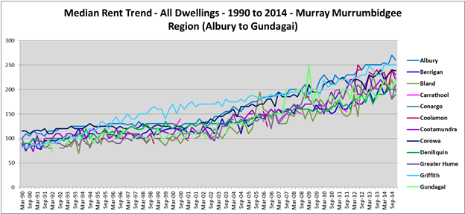

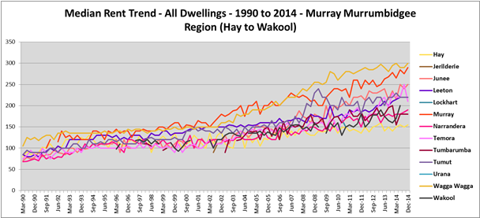

Median Rents in Murray Murrumbidgee March 2008 to December 2014
 | Mar-2008 |  |  |  |  | Dec-2014
Area | 0 bed | 1 bed | 2 bed | 3 bed | 4 bed | 0 bed | 1 bed | 2 bed | 3 bed | 4 bed
Albury |  | 115 | 170 | 250 | 288 |  | 158 | 215 | 290 | 380
Berrigan |  |  | 130 | 180 |  |  |  | 145 | 220
Bland |  |  | 130 | 170
Carrathool
Conargo
Coolamon |  |  |  |  |  |  |  |  | 235
Cootamundra |  |  | 140 | 193 |  |  |  | 190 | 240
Corowa Shire |  |  | 153 | 210 |  |  |  | 180 | 255 | 305
Deniliquin |  |  | 123 | 200 |  |  | 85 | 168 | 250 | 320
Greater Hume Shire |  |  |  | 180 | 240 |  |  |  | 210
Griffith |  | 120 | 160 | 220 | 280 |  | 150 | 200 | 270 | 340
Gundagai |  |  |  | 220
Hay |  |  | 120 | 150 |  |  |  | 140
Jerilderie
Junee |  |  | 128 | 195 |  |  |  |  | 248
Leeton |  |  | 150 | 185 | 240 |  |  | 175 | 220 | 280
Lockhart
Murray |  |  | 180 | 245 |  |  |  | 230 | 320
Murrumbidgee
Narrandera |  |  | 130 | 170 |  |  |  | 170 | 200
Temora |  |  | 140 | 125 |  |  |  |  | 230
Tumbarumba
Tumut Shire |  |  | 160 | 225 | 270 |  |  | 195 | 245 | 310
Urana
Wagga Wagga |  | 138 | 188 | 268 | 330 |  |  | 243 | 320 | 370
Wakool
Note there were insufficient dwellings in some bedroom categories in a number of LGAs to ascertain the median rent. No LGA had sufficient studio dwellings to calculate a median rent. This indicates the small size and lack of diversity in bedroom mix of the private rental markets in many of the LGAs in this region.

Vacancy Rate
- The graph below shows the vacancy rate in the private rental market (taken from REINSW data) in Albury and the Murrumbidgee region over the period from October 2006 to July 2015.
- A vacancy rate of 3% is regarded as representing a balance between supply and demand. Vacancy rates in Albury have been tight – below the 3% level for almost the entire period, while for Murrumbidgee, they have been very tight since December 2011, indicating an undersupply of private rental accommodation across the region. At July 2015, the REINSW vacancy rate for Albury was 2.2% and for Murrumbidgee was 2.6%.
- The graph below shows the vacancy rate for Albury and for the Murrumbidgee region from 2006 to 2015 using REINSW data.

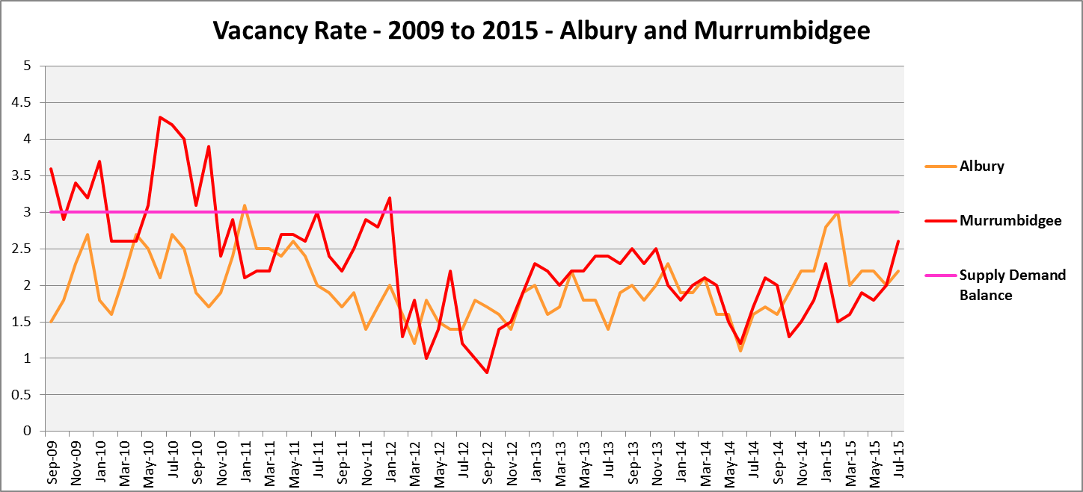

Affordable Rental
- The general trend across Sydney and NSW has been for a decline in the proportion of rental stock which is affordable for very low, low and moderate income earners. Historically much of this region has been more affordable for rental than the average for the rest of NSW. Nevertheless, the proportion of affordable rental has declined for both very low and low income households in the majority of LGAs in the region over the period from 2001 to 2014.
- The proportion of affordable rental for very low income households has declined in fourteen LGAs in the Murray Murrumbidgee Region, increased in five and for the remaining seven LGAs there was insufficient activity in the private rental market to assess rental affordability. Between 2001 and 2014 Junee had the biggest drop in rental affordability (down 34.4%), followed by Temora (32.3%), Albury (30.3%) and Gundagai (29.1%), all larger declines than the Rest of NSW average of 27.6%. At June 2014, Wagga Wagga had the lowest proportion of affordable rental with 23.6%, followed by Murray (24.3%) and Albury (29.3%) – every LGA in the region has a higher proportion of affordable rental than the Rest of NSW average of 20.9%. Nevertheless, these three LGAs have low proportions of affordable rental for very low income households.
- The graph below shows the proportion of rental properties that were affordable to very low income households in each of the Murray Murrumbidgee region local government areas between 2001 and 2014.

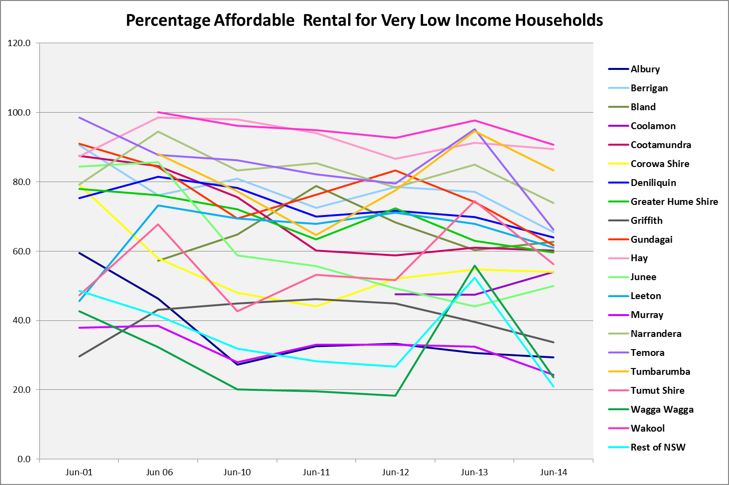

- Between 2001 and 2014, the proportion of rental affordable for low income households declined in sixteen Murray Murrumbidgee region LGAs, increased in four and in the remaining six there was insufficient activity in the rental market to calculate the proportion of affordable rental. Over that period Albury had the largest decline in affordable rental for low income households, with a drop of 31.6%, followed by Wagga Wagga with 26.5%. No LGA in the region had a larger decline than the Rest of NSW average of 33.0%. At June 2014 Albury had the lowest proportion of affordable rental for low income households in the region with 55.3%, followed by Wagga Wagga with 56.9%. No LGA in the region had a lower proportion of affordable rental for low income households than the Rest of NSW average of 49.8%.
- Despite some variability in affordability of this time frame, rental affordability for very low income households in Murray Murrumbidgee is the lowest it has been since 2001 in the majority of LGAs in the region.
- The graph below shows the proportion of rental properties affordable for low income households in the Murray Murrumbidgee region LGAs between 2001 and 2014.
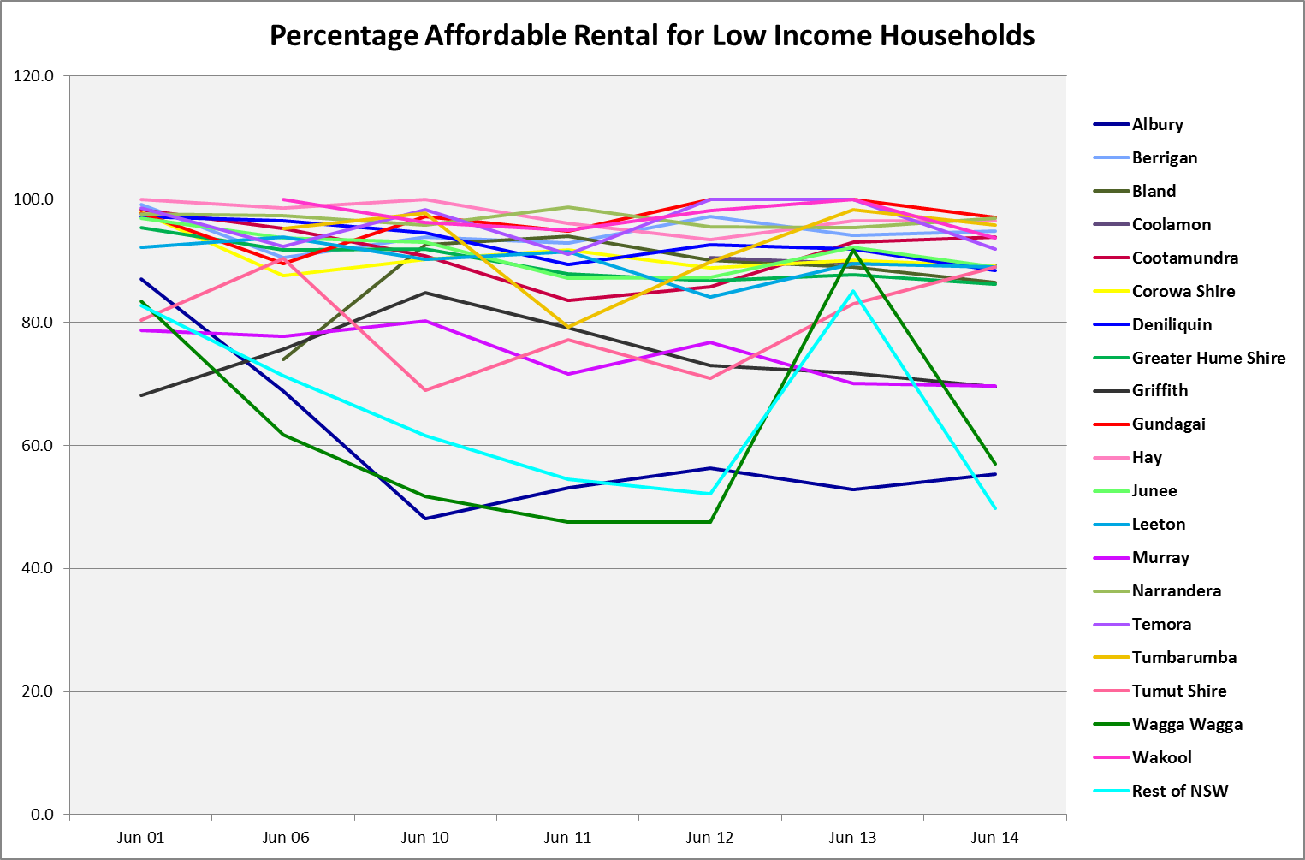

Rental Stress
- Households regarded as being in rental stress are renting in the private rental market and paying more than 30% of their income in rent. Lower income households in rental stress will struggle to pay for other essential household items, such as medical or educational expenses, food, transport and energy costs.
- The proportion of very low income households in rental stress ranges between 91% in Wagga Wagga and 29% in Jerilderie, with Wagga Wagga and Albury having an equivalent to or higher proportion in stress than the average for the Rest of NSW of 87%.
- Low income households in stress in Murray Murrumbidgee ranged between 57% in Wagga Wagga and 0% in Conargo. Wagga Wagga was the only LGA in this region with a higher proportion of low income households in rental stress than the average of 54% for the Rest of NSW – Murray was the next highest with 52%.
- The graph below shows the proportions of very low and low income households in rental stress in the Murray Murrumbidgee region and Rest of NSW at the 2011 Census.

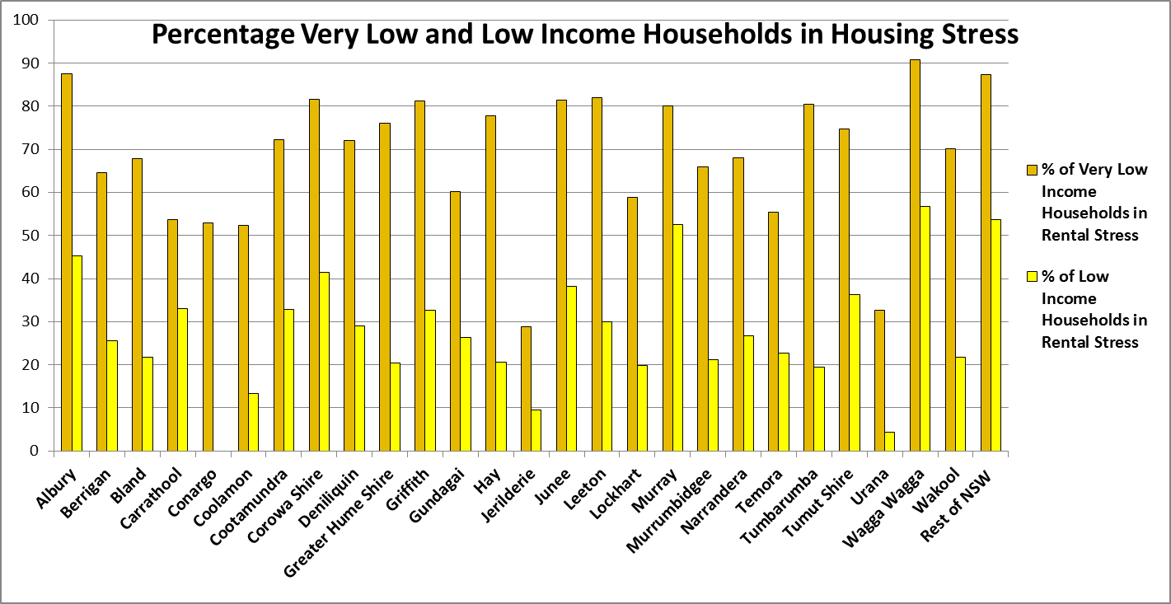

- The table below shows the number and proportion of residents in the private rental market in the Murray Murrumbidgee region who are recipients of Commonwealth Rent Assistance and even after this additional income support, are still in housing stress. There are a total of 4,324 CRA recipients in housing stress in this region, with Wagga Wagga having the highest number (1,840) and the highest percentage with 43.4% - the only LGA in the region with a higher proportion in stress than the average of 32.4% in the Rest of NSW.
- The high number and proportion of CRA recipients in housing stress in Wagga Wagga in particular but also in Albury (1,185 CRA recipients in housing stress) is another indicator of the demand for and undersupply of affordable housing.
- The proportions of lower income households in rental stress indicate that there is insufficient affordable rental housing to meet demand in some LGAs in the region – this is true of the major regional centres and Wagga Wagga particularly.

Area | Total CRA recipients 2012 | CRA recipients in Housing Stress 2012 | % in Stress
Albury | 4,086 | 1,185 | 29.0
Berrigan | 489 | 63 | 12.9
Bland | 175 | 24 | 13.7
Carrathool | 76 | 11 | 14.5
Conargo | 26 | 3 | 11.5
Coolamon | 151 | 24 | 15.9
Cootamundra | 343 | 58 | 16.9
Corowa Shire | 644 | 114 | 17.7
Deniliquin | 606 | 79 | 13.0
Greater Hume Shire | 400 | 63 | 15.8
Griffith | 1,403 | 303 | 21.6
Gundagai | 117 | 17 | 14.5
Hay | 180 | 23 | 12.8
Jerilderie | 43 | 9 | 20.9
Junee | 279 | 58 | 20.8
Leeton | 652 | 112 | 17.2
Lockhart | 94 | 20 | 21.3
Murray | 579 | 84 | 14.5
Murrumbidgee | 132 | 7 | 5.3
Narrandera | 349 | 37 | 10.6
Temora | 285 | 36 | 12.6
Tumbarumba | 152 | 31 | 20.4
Tumut Shire | 586 | 104 | 17.7
Urana | 38 | 6 | 15.8
Wagga Wagga | 4,240 | 1,840 | 43.4
Wakool | 176 | 13 | 7.4
Rest of NSW | 181,401 | 58,843 | 32.4

Loss of Affordable Housing Stock
- FACS has calculated the number of new rental bonds lodged that were affordable to low income earners in the Murray Murrumbidgee region in 2006, 2010 and 2013.
- Sixteen of the local government areas in this region experienced a reduction in the number of affordable bonds lodged between 2006 and 2013. Across the region there were a total of 812 fewer affordable rental bonds lodged in 2013 than in 2006. Albury (302), Wagga Wagga (102), Tumut (95) and Griffith (86) had the largest losses in numeric terms. In terms of proportion of affordable rental lost, Murrumbidgee had the biggest loss with 48%, followed by Bland and Temora (39%). Given the strong increase in numbers of lower income rental households resident in this region, this is concerning.
- Note that in some LGAs there was an increase in the number of affordable rental properties between 20201 and 2013, however none recovered to the level of affordable rental properties in 2006.
- The table below shows the number of new bonds lodged that were affordable to low income earners in the Murray Murrumbidgee LGAs in 2006, 2010 and 2013.

LGA | No. of affordable rental properties for low income households
LGA | 2006 | 2010 | 2013
ALBURY | 1,223 | 772 | 921
BERRIGAN | 157 | 236 | 197
BLAND | 122 | 91 | 75
CARRATHOOL | 42 | 25 | 29
CONARGO | 1 | 4 | 1
COOLAMON | 32 | 14 | 38
COOTAMUNDRA | 120 | 134 | 138
COROWA SHIRE | 200 | 183 | 208
DENILIQUIN | 299 | 264 | 252
GREATER HUME SHIRE | 126 | 117 | 111
GRIFFITH | 496 | 487 | 410
GUNDAGAI | 54 | 57 | 49
HAY | 120 | 96 | 99
JERILDERIE | 27 | 21 | 28
JUNEE | 108 | 106 | 94
LEETON | 296 | 291 | 250
LOCKHART | 23 | 36 | 30
MURRAY | 88 | 76 | 68
MURRUMBIDGEE | 69 | 59 | 36
NARRANDERA | 134 | 95 | 123
TEMORA | 138 | 100 | 84
TUMBARUMBA | 64 | 63 | 75
TUMUT SHIRE | 278 | 169 | 183
URANA | 10 | 8 | 13
WAGGA WAGGA | 864 | 566 | 762
WAKOOL | 60 | 80 | 65
Source : RBB Data (Office of Fair Trading). Analysis by FACS
1. Affordable rent threshold was calculated as 30% of the 40th percentile of household income (approximated by 80% of the median household income).
2. Rent threshold was calculated separately for Sydney and Rest of NSW.
3. All new rental bonds in Sydney and Rest of NSW with rents below the respective thresholds are counted as affordable.

Housing Market - Purchase

Sales Price
- The following graphs for the median sales price trend for houses show that there has been considerable variation in the median sales price over the period from 1991 to 2014, and a significant increase in the sales price of houses in the Murray Murrumbidgee region. The variation masks the fact that Murray LGA has consistently had one of the highest median sales prices in the region, with Wagga Wagga and Albury also consistently having relatively strong median sales prices.

- Most of the increase for houses took place from between 2000 and 2003 onwards. This is similar to the trend time line for rents. Between 1993 and 2013, growth in median house prices was strongest in Murrumbidgee (593%), Gundagai (357%), Wakool (354%), Hay (318%), Cootamundra (316%), Lockhart (314%), Narrandera (306%) and Junee (302%). These are very strong increases. Median sales prices increases in the region range between 593% in Murrumbidgee and 87.5% in Greater Hume.

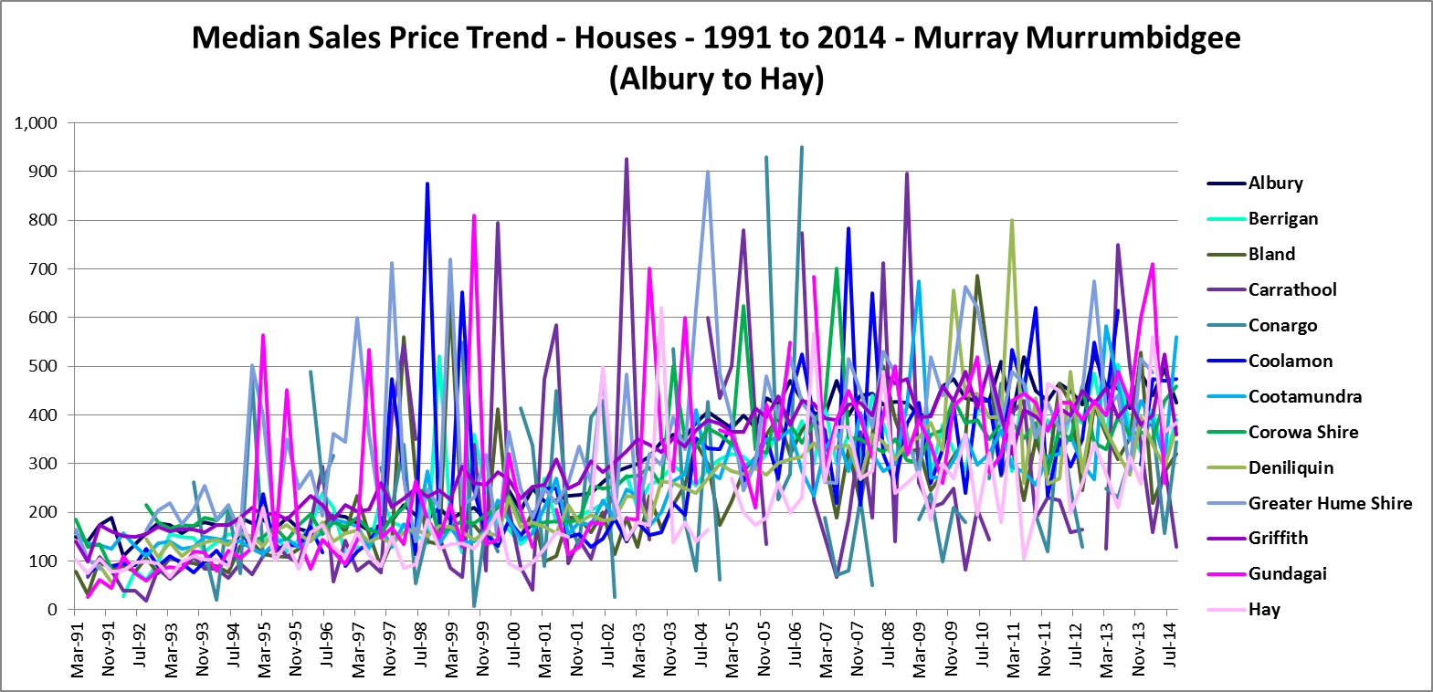

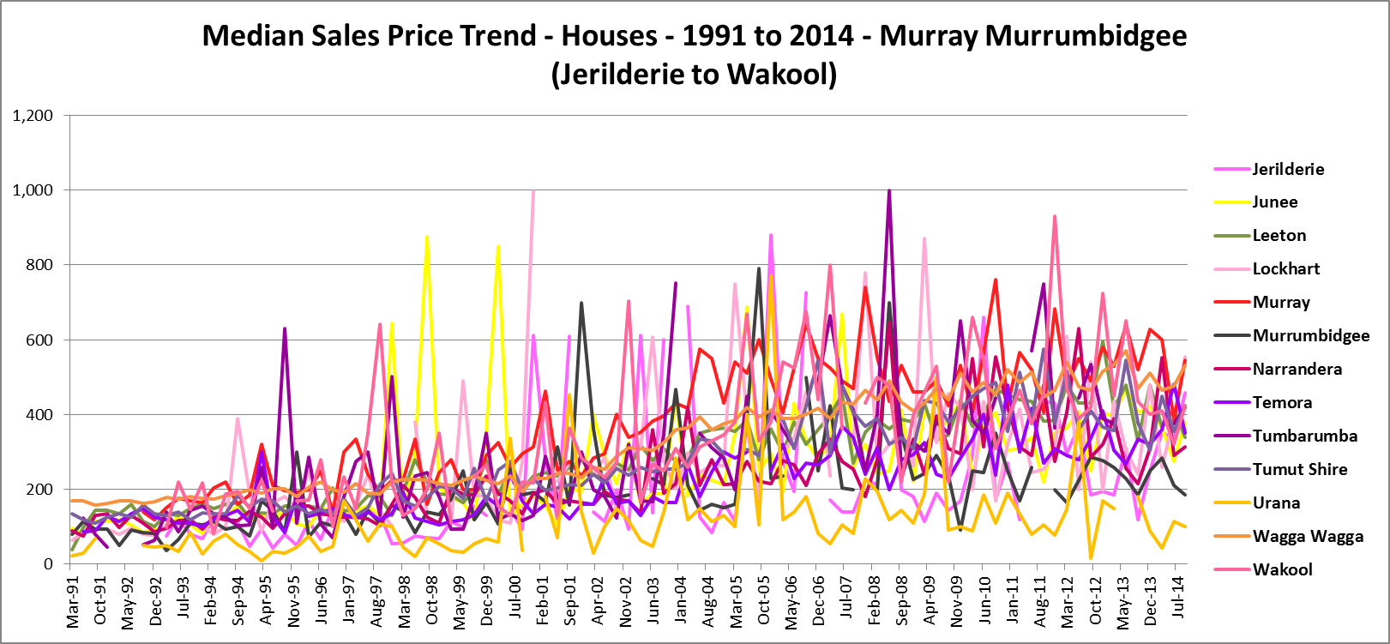

- The graph below shows the sales price trend for strata properties between 1991 and 2014 in the Murray Murrumbidgee region LGAs – although fourteen of the local government areas in this region had insufficient sales of strata properties to give any sort of trend line for this period. Median sales price increases for strata properties were generally weaker than for houses over the same period, ranging between 15.5% increase in Deniliquin and 168% in Murray.

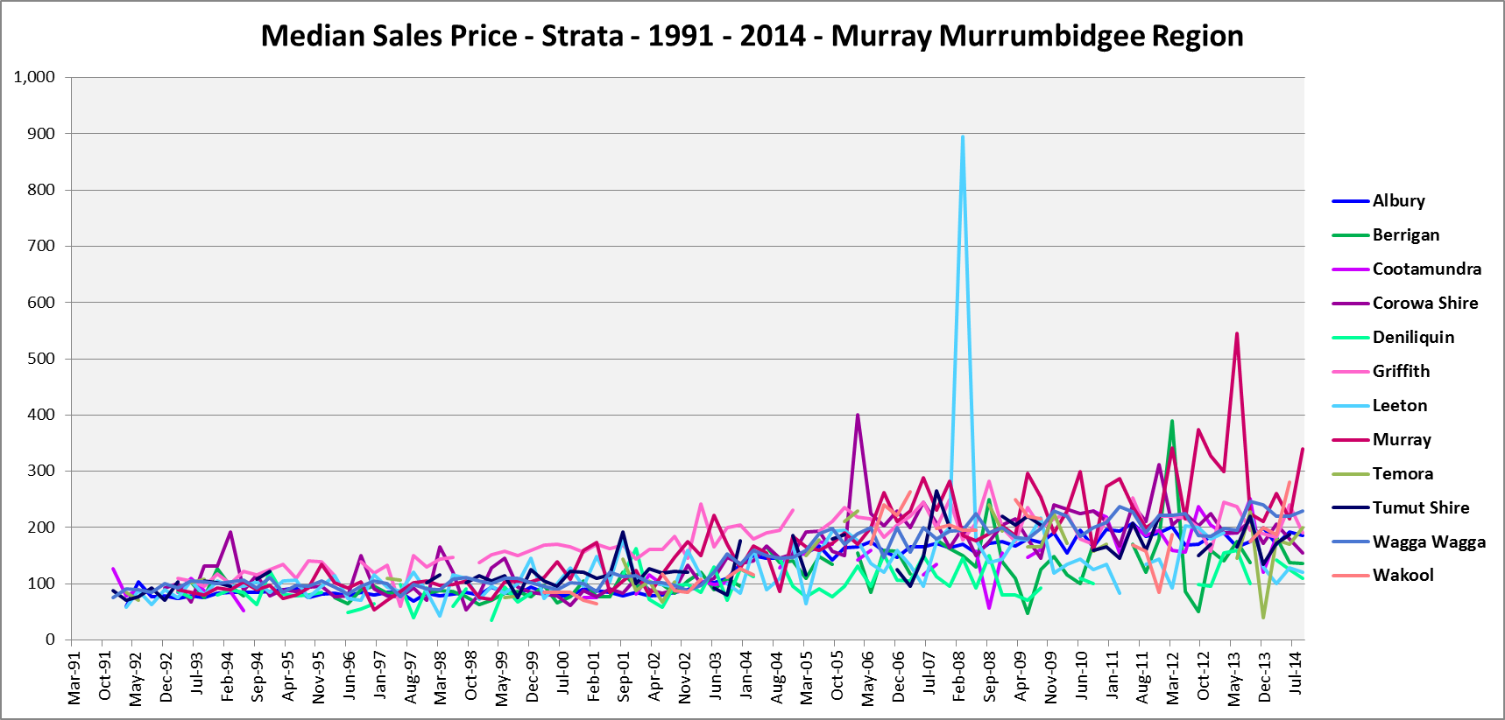

- The table below shows changes in the median sales price of both houses and flats (where there is sufficient data to calculate a median) over the last few years in the Murray Murrumbidgee region. Changes in house price over the period from March 2008 to March 2013 have been upward in thirteen LGAs, downward in twelve and static in one LGA. For flats, median sales prices increased in eight and declined in two.
- At March 2013 (this was the most recent date that did not include a median sales price over $1million, which would distort the results) Wagga Wagga had the highest median house price with $535k, closely followed by Murray with $530k and Albury next highest with $460k and Griffith with $455k.
- For flats, at September 2014, Murray had the highest median sales price with $341k, followed by Wagga Wagga with $229k, Cootamundra $222k and Temora $200k.

 | Flats |  |  |  | Houses
 | Sep-09 | Sep-14 | Change | % | Mar-08 | Mar-13 | Change | %
Albury | 174 | 185 | 11 | 6.3 | 445 | 460 | 15 | 3.4
Berrigan | 125 | 137 | 12 | 9.2 | 440 | 360 | -80 | -18.2
Bland |  |  |  |  | 360 | 360 | 0 | 0.0
Carrathool |  |  |  |  | 190 | 125 | -65 | -34.2
Conargo |  |  |  |  | 50 | 250 | 200 | 400.0
Coolamon |  |  |  |  | 650 | 425 | -225 | -34.6
Cootamundra | 161 | 222 | 62 | 38.3 | 320 | 582 | 262 | 81.9
Corowa Shire | 145 | 155 | 10 | 6.9 | 335 | 330 | -5 | -1.5
Deniliquin | 93 | 110 | 18 | 18.9 | 360 | 370 | 10 | 2.8
Greater Hume Shire |  |  |  |  | 375 | 413 | 38 | 10.0
Griffith | 200 | 190 | -10 | -5.0 | 400 | 455 | 55 | 13.8
Gundagai |  |  |  |  | 313 | 400 | 87 | 27.8
Hay |  |  |  |  | 285 | 280 | -5 | -1.8
Jerilderie |  |  |  |  | 213 | 185 | -28 | -12.9
Junee |  |  |  |  | 240 | 402 | 162 | 67.4
Leeton | 218 | 120 | -98 | -44.8 | 384 | 420 | 36 | 9.3
Lockhart |  |  |  |  | 280 | 435 | 155 | 55.4
Murray | 254 | 341 | 87 | 34.2 | 553 | 530 | -23 | -4.1
Murrumbidgee |  |  |  |  | 200 | 260 | 60 | 30.0
Narrandera |  |  |  |  | 280 | 390 | 110 | 39.3
Temora | 165 | 200 | 35 | 21.2 | 313 | 305 | -8 | -2.4
Tumbarumba |  |  |  |  | 400 | 375 | -25 | -6.3
Tumut Shire | 205 |  |  |  | 390 | 358 | -33 | -8.3
Urana |  |  |  |  | 195 | 150 | -45 | -23.1
Wagga Wagga | 198 | 229 | 32 | 15.9 | 440 | 535 | 95 | 21.6
Wakool | 216 |  |  |  | 500 | 449 | -51 | -10.2

Purchase Affordability
- Purchase affordability for very low income earners in the Murray Murrumbidgee region has declined since 2001 in most LGA’s. At June 2014, two LGA’s had a lower proportion affordable for purchase by very low income households than the Rest of NSW average of 5.9%, with Murray having 0% and Wagga Wagga just 3.1%. Griffith had just 8.7% and Albury 9.7%.
- The graph below shows the proportion of properties that are affordable for purchase by very low income households in each of the Murray Murrumbidgee region local government areas and the Rest of NSW between 2001 and 2014.

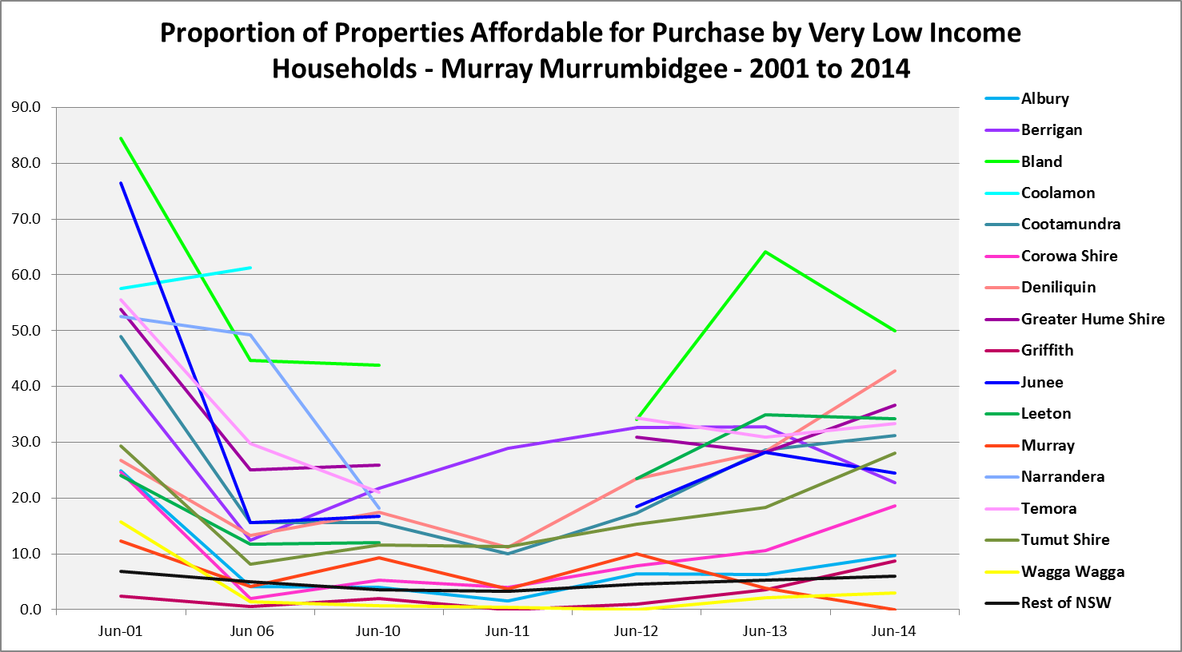

- Purchase affordability has also declined for low income households in every LGA in the Murray Murrumbidgee region from 2001 to 2014, with the exception of Griffith. Within the region, Murray (18.8%) was the only LGA with a lower proportion of properties affordable to purchase for low income households than the average for the Rest of NSW (23.1%). Wagga Wagga was the next lowest with 28.6%. Most LGAs experienced some improvement in affordability after 2006 but generally not to the level of affordability at 2001.
- The graph below shows the proportion of properties that were affordable for purchase by low income households in the Murray Murrumbidgee region LGAs over the period from 2001 to 2014.

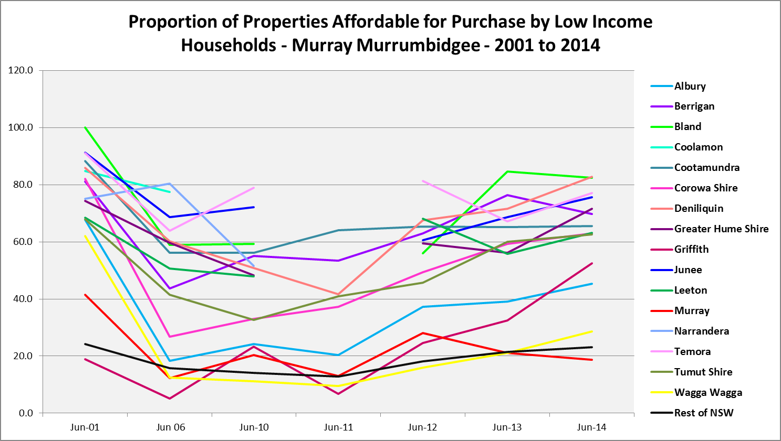

Additional Data
Additional data on rents and sale prices, including both current and historical data, is available from the Rent and Sales Report on the Housing NSW website at:
http://www.housing.nsw.gov.au/About+Us/Reports+Plans+and+Papers/Rent+and+Sales+Reports/

More detailed housing data and tables used in this Snapshot are available from the Local Government Housing Kit Database on the Housing NSW website at:
http://www.housing.nsw.gov.au/Centre+For+Affordable+Housing/NSW+Local+Government+Housing+Kit/Local+Government+Housing+Kit+Database/

Information on vacancy rates is available from the Real Estate Institute of NSW:
http://www.reinsw.com.au/imis15_Prod/web
Or from SQM Research at:
http://www.sqmresearch.com.au/terms_vacancy.php

