Murray Murrumbidgee Region – What’s Happening with Housing Supply and is it a good match?

Most local government areas in the Murray Murrumbidgee region had a lower proportion of couple family with children households than the average for the Rest of NSW at the 2011 Census and the decline in the proportion of this household type was stronger in each of the LGAs in the region than for the Rest of NSW. There are significant proportions of single person and couple only households and the number of lone person households is forecast to increase in more than half of the LGAs in the region. However this not reflected in the housing supply across the region. In fact there is little variation within the region in dwelling type and bedroom mix and the match between household type and bedroom number is actually worsening.

Dwelling Type
- The vast majority of dwellings in the Murray Murrumbidgee region at the 2011 Census are separate houses, comprising between 84.3% in Lockhart and 67.8% in Jerilderie, with both Albury and Wagga Wagga having 69.5% of the total dwelling stock in the form of separate houses. Lockhart, Albury, Wagga Wagga and Corowa (70.2%) are the only LGAs in the region having a lower proportion of separate houses than the average of 72.2% across the Rest of NSW.
- Attached houses comprise between 5.1% (Albury) and 0.1% (Conargo, Hay, Jerilderie, Lockhart, Murrumbidgee and Tumbarumba) compared to 6.4% in the Rest of NSW, while flats make up between 14.7% (Albury) and 0.1% (Conargo), compared to 6.7% on average in the Rest of NSW. Albury, Wagga Wagga (9.3%) and Corowa (7.2%) are the only LGAs with a higher proportion of flats than the Rest of NSW average.
- At the 2011 Census there were 557 households living in caravan, cabin and houseboat accommodation in the region, well down (by 23.0%) from 724 in 2006. Caravan or residential parks are one of the few remaining affordable housing options for lower income earners and this decline is another indicator of the loss of affordable housing.
- Note that most (twenty) of the LGAs in this region had higher proportions of unoccupied dwellings than the average of 13.4% for the Rest of NSW, with Jerilderie the highest with 29.0%, then Tumbarumba (23.1%), Carrathool (22.1%) and Hay (20.2%), with Wagga Wagga (9.7%) and Albury (10.2%) having the lowest proportions of unoccupied dwellings.
- The graph below shows the proportion of key dwelling types in each local government area in the region as well as for the Rest of NSW. It demonstrates the lack of diversity in dwelling types in the Murray Murrumbidgee region.

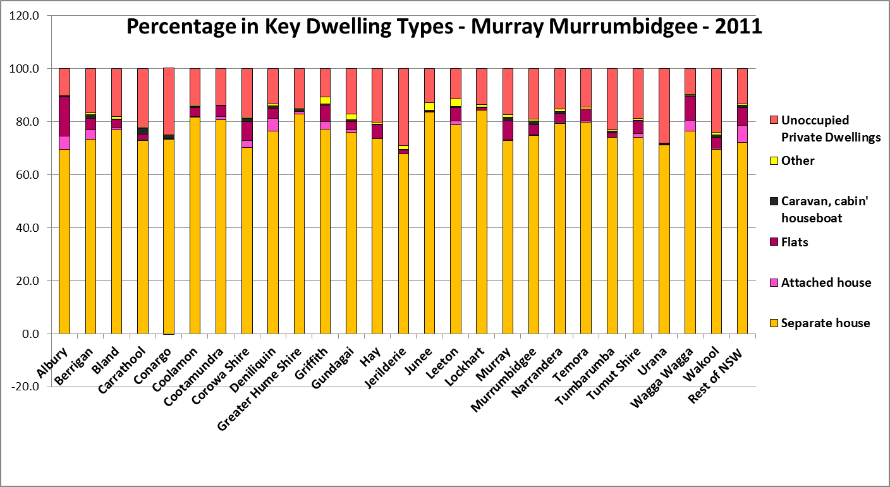

Bedroom Mix
- At the 2011 Census, the overwhelming majority of homes have three, four or more bedrooms, ranging between 95.8% of all dwellings in Conargo and 84.4% in Murray. This is in spite of the fact that across the region lone person and couple households comprise between 64% and 48% of all households in every Murray Murrumbidgee region LGA.
- Two bedroom homes comprise between 4.2% (Conargo) and 15% (Murray) of all dwellings, with only four LGAs (Murray, Albury, Corowa and Hay) having a higher proportion than the Rest of NSW average of 13.2%
- One bedroom dwellings comprise between 0.2% (Conargo) and 1.6% (Urana), with only four LGAs (Urana, Tumbarumba, Leeton and Coolamon) having a higher proportion than the Rest of NSW average of just 1.2%.
- Studio dwellings comprise between 0.0% (Cootamundra, Corowa, Greater Hume and Leeton) and just 0.8% (Jerilderie) of all dwellings across the region, with seven LGAs (Jerilderie, Gundagai, Hay, Wakool, Berrigan, Tumbarumba and Urana) having a higher proportion than the Rest of NSW average of just 0.2%.
- Census data shows that between 2001 and 2011 there has been a significant increase in four or more bedroom dwellings across the region, but overall losses in every other bedroom type. Nineteen of the twenty six Murray Murrumbidgee region LGA lost studio dwelling stock between 2001 and 2011, nineteen LGAs lost one bedroom stock, twenty two lost two bedroom stock and twenty four lost three bedroom stock. Over the same period, twenty LGAs had an increase in four bedroom dwellings. Overall across the region there was a loss of 22 studio dwellings, 66 one bedroom dwellings, 738 two bedroom dwellings, 2,156 three bedroom dwellings and an increase of 4,565 four bedroom dwellings between 2001 and 2011. The trend to the increase in four bedroom stock at the expense of diversity and loss in other bedroom categories is common across the Rest of NSW.
- Murray (15.7%) and Albury (15.0%) are the only LGAs in the region with a higher combined proportion of studios, one and two bedroom dwellings than the Rest of NSW average (just 14.6%) and the Rest of NSW average is low. Within the region, the high proportion of seniors and frail aged as well as lone person households suggests that the proportion of studio, one and two bedroom dwellings should be much higher. Frail aged in particular are less able to deal with maintenance and managing a large house and garden, so smaller dwellings are more suitable for this group. It is surprising that Wagga Wagga, with a significant student population, has so little studio and one bedroom stock.
- The graph below shows the proportion of studio, one, two, three and four or more bedroom dwellings in each Murray Murrumbidgee LGA at the 2011 Census.

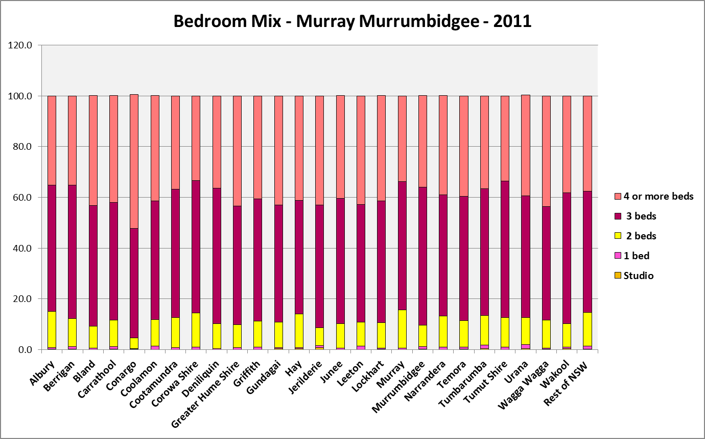

- The table below shows the change in the number of bedrooms for studio (0), one, two, three and four or more bedroom dwellings between 2001 and 2011.

Change in number of bedrooms 2001 – 2011
Area | 0 bedroom | 1 bedroom | 2 bedroom | 3 bedroom | 4 bedroom | total
Albury | 8 | 4 | -125 | 67 | 1,062 | 1,016
Berrigan | 0 | -10 | -17 | -9 | 95 | 59
Bland | 0 | -7 | -37 | -109 | 44 | -109
Carrathool | -6 | -6 | -20 | -105 | -37 | -174
Conargo | 0 | -4 | -17 | -37 | -17 | -75
Coolamon | 0 | 8 | -1 | -42 | 82 | 47
Cootamundra | -3 | 5 | 16 | -107 | 107 | 18
Corowa Shire | -7 | -1 | 8 | -19 | 167 | 148
Deniliquin | -3 | -6 | -79 | -187 | 63 | -212
Greater Hume Shire | -3 | 4 | -13 | -121 | 216 | 83
Griffith | -7 | -27 | -183 | -280 | 465 | -32
Gundagai | 4 | -5 | -12 | -8 | 48 | 27
Hay | 3 | 3 | -14 | -126 | 18 | -116
Jerilderie | 3 | -6 | -35 | -32 | -41 | -111
Junee | 0 | -2 | -20 | -66 | 92 | 4
Leeton | -3 | -1 | -101 | -185 | 102 | -188
Lockhart | -3 | -2 | -20 | -62 | -29 | -116
Murray | -6 | -7 | 31 | 156 | 203 | 377
Murrumbidgee | 0 | 0 | -14 | -85 | 14 | -85
Narrandera | -6 | -1 | -67 | -94 | 18 | -150
Temora | 3 | 6 | -34 | -63 | 84 | -4
Tumbarumba | 0 | 4 | 9 | -63 | 25 | -25
Tumut Shire | 3 | -2 | -10 | -115 | 100 | -24
Urana | 0 | -1 | -16 | -22 | -13 | -52
Wagga Wagga | 0 | -10 | 66 | -315 | 1,734 | 1,475
Wakool | 1 | -2 | -33 | -127 | -37 | -198
Rest of NSW | -268 | -515 | -7,180 | -7,379 | 59,288 | 43,946

Tenure
- The trend across the Rest of NSW has been for a decline in the proportion of households which own or are purchasing their home. In Murray Murrumbidgee region, eleven LGAs similarly experienced a decline in owner/purchasers between 2001 and 2011, one remained stable and the majority actually experienced an increase. However, there has been a shift between the two tenures of owning and purchasing. Every single LGA in Murray Murrumbidgee had a decline in the number and proportion of home owners in line with the trend across NSW, while there was an increase in every LGA in the number and proportion of households purchasing. Bucking the trend in the Rest of NSW, sixteen of the region’s LGAs have also experienced a small decrease in the proportion of private rental housing while the remaining ten LGAs had small increases in the proportion of private rental.
- Coolamon had the largest proportional decline in home owners (-15.5%) and Deniliquin the smallest (-3.0%) compared to -7.8% in the Rest of NSW. Conargo had the largest proportional increase in home purchasers (15.4%) and Deniliquin the smallest (3.4%) compared to 7.0% in the Rest of NSW. Urana had the biggest decline in private rental (-9.6%) and Tumbarumba the biggest increase (3.9%) compared to 0.4% in the Rest of NSW.

- At 2011, Murrumbidgee had the highest proportion of private rental in the region with 32.0%, followed by Carrathool with 29.5%, Albury with 27.6%, Hay 27.1%, Wagga Wagga 26.8% and Griffith 26.0%, all well above the Rest of NSW average of 23.0%. Only nine of the twenty six LGAs in this region have a higher proportion of private rental than the Rest of NSW average. Generally the regional centres have higher proportions of rental housing, which is important given the role that these centres play in providing housing choice.
- Twenty one LGAs in the Murray Murrumbidgee region have an equivalent or higher proportion of home owners than the Rest of NSW average. Only nine LGAs had a higher proportion of home purchasers than the Rest of NSW average.
- The graph below shows the proportion in each of the key tenure groups for every Murray Murrumbidgee LGA and the Rest of NSW at the 2011 Census.

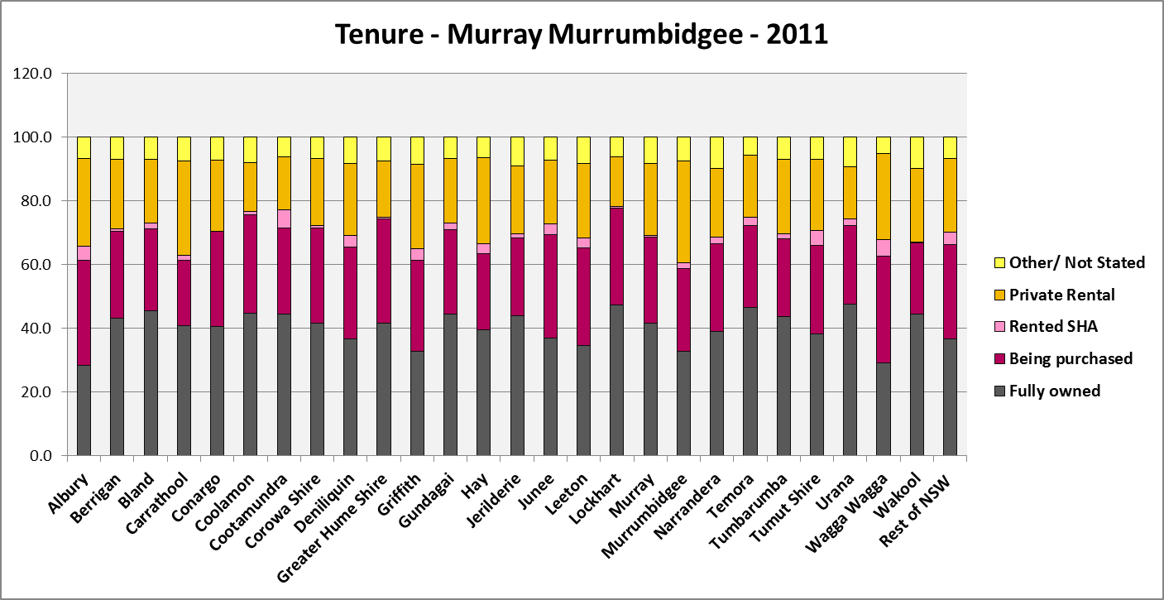

Public Housing
The table below shows the number of public housing properties in the Murray Murrumbidgee region as at December 2014. Please note that Census data on public housing is not particularly accurate, as public housing tenure is under reported in the Census. The figures below do not include community housing properties. According to the 2011 Census, Cootamundra, Wagga Wagga, Tumut and Albury all have a higher proportion of public housing than the Rest of NSW average of 4.0%.

Area | Public Housing stock December 2014
Albury | 899
Berrigan | 0
Bland | 32
Carrathool | 0
Conargo | 0
Coolamon | 3
Cootamundra | 186
Corowa Shire | 39
Deniliquin | 0
Greater Hume Shire | 4
Griffith | 312
Gundagai | 36
Hay | 30
Jerilderie | 0
Junee | 71
Leeton | 158
Lockhart | 3
Murray | 0
Murrumbidgee | 4
Narrandera | 46
Temora | 60
Tumbarumba | 14
Tumut Shire | 191
Urana | 0
Wagga Wagga | 1,146
Wakool | 0
Rest of NSW | 36,388

- The table below shows expected waiting times for social housing (wait turn allocation not priority housing) for the Murray Murrumbidgee region at December 2014. Note that waiting times in Albury are no more than five years in any bedroom category, in Griffith are up to five years except for three bedroom properties (which are up to 10 years) and in Wagga Wagga are up to five years except for larger properties (four plus bedrooms) which have a wait of 10 years or more.

Expected Waiting Time by Table
ALLOCATION ZONE | 1 bed | 2 bed | 3 bed | 4 bed
Murrumbidgee
S91 ALBURY
S93 BERRIGAN
S94 WEST WYALONG
S96 HILLSTON/CARRATHOOL
S98 COOLAMON
S99 COOTAMUNDRA
S100 COROWA
S101 CULCAIRN
S102 DENILIQUIN
S103 GRIFFITH
S104 GUNDAGAI
S105 HAY
S106 HOLBROOK
S107 JERILDERIE
S108 JUNEE
S109 LEETON
S111 LOCKHART
S112 MATHOURA/MURRAY
S113 COLEAMBALLY
S114 NARRANDERA
S115 TEMORA
S117 TUMBARUMBA
S118 TUMUT
S119 URANA
S120 WAGGA WAGGA
S121 BARHAM/WAKOOL
S123 ADELONG
S126 DARLINGTON POINT
S128 FINLEY
S129 GANMAIN
S130 HENTY
S132 MOAMA
S133 MOULAMEIN
S134 MULWALA
S135 THE ROCK
S136 TARCUTTA
S137 TOCUMWAL
S140 YENDA

Legend for Expected Wait Time Bands
Up to 2 years
2 to 5 years
5 to 10 years
10 + years
No properties

The Gap
- Historically this region has been more affordable for rental and purchase (with the exception of a few LGAs such as Murray, Wagga Wagga and Albury) than much of the Rest of NSW.
- That might lead to the assumption that housing affordability is not really an issue in Murray Murrumbidgee. Yet low income households predominate and are increasing, even in areas that have lost population. Low income rental households are increasing even more rapidly than low income households generally.
- Therefore demand for affordable housing, particularly affordable rental housing is increasing across the region. This is demonstrated in the graph below, which shows the change in the number of low income renters between 2006 and 2011 in each LGA in the region.

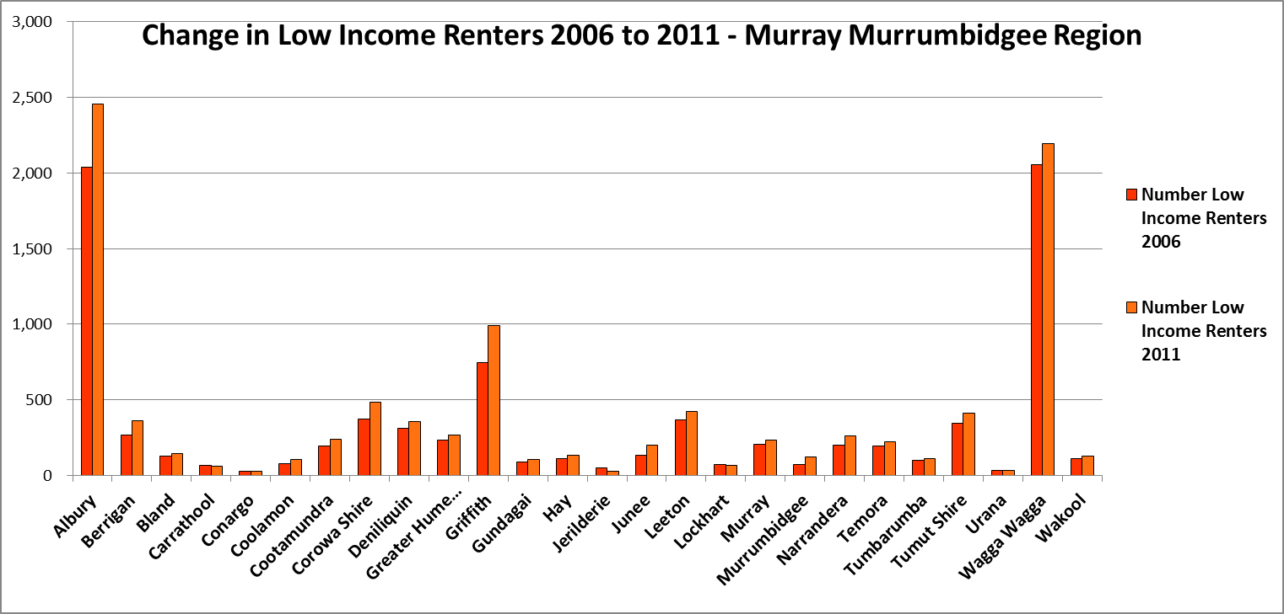

- While demand is increasing, the stock of affordable rental housing is declining. The graph below compares the change in the number of low income renters between 2006 and 2011 with the change in the number of affordable rental dwellings between 2006 and 2010. The graph demonstrates the decline in affordable rental at the same time that low income renters are increasing across the region.

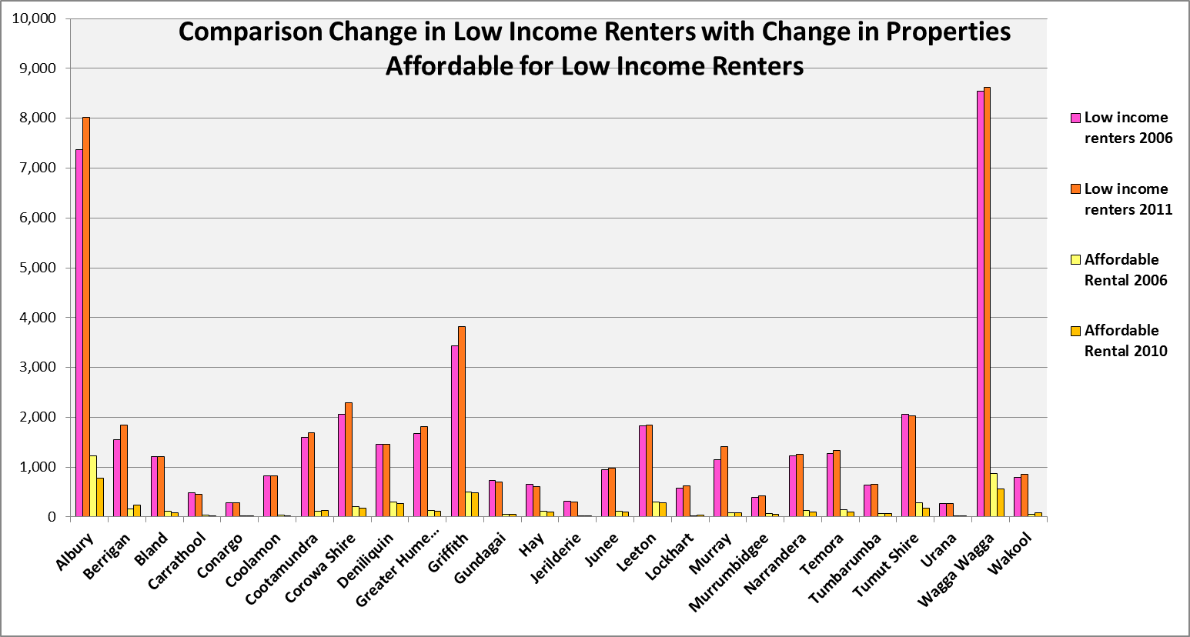

- The vacancy rates in Albury and the Murrumbidgee region indicate an undersupply of private rental accommodation for at least the last four years in Murrumbidgee and much longer in Albury.
- In the LGAs with the largest regional centres, Albury and Wagga Wagga, there are also low proportions of affordable rental and purchase for very low and low income households, high proportions of very low and low income earners and CRA recipients in housing stress, and along with Murray, relatively high median rents and median sales price. This further indicates a need for an increase in the supply of affordable housing, and again the data demonstrates that there has been a decline in supply. The demand for affordable rental housing from students in Wagga Wagga is clearly impacting the housing market there. There is a need for additional appropriate housing to meet this need.
- Further, there are declining numbers of long term residents of caravan/ residential parks, with a 23% drop between 2006 and 2011. The loss of this stock, which represents one of the few remaining affordable housing options for lower income households, reduces housing choice.
- There is little diversity in housing type and bedroom mix across the region, with a poor and rapidly worsening match between number of bedrooms and household type. The population of the region is ageing and the proportion of lone person households is increasing. Housing suitable for older residents and single person households is required to meet existing and future needs.
- In common with other parts of NSW, the dwelling stock in Murray Murrumbidgee was largely built at a time when couple family households were the dominant household type. The proportion of lone person and couple households has increased significantly and these two household types combined comprise the majority of households across the region. DPE population projections forecast stable or increasing proportions of lone person households in a majority of LGAs to 2031, more so than any other household type.
- Much of the existing population is aged over 50, with significant proportions of seniors and frail aged. The DPE are forecasting strong growth in residents aged over 65 across the region to 2031. Frail aged residents are less able to deal with maintenance of a large house and garden. Significant and increasing proportions of seniors and frail aged will impact on the housing needs of the region and require appropriate housing responses.
- The increasing predominance of single person households and older age groups suggests increasing demand for studio, one and two bedroom dwellings.
- Yet across the region there has been a loss in studio, one and two bedroom dwellings and a significant increase in four bedroom stock. The graph below compares the change in four bedroom and one bedroom stock between 2001 and 2011 in each LGA in the region.

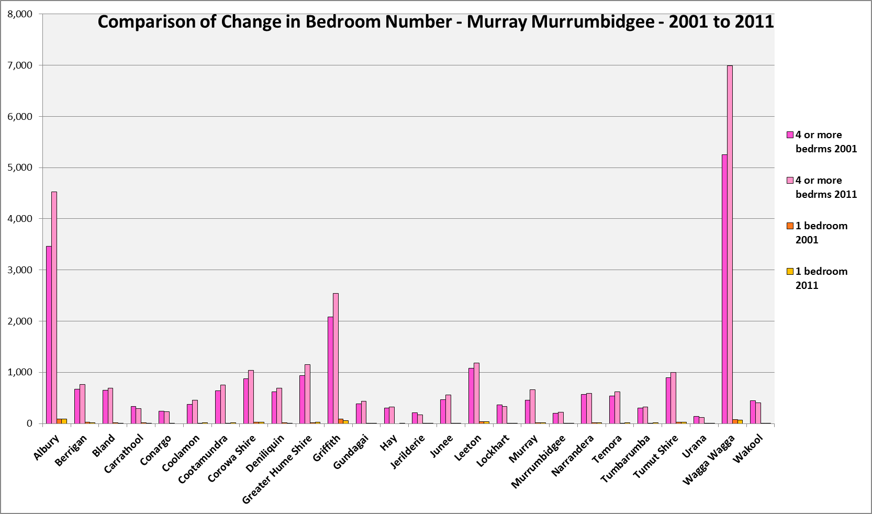

- The graph below compares the number of lone person and couple only households with the number of studio and one bedroom dwellings. It clearly demonstrates the significant mismatch between household type and bedroom number.

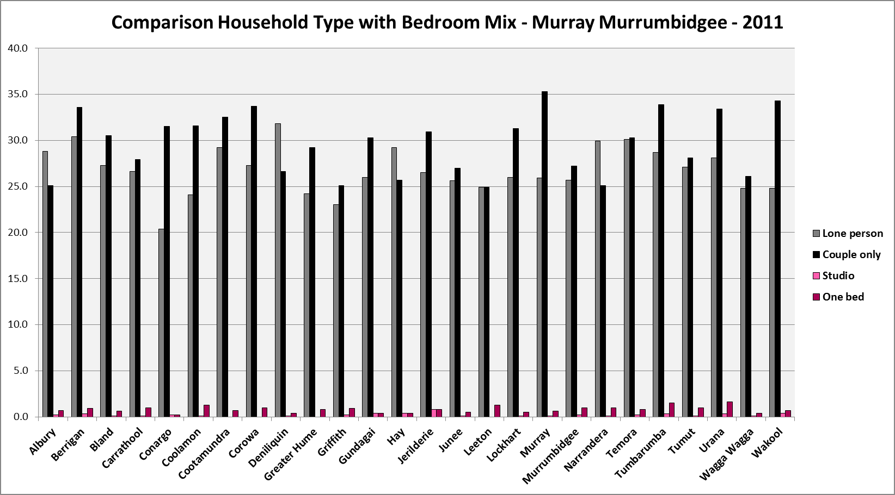

- The evidence shows that there is a poor and worsening match between household type, household need and bedroom numbers. There is little housing choice for example for frail aged wishing to stay in their communities with their social and support networks, yet unable to manage looking after a large family home and garden.
- Proactive measures are required to increase the number of one and two bedroom dwellings suitable for single and couple only households. This would provide greater flexibility in the dwelling stock to meet the range of housing needs in the local community, including for older age groups. This can be difficult to achieve where population growth is not occurring or where it is difficult to attract new residential investment.
- However, secondary dwellings can be readily installed in the backyard of existing homes relatively affordably and suit larger residential sites closer to centres providing a range of services and facilities. This also has the potential of assisting in affordability.
- Secondary dwellings in particular could suit older residents or people with a disability – although they would also be suitable for a range of age groups. They enable residents to stay in familiar surroundings but in a more manageable sized home, with support close by.
- New generation boarding houses (which are essentially studio dwellings with some communal facilities) can suit students and single workers. The university in Wagga Wagga and in Albury is clearly impacting on the demand for and availability of affordable rental accommodation. New generation boarding houses would provide more affordable rental housing suitable for students. There is also potential for this accommodation type to meet some of the fluctuating additional housing demand from seasonal workers.

Additional Data
More detailed housing data and tables used in this Snapshot are available from the Local Government Housing Kit Database on the Housing NSW website at:
http://www.housing.nsw.gov.au/Centre+For+Affordable+Housing/NSW+Local+Government+Housing+Kit/Local+Government+Housing+Kit+Database/

More information on Expected Waiting Times for Public Housing is available on the Housing NSW website by region at:
http://www.housingpathways.nsw.gov.au/How+to+Apply/Expected+Waiting+Times/

