Murray Murrumbidgee Region – What’s the Housing Demand?

Population Forecast
- The Department of Planning and Environment have prepared population and household projections for all of the local government areas in the Murray Murrumbidgee region for the period from 2011 to 2031. They forecast population growth to 2031 in Albury, Murray and Wagga Wagga as well as Conargo and Griffith.

Age
- The median age of the population in each of the twenty six LGAs comprising the Murray Murrumbidgee region has increased from 2001 to 2011 and ranges between 34 years (Wagga Wagga) and 48 (Berrigan and Wakool). Only seven LGAs (Wagga Wagga, Griffith, Leeton, Albury, Murrumbidgee, Junee and Carathool) have a lower median age than the average for the Rest of NSW (excluding the Sydney Statistical Division), while sixteen have a higher median (Berrigan, Wakool, Cootamundra, Corowa and Murray, Jerilderie, Urana, Deniliquin, Lockhart, Temora, Tumbarumba, Coolamon, Greater Hume, Hay, Narrandera and Gundagai) with the remaining three (Bland, Conargo and Tumut) being right on average.
- There is remarkable similarity in the age profile of the Murray Murrumbidgee LGAs. Almost all have a higher proportion of residents aged 0 – 14 and aged over 50:
  - Sixteen of the twenty six Murray Murrumbidgee LGAs have a higher proportion of 0 – 14 year olds than the average for the Rest of NSW,
  - Only Wagga Wagga, Albury, Leeton and Griffith have a higher proportion of 15 – 24 year olds than the Rest of NSW average.
  - Only seven LGAs have a higher proportion of 25 – 49 year olds.
  - Fourteen LGAs have a higher proportion of 50-64 year olds than the Rest of NSW.
  - Seventeen LGAs have a higher proportion of seniors than the Rest of NSW (65-79 years).
  - There is a mix of LGAs with high and lower proportions of frail aged (aged 80+) with around half having a higher proportion and half having a lower proportion.
- This age profile indicates that a range of housing is required to meet the needs of the community, including family homes, student housing (in a limited number of LGAs) and particularly housing suitable for seniors and frail aged.
- The DPE forecast a strong increase in residents aged over 65 across this region. The graph below shows the key age cohorts for each LGA in the region at the 2011 Census.

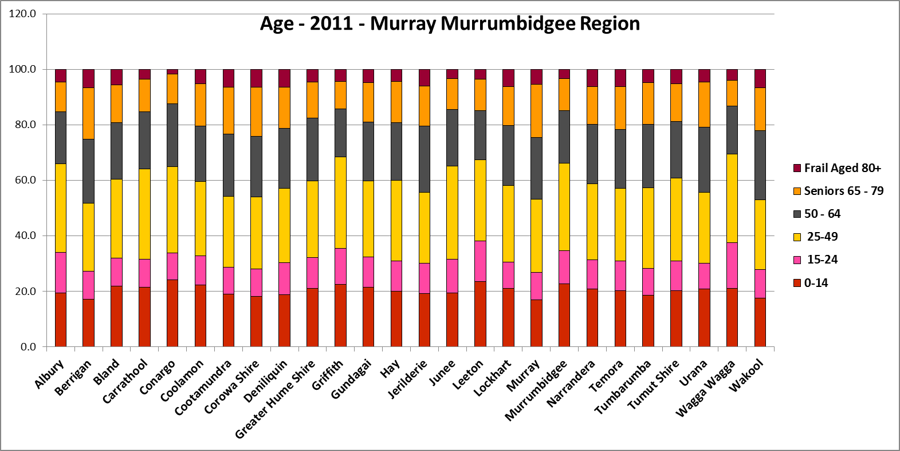

Household Type
- There has been a decline in the proportion of couple family with children households in every LGA in Murray Murrumbidgee between 2001 and 2011. This is in line with the trend for the Rest of NSW but the decline was much stronger in each of the twenty six LGAs in this region than for the Rest of NSW, with the exception of Greater Hume. Against the trend in the Rest of NSW, the proportion of couple households declined in fourteen Murray Murrumbidgee region LGAs (Berrigan, Bland Corowa, Deniliquin, Greater Hume, Jerilderie, Junee, Leeton, Lockhart, Murrumbidgee, Narrandera, Tumbarumba, Urana and Wakool). The proportion of lone person households increased in every Murray Murrumbidgee LGA (excepting Conargo, Hay and Urana) consistent with the trend in the Rest of NSW.
- Couple families with children comprise between 21.9% (Berrigan) and 35.5% (Conargo) of all households compared with 26.7% on average in the Rest of NSW. They are the largest household type in only seven (Conargo, Greater Hume, Griffith, Junee, Leeton, Murrumbidgee and Wagga Wagga) of the twenty six LGAs of the region.
- Couple only households comprise the largest household type in the majority (fifteen) of the region’s LGAs (Berrigan, Bland, Carrathool, Coolamon, Cootamundra, Corowa, Gundagai, Jerilderie, Lockhart, Murray, Temora, Tumbarumba, Tumut, Urana and Wakool). The proportion of couple only households ranges between 24.9% (Leeton) and 34.3% (Wakool) compared to 27.7% in the Rest of NSW.
- Lone person household comprise the largest household type in four LGAs – Albury, Deniliquin, Hay and Narrandera. The proportion of lone person households ranges between 20.4% (Conargo) and 31.8% (Deniliquin) compared to 25.6% in the Rest of NSW. The DPE forecasts growth in this household type across more LGAs in the region than for any other household type.
- Overall, lone person and couple households combined comprise between 48.1% (Griffith) and 64.0% (Berrigan) of all households across Murray Murrumbidgee. This compares to 53.3% in the Rest of NSW. Twenty of the twenty six LGAs in the region have a higher proportion of lone person and couple households combined than the Rest of NSW average.
- This data should be compared with the data on bedroom number to determine if there is a good fit between household types and housing stock.
- Although there should be plenty of housing suitable for families of different sizes, there is also a need for a variety of dwellings with different bedroom numbers to suit couples and single person households.
- The graph below shows the proportion of the population in each of the key household types in each of Murray Murrumbidgee region local government areas (LGAs) at the 2011 Census.

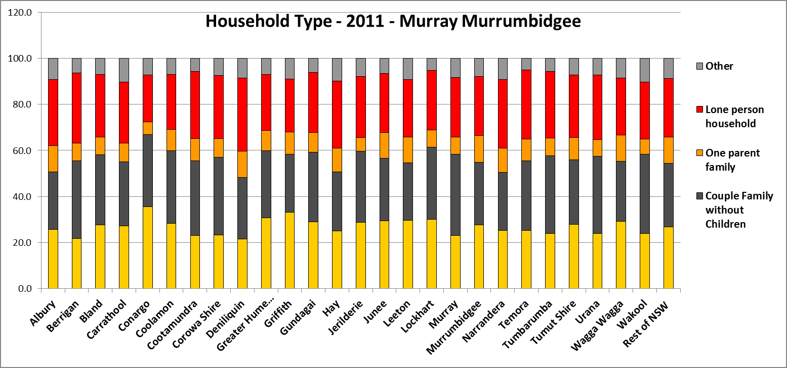

Household Size
- In the Murray Murrumbidgee region, eleven LGAs have a higher average household size than for non metropolitan NSW (2.4 persons) while fifteen LGAs have an average household size equal to or lower than the average for the Rest of NSW. Across the region, average household size ranges between 2.2 persons per household (in Berrigan and Deniliquin) and 2.7 (in Griffith). Since 1996, average household size has declined in every LGA in the region in line with the trend for the Rest of NSW.
- The table below gives the average household size in all Murray Murrumbidgee region LGAs for 1996, 2001, 2006 and 2011.

Area | Average Household Size 1996 | Average Household Size 2001 | Average Household Size 2006 | Average Household Size 2011
Albury | 2.50 | 2.50 | 2.40 | 2.40
Berrigan | 2.60 | 2.40 | 2.40 | 2.20
Bland | 2.70 | 2.60 | 2.50 | 2.40
Carrathool | 2.80 | 2.60 | 2.50 | 2.40
Conargo | 3.00 | 2.80 | 2.70 | 2.70
Coolamon | 2.80 | 2.70 | 2.60 | 2.60
Cootamundra | 2.60 | 2.50 | 2.40 | 2.30
Corowa Shire | 2.50 | 2.40 | 2.40 | 2.30
Deniliquin | 2.50 | 2.40 | 2.30 | 2.20
Greater Hume Shire | 2.80 | 2.70 | 2.50 | 2.50
Griffith | 2.80 | 2.80 | 2.70 | 2.70
Gundagai | 2.70 | 2.60 | 2.60 | 2.50
Hay | 2.60 | 2.50 | 2.50 | 2.40
Jerilderie | 2.70 | 2.60 | 2.50 | 2.50
Junee | 2.80 | 2.70 | 2.60 | 2.50
Leeton | 2.70 | 2.70 | 2.60 | 2.50
Lockhart | 2.80 | 2.70 | 2.60 | 2.50
Murray | 2.60 | 2.50 | 2.40 | 2.30
Murrumbidgee | 2.70 | 2.60 | 2.50 | 2.50
Narrandera | 2.70 | 2.60 | 2.40 | 2.40
Temora | 2.60 | 2.50 | 2.40 | 2.30
Tumbarumba | 2.60 | 2.50 | 2.40 | 2.30
Tumut Shire | 2.60 | 2.50 | 2.40 | 2.40
Urana | 2.70 | 2.60 | 2.40 | 2.40
Wagga Wagga | 2.70 | 2.60 | 2.60 | 2.50
Wakool | 2.70 | 2.70 | 2.50 | 2.40
Rest of NSW | 2.70 | 2.50 | 2.50 | 2.40
FACS Local Government Housing Kit Database- Source: ABS, Analysis FACS

Income
- In every Murray Murrumbidgee LGA low income households comprise the largest proportion of all households, as is the case in the Rest of NSW as a whole. The proportion of low income households in this region ranges between 58.9% in Urana and 38.6% in Wagga Wagga. Only six LGAs in the region have a lower proportion of low income households than the Rest of NSW average of 47.3% (Albury, Carrathool, Griffith, Leeton, Tumut and Wagga Wagga).
- Most (seventeen) LGAs had a higher proportion of moderate income households than the Rest of NSW average of 25.2% and only five LGAs (Albury, Carrathool, Griffith, Tumut and

Wagga Wagga) had a higher proportion of high income households than the Rest of NSW average of 27.5%.
- Between 2006 and 2011 the actual number of low income households increased in the majority (nineteen) of the Murray Murrumbidgee LGAs, excepting Bland, Carrathool, Coolamon, Gundagai, Hay, Jerilderie and Tumut. Of these seven, Bland Carrathool, Gundagai, Hay and Jerilderie all lost population. In fact, eight LGAs (Corowa, Deniliquin, Leeton, Lockhart, Murrumbidgee, Narrandera, Tumbarumba and Urana) all had an increase in the number of low income households despite a decline in population.
- The two LGAs with the largest regional centres, Albury and Wagga Wagga both have a higher proportion of low income households than any other income group and both had an increase in the number of low income households between 2006 and 2011. Albury had an increase in the proportion of low income households between 2006 and 2011, no change in the proportion of high income households and a decline in the proportion of moderate income households. Wagga Wagga actually experienced a decline in the proportion of low income households (in step with the trend in the Rest of NSW) over the same period, with increases in both moderate and high income households.
- Eleven of the twenty six LGAs in this region had a higher proportional increase in the number of low income household than the Rest of NSW average of 3.8%, with Murray having the highest increase at 23.8%. Twenty of the twenty six LGAs in the region had a higher proportional increase in the number of low income renter households than the Rest of NSW average of 12.1% - this demonstrates the demand for affordable rental housing is increasing.
- The graph below shows the percentage distribution of low, moderate and high income households in each LGA in the Murray Murrumbidgee region at the 2011 Census.

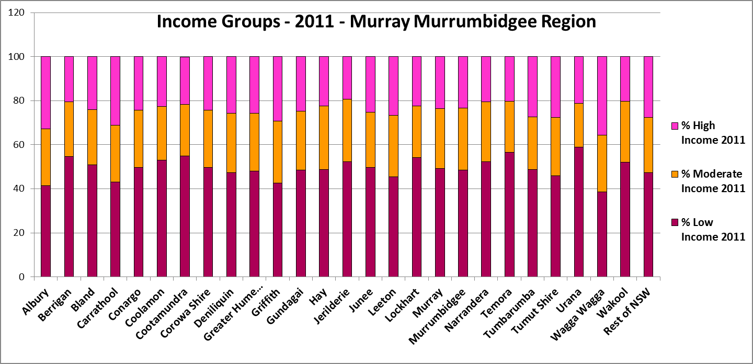

Industry Structure
- Looking at the industry structure for the Murray Murrumbidgee, it is evident that agriculture, forestry and fishing is significant, with every LGA in the region (excepting Albury and Wagga Wagga) having a higher proportion working in this sector than the Rest of NSW average of 5.8%, and Conargo having the highest proportion at 61.6%, followed by Carrathool with 46.5%, Jerilderie with 45.8% and Urana with 41.5%.
- Fourteen LGAs in the region have a higher proportion employed in manufacturing than the Rest of NSW average of 8.3% - Leeton (20.2%), Corowa (19.0%), Griffith 17.9%, Tumut (15.8%), Albury (12.6%), Tumbarumba (12.1%), Murrumbidgee (11.5%), Gundagai (10.8%), Narrandera (10.6%), Cootamundra (10.4%), Murray (9.5%), Greater Hume, Junee (9.2%) and Berrigan (8.6%).

- Sixteen LGAs had a higher proportion employed in transport, postal and warehousing than the Rest of NSW average of 4.2%, with Urana the highest with 14.8%.
- There is a relative lack of diversity of industry structure in most LGAs in this region in comparison with other regions, with agriculture, manufacturing and transport comprising around 30% or more of all employment in almost every LGA (excepting Albury, Wagga Wagga and Deniliquin, with Murray and Cootamundra a little under that proportion).
- Eleven LGAs in the region have a higher proportion employed in electricity, gas, water and waste services than the Rest of NSW average, with Tumbarumba the highest on 4.1%. Only Albury (8.6%) and Murray (8.3%) had a higher proportion employed in construction. Eleven LGAS had a higher proportion employed in wholesale trade, with Temora the highest with 4.7%. Eight LGAs had a higher proportion employed in retail trade, with Griffith the highest with 13.9%. Seven LGAs had a higher proportion employed in accommodation and food services, with Murray the highest with 11.7%. Cootamundra was the only LGA with a higher proportion employed in professional, scientific and technical services (4.7%). Bland was the only LGA with a higher proportion employed in mining (9.3%). Albury was the only LGA with a higher proportion employed in information, media and telecommunications (1.3%). Five LGAs had a higher proportion employed with public administration and safety, with Junee and Wagga Wagga the highest with 11.9%. Four LGAs had a higher proportion employed in Education and Training, with Wagga Wagga the highest on 10.8%. Four LGAs had a higher proportion employed in Health Care and Social Assistance, with Deniliquin having the highest proportion with 14.7%. Five LGAs had a higher proportion employed in arts and recreation services, with Murray the highest with 2.1%.
- Every LGA in the region had lower proportions employed in financial and insurance services, rental hiring and real estate services and administrative and support services than the rest of NSW average.
- The graph below shows the key industry categories in Murray Murrumbidgee at the 2011 Census.

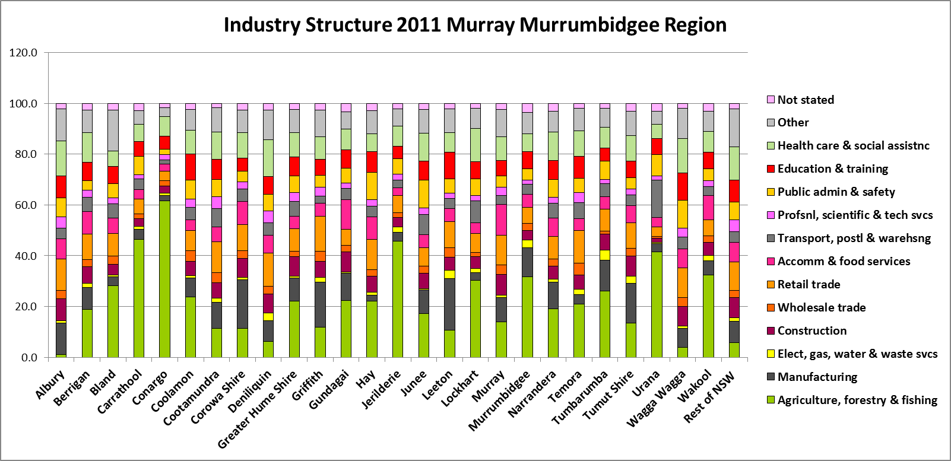

Homelessness
The table below shows the number of homeless people in the Murray Murrumbidgee region according to the 2011 Census. This is one indicator of unmet housing demand.

2011 | Total Homeless
Albury | 146
Berrigan | 17
Bland | 7
Carrathool | 6
Conargo | 3
Coolamon | 17
Cootamundra | 4
Corowa Shire | 16
Deniliquin | 16
Greater Hume Shire | 6
Griffith | 101
Gundagai | 3
Hay | 0
Jerilderie | 0
Junee | 10
Leeton | 21
Lockhart | 0
Murray | 9
Murrumbidgee | 0
Narrandera | 4
Temora | 12
Tumbarumba | 3
Tumut Shire | 20
Urana | 3
Wagga Wagga | 155
Wakool | 8
TOTAL | 587

Additional Data
More detailed housing data and tables used in this Snapshot are available from the Local Government Housing Kit Database on the Housing NSW website at:
http://www.housing.nsw.gov.au/Centre+For+Affordable+Housing/NSW+Local+Government+Housing+Kit/Local+Government+Housing+Kit+Database/

More detailed information and resources on an Ageing Population is available on the Local Government NSW website, in the Resource for an Ageing Population:
http://www.lgnsw.org.au/policy/ageing

More detailed information on population, household and dwelling projections is available on the Department of Planning and Environment website at:
http://www.planning.nsw.gov.au/en-us/deliveringhomes/populationandhouseholdprojections.aspx

More information on homelessness is available on the Housing NSW website at:
http://www.housing.nsw.gov.au/Help+with+Housing/Homelessness/

For more information/statistics on FACS clients by FACS districts:
http://www.facs.nsw.gov.au/facs-statistics

