# Western City District – What’s happening with Supply and is it a good match

This Housing Snapshot looks at dwelling type, bedroom mix, tenure, social housing supply and the gaps between demand and supply, with a focus on lower income households.

There have been significant changes in Western City since the 2016 Census and further developments impacting housing supply since the 2021 Census.

The Australian Bureau of Statistics reported that across Australia for January 2023, "approvals for private sector houses fell by 13.8 per cent, the fifth consecutive drop, to be the lowest result recorded since June 2012". Further, total dwelling approvals decreased in New South Wales by -49.0 per cent.

At a time when immigration is surging and there is strong demand for housing, there is a critical shortage of private rental accommodation as well as a skills shortage in the building sector. This suggests that it is likely to be some time before supply pressures ease.

## Dwelling Type

* At the 2021 Census there were 391,251 dwellings in Western City, up from 339,451 in 2016.
* Of these 94.3% were occupied, (up from 92.4% in 2016), above the 92.0% average percentage occupied in Greater Sydney.
* Consequently 5.7% were unoccupied (down from 7.6% in 2016) and compared to 8.0% in Greater Sydney.
* The reasons homes are unoccupied vary and include (according to a report by the Australian Housing and Urban Research Institute “Are there 1 million empty homes and 13 million unused bedrooms?”):
  + homes are being renovated
  + homes being sold as vacant possession
  + newly built or bought homes where no one has moved in yet
  + rental homes awaiting new tenants
  + people living away temporarily from home during the census count (travelling or visiting other homes)
  + homes are deemed unliveable
  + subject to a probate application or other legal proceedings
  + holiday homes
  + homes owned by people currently living overseas
  + homes being land banked, that is held vacant until the local area economics (or personal circumstances) make it more profitable to sell or redevelop the property.
* The graph below shows the proportion of occupied and unoccupied dwellings in Western City and Greater Sydney at the 2021 Census. Note that Blue Mountains has a much higher proportion of unoccupied homes (10.5%) than the rest of the LGAs in Western City and the Greater Sydney average.

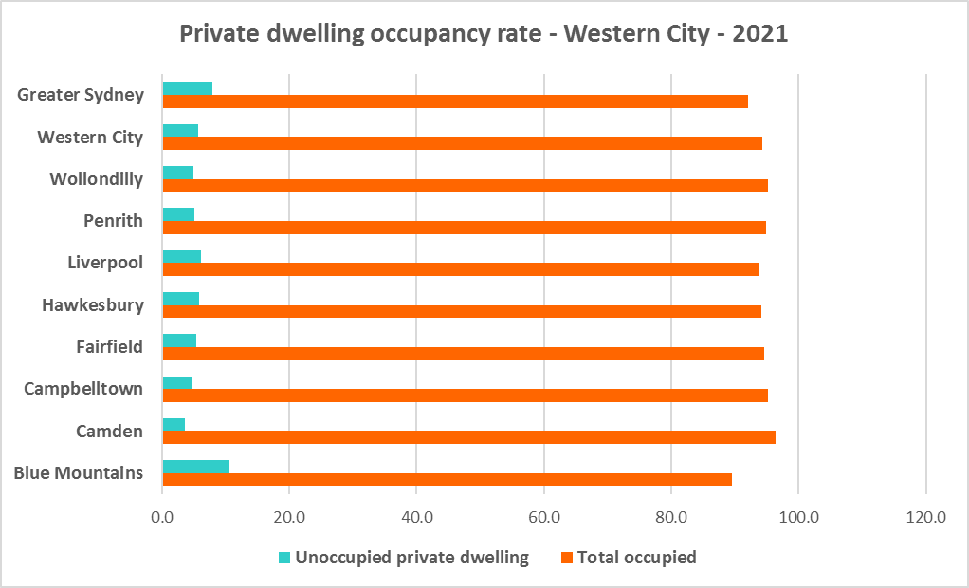

* At the 2021 Census, the majority of occupied dwellings in Western City were separate houses, comprising 80.2% of all occupied dwellings, well above the average of 55.4% for Greater Sydney. This is slightly more diverse than in 2016 when 81.0% of homes in Western City were separate houses. The proportion of separate houses in Western City ranged from 94.6% in Wollondilly to 72.2% in Fairfield at the 2021 Census.
* A further 10.5% of occupied homes in Western City were semi-detached, terrace or town houses (down marginally from 11.0% in 2016), compared to 31.0% in Greater Sydney. The proportion of attached homes in Western City ranged from 15.2% in Campbelltown to 3.5% in Wollondilly.
* Just 8.9% of occupied homes in Western City were flats (up from 7.2% in 2016), compared to 12.9% in Greater Sydney. The proportion of flats in Western City ranged from 16.3% in Liverpool to 1.0% in Camden and Wollondilly.
* While there has been an increase in the proportion of flats in the region, the proportion of semi-detached, terrace and townhouses has declined and a greater diversity of housing is needed to suit different household types and age cohorts.
* The graph and table below show the proportion of dwelling types for Western City at the 2021 Census. Note that the more established LGAs such as Fairfield and Liverpool tend to have greater dwelling diversity than the LGAs with significant new release areas such as Camden (the Blue Mountains, as a more established area, being an exception with 92.1% separate houses).

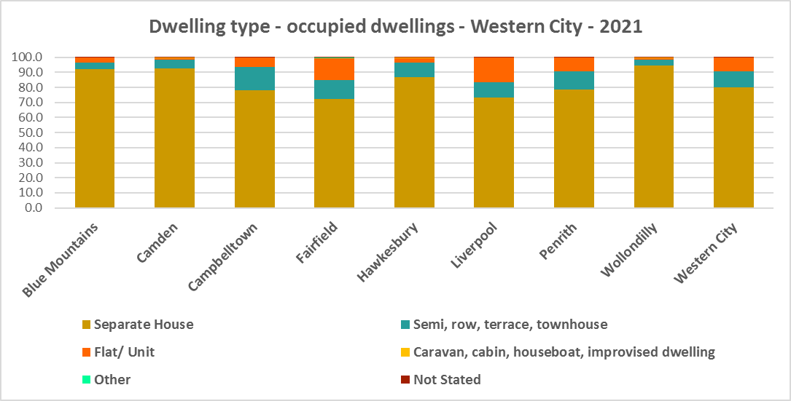



* The graph below compares the proportion of dwelling types in Western City with the average for Greater Sydney.
* Other types of dwellings comprised just 0.1% of occupied homes in the region at the 2021 Census and include caravans, cabins, houseboats, improvised dwellings and flats attached to shops or offices. Census data shows 144 households living in caravans, 333 living in cabins or houseboats, 32 living in improvised dwellings and 314 in flats attached to shops or offices in the region.
* Note that at the 2021 Census there were 477 household living in caravan, cabin/houseboat accommodation, down from 494 in 2016.
* While people living in caravans are included in the homeless data in the Census, caravan or residential parks are one of the few remaining affordable housing options for lower income earners. The loss of this accommodation reduces options for lower income households and is another indicator of the loss of affordable housing.
* The region also has 32 improvised dwellings. According to the ABS;
  + “Persons in other improvised dwellings are those people who were enumerated on Census night in the dwelling category of an improvised dwelling, tent or sleepers out who reported either being 'at home' on Census night or having no usual address, and are not considered, on balance, to be homeless. Under the ABS definition they are not classified as homeless because they have accommodation alternatives, and in many living situations, the dwelling will be adequate. They are however included in marginal housing and may be at risk of homelessness.”

## Bedroom Mix

* Western City also has insufficient variation in the number of bedrooms per dwelling, with 36.7% of dwellings having three bedrooms and a further 45.5% having four or more bedrooms, totalling 82.2% with three or more bedrooms. Only 0.3% of homes are studios, 2.9% have one bedroom and 13.2% have two bedrooms in Western City.
* This compares to 0.9% studios, 8.1% one bedroom and 25.9% two bedroom, 31.0% three bedroom and 32.8% four or more bedrooms in Greater Sydney as a whole.
* It is important to note that this is an improvement from 2016, when 0.1% of homes in Western City were studios, 0.8% were one bedroom and two bedrooms comprised 8.6% of residential stock on average across the district.
* Within Western City,
  + Liverpool has the highest proportion of studio dwellings with 0.5% and Camden the lowest with 0.1%;
  + Fairfield has the highest proportion of one bedroom homes with 4.1% and Wollondilly the lowest with 1.9%;
  + Fairfield has the highest proportion of two bedroom homes with 18.0% and Camden the lowest with 4.4%;
  + Campbelltown has the highest proportion of three bedroom homes with 44.3% and Camden the lowest with 20.6%; and
  + Camden has the highest proportion of four or more bedroom homes with an exceptionally high 71.6% (the highest proportion in NSW - the next closest is The Hills with 67.5%, followed by 60.8% in Wollondilly and 52.1% in Yass Valley) and Fairfield the lowest with 36.4%.
* The graph and table below show the proportion of studio, one, two, three and four or more bedroom occupied dwellings in Western City at the 2021 Census.

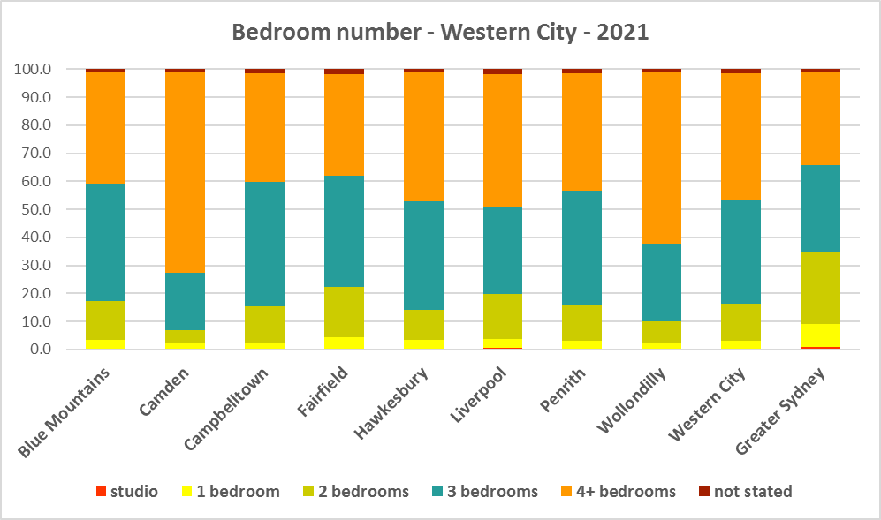



* Clearly Western City lacks diversity in bedroom mix compared to Greater Sydney, and this is particularly the case in Camden and Wollondilly.
* Given that lone person and couple only households comprised 39.2% of all households in Western City (up from 37.4% in 2016), the fact that studio and one bedroom homes combined comprise just 3.2% of the housing stock means there is a mismatch between household type and bedroom number. There are insufficient housing options for smaller households. Note that the proportion of lone person and couple only households combined ranges between 54.6% in Blue Mountains which has only 3.4% studio and one bedroom homes and 33.2% in Liverpool which has 3.8% studio and one bedroom homes – so the degree of housing choice varies within Western City.
* The forecast increase in older age groups in Western City is likely to increase the demand for smaller, more manageable and affordable homes.
* Ideally there should be an increase in the number of studio, one and two bedroom dwellings to suit these household types and to offer some housing choice. Two bedroom dwellings in particular offer the most flexibility, given they are also suitable for small families and allow older residents to have family members or carers to stay while giving them a more manageable size home to maintain. Providing choice in the number of bedrooms enables them to downsize and stay in their community and more broadly may help with affordability.
* Note that new dwelling stock generally represents 1 – 2% of the total dwelling stock while established dwellings represent the remaining 98 – 99% of stock – so alterations and additions to existing stock has a significant impact on bedroom mix.
* When considering the fit of housing stock to household type into the future, this is an important consideration.

## Tenure

* At the 2021 Census, the most common tenure type in the Western City District was households owning their home with a mortgage (unlike regional NSW or North District where owning a home outright is the most common tenure, or Eastern City where rental is the largest tenure) – comprising 38.0% of all households. Within the district households owning their own home with a mortgage ranged from 53.2% in Camden to 27.6% in Fairfield.
* Rental households comprised a total of 32.2% of all households in Western City, ranging between 39.0% in Fairfield and 18.0% in the Blue Mountains.
* Households renting from a real estate agent comprise 21.1% of all households in Western City – with Penrith having the highest proportion at 25.2% and the Blue Mountains the lowest with 11.8% of households renting though a real estate agent.
* The remainder of rental households are comprised of households renting from the state housing authority (4.9% in the region), community housing providers (1.0%) and other landlords (5.2%).
* The next largest tenure type was households owning their home outright – comprising 28.5% of all households. The proportion in this tenure ranged from 41.5% in the Blue Mountains to 20.2% in Camden, within the district.
* The graph and table below give the tenure composition for the district and individual LGAs at the 2021 Census.

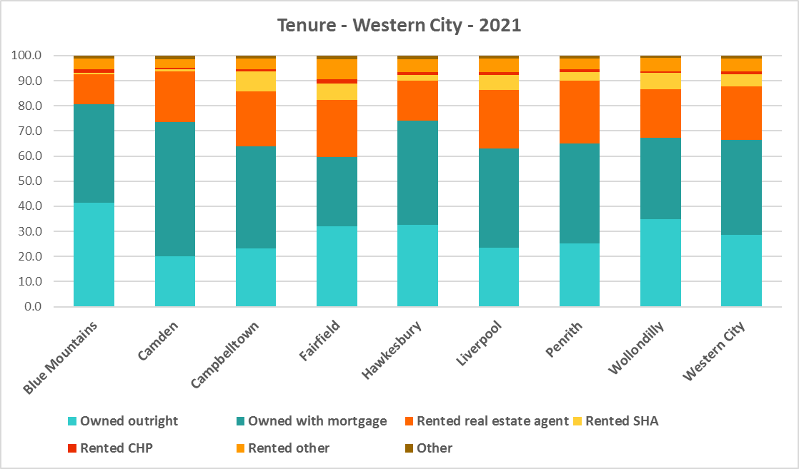



* The general trend is for increasing numbers of households relying on the private rental market as a long term tenure rather than a transitional one between leaving home and buying a home, as housing costs have increased much faster than wages.
* Subsequent high interest rates and high inflation levels have made it increasingly difficult for lower income households in particular to manage housing costs.
* Noting that the rental market in Sydney – and NSW generally – is very tight (see the Housing Snapshot on What’s Happening in the Housing Market) it is therefore important to encourage tenure diversity and a range of price points to meet local needs, including facilitating social and affordable housing development.

## Social Housing

* Social housing is secure and affordable rental housing for people on low incomes with housing needs. It includes public, community and Aboriginal housing. Public housing is managed by DCJ while community housing is managed by non-government organisations.
* As at June 2022, there are 154,600 social housing dwellings in NSW, with 96,712 managed by public housing, 48,264 managed by community housing and 9,624 managed exclusively for Aboriginal people – of these the Aboriginal Housing Office (AHO) are responsible for 4,120 and Aboriginal Community Housing Providers (ACHP) manage 5,504.
* The table below shows the number of public housing properties in the Western City LGAs as at June 2022. Please note that Census data on public housing is not totally accurate, as public housing tenure is under reported in the Census. The figures below do not include community housing properties.



* Campbelltown, Fairfield and Liverpool have a much higher proportion of social housing than the average for Greater Sydney, with some significant concentrations in public housing estates.
* In addition, community housing providers manage a number of properties – including social housing, affordable housing, transitional housing and crisis accommodation in Western City, as outlined in the table below.
* Note that affordable housing is not the same as social housing. Affordable housing is open to a broader range of household incomes than social housing. Households do not have to be eligible for social housing to apply for affordable housing, though people who are eligible for social housing may also be eligible for affordable housing properties.
* Affordable housing is managed more like a private rental property, but there are eligibility criteria and the managers are mostly not for profit community housing providers.



* The next table gives the number of Aboriginal Housing Office (AHO) homes and the number managed by Aboriginal community housing providers (ACHPs) in South Western Sydney; and Nepean/Blue Mountains as at June 2022.



* Note that there are 3 types of social housing available for Aboriginal people:
  + Public housing – these properties are managed by the Department of Communities and Justice (DCJ).
  + Aboriginal Housing Office homes – these are properties owned by the Aboriginal Housing Office and managed by DCJ.
  + Community housing properties – these properties are managed by community housing providers and Aboriginal community housing providers.

## The table below shows the expected waiting times for general housing approved social housing applicants (not for priority housing applicants) by bedroom category in the Western City District at June 2022. It also gives the number of general and priority housing applicants in each allocation zone. This District has a higher than average amount of social housing compared to other Sydney Districts and waiting times for general housing are between 5-10 years or 10+ years depending on allocation zone or bedroom numbers.



* More information on Expected Waiting Times for Public Housing is available on the DCJ website by region at: <http://www.housingpathways.nsw.gov.au/How+to+Apply/Expected+Waiting+Times/>

## The Gap

* Despite this district being relatively more affordable compared to other districts in Sydney, there is a large and growing gap between the increasing number of low income earners in the private rental market and the declining number of private rental properties that are affordable for low income households in Western City. There is also extremely limited opportunity for low income purchasers to buy a home in Western City.
* Low income (including very low income) households are (just) proportionately and numerically the largest income group across the District. Between 2016 and 2021 the number of low income households declined by -3.7%, the number of moderate income households increased by 6.7% and the number of high income households increased by 54.3%.
* Over the same time period, very low income **rental** households increased by 32.4% and low income **rental** households have increased by 35.3% in Western City, despite a decline in the number of low income households.
* Yet affordable private rental housing, as measured by new rental bonds lodged that were affordable to low income households, declined by -5.8% in Western City just between 2021 and 2022.
* There is a clear need for more affordable rental accommodation to begin to address the significant demand supply imbalance, particularly for lower income households and the increasing number of seniors and frail aged.
* The vacancy rate in Sydney and regional areas of NSW has been tight for over a year, indicating a chronic shortage of rental accommodation. At April 2023 the vacancy rate was just 1.3% in Sydney overall, with 1.2% in the middle ring and 1.3% in the outer ring.
* The strong increase in rental levels, decline in rental affordability for lower income earners and significant loss of affordable rental properties, combined with the very high proportion and increase in very low and low income rental households, further demonstrates the need to increase the supply of private rental housing and more particularly, affordable rental housing for long term tenants.
* The graph below shows the decline in the number of new bonds lodged that were affordable to rent for low income households in Western City between 2021 and 2022.

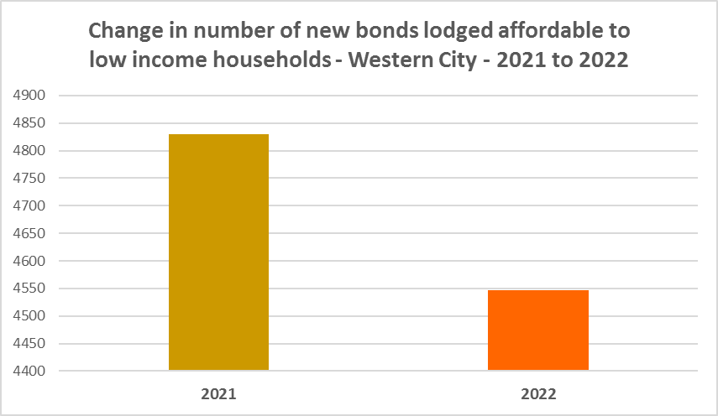

* The next graph compares changes in population, income, renters and housing stress between 2016 and 2021. As noted above, while the population has increased the number of low income households declined marginally between 2016 and 2021 in Western City. Yet low income **rental** households have increased. Of note also is that the number of CRA recipients are growing more quickly than the population generally, and CRA recipients in housing stress are increasing more rapidly than low income rental households in Western City.

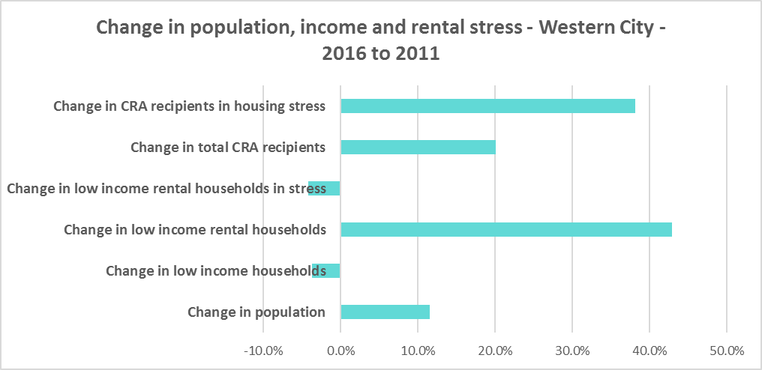

* This demonstrates the increase in demand and need for affordable rental housing in Western City.
* As well as the gap between supply and demand for affordable rental, there is generally a significant gap between dwelling size (bedroom numbers) and household size. The graph below compares the number of smaller household types - lone person and couple only – with the amount of studio and one bedroom accommodation available. It is clear that if smaller households wished to live in smaller housing, they have very little opportunity to do so. While 39.2% of households in Western City are lone person or couple only (below the 45.5% average in Greater Sydney), only 3.2% of dwelling stock is studio or one bedroom (well below the 9.0% average in Greater Sydney).
* This mismatch can impact on affordability, with smaller households required to consume more housing than they need because of lack of choice.
* It also limits the opportunity for empty nesters or older single households to downsize to smaller more manageable homes within their communities. This can impact on the independence of older residents and their ability to age in place. This will become increasingly important as the population of Western City is forecast to have an increase in older age groups.

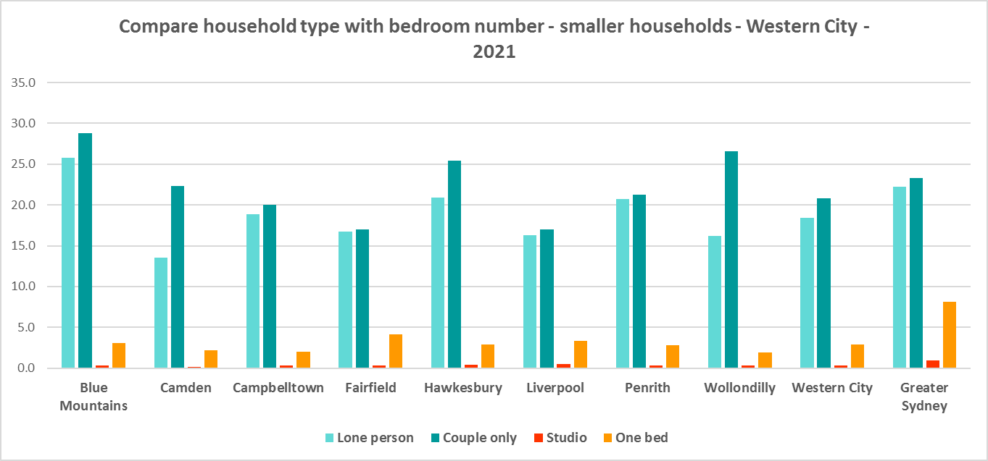

* While there has been an increase in studio and one bedroom homes since the 2016 Census, the number is significantly outweighed by the enormous increase in the number of four and more bedroom homes, as seen in the graph below.

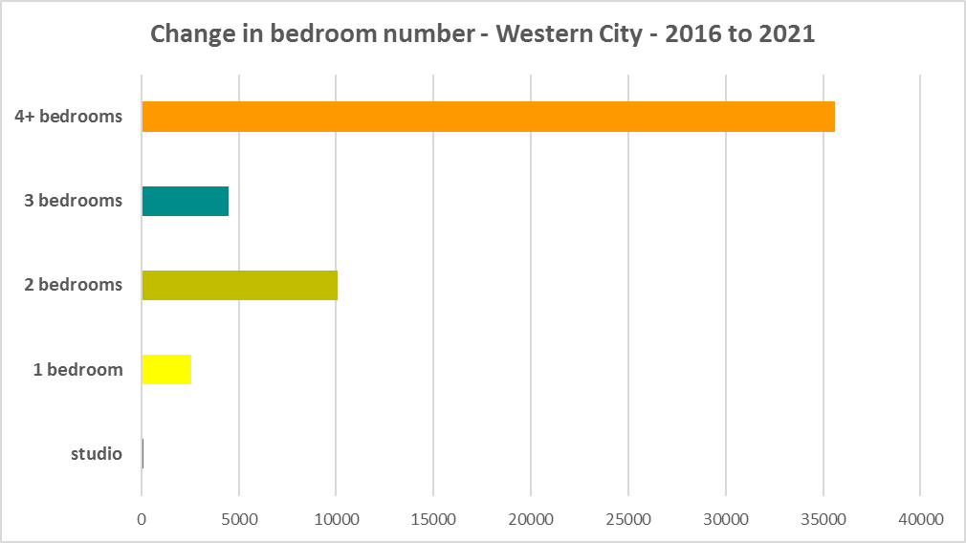

* A proactive stance is required to encourage an increase in studio, one and two bedroom properties. Two bedroom homes are particularly important as longer term they provide the most flexibility, since they can cater to small families as well as lone person, couple only and small share households.
* This is important given that annually the addition of new dwellings represents around 1% of the total dwelling stock – so change occurs very slowly. There is also a need to take into account the impact of alterations and additions to existing stock, for example, adding extra bedrooms to two and three bedroom houses. Given the current overwhelming supply of and increase in four plus bedroom homes, strong incentives/requirements would need to be put in place to ensure a better balance and more diversity to meet housing need. Continuing to encourage development of two bedroom homes is helpful.
* New generation boarding houses would also help fulfil some of this demand – particularly as they cannot be subdivided and must provide rental accommodation. Note that the NSW Community Housing Industry Association has an Affordable Housing Tool Kit to help deal with community resistance to affordable housing, which is available on their website. They also have a couple of excellent vimeos showcasing new generation boarding house developments and their tenants.
* The next graph compares larger household types – couple family with children, one parent family and group households – with the amount of two, three and four or more bedroom accommodation available. It is clear that there is an oversupply of larger dwellings, by comparison with the household types which might need large homes, particularly in Camden and Wollondilly.

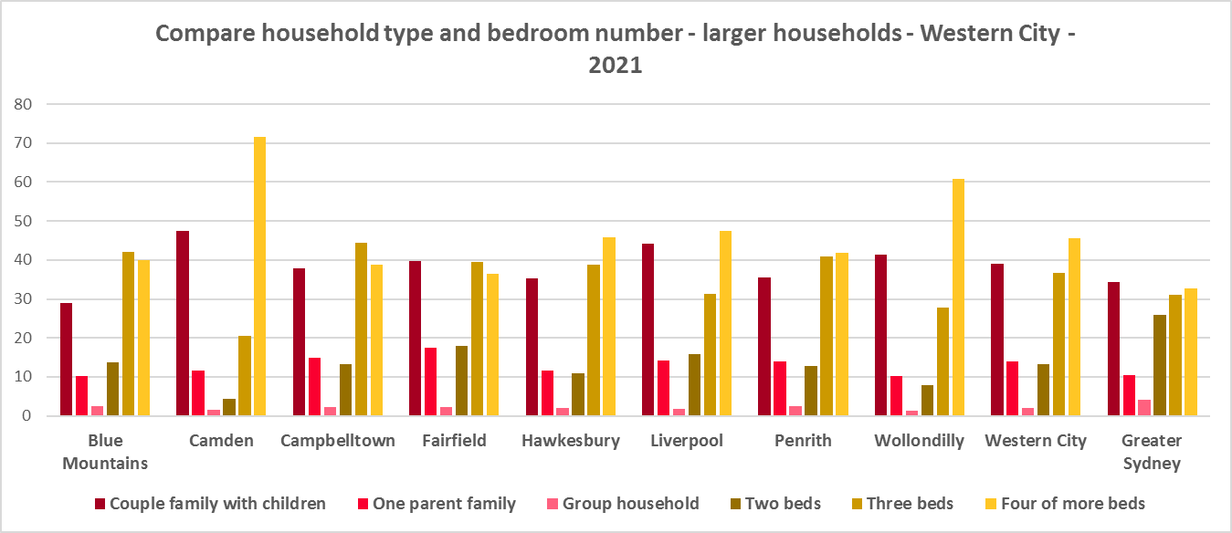

* As couple only households comprise a little over a fifth of all households in Western City, it is important to continue to encourage provision of one and two bedroom stock as well as studios, new generation boarding houses and secondary dwellings, to maintain a balance to meet local need, particularly where there are higher proportions of seniors and frail aged. This will give older residents opportunity to downsize into more manageable and appropriate homes.
* Enabling the provision of more semi-detached, terrace and town houses could help fulfil some of the demand for smaller more manageable homes.

**Who needs affordable housing**

* A wide range of people need affordable housing. Single income earners who fall into the low income category include aged care and disability workers, retail sales assistants, production workers, receptionists and early career child care workers.
* People working in accommodation and food services comprise 5.2% of the workforce living in Western City and are amongst the lowest paid workers. Similarly retail trade employs 9.8% of workers living in Western City.
* Health care and social assistance is the largest employment sector of residents in Western City (employing 13.4%). A 2017 survey of NSW Nurses and Midwives Association (NSWMA) members showed that thirty six per cent of respondents moved home or changed jobs in the previous 12 months because of housing affordability issues.
* For example, households earning $790 per week gross (broadly indicative of a wage for a laundry worker) could afford to pay just $237 per week in rent before being in housing stress. Households earning $960 (broadly indicative of wages for a commercial cleaner, delivery driver and entry level firefighter) could afford to pay just $288 per week in rent before being in housing stress. Households with an income of $1,150 (broadly indicative of the wage for an enrolled nurse, child care worker and ICT support technician) can afford to pay just $345 per week in rent before being in housing stress.
* At a weekly income of $1,450/$1,500 (an indicative wage for an early career Registered Nurse), a household could afford to pay $435 to $450 per week in rent before being in housing stress.
* At June 2023, none of the Western City LGA has sufficient new bonds lodged to calculate a median rent for studio dwellings and Wollondilly had insufficient to calculate a median for one bedroom homes – which speaks to lack of supply.
* At June 2023, the median rent for a one bedroom home in Western City ranged between was $310 per week in Fairfield and $420 per week in Liverpool; for a two bedroom home ranged between $400 per week in Fairfield and $460 per week in Blue Mountains; for a three bedroom home ranged between $520 per week in Campbelltown, Penrith and Wollondilly and $600 in Camden; and for a four or more bedroom home ranged between $650 per week in Blue Mountains and $750 per week in Fairfield. These rents are out of reach for single income households on low incomes.
* Single income households in particular are less able to compete in the housing market.
* Increasing numbers of older single women are homeless or at risk of homelessness due to the lack of available affordable rental housing. In fact they are the fastest growing cohort of the homeless population.
* Partnering or collaborating with community housing providers is one effective way to meet some of the local need for appropriate affordable housing. Not for profit community housing providers are owners, managers and developers of affordable rental housing for lower income households and residents with specific housing needs. They work with partners, investors and government to provide housing and deliver support for tenants. For more information about community housing providers, see the NSW Community Housing Industry Association website.

**Additional Data**

Housing data and tables used in this Snapshot are available from the Local Government Housing Kit Database on the Housing NSW website at:

<https://www.facs.nsw.gov.au/resources/nsw-local-government-housing-kit/chapters/local-government-housing-kit-database>

More information on Expected Waiting Times for Public Housing is available on the DCJ/FACS website by region at:

<https://www.facs.nsw.gov.au/housing/help/applying-assistance/expected-waiting-times>

Additional data on social housing dwellings and delivery is available on the FACS website at:

<https://www.facs.nsw.gov.au/resources/statistics/social-housing-residential-dwellings/facs-quarterly-statistics-social-housing-dwellings>

or go straight to the dashboard:

<https://public.tableau.com/app/profile/facs.statistics/viz/Social_Housing_Residential_Dwellings/Dashboard>

and

<https://www.facs.nsw.gov.au/resources/statistics/social-housing-delivery2/interactive-dashboard>

More information about community housing providers is available on the NSW CHIA (Community Housing Industry Association) website:

NSW CHIA Snapshot of the Community Housing Sector in NSW:

<https://communityhousing.org.au/wp-content/uploads/2022/08/Community-Housing-Snapshot-2022.pdf>

Data on community housing properties is available from the NSW CHIA Dashboard at:

<https://communityhousing.org.au/our-impact/data-dashboard/>

CHIA NSW affordable housing tool kit. The Tool Kit is based on extensive research about reasons for community resistance to affordable housing, and effective ways of building support for affordable housing:

https://nswfha-my.sharepoint.com/personal/josha_communityhousing_org_au/_layouts/15/onedrive.aspx?ga=1&id=%2Fpersonal%2Fjosha%5Fcommunityhousing%5Forg%5Fau%2FDocuments%2FAffordable%20Housing%20Toolkit%2FFiles