**North Coast Region – What’s Happening in the Housing Market?**

This Housing Snapshot looks at aspects of the housing market in the North Coast, particularly from the 2016 Census to the 2021 Census – including rents, vacancy rate, affordable private rental for very low and low income households, rental stress for low income households, number of new bonds lodged affordable to low income households, sales price, purchase affordability for very low and low income households and purchase stress for low income households.

The North Coast region covers twelve local government areas on the north coast and immediate hinterland, including significant regional centres. While there are differences across the region in median rent and house prices and rent and house price growth, there has been a reduction in both rental and purchase affordability in every LGA in the region and a loss of affordable rental housing.

Significant changes have occurred since the 2016 Census, with Covid causing significant outmigration from cities to regional areas and flood affected regions suffering adverse impacts to rental affordability. More recently additional cost of living pressures, including rising inflation and interest rates with continued low wage growth, have created additional problems for lower income earners and their capacity to manage housing costs.

***Housing Market - Rental***

**Rents**

* While the graph and table below show very strong recent increases in the median rents for all dwellings (all bedroom categories and all dwelling types) in the local government areas of the North Coast, the story is more nuanced.

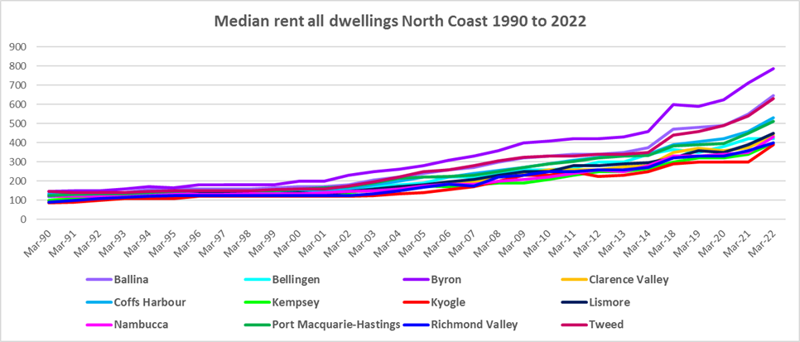



* Between 2019 and 2020 when Covid lockdowns were introduced, median rents in most bedroom categories in most North Coast local government areas were fairly stable – with no change, slight increases or slight decreases in median rents as the table below demonstrates.
* During that period, the largest percentage drop in median rents was in Byron LGA for three bedroom homes (-7.7%) while the biggest increase was for one bedroom homes in Clarence Valley (13.6%).



* However, between 2020 and 2022 when Covid restrictions were relaxed, there were strong increases in median rents across the region, as the table below shows. (The largest percentage increases are highlighted in pink and the largest numerical increases in dollar terms are highlighted in yellow.)
* Generally Ballina ($202 for 4 bedroom), Byron ($475 for 4 bedroom) and Tweed ($220 for 4 bedroom) experienced the largest increases in rents in dollar terms. Note that Coffs Harbour, Lismore and Port Macquarie-Hastings also experienced strong dollar increases in median rents over this period.
* In percentage terms, increases in median rents were robust across all LGASs and bedroom categories in the North Coast, with Lismore also experiencing strong rental rises (37.6% for 3 bedroom). Many parts of the North Coast experienced significant flooding over this time period and the large increases in rents in places such as Lismore indicate strong demand with diminished supply due to loss of stock in the floods.
* Overall the highest percentage increase in median rents between June 2020 and June 2022 was for four bedroom homes in Byron (65.5%), followed by three bedroom homes in Byron (50.0%) and Ballina (40.0%) and one bedroom homes in Byron (40.0%).



**Vacancy Rate**

* A vacancy rate of 3% is understood to represent a balance between supply and demand in the rental market. Vacancy rates below 3% represent a tight rental market while longer term vacancy rates below 2% represent a chronic undersupply of rental housing.
* According to Real Estate Institute of NSW (REINSW) data, the vacancy rate at April 2023 is 2.2% in Coffs Harbour and IS 1.4% in both the Northern Rivers the Mid North Coast.
* Almost universally, vacancy rates across regional and metropolitan NSW are tight. At April 2023, the vacancy rate in New England was 2.1%, in Newcastle was 1.8%, in the rest of the Hunter was 2.0%, on the Central Coast was 1.7% and in Sydney was 1.3%.
* Anecdotally there are reports of the difficulties tenants are experiencing finding and retaining rental accommodation – strong competition for properties, rent bidding and significant increases in rents, tenants paying too much of their income in rent, facing evictions and potential homelessness.
* The two graphs below shows the long term vacancy rate in Coffs Harbour and Northern Rivers and also for the Mid North Coast from 2006 to 2023 using REINSW data.

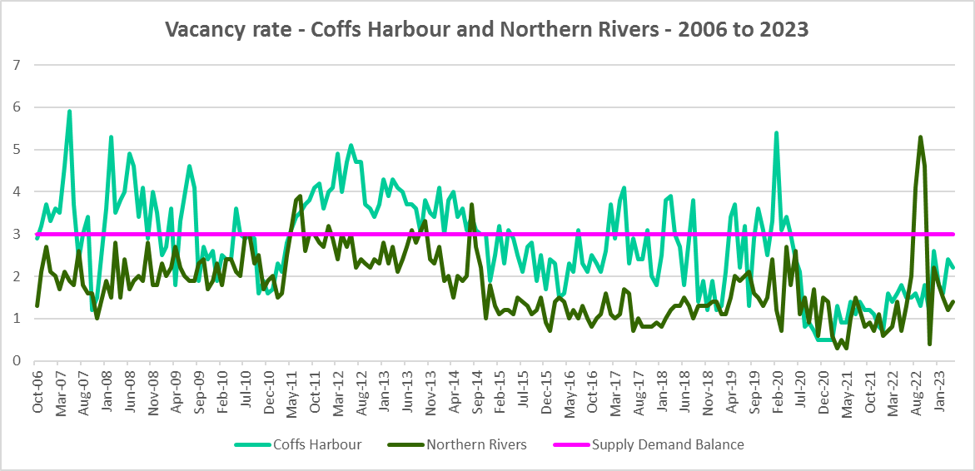

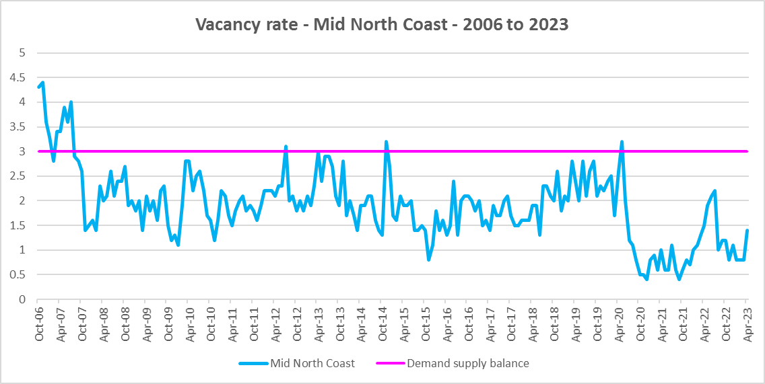

**Affordable Rental**

* The SGS Economics and Planning November 2022 Rental Affordability Index report notes that:
  + The greatest decline in rental affordability over the past two years is evident in the coastal areas of regional NSW (e.g., Tweed Heads, Woolgoolga, Port Macquarie)
  + Regional NSW was severely affected by the 2022 eastern Australian floods, one of the worst recorded flood disasters. Towns in the Northern Rivers region suffered damage to thousands of properties and affected homeowners and renters alike.
  + The impact on the rental market and affordability is evident in Lismore, one of the worst affected towns, where rental affordability was reduced by 10 per cent between 2021 and 2022.
  + Bellingen was similarly affected, with affordability declining by 14 per cent.
* The NSW wide trend to decline in the proportion of rental housing that is affordable for lower income households is evident in the North Coast.
* Again, looking at the period from 2018 to 2019 and from 2020 to 2021, this broad trend is more nuanced. Kyogle, Richmond Valley, Clarence Valley and Coffs Harbour experienced a decline in the proportion of private rental affordable to very low income households between 2018 and 2019. Almost all North Coast LGAs experienced a decline in private rental affordable to very low income households between 2020 and 2021 – with Bellingen, Nambucca and Kempsey the only exceptions.
* All the LGAs in this region have a significantly lower proportion of affordable rental for very low income households in 2021 than in 2017. Seven of the twelve LGAs in this region have a lower proportion of affordable rental than the Rest of NSW average of 21.9% (Tweed, Byron, Ballina, Clarence Valley, Coffs Harbour, Bellingen and Port Macquarie-Hastings). Byron had the lowest proportion of affordable rental for very low income households with just 0.9%, followed by Ballina with 2.6%, Tweed with 4.6%, Port Macquarie-Hastings with 7.3% and Coffs Harbour with 7.8%.
* The table and graph below, show the change in the proportion of private rental accommodation (as measured by new rental bonds lodged) that is affordable to very low income households in all LGAs in the North Coast region between 2001 and 2021.

Proportion private rental affordable rental for very low income earners



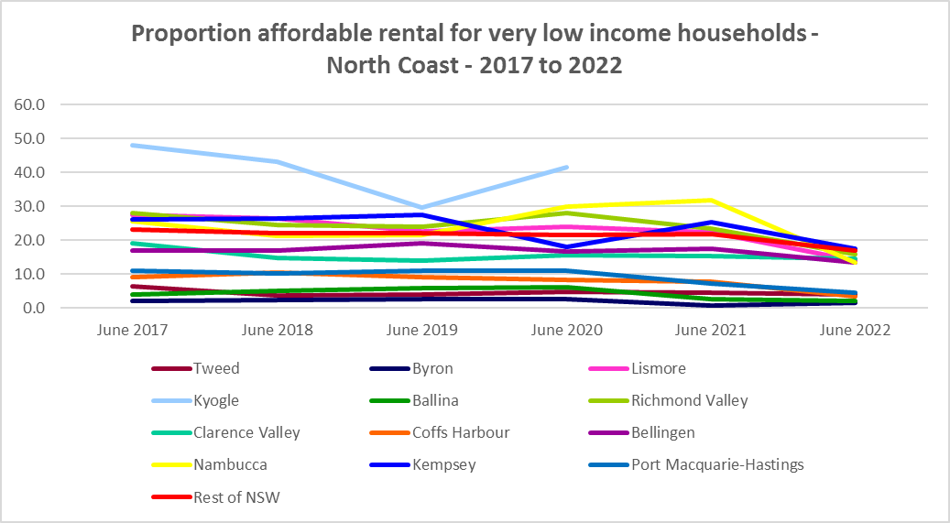

* As for very low income households, low income households have experienced recent ups and downs in affordability of private rental.
* Between 2018 and 2019 the proportion of private rentals affordable for low income households declined in Tweed, Lismore, Kyogle, Richmond Valley, Coffs Harbour, Bellingen and Kempsey but improved in Byron, Ballina, Clarence Valley, Nambucca and Port Macquarie-Hastings.
* Between 2019 and 2020, the proportion of private rentals affordable for low income households increased in every LGA except Ballina, Coffs Harbour and Kempsey.
* Between 2020 and 2021 the proportion of affordable rental declined in every LGA except Kempsey, where it remained stable.
* Again all LGAs have a lower proportion of private rental properties affordable for low income households in 2021 than in 2017, with six LGAs (Tweed, Byron, Ballina, Coffs Harbour, Bellingen and Port Macquarie-Hastings) having a lower proportion than the average for the Rest of NSW. Byron has the lowest proportion of affordable rental for low income households with just 8.2%, followed by Ballina with 17.0% and Tweed with 18.5% - all well below the Rest of NSW average of 51.0%.

Proportion of private rental affordable to low income households



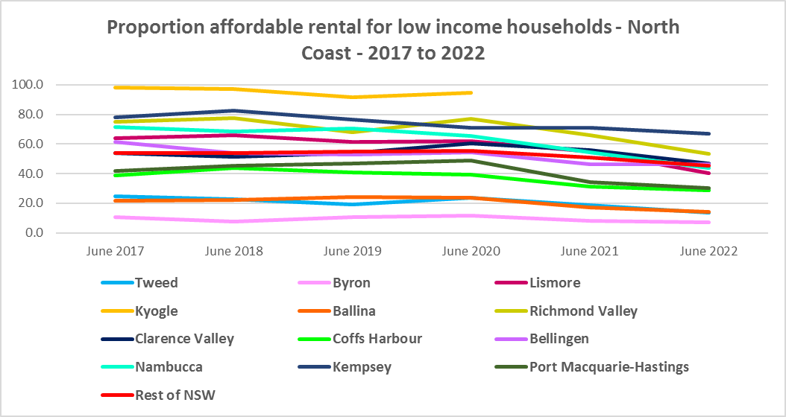

* There is evidence that short term holiday rentals such as Airbnb are impacting the supply of housing, including long term rental and affordable housing in cities and coastal communities. The North Coast sub-region and Byron Shire in particular has experienced significant impacts, including loss of long term and affordable rental housing.
* The University of Sydney Urban Housing Lab undertook a study and prepared a report for the Australian Coastal Councils on short term holiday rentals: “Planning responses to online short term holiday rental platforms” - Research Project for Australian Coastal Councils Association Inc. September 2018 by Nicole Gurran, Yuting Zhang, Pranita Shrestha, Catherine Gilbert.
* The study found (p7) “that there has been a rapid growth in online holiday rental listings overall and in coastal Australia in particular. Since Airbnb was launched in Australia, the number of listings has risen to over 130,000 properties, amounting to around 0.2% of the housing stock nationwide. If holiday rentals are considered to be part of the rental housing stock (a smaller proportion of Australian homes), then Airbnb listings for whole homes represent around 3.5% of rental accommodation. In coastal communities, the rate is much higher. Across the communities in this study, between 0.3% (Moreton Bay) and 17.6 % (Byron) of the total housing stock is listed on Airbnb.”
* Further (p36) “Many… of the case study communities report that lower income residents and local workers face barriers in securing affordable rental housing or entering home ownership … – particularly Byron Bay … – online holiday rentals permeate residential neighbourhoods which were formally places for lower income earners and local workers to find permanent rental housing.”
* “In these localities, interviewees described a tightening rental market where renters struggled to find accommodation in the towns where they worked, or faced eviction notices prior to holiday seasons. In Byron, interviewees described a process of tourism displacement whereby local workers and aspiring first home buyers with ties to the locality, have been priced out of the market by tight rents and unaffordable prices.”
* New residential development intended to increase the housing supply was often purchased by investors with the intention of listing them as holiday rentals rather than offering them to long term tenants.
* The report notes that in Byron (p58) “The rental housing market has always been tight, with many renters needing to vacate during summer peak seasons. However, since the rise of online platforms …permanent rental accommodation is almost impossible to access within Byron Bay itself, and difficult across the entire local government area. There is a particular concern about the potential for new housing supply to be subsumed within the holiday rental stock rather than contributing to local housing need.”
* As the study points out (p46) “in communities where demand for rental housing outstrips supply, any conversion of the residential stock to tourism will exacerbate housing affordability issues.”
* The study outlines a range of potential planning, regulatory and industry responses, including a checklist for local government to consider.
* More recently, research by SQM showed that between July 2019 and July 2020 Ballina experienced a 32% increase in Airbnb listings, East Ballina 21%, Nambucca 6%, Port Macquarie-Hastings 4%, while Bellingen and Clarence Valley were down -3%, Tweed and Lennox Head were down -13%, Coffs Harbour – 18%, Kempsey -22%, Richmond Valley and Byron -26%, with Lismore -39% and Kyogle -47%.
* Since 2020 it is likely that Airbnb listings have picked up again in the North Coast, with the exception of flood impacted areas.

**Rental Stress**

* Households regarded as being in rental stress are renting in the private rental market and paying more than 30% of their income in rent. Lower income households in rental stress will struggle to pay for other essential household costs, such as medical or educational expenses, food, transport and energy costs.
* At June 2021 the proportion of very low income households in rental stress in the Rest of NSW (that is, excluding Sydney) was 91.7%. Within North Coast, the proportion varied from 84.7% in Kyogle to 97.4% in Byron. The proportion of very low income households in rental stress increased between 2016 and 2021 in every single LGA within the North Coast region. Again the proportion of low income earners in rental stress increased in every LGA between 2016 and 2021, in some areas quite dramatically (for example Ballina increased from 60.9% in 2016 to 85.4% in 2021). However, the picture is actually more complex.
* While the percentage in stress increased, the total number of very low and low income households in rental stress declined in each LGA (except for Kempsey, Kyogle and Nambucca which all experienced an increase) – against the trend in the Rest of NSW.
* Below is a graph of the proportion of very low and low income households in rental stress in each North Coast LGA at 2021 and a table showing the change in the proportion of very low and low income households in stress between 2016 and 2021.

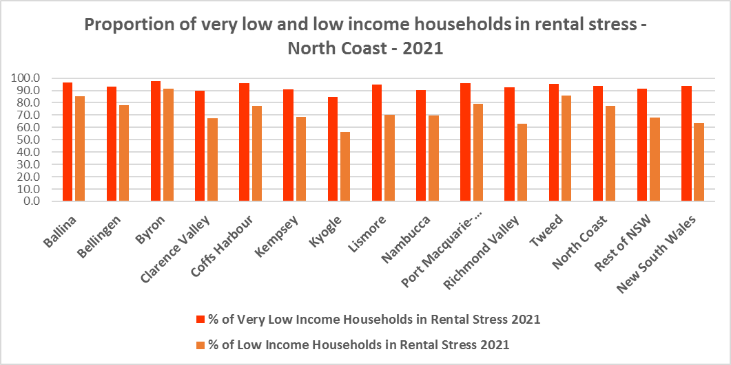



* The next table shows the change in the number of very low and low income households in rental stress at 2016 and at 2021.
* Again Covid has had an impact on the rental market and on tenants.
* A look at CRA (Commonwealth Rent Assistance) recipients in housing stress gives some further information on what has been happening with lower income households in rental stress over this time frame.



* Between 2016 and 2020, the total number of CRA recipients in the North Coast increased significantly, while the number in stress actually declined. However, between 2020 and 2021 the number of CRA recipients declined while the number in stress increased.
* The number of CRA recipients in housing stress has increased from the June 2020 figures as the temporary Coronavirus Supplement ended on 31 March 2021.
* The Coronavirus Supplement was $550 per fortnight for new and existing recipients of JobSeeker Payment, Parenting Payment, Youth Allowance for jobseekers, Farm Household Allowance and Special Benefit. The temporary supplement almost doubled the maximum payment rate for a JobSeeker Payment recipient. Hence it made rent more affordable for some CRA recipients in June 2020 and resulted in a lower proportion of CRA recipients in rental stress than usual.
* Since the end of Covid restrictions, the number of people in employment has increased, so fewer people are relying on rent assistance from the Commonwealth.
* This scenario is evident in the two graphs below.
* Note that, according to SGS Economics and Planning Rental Affordability Index of November 2022 “Regional rental markets were not exposed to COVID-19 restrictions that capital cities were; therefore, the rebound from the pandemic played out differently. While Australia’s regions were spared the worst of pandemic response measures, there has been concern regarding the impacts of outward-migrating city residents on housing, and rental, affordability. This phenomenon is observed in the most recent data, which shows that affordability has worsened in the regional areas of every state, even more so than in the capital cities (P55)”.

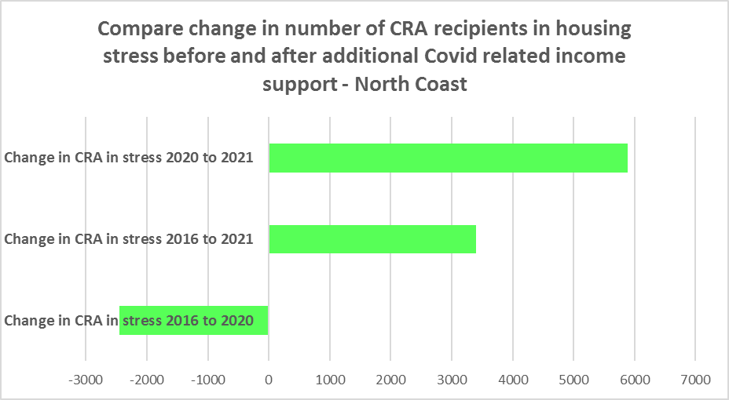

* The table below shows the number and proportion of tenants in the North Coast region who are in the private rental market, are in receipt of Commonwealth Rent Assistance, and even with this additional income support, are in housing stress.
* There were a total of 22,057 tenants in receipt of CRA and in housing stress across the North Coast region in 2021, up from 18,663 in 2016. The North Coast is home to 26.4% of all the CRA recipients in housing stress across the Rest of NSW (although only 25.3% of all CRA recipients).
* This is a very high proportion and indicates that this region is not affordable for rental, relative to other regions outside Sydney. Tweed had the highest number of CRA recipients in housing stress with 4,179, while Coffs Harbour (3,589) and Port Macquarie Hastings (3,492) also have a significant number.
* Six North Coast LGAs have a higher percentage of CRA recipients in housing stress than the average for the Rest of NSW of 39.2% (Ballina, Bellingen, Byron, Coffs Harbour, Lismore and Tweed). Byron has the highest proportion in the region with 58.6%. This demonstrates that many low income North Coast residents are not able to access affordable housing in the region.



**Loss of Affordable Housing Stock**

* The Department of Communities and Justice (DCJ) has calculated the number of new bonds lodged that were affordable to low income earners on the North Coast in 2017, 2021 and 2022.
* All North Coast region LGAs experienced a significant loss of affordable private rental housing stock between 2017 and 2022, averaging -43.5% fewer affordable bonds lodged in 2022 than in 2017. A total of -829 fewer affordable private rental bonds were lodged in the twelve North Coast LGA’s over this period, with the largest numeric losses occurring in Tweed (-115 or -60.5% fewer), Port Macquarie Hastings (-109 or -34.0% fewer), and Clarence Valley (-108 or -40.9% fewer).
* At 2022, Byron had just 20 affordable rental bonds lodged, Kyogle just 29, Bellingen 31, Ballina only 47 and Nambucca 48. In fact Nambucca had the largest proportion reduction in private rental bonds lodged affordable to low income households, with -65.0% fewer in 2022 than in 2017.
* This loss of affordable rental housing is concerning. Significant losses are occurring in places that have historically been amongst the more affordable North Coast LGAs.
* The table below shows the number of new bonds lodged that were affordable to low income households in 2017, 2021 and 2022.



***Housing Market - Purchase***

**Sales Price**

* Changes in the median sales price of both houses and flats over the ten years to March 2022 have been upward in the North Coast.
* Byron (276.6%), Bellingen (182.6%), Tweed (177.4%), Ballina (156.7%) and Lismore (147.9%) had the largest proportional increase in median sales price for houses over this period within the North Coast region.
* For strata properties, Ballina (139.5%) and Tweed (141.9%) had the largest proportional increase in median sales price over the ten year time frame.
* At March 2022, Byron had the highest median sales price for houses with $2,120,000, followed by $1,240,000 in Ballina, $1,237,000 in Tweed and $1,026,000 in Bellingen. Ballina had the highest median sales price for flats at March 2022 with $812,000, followed by Tweed with $716,000.
* The table below shows changes in the median sales price of both houses and flats over the last ten years in the North Coast region.



* However, between 2019 and 2022 there were more complex changes in the market, as the two tables below demonstrate, with both Covid and floods having an impact.
* Between March 2019 and 2020 median house and strata prices experienced relatively low growth, with Byron seeing a fall in median house prices over that year. Changes in median sales price for houses ranged between -1.0% in Byron and 15.7% in Bellingen, while for strata the median increase ranged between 2.7% in Ballina and 11.5% in Coffs Harbour.
* Between March 2021 and March 2022 there was very strong growth in median house and strata prices. Increases in the median sales price for houses ranged between 53.6% in Lismore and 20.3% in Richmond Valley, while for strata between 34.8% in Tweed and 18.8% in Port Macquarie Hastings.





* The long term median sales price trend for houses and flats shows growth across all LGAs, particularly from around 2002.
* The long term trend for strata properties is similar, with increases occurring primarily after 2001.
* The two graphs below show the median sales price trend for houses and for strata properties from 1991 to 2022 in all North Coast LGAs. Median sales prices are highest in the far North Coast LGAs of Ballina, Byron and Tweed, with Coffs Harbour and Port Macquarie Hastings next highest.

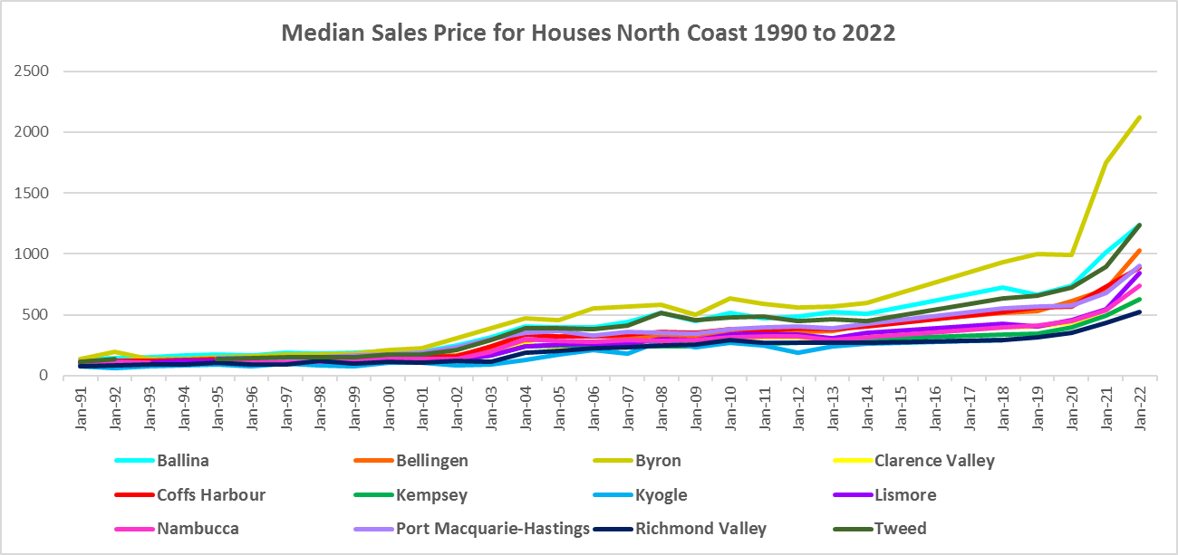

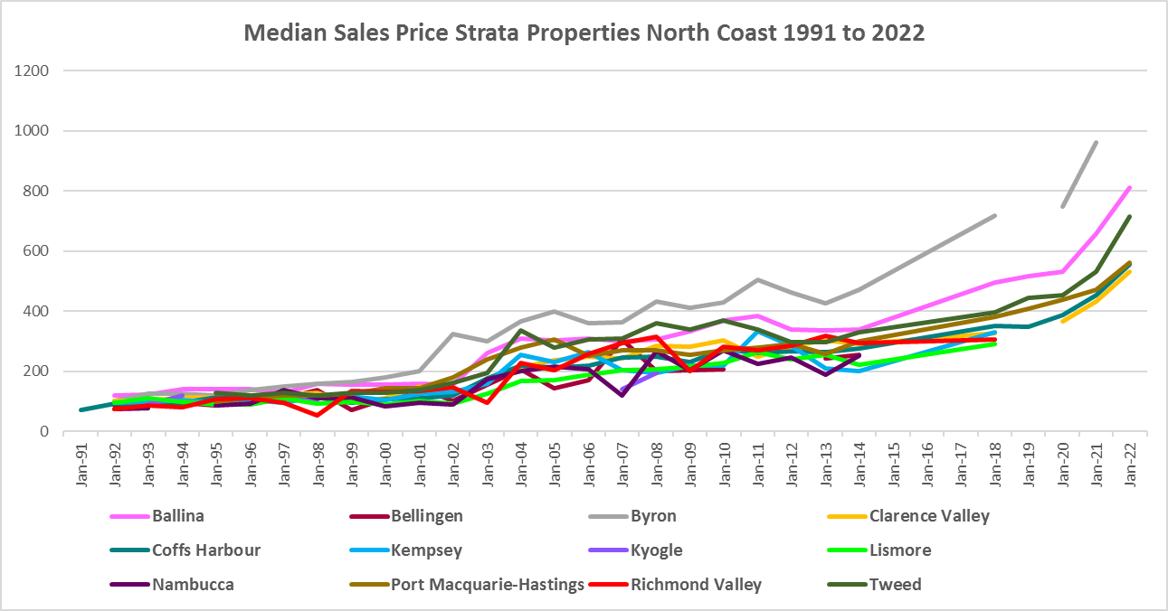

**Purchase Affordability**

* Purchase affordability for very low income households has been extremely low for a long time across much of NSW, including the North Coast. However, historically there were pockets of the North Coast that were more affordable – for example, Kyogle and Kempsey. That is no longer the case.
* At June 2021, the proportion of sales in the North Coast LGAs that were affordable to very low income households ranged from 0% in Ballina, Byron and Port Macquarie Hastings to 8.7% in Kyogle. While Kyogle is the only LGA with a higher proportion of affordable purchase for very low income households than the Rest of NSW average of 7.5%, Kyogle had 27.8% affordable purchase in June 2020 and has experienced a significant drop in affordability.
* Nambucca has the next highest proportion at June 2021 with just 3.8%, then Richmond Valley with 2.9% and Bellingen with 2.3%. Kempsey had just 1.8% affordable purchase.
* The graph below shows the purchase affordability for very low income households in the North Coast LGAs from 2017 to 2021.

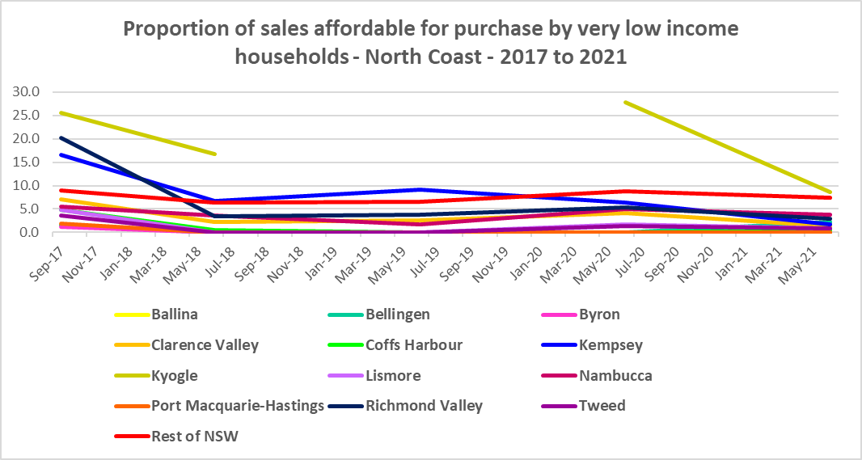

* The table below gives the proportion of affordable purchase for very low income households in North Coast LGAs from 2017 to 2021.



* Purchase affordability for low income households is a little more feasible for low income households in the North Coast, but still tight. Across the Rest of NSW 23.8% of sales at the June quarter 2021 were affordable for purchase by low income households. In the North Coast, the proportion ranged from 0% in Ballina and Byron to 39.1% in Kempsey.
* Ballina, Byron, Tweed, Port Macquarie-Hastings, Coffs Harbour, Bellingen, Nambucca and Lismore all had a lower proportion of affordable purchase for low income households than the Rest of NSW average at June 2021.
* Bellingen was the only LGA in the region to have a (slightly) higher proportion affordable purchase for low income households in 2021 than in 2017.
* The graph and table below show the change in the proportion of affordable purchase for low income households in the North Coast from 2017 to 2021.

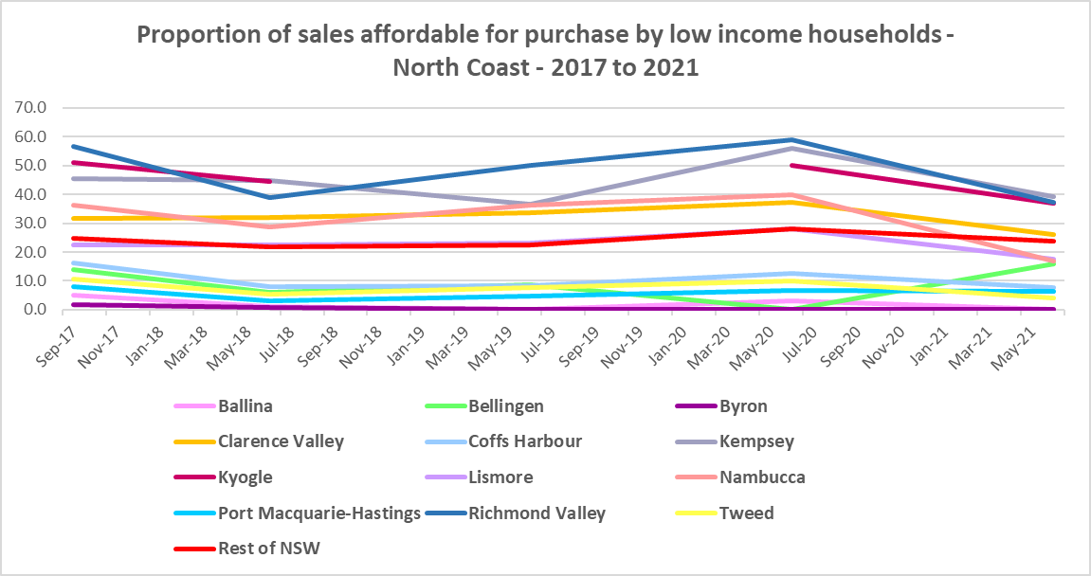



**Purchase Stress**

* In 2021 there were 2,699 very low income households and 2,913 low income households purchasing a home and in stress across the North Coast – that is, paying more than 30% of their income on their mortgage. This represents 45.5% of very low and low income purchasers in the region – a slightly higher proportion than the average for the Rest of NSW at 43.9%.
* Byron had the highest proportion with 55.1%, followed by Tweed with 51.8% and Ballina with 50.4%.
* Tweed had the highest number of very low and low income purchasers in stress with 2,213, followed by Port Macquarie Hastings with 1,643, Coffs Harbour with 1,571 and Clarence Valley with 1,476.



* However the number of very low and low income purchasers in stress is significantly lower than the number of very low and low income renters in stress in the region, as the graph below demonstrates.

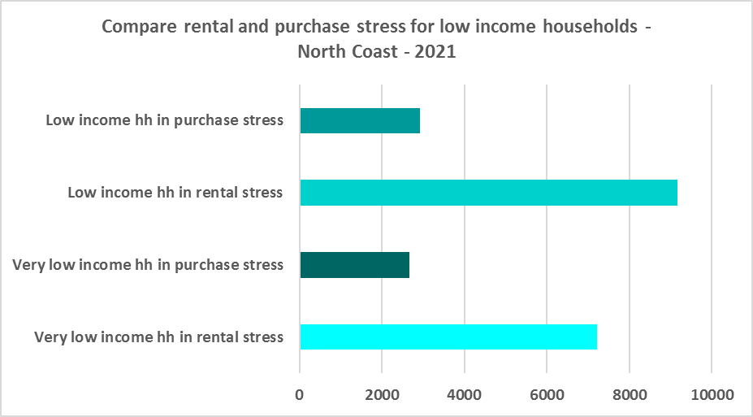

**Additional Data**

Additional data on rents and sale prices, including both current and historical data, is available from the Rent and Sales Report and the interactive Dashboard on the Housing NSW website at:

<https://www.facs.nsw.gov.au/resources/statistics/rent-and-sales/dashboard>

More detailed housing data and tables used in this Snapshot are available from the Local Government Housing Kit Database on the Housing NSW website at:

<https://www.facs.nsw.gov.au/resources/nsw-local-government-housing-kit/chapters/local-government-housing-kit-database>

More information on vacancy rates is available from the Real Estate Institute of NSW website:

<https://www.reinsw.com.au/Web/Web/Members/Property_data/Vacancy_Rates_Survey.aspx>

The Rental Affordability Index is at

<https://sgsep.com.au/projects/rental-affordability-index>