**New England North West – What’s Happening in the Housing Market?**

This Housing Snapshot looks at aspects of the housing market in the New England North West, particularly from the 2016 Census to the 2021 Census – including rents, vacancy rate, affordable private rental for very low and low income households, rental stress for low income households, number of new bonds lodged affordable to low income households, sales price, purchase affordability for very low and low income households and purchase stress for low income households.

The New England North West Region covers twelve local government areas, including growing regional centres, significant agricultural production, mining, regional tourism and areas of high environmental value . Housing market conditions and rent and purchase affordability varies significantly within the region, particularly between the larger centres, mining communities and the rest of the region. There is a tight vacancy rate, declining numbers of affordable rental properties in the private rental market and higher numbers of lower income rental households in housing stress.

**New England North West Region – What’s Happening in the Housing Market?**

# ***Housing Market - Rental***

**Rents**

* Looking at median rents for all residential dwellings combined together, there have been strong increases in the New England North West region since 2003. While there have been variations in median rents since then the period from 2019 to 2022 has been more complex.
* The graph below shows the increase in median rents for all dwellings (including all bedroom categories) in each New England North West LGA from June 1990 to June 2022.

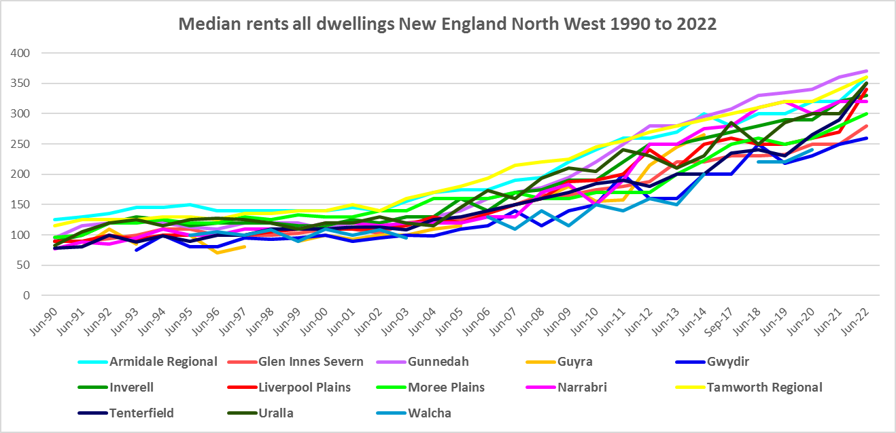

* The table below shows the change in median rents for all dwellings in each New England North West LGA between 2017 and 2022. Increases in rents varied between 14.3% in Narrabri to 48.9% in Tenterfield over this time frame.



* However, there was not an even increase in rents over this five year period.
* Between 2019 and 2020 when Covid lockdowns were introduced, there were generally lower increases, and in some cases decreases in median rents. Glen Innes Severn (-3.8%), Inverell (-0.9%), Narrabri (-2.3%) and Tamworth (-1.1%) all experienced drops in median rent for two bedroom homes during that year. In addition Inverell (-3.3%) and Moree Plains (-6.7%) had reductions in median rent for three bedroom properties and Tamworth (-1.3%) for four bedroom homes.
* Although rent rises were mostly modest, there were some strong increases in median rents over the same period - with a 24.2% increase for four bedroom homes in Moree Plains, along with a 14.7% rise in Liverpool Plains and 12.0% in Gunnedah for two bedroom homes.
* The table below gives the weekly median rents in dollar terms and the changes between 2019 and 2020 for New England North West LGAs.



* Between June 2020 and June 2022 a different pattern emerges, with all LGAs in New England North West experiencing strong increases in median rents, as the table below shows.
* Over this time frame Moree Plains and Tamworth had the largest increase in median rent in dollar terms for one bedroom homes ($20), Glen Innes Severn for two bedroom properties ($53), Uralla for three bedroom homes ($83) and Armidale Regional for four bedrooms ($70).
* In percentage terms, increases in median rents ranged from 29.6% in Liverpool Plains for three bedroom homes to 1.3% in Moree Plains for four bedroom properties, with most rent increases across the region being in double figures between 2020 and 2022.



* At June 2022, median rents for one and two bedroom homes were highest in Gunnedah ($280 and $315 respectively); for three bedroom homes were highest in Narrabri ($395); and for four bedroom they were highest in Uralla ($575).

**Vacancy Rate**

* A vacancy rate of 3% is understood to represent a balance between supply and demand in the rental market. According to REINSW data, vacancy rates were below 3% for the New England area since June 2020, indicating a tight rental market with insufficient supply. Vacancy rates below 2% represent a chronic undersupply of rental housing.
* At April 2023 the vacancy rate in New England was 2.1% - up from 1.6% in March. Vacancy rates are tight across almost all of New South Wales, with for example Central West and Orana both 1.7% at April 2023, Coffs Harbour 2.2%, Mid North Coast and Northern Rivers both 1.4%, Newcastle 1.8% and the rest of the Hunter 2.0%.
* Anecdotally there are stories of the difficulties tenants are facing finding and retaining housing – including strong competition for rental accommodation, rent bidding, significant rent increases, having to pay too much of their income in rent, facing eviction and potential homelessness.
* The graph below shows the long term vacancy rate for New England, using REINSW data, from 2006 to 2023.

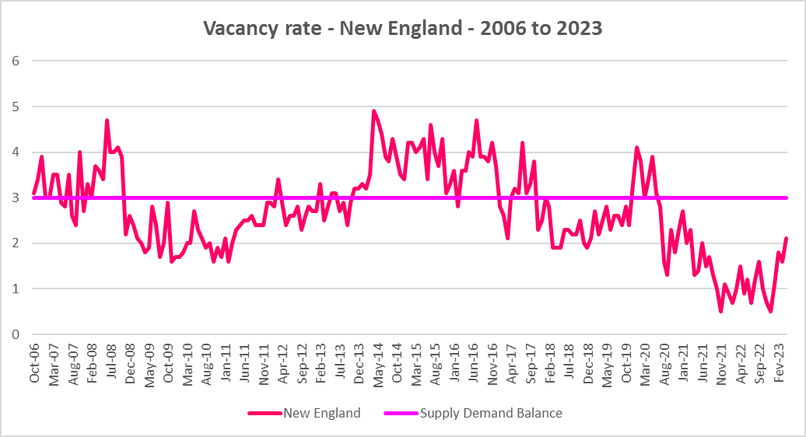

**Affordable Rental**

* The general trend across Sydney and NSW has been for a decline in the proportion of rental stock which is affordable for very low, low and moderate income earners.
* This has been the trend also in New England North West, with the majority of LGAs having a lower proportion of private rental affordable for very low income earners in 2022 than in 2017. (The exceptions being no change in Uralla and slight increases in Narrabri and Tamworth Regional.)
* However, along with elsewhere in NSW, there were more complex factors at play between 2019 and 2022.
* Across the Rest of NSW, the proportion of affordable rental for very low income households stayed at the 2018 level of 22.0% for 2019, improved slightly to 21.7% in 2020 and again to 21.9% in 2021 then declined in line with the longer term trend to 17.0% in 2022.
* In New England North West, this pattern was more varied. Between 2018 and 2019 rental affordability for very low income households stayed steady in Armidale Regional, improved in Gunnedah, Liverpool Plains, Moree Plains and Narrabri and declined in all the other LGAs in the region.
* Between 2019 and 2020 the proportion affordable for rental by very low income households increased in Armidale Regional, Glen Innes Severn, Inverell, Moree Plains, Narrabri and Tamworth Regional, while declining in the other LGAs in the region.
* Between 2020 and 2021 rental affordability improved in Armidale Regional, Gunnedah, Moree Plains, Narrabri and Tamworth Regional and declined elsewhere in the region.
* Between 2021 and 2022 rental affordability for very low income households declined in every New England North West LGA with the exception of Narrabri.
* At June 2022, none of the New England North West LGAs had a lower proportion of affordable rental for very low income households than the Rest of NSW average of 17.0%. Gunnedah had the lowest proportion in the region with 27.1%, followed by Tenterfield with 29.7%, Tamworth Regional with 32.0% and Armidale Regional with 34.8%.
* The table and graph below show the change in the proportion of private rental accommodation affordable to **very low income** households in New England North West between 2017 and 2022. Note there are not always sufficient new bonds lodged in a local government area to reliably calculate the proportion – so no data will be recorded where this is the case.

Proportion affordable rental for very low income households



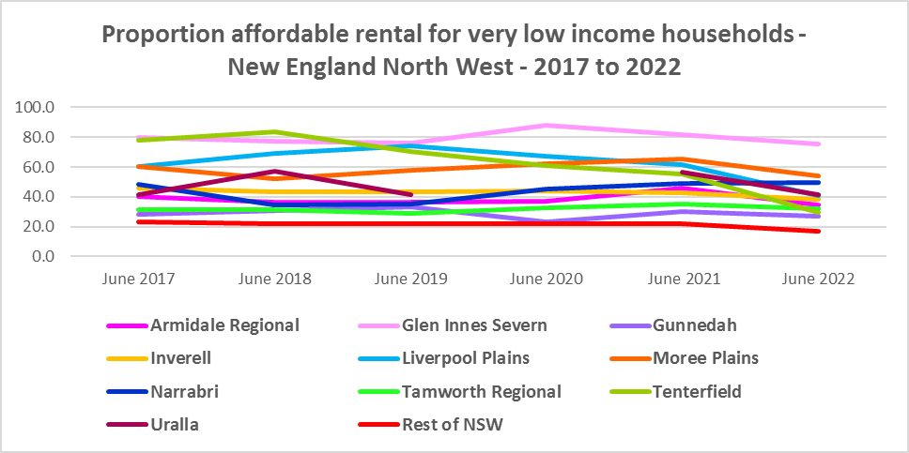

* In the Rest of NSW, between 2018 and 2020 the proportion of rental affordable for low income households increased gently from 54.1% to 55.2% and then declined again to 45.4% in June 2022. Again the picture in the region was more varied.
* Overall Armidale Regional, Liverpool Plains, Tenterfield and Uralla have a lower proportion of private rental affordable for low income households in 2022 than in 2018, while all the other LGAs in the region have a higher proportion in 2022.
* The table and graph below show the change in the proportion of private rental accommodation affordable to **low income** households in New England North West between 2001 and 2022.

Proportion affordable rental for low income households



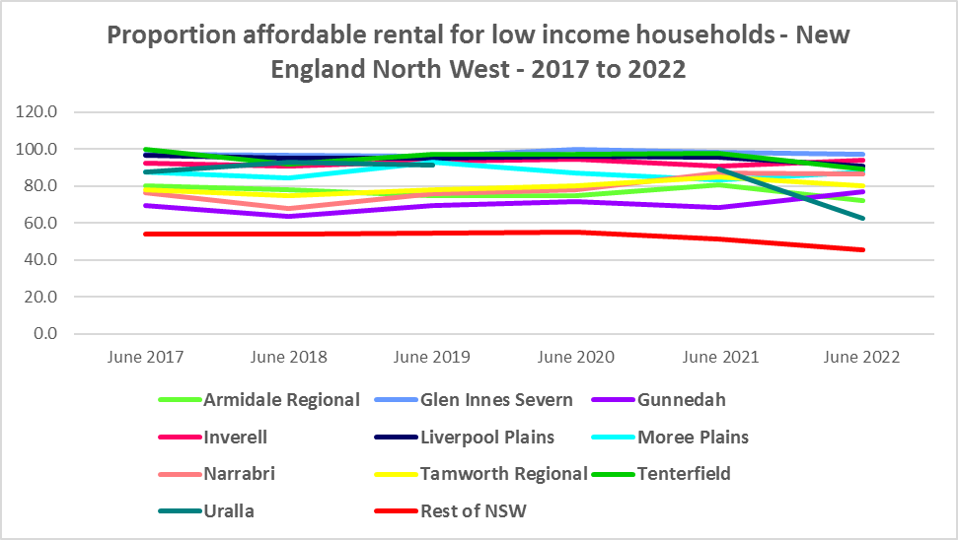

**Rental Stress**

* Households regarded as being in rental stress are renting in the private rental market and paying more than 30% of their income in rent. Lower income households in rental stress will struggle to pay for other essential household costs, such as medical or educational expenses, food, transport and energy costs.
* At June 2021 the proportion of very low income households in rental stress in the Rest of NSW (that is, excluding Sydney) was 91.7%. Within New England North West the average was lower at 87.1%, with the proportion varying from 90.5% in Armidale Regional to 70.1% in Gwydir.
* For the Rest of NSW at 2021 the proportion of low income households in rental was 68.3%, with New England North West on average much lower with 53.4%. Across the region the proportion of low income households in stress ranged from 58.6% in Gunnedah to 30.3% in Gwydir.
* Every LGA in New England North West, with the exception of Uralla, had a higher proportion of very low income households in rental stress in 2021 compared to 2016. All the New England North West LGAs experienced an increase in the proportion of low income renters in stress between 2016 and 2021.
* Over the same period the actual numbers in stress have declined in most LGAs in the region (the exception being an increase in low income renters in stress in Armidale Regional).
* Below is a graph of the proportion of very low and low income households in rental stress in each New England North West LGA at 2021, as well as a table showing the change in the proportion of very low and low income households in stress between 2016 and 2021.



* The next table shows the change in the number of very low and low income households in rental stress from 2016 to 2021.
* Again Covid has had an impact on the rental market and on tenants, with overall the number of both very low and low income households in rental stress declining between 2016 and 2021 in New England North West.
* A look at CRA (Commonwealth Rent Assistance) recipients in housing stress gives some further information on what has been happening with lower income households in rental stress over this time frame.



* In line with other parts of NSW, between 2016 and 2020, the total number of CRA recipients in New England North West increased significantly, while the number in stress actually declined. However, between 2020 and 2021 the number of CRA recipients declined while the number in stress increased.
* The number of CRA recipients in housing stress has increased from the June 2020 figures as the temporary Coronavirus Supplement ended on 31 March 2021.
* The Coronavirus Supplement was $550 per fortnight for new and existing recipients of JobSeeker Payment, Parenting Payment, Youth Allowance for jobseekers, Farm Household Allowance and Special Benefit. The temporary supplement almost doubled the maximum payment rate for a JobSeeker Payment recipient. Hence it made rent more affordable for some CRA recipients in June 2020 and resulted in a lower proportion of CRA recipients in rental stress than usual.
* Since the end of Covid restrictions, the number of people in employment has increased, so fewer people are relying on rent assistance from the Commonwealth.
* The two graphs below clearly demonstrate this experience in the region.

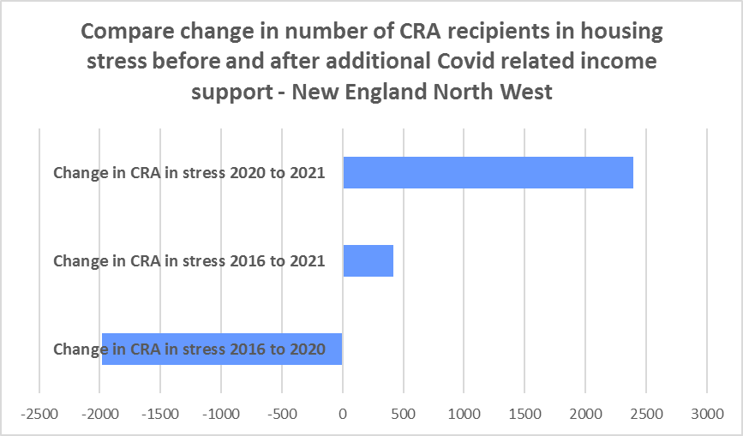

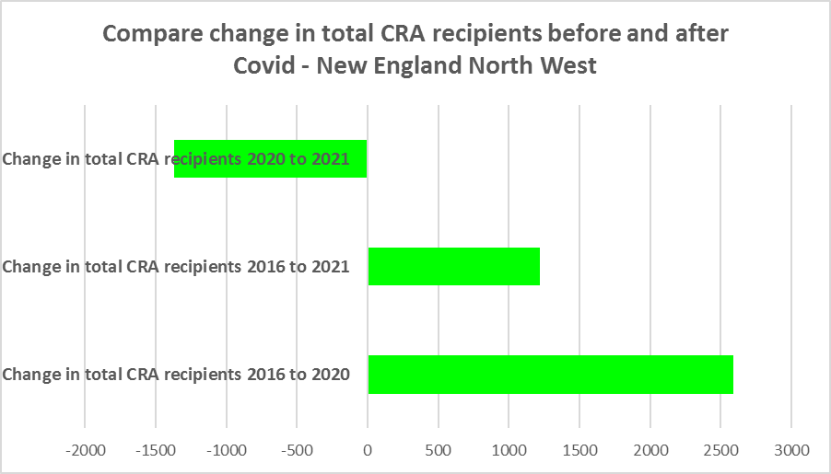

* The table below shows the number and proportion of tenants in New England North West who are in the private rental market, are in receipt of Commonwealth Rent Assistance, and even with this additional income support, are in housing stress.
* There were a total of 5,108 tenants in receipt of CRA and in housing stress across the region in 2021, up from 4,692 in 2016. In 2016, 31.4% of CRA recipients in New England North West were in stress, increasing marginally to 31.6% in 2021.
* As a whole, New England North West has a lower proportion of CRA recipients in housing stress than the Rest of NSW average (39.2%). However, within the region, Armidale Regional (40.6%) has a higher proportion of CRA recipients in housing stress than the Rest of NSW average.



**Loss of Affordable Housing Stock**

* DCJ has calculated the number of new bonds lodged with the Rental Bond Board that were affordable to low income earners in New England North West in 2017, 2021 and 2022. The region experienced a decline in affordable rental bonds lodged, and consequently loss of affordable rental housing between 2017 and 2022 – with 17.8% fewer affordable bonds lodged – and only 1,230 affordable rental bonds lodged over the entire region at 2022.
* The table below shows the number of new bonds lodged that were affordable to low income households (including very low income households) in 2017, 2021 and 2022 in each of the New England North West LGAs as well as the total for the Region.
* Note that Gwydir and Walcha had no affordable rental bonds lodged and the numbers were low in every New England North West LGA.



* These are so few affordable rental bonds lodged across the region, so these losses are significant and indicate the need for provision of affordable rental housing.

# ***Housing Market - Purchase***

**Sales Price**

* The general trend has been for an increase in the median sales price of both houses and flats over the ten years to March 2022.
* Within New England North West, Uralla (118.7%), Narrabri (117.4%) and Inverell (88.9%) had the strongest increases in median sales price between March 2012 and March 2022.
* The table below shows changes in the median sales price of all dwellings (including both houses and flats) over the last ten years in New England North West. Note that the median cannot be calculated where there are insufficient sales in an LGA.

Median Sales Price – all dwellings



* However, between 2019 and 2022 there were clear impacts from Covid, creating more complex changes in the market, as the table below demonstrates.
* Between March 2019 and 2020 median house prices experienced comparatively low growth in most LGAs in the region, with the median dwelling price remaining unchanged in Armidale Regional over that year. Changes in the median sales price ranged between 0% in Armidale Regional and 21.6% in Inverell, with most LGAs (with sufficient sales data to calculate the median) seeing much smaller increases.
* Between March 2021 and March 2022 there was strong growth in median house prices in every New England North West LGA with the exception of Moree Plains (which experienced a decline of -7.2%). Increases in the median sales price for houses ranged between 53.4% in Narrabri and 12.4% in Tenterfield, with the biggest increase in dollar terms being the $174,000 increase in the median in Narrabri.



* The long term median sales price trend shows growth across all LGAs in the region.
* At March 2022, the median sales price for houses is highest in Uralla ($538,000), Narrabri ($500,000), Armidale Regional ($463,000), Tamworth Regional ($449,000) and Gunnedah ($430,000).
* The graph below shows the median sales price trend for all dwellings from 1991 to 2022 in all the New England North West LGAs, with many showing sharp upturns in price from 2021.

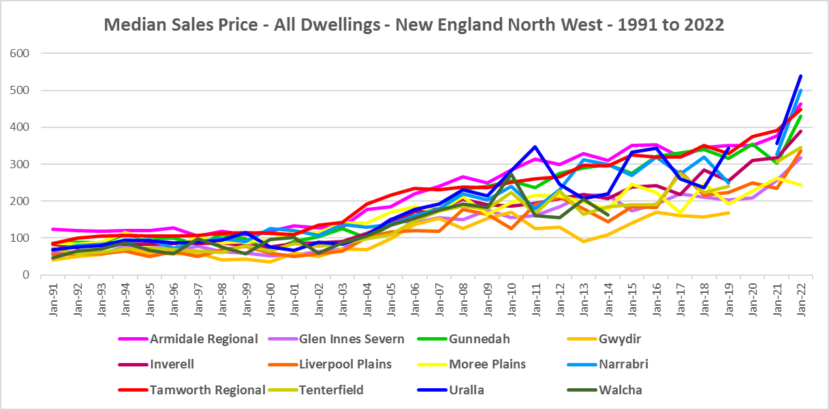

**Purchase Affordability**

* Purchase affordability for very low income earners has varied over the period from 2001 to 2021 and in the Rest of NSW the proportion of sales affordable to purchase by very low income households is actually slightly higher in 2021 than in 2001.
* This is not the case in New England North West. Apart from Moree Plains and Narrabri, purchase affordability for very low income households has declined in every LGA in the region.
* Uralla (2.7%) is the only LGA in the region with a lower proportion affordable for purchase than the average for the Rest of NSW of 7.5%. Armidale Regional was the next lowest with 16.0%, followed by Tamworth Regional with 16.3%.
* At June 2021, within the region, the proportion affordable for purchase by very low income households ranged from 2.7% in Uralla to 53.7% in Glen Innes Severn.
* The graph and table below shows purchase affordability for very low income households in New England North West LGAs and the Rest of NSW between 2001 and 2021, as measured by the proportion of sales affordable to very low income households.

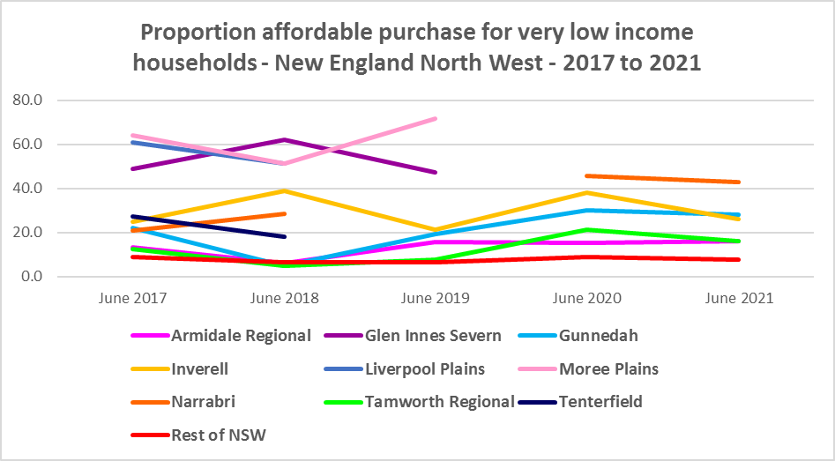

Proportion affordable purchase for very low income households



* In the Rest of NSW, the proportion of affordable purchase for low income households in 2021 (23.8%) is only marginally below that for 2001 (24.2%) with significant variation in the intervening period.
* For low income households in New England North West, only Gunnedah, Liverpool Plain and Narrabri had a higher proportion of sales affordable to low income households in 2021 than in 2001.
* At June 2021, Uralla had the lowest proportion of affordable purchase for low income households with 43.2%, followed by Armidale Regional with 55.4% and Inverell with 66.7%. No LGAs in the region had a lower proportion than the Rest of NSW average.
* The graph and table below show the change in purchase affordability for low income households in New England North West, compared to the Rest of NSW, between 2001 and 2021, as measured by the proportion of sales affordable to low income households.

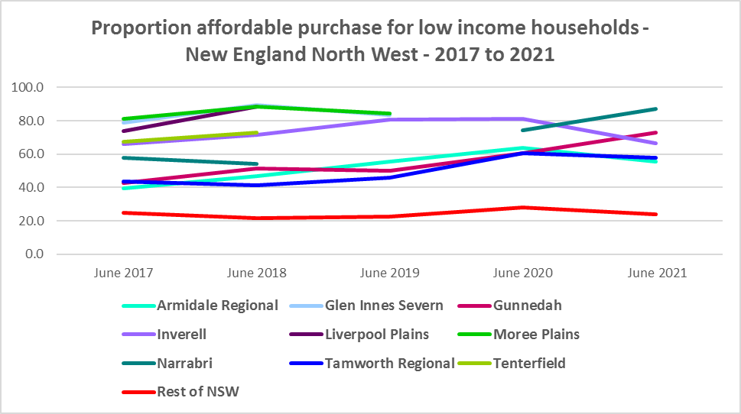

Proportion affordable purchase for low income households



**Purchase Stress**

* In 2021 there were 830 very low income households and 780 low income households purchasing a home and in stress across the region – that is, paying more than 30% of their income on their mortgage. This represents 53.4% of very low income purchasers and 27.3% of low income purchasers in New England North West – well below the average for the Rest of NSW of 60.7% and 34.8% respectively.
* Gunnedah was the only LGA in the region with a higher proportion of very low income purchaser households in stress, with 61.7%. Uralla had the next highest proportion of very low income purchaser households in stress with 59.8%, closely followed by Armidale Regional with 59.6%.
* Narrabri has the highest proportion of low income purchaser households in stress with 32.7%, closely followed by Walcha with 32.5% - no LGA in the region had a higher proportion than the Rest of NSW average.



* However the number of very low and low income purchasers in stress is significantly lower than the number of very low and low income renters in stress in the region, as the graph below demonstrates.

**Additional Data**

Additional data on rents and sale prices, including both current and historical data, is available from the Rent and Sales Report and the interactive Dashboard on the Housing NSW website at:

<https://www.facs.nsw.gov.au/resources/statistics/rent-and-sales/dashboard>

More detailed housing data and tables used in this Snapshot are available from the Local Government Housing Kit Database on the Housing NSW website at:

<https://www.facs.nsw.gov.au/resources/nsw-local-government-housing-kit/chapters/local-government-housing-kit-database>

More information on vacancy rates is available from the Real Estate Institute of NSW website:

<https://www.reinsw.com.au/Web/Web/Members/Property_data/Vacancy_Rates_Survey.aspx>

The Rental Affordability Index is at

<https://sgsep.com.au/projects/rental-affordability-index>