**South and East Tablelands Region – What’s the Housing Demand?**

This Housing Snapshot looks at aspects of housing demand in the South and East Tablelands, particularly from the 2016 Census to the 2021 Census – including population, age profile, household type, household size, income (change in low, moderate and high income households and low income rental households), homelessness and people with disability.

There have been significant challenges to this region since the 2016 Census, including natural disasters and unexpectedly high additional inmigration – in part due to the desire for sea and tree changes and increased ability to work remotely - which have impacted the community and the demand for housing.

**Population Forecast**

* Between 2016 and 2021, the population of the South and East Tablelands grew by 9.3% or 24,770, from 266,546 to 291,316 (using ABS Census population data).
* On an individual LGA basis, population growth ranged from 13.0% in Queanbeyan-Palerang Regional to 4.1% in Hilltops. In terms of numbers, Queanbeyan-Palerang Regional had the largest increase with an additional 7,277 residents, followed by Wingecarribee with 4,831 and Eurobodalla with 3,364.
* Queanbeyan-Palerang has the largest population of the South and East Tablelands LGAs with 63,304, followed by Wingecarribee with 52,709, while Upper Lachlan has the smallest population with 8,514.
* The Department of Planning and Environment have prepared demographic information on every LGA in the region. Their projections indicate that all the LGAs in the region are anticipated to increase in population to 2041. The Department of Planning and Environment forecast a stronger growth rate in Queanbeyan-Palerang, Wingecarribee and Goulburn-Mulwaree than the NSW average of 0.95% per annum and project the strongest proportional population growth in Wingecarribee, with an annual growth rate of 1.54%.
* The table below shows the population change for each South and East Tablelands LGA and the region as a whole, from 2011 to 2016 then to 2021, using ABS Census data.



**Age**

* The age profile of the region and particularly each LGA will impact on housing need and demand, including number of bedrooms, affordability, location and dwelling type.
* The median age of the population of the South and East Tablelands LGAs at the 2021 Census ranges between 38 years (Queanbeyan-Palerang) and 54 (Eurobodalla). This compares to the median age for the Rest of NSW (excluding Sydney) of 43 years. The big range in median age indicates that there are very different age profiles within the region.
  + Bega Valley, Eurobodalla and Upper Lachlan have higher proportions of residents aged over 55 and lower proportions of younger residents.
  + Wingecarribee is similar, in that there are higher proportions of residents aged over 65, but dissimilar in that there are a higher proportion of 15-19 year olds.
  + Hilltops has higher proportions of residents aged under 20 and over 75.
  + Goulburn-Mulwaree and Queanbeyan-Palerang have higher proportions of residents aged under 55.
  + Snowy-Monaro has higher proportions of residents aged between 20 and 64.
  + Upper Lachlan has higher proportions of those aged under 14 and over 45.
  + Yass Valley has higher proportions of residents aged under 19 and between 35 and 54.
* All the South and East Tablelands LGAs age profiles differ from the average for the Rest of NSW, which is evident in the table below.

Proportion of population in each age cohort at the 2021 Census for South and East Tablelands



* The graph below show the proportion of the population in each key age cohort in the South and East Tablelands.

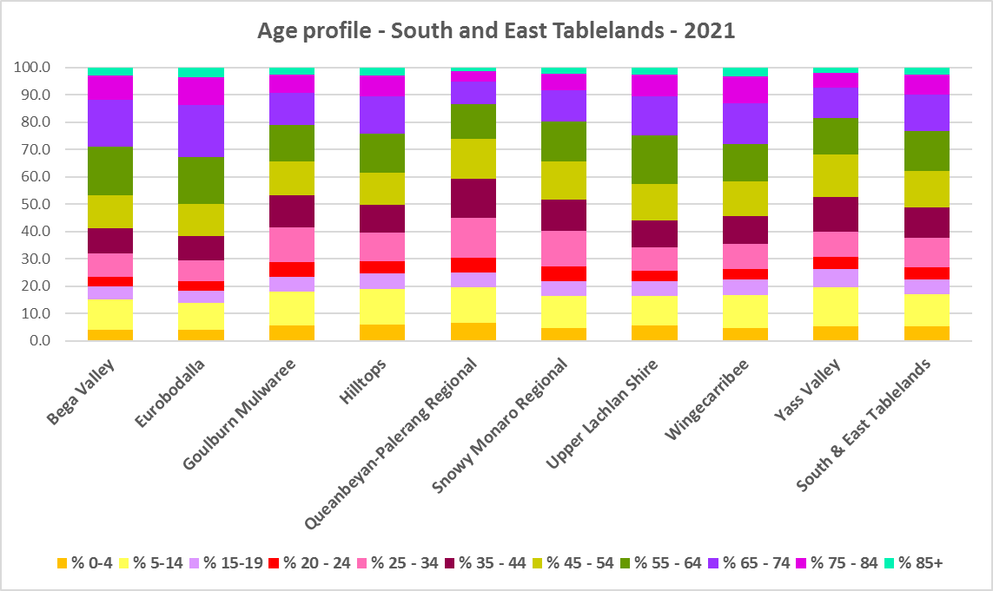

* The Department of Planning and Environment forecast increases in residents aged over 65 to 2041 in every South and East Tablelands LGA, as well as an increase in younger age groups in Goulburn-Mulwaree, Queanbeyan-Palerang and Upper Lachlan.
* The diversity of age groups requires a range of different housing to meet the needs of the community throughout the housing life cycle. However, the higher median age and higher proportions of older age cohorts indicates that there is a need for housing to suit older residents most particularly in Bega Valley, Eurobodalla and Wingecarribee. Although increasingly this will be an issue for all the South and Eastern Tablelands LGAs.
* As the Australian Institute for Health and Welfare (AIHW) note:

Many older Australians prefer to age in place, meaning they wish to stay in their local home or community. However, their capacity to do so can be influenced by:

* + the appropriateness and quality of their home (for example, size, layout)
  + their ability to modify their home to suit their functional requirements
  + the cost and availability of suitable housing
  + their need for formal care and assistance
  + their proximity to services and social support.
* Although the majority of older Australians own their own home, this number is declining. About 15% of older Australians are renters. These people are generally a highly vulnerable and economically disadvantaged group, particularly single person households, with older women being the fastest growing demographic of people experiencing homelessness. There is therefore a need for more adaptable, accessible dwellings, well located, secure, low maintenance and affordable to meet the needs of seniors and frail aged in particular, within their communities. Those most in need are households in the private rental market, who struggle to afford housing on an Aged Pension or inadequate superannuation. (Source: "Housing Decisions of Older Australians" Productivity Commission December 2015).

**Household Type**

* A look at household types gives some insight into the type of housing – particularly number of bedrooms – that is likely to be appropriate to meet the housing needs of the community.
* Household types in the South and East Tablelands vary between the LGAs within the region and generally differ from the average for NSW.
* At the 2021 Census in the Rest of NSW, couple families without children (27.7%) and lone person households (26.1%) are the largest two household types. This is true for the South and East Tablelands as a region but individual LGAs vary.
* In the South and East Tablelands, Queanbeyan-Palerang, Wingecarribee and Yass Valley have couple families with children and couple families without children as the largest two household types. The remainder of the LGAs in the region are in line with the Rest of NSW.
* At the 2021 Census in South and East Tablelands:
  + The proportion of couple families without children ranged from 33.6% in Eurobodalla to 24.1% in Queanbeyan-Palerang
  + The proportion of couple families with children ranged from 35.2% in Yass Valley to 16.9% in Eurobodalla
  + The proportion of lone person households ranged from 28.3% in Eurobodalla (with Hilltops on 28.2%) and 18.7% in Yass Valley
  + Goulburn-Mulwaree has the highest proportion of one parent families with 11.5%
  + Snowy Monaro has the highest proportion of other household types with 18.5% and the highest proportion of group households with 2.8%.
* There has been a small shift since the 2016 Census, with an increase in couple family without children households in the Rest of NSW (0.7%), a decline in couple families with children households (-0.6%) and a slight increase in lone person households (0.5%).
* Some of the LGAs in South and East Tablelands have experienced more pronounced change in household types between 2016 and 2021:
  + Couple family without children households increased by 1.8% in Snowy Monaro, 1.6% in Upper Lachlan and 1.5% in Queanbeyan-Palerang, while Yass Valley saw a slight decline of -0.1%.
  + Couple family with children households increased by 0.6% in Queanbeyan-Palerang and Snowy Regional and 0.3% in Yass Valley and declined by -1.0% in Goulburn-Mulwaree.
  + Lone person households increased by 0.9% in Goulburn Mulwaree and declined by -1.7% in Upper Lachlan.
* The graph and table below show the proportion in each key household type for every South and East Tablelands LGA, as well as the Rest of NSW at the 2021 Census.

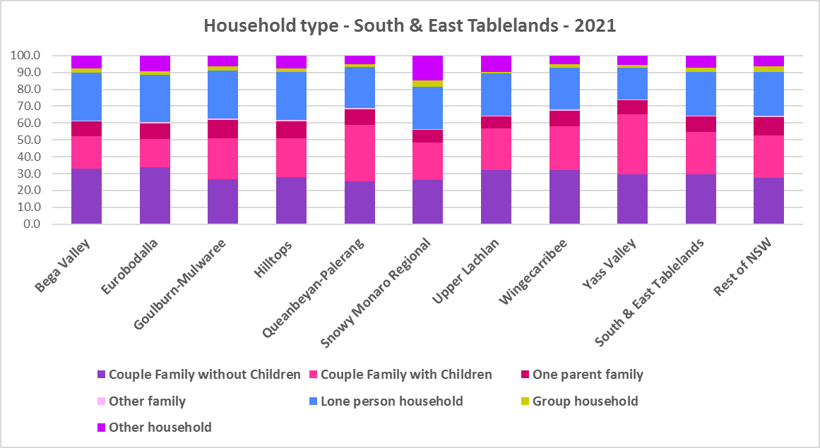



* Given the number of lone person and couple only households, it is important to ensure that housing choice in the community reflects this through availability of studio, one and two bedroom homes.

**Household Size**

* At the 2021 Census, the average household size for the Rest of NSW was 2.4 persons per household – unchanged from 2016 and 2011.
* Yass Valley (2.7 persons per household) and Queanbeyan-Palerang (2.6 persons per household) have a larger average household size than the Rest of NSW, while Bega Valley and Eurobodalla (both 2.2 persons per household) have a smaller average household size than the Rest of NSW.
* Since 2016, average household size has been stable in every South and East Tablelands LGA excepting Snowy Monaro, which increased from 2.3 to 2.4 persons per household.
* The table below gives the average household size in each of the South and East Tablelands LGAs as well as the Rest of NSW for 2011, 2016 and 2021



**Income**

* At the 2021 Census, low income households comprise the largest proportion of all households in the Rest of NSW and every South and East Tablelands region LGA, with the exception of Queanbeyan-Palerang.
* Hilltops (61.8%), Bega Valley (61.1%), Upper Lachlan (51.6%) and Goulburn-Mulwaree (51.2%) all have a higher proportion of low income households than the average for the Rest of NSW (49.3%). Across the region the proportion of low income households ranges from 19.4% in Queanbeyan-Palerang to 61.8% in Hilltops.
* Moderate income households in the Rest of NSW comprise 21.5% of all households, while in the South and East Tablelands they range from 15.2% in Queanbeyan Palerang to 22.7% in Eurobodalla.
* High income households comprise 29.2% of all households in the Rest of NSW and in the South and East Tablelands LGAs range between 18.4% in Hilltops and 65.4% in Queanbeyan-Palerang. Apart from Queanbeyan-Palerang, Wingecarribee (46.9%) and Snowy Regional and Yass Valley (46.2%) have higher proportions of high income households than the Rest of NSW average.
* The graph below shows the proportion of low, moderate and high income households in all the South and East Tablelands LGAs, compared with the Region and Rest of NSW at the 2021 Census.

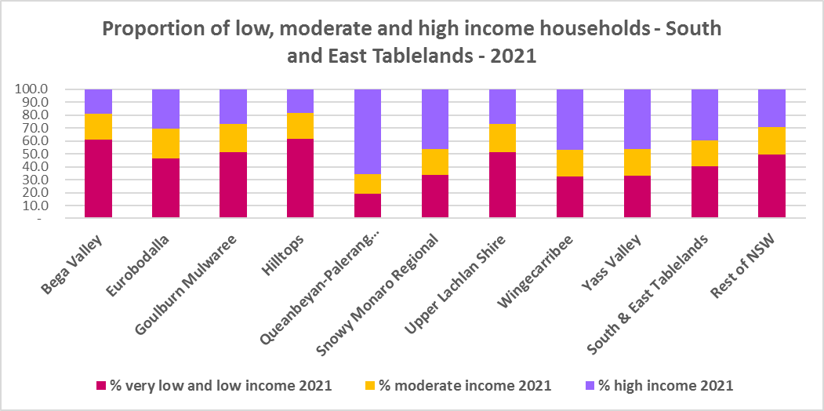

* Between 2016 and 2021 while the number of low income households increased in the South and East Tablelands as a whole, the number of low income households declined in Eurobodalla, Queanbeyan-Palerang, Snowy Monaro Regional and Wingecarribee. The number of low income households increased in all the other LGAs in the region.
* Over the same period, the number of moderate income households increased in every South and East Tablelands LGA.
* While the number of high income households increased overall in the region, the number of high income households declined in Bega Valley, Goulburn-Mulwaree, Hilltops, Upper Lachlan and Yass Valley (and increased elsewhere).
* The graph below shows the change in the proportion of low (including very low) income households from 2016 to 2021 in the South and East Tablelands region.

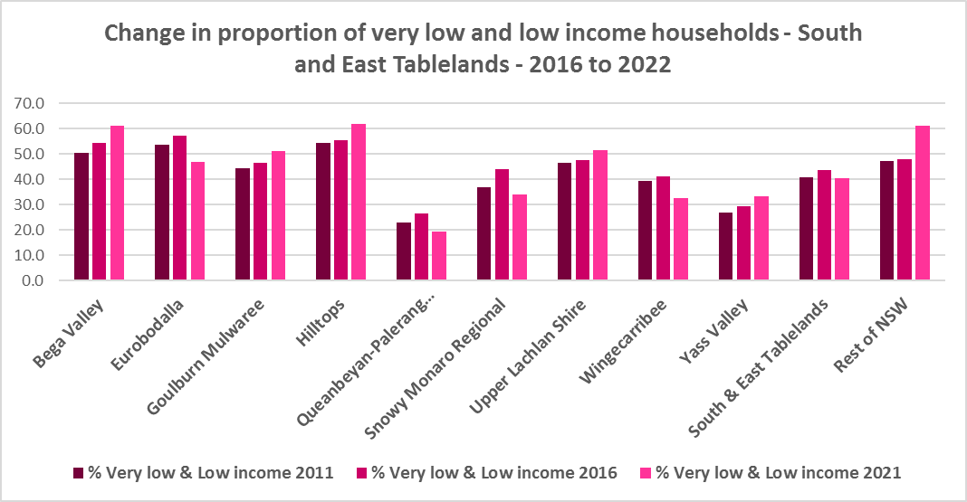

* The graph below shows the numerical change in the number of low, moderate and high income households for the South and East Tablelands region as a whole, between 2016 and 2021.

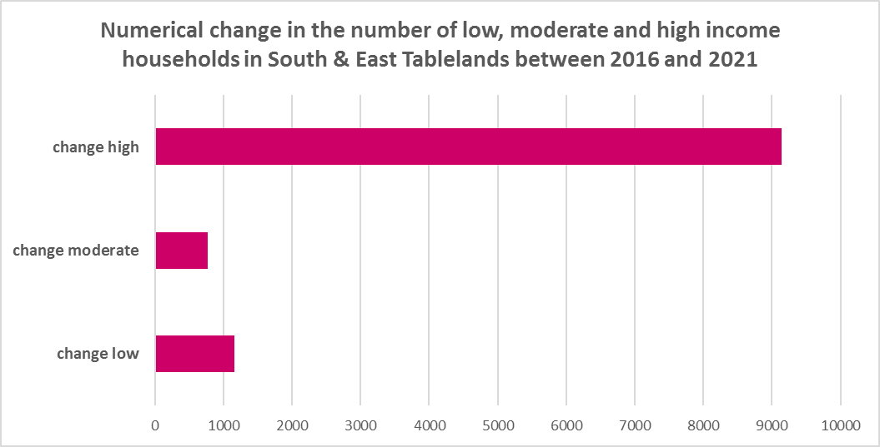

* However, despite the increase in the number of low income households between 2016 and 2021, all the South and East Tablelands LGAs experienced a strong decline in very low income **rental** households over the same period, varying between a -51.5% decline in Yass Valley and a -16.4% decline in Wingecarribee.
* Most also had declines in low income **rental** households over the same period, with Yass Valley again having the largest proportional decline of -27.7%, while Goulburn-Mulwaree (5.0%) and Bega Valley (1.8%) were the only LGAs to experience an increase.
* The reduction in both very low (-1,379) and low income renters (-382) across the South and East Tablelands region is likely due to the additional Commonwealth financial assistance to renters during the pandemic and may therefore be temporary as this has subsequently been discontinued, as explained in the What’s Happening in the Housing Market” snapshot for the South and East Tablelands. It is also likely that lower income rental households have been priced out of the region and/or impacted by the loss of long term rental to short term rental or home purchase/ownership. The snapshot of What’s Happening in the Housing Market shows the significant decline in the proportion of private rental that is affordable to very low income households.
* These changes underline the need to consider tenure as well as price point when considering responses to meet housing need.
* The graph below shows the change in the number of very low and low income **renters** between 2016 and 2021 in the South and East Tablelands LGAs.

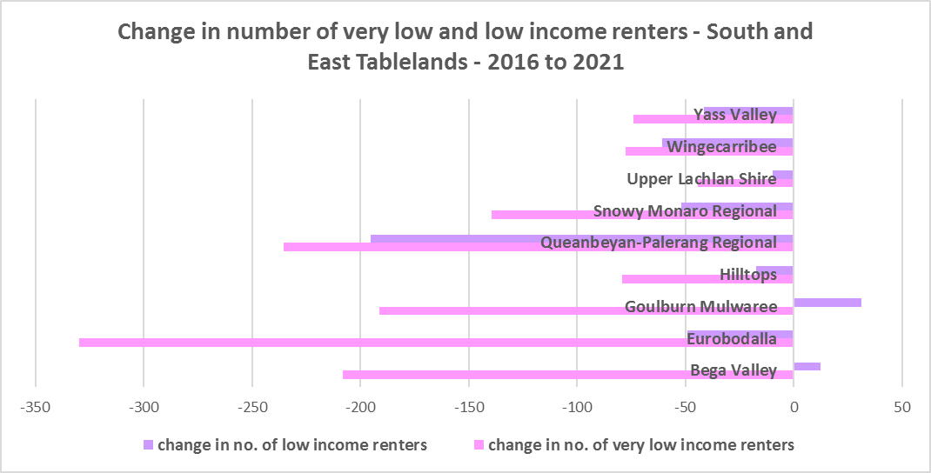

* Queanbeyan-Palerang ($2,295) and Yass Valley ($2,289) are the only LGAs in the South and East Tablelands with a higher median income at 2021 than the Rest of NSW ($1,434).
* The table below shows the change in median income in each South and East Tablelands LGA along with the Rest of NSW from the 2011, 2016 and 2021 Census.



**Homelessness**

* People experiencing homelessness and those at risk of homelessness are among Australia’s most socially and economically disadvantaged. State, Commonwealth and some local governments fund services to support people who are homeless, or at risk of homelessness. Services are delivered mainly by non–government organisations, some of which specialise in delivering services to specific groups (such as young people or people experiencing domestic violence).
* Inadequate income and inability to access affordable housing are significant contributing factors to homelessness, along with individual factors such as experience of family and domestic violence, ill health and disability.
* The ABS identifies someone as homeless “where they do not have suitable accommodation alternatives and their current living arrangement:
  + Is in a dwelling that is inadequate;
  + Has no tenure or their initial tenure is short and not extendable; or
  + Does not allow them to have control of and access to space for social relations.”
* The ABS uses “six operational groups for presenting estimates of people experiencing homelessness on Census night:
  + People living in improvised dwellings, tents or sleeping out
  + People living in supported accommodation for the homeless
  + People staying temporarily with other households
  + People living in boarding houses
  + People in other temporary lodgings
  + People living in ‘severely’ overcrowded dwellings.”
* The ABS “also compiles estimates from Census data for the following three groups of people who may be marginally housed but are not classified as homeless:
  + People living in other crowded dwellings
  + People in other improvised dwellings
  + People marginally housed in caravan parks.”
* The table below shows that ABS 2021 Census data for the South and East Tablelands on the homeless and marginally housed.
* Note that due to additional assistance provided during the pandemic, the number of people counted as homeless on Census night in 2021 is lower than at the 2016 Census. Nevertheless, there were 834 people counted as homeless in the Riverina Murray at the 2021 Census and a further 661 who were counted as marginally housed.
* Of those who were counted as homeless in the South and East Tablelands, the largest number were people living in severely overcrowded dwellings (258 or 30.9%), followed by people staying temporarily with other households (252 or 30.2%), then people in supported accommodation for the homeless (173 or 20.7%). Of those who were counted as marginally housed, the overwhelming majority were people living in other crowded dwellings (480 or 72.6%). The region also has a significant number of people who are marginally housed in caravan parks – most particularly Eurobodalla (with 77 of the 143 people marginally housed in caravan parks in the region).
* This clearly indicates the need for more affordable rental housing.



* The 2023 NSW street count, the NSW Government’s fourth annual rough sleeping street count, was completed between 2 February and 27 February 2023.
* Over 300 local organisations either consulted in the planning phase or participated in the delivery of street counts. Organisation which partnered with the Department of Communities and Justice (DCJ) included Community Housing Providers, local councils and Specialist Homelessness Services, as well Aboriginal organisations, Local Health Districts, local community groups, and Police.
* 1,623 people were counted sleeping rough during these street counts, a 34% increase from 2022.
* Street counts took place in more than 350 towns in 76 LGAs, compared to 71 LGAs in 2021 and 65 LGAs in 2020.
* The table below gives the street count results for the South and East Tablelands region locations.



## People with Disability

* According to the Australian Institute of Health and Welfare (AIHW) and data from the 2018 Australian Bureau of Statistics (ABS) Survey of Disability, 18% of people in Australia have disability. Another 22% have a long term health condition but not disability.
* Nearly one third (32%) of people with disability have severe or profound disability. This means needing help with daily self-care, mobility or communication activities, having difficulty understanding or being understood by family or friends, or communicating more easily using sign language or other non-spoken forms of communication.
* The survey data shows:
  + 7.6% of children aged 0–14 have disability
  + 9.3% of people aged 15–24 have disability
  + 13% of people aged 15–64 have disability
  + 50% of people aged 65 and over have disability (ABS 2019b).
* For about 3 in 4 (77%) people with disability, the main type of disability is physical, while for the remaining 1 in 4 (23%), the main type of disability is mental or behavioural.
* Clearly housing is a significant factor in the health and wellbeing of people with disability. The availability of affordable, sustainable and appropriate housing helps people with disability to participate in the social, economic and community aspects of everyday life. Someone without access to affordable, secure and appropriate housing is more likely to experience homelessness, poor health, and lower rates of employment and education.
* While most people with disability live at home in the community (96% in private dwellings), some live in cared accommodation.
* Cared accommodation is usually long term and may be institutional in style, including hospitals, residential aged care, cared components of retirement villages, aged care hostels, psychiatric institutions and group homes for people with disability. The more severe a person’s disability is, the more likely they are to live in cared accommodation and the less likely they are to live in the community.
* There has been a significant shift towards supporting people with disability to live in private dwellings, rather than being in institutional care over recent decades. Largely this has been driven by changes for young people with disability.

## Additional Data

More detailed housing data and tables used in this Snapshot are available from the Local Government Housing Kit Database on the FACS website at:

<https://www.facs.nsw.gov.au/resources/nsw-local-government-housing-kit/chapters/local-government-housing-kit-database>

More information on the housing needs of older Australians and people with disability:

The Australian Institute of Health and Welfare – Older Australians Housing and Living Arrangements on the AIHW website at:

<https://www.aihw.gov.au/reports/older-people/older-australians/contents/housing-and-living-arrangements>

The Australian Institute of Health and Welfare – People with Disability in Australia

<https://www.aihw.gov.au/reports/disability/people-with-disability-in-australia/contents/people-with-disability/prevalence-of-disability>

and relating to housing needs

<https://www.aihw.gov.au/reports/disability/people-with-disability-in-australia/contents/housing>

The Productivity Commission’s report Housing Decisions of Older Australians is at:

<https://www.pc.gov.au/research/completed/housing-decisions-older-australians>

More detailed information on population, household and dwelling projections is available on the Department of Planning and Environment website at:

<https://www.planning.nsw.gov.au/Research-and-Demography/Population-Projections/Projections>

<https://pp.planningportal.nsw.gov.au/populations>

More data on homelessness, specifically homelessness service data is available on the Homelessness NSW website at:

<https://homelessnessnsw.org.au/resource/specialist-homelessness-service-data/>

And from the AIHW website here:

<https://www.aihw.gov.au/reports/australias-welfare/homelessness-and-homelessness-services>

The 2023 Street Count result is at the DCJ/ FACS website here:

<https://www.facs.nsw.gov.au/reforms/homelessness/premiers-priority-to-reduce-street-homelessness/street-count>

Further information on ABS estimation of homelessness is available at the ABS website:

<https://www.abs.gov.au/statistics/people/housing/estimating-homelessness-census/2021>