

Draft NSW Homelessness Strategy Check-in

November 2024 to February 2025

### We are finalising a new Homelessness Strategy for NSW

The NSW Government has been working with stakeholders to develop a new ten-year NSW Homelessness Strategy 2025-35.

The Strategy’s vision is to make NSW a place where homelessness is rare, brief and not repeated because people have a safe home and the support to keep it.

Flexible whole-of-government action plans will sit under the Strategy and set out the actions to meet this vision.

### Next steps

We want to take this opportunity to check in with you to understand how we can implement the Strategy’s principles and outcomes, and what we should focus on in the first action plan.

Through late 2024 and early 2025 we will also use existing forums to talk directly with stakeholders and our lived experience advisory groups as we develop the stand alone Action Plans for Aboriginal people and children and young people.

We’d love to hear from you. Please refer to our questions below and send your response to [**homelessness.strategy@homes.nsw.gov.au**](mailto:homelessness.strategy@homes.nsw.gov.au) **by 14 February 2025.**

We will consider all feedback.

The final NSW Homelessness Strategy and Action Plans will be released in 2025.

### How we got here

In late 2023, the NSW Government engaged ARTD and the Cultural and Indigenous Research Centre Australia to find out how people wanted to be involved in developing the new Strategy.

They found people wanted a process that:

* listens to what people have already told us and avoids duplication.
* builds on what we already all know
* is clear about what advice is needed and how it will be used
* is an ongoing partnership rather than a one-off consultation
* provides flexible, trauma-informed ways for different voices to be heard, including those of people with lived experience, and Aboriginal communities.
* uses existing forums, rather than making additional demands on people’s time.

The diagram below outlines where this engagement fits into the Strategy development process:

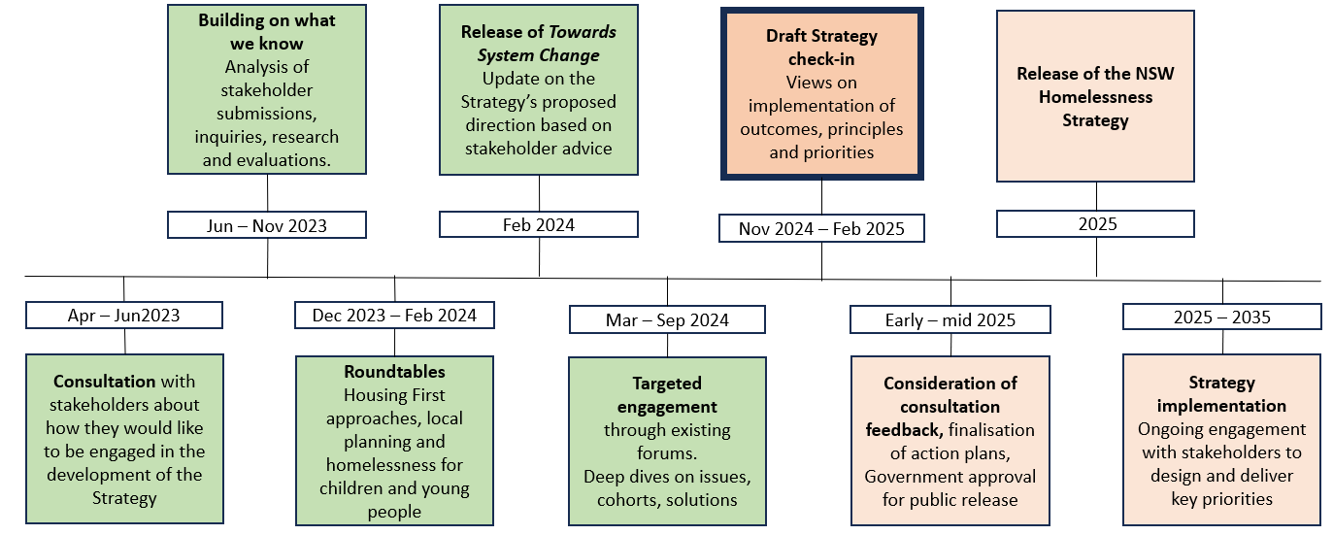

We have drafted the NSW Homelessness Strategy 2025 -2035 by drawing from what we all know and engaging with people over the past six months to explore issues and test ideas.

### Section 1: Guiding principles of the Strategy

The following aspirational principles will guide system improvement, commissioning, service design and delivery, resource allocation and any future homelessness and housing investment over the life of the Strategy.

* Housing is a human right.
* Aboriginal expertise and leadership are respected.
* People with lived experience inform service design.
* Person-centred principles are embedded in policy and practice.
* Prevention is prioritised.
* Housing First principles are embedded in policy and practice.
* Service planning and delivery is flexible, localised and joined-up.
* The workforce is strong and supported.
* Systems, tools and measurement are consistent and fit for purpose.

Each of these principles has been translated into areas for action through the Strategy.

|  |
| --- |
| **Questions:**   1. What do we need to consider as we implement services and system reform guided by these principles over the next 10 years? 2. Which principles should be prioritised and why? |

### Section 2: Strategy focus areas

#### Homelessness is rare

**Outcome 1: Wherever possible, homelessness is prevented from happening in the first place, making it rare.**

|  |
| --- |
| **1.1 People can get and keep a safe and affordable home** |
| *We will:*   * Increase the supply of a range of quality accessible and appropriate housing types in NSW, including social, affordable and key worker housing. * Improve support so people can keep their housing, regardless of the type of housing they have. * Support people to remain in or enter the private rental market through tapered subsidies and other rental products. * Support people leaving government services into appropriate housing. |
| **1.2 People at risk of homelessness are identified early and linked with the right supports** |
| *We will:*   * Build capacity of mainstream government and community services to identify people at risk and connect them to appropriate services. * Build on effective prevention approaches that identify and support people and families at risk of homelessness. |
| **1.3 People know where to get information and support to prevent homelessness** |
| *We will:*   * Improve public awareness about information, services and supports to prevent homelessness, such as tenancy advice, family early intervention services, mental health support and financial counselling. * Work to change the negative attitudes and stigma about homelessness that can prevent people from seeking support. * Use existing mainstream and community hubs to link people to information and supports without needing a label of ‘homeless’. |

|  |
| --- |
| **Questions:**   1. To make homelessnsess rare, what should NSW prioritise for action and why? 2. What opportunities and risks are there for implementing actions under this outcome? 3. What types of target(s) would be most useful to measure our impact and why? |

#### Homelessness is brief

**Outcome 2 - When homelessness does occur, people are quickly connected to housing and the supports they need**

|  |
| --- |
| **2.1 People’s needs are quickly identified and they are referred to the right support** |
| *We will:*   * Support local coordination groups to improve screening, triage and referral. * Revise policies, practice and tools for homelessness screening, assessment and intake. * Revise housing policies and practices so they are responsive to need, flexible, culturally appropriate and support pathways out of homelessness. * Introduce a homelessness registry so services work better together to meet people’s needs. * Improve responses to people sleeping rough in public spaces and during extreme weather. |
| **2.2 People get safe crisis accommodation with appropriate support when they need it** |
| *We will:*   * Shift from commercial hotels and motels to temporary accommodation models delivered by the homelessness and housing sectors. * Deliver high quality crisis accommodation with no barriers to access. * Increase access to person and family-centred supports, particularly for people with complex needs, who are staying in temporary accommodation. * Improve the safety net for young people so that temporary accommodation is safe and responsive to their needs e.g. by providing youth specialist supports and working towards compliance with the National Principles for Child Safe Organisations. |
| **2.3 People are supported out of homelessness into longer-term housing with tailored support** |
| *We will:*   * Support people into good quality, stable, accessible and appropriate social and affordable housing that meets their needs. * Support Aboriginal people and families into culturally appropriate longer-term housing including private rental and homeownership. * Assist children and young people into housing and support models that meet their developmental needs. * Encourage flexible and sustainable use of properties and support services over time as demand for temporary accommodation decreases. |

|  |
| --- |
| **Questions:**   1. To make homelessness brief, what should NSW prioritise for action and why? 2. What opportunities and risks are there for implementing actions under this outcome? 3. What types of target(s) would be most useful for measuring our impact and why? |

#### Homelessness is not repeated

**Outcome 3 - When homelessness does occur, people do not experience multiple episodes of homelessness**

|  |
| --- |
| **3.1 People with complex needs can access comprehensive, longer-term support so they do not experience repeat homelessness** |
| *We will:*   * Deliver case management that links housing and support for people experiencing chronic homelessness and those with complex needs due to trauma, poor health, mental illness and alcohol and other drugs. * Provide tailored models for children and young people with complex needs so they can maintain stable housing and achieve their goals. |
| **3.2 People have strong connections to their community that protect against repeat homelessness** |
| *We will:*   * Support people to build resilience and connections to family and community through community development approaches such as community gardening initiatives, playgroups and children’s activities, local libraries and community centres. * Strengthen relationships with local councils, which play a key role in developing connected and resilient communities, and links with their Homelessness Action Planning processes. |
| **3.3 People have access to housing that meets their changing needs across their lifespan** |
| *We will:*   * Work with Commonwealth Government services to integrate housing, aged care and disability supports so people have greater choice and control. * Work to make mainstream services more culturally safe for Aboriginal people at risk of or experiencing homelessness. * Design and modify social housing to meet people’s ageing, disability, cultural or other needs, such as accessibility, safety or community integration. * Provide well-maintained, quality social homes to ensure people’s safety and well-being. |

|  |
| --- |
| **Questions:**   1. To ensure homelessness is not repeated, what should NSW prioritise for action and why? 2. What opportunities and risks are there in implementing actions under this outcome? 3. What types of target(s) would be most useful to measure our impact and why? |

|  |
| --- |
| **General comments:** |