

NSW Homelessness Strategy 2025-2035

Fact Sheet #1: Respecting the diversity of homeless experiences

November 2024

# Introduction

Homelessness is not a personal failing. Anyone can be at risk of or experience homelessness, but we know that some people are more likely to experience it than others, and some face additional challenges accessing support.

Structural drivers create an environment where homelessness can happen. Structural drivers include low income, housing availability and affordability, economic and employment opportunities and discrimination. Where structural drivers exist, homelessness can be triggered by mental ill health, poor physical health, drug and alcohol use and critical life events, such as domestic and family violence[1] and trauma. Together, these factors influence the extent to which homelessness occurs in the first place, and the nature of the experience[2].

As shown in **Figure 1** on page 2, people who experience discrimination, disadvantage, and barriers to access are overrepresented in homelessness data. These groups are at greater risk of experiencing homelessness and their experiences of homelessness are often more severe.

## **Children and young people**

* **Young people in NSW make up 19 per cent of all people presenting to Specialist Homelessness Services (SHS). Of these individuals, 32 per cent are Aboriginal and 69 per cent were not enrolled in any form of education or training.**
* **Children and young people have diverse experiences of homelessness. They may accompany a parent or be on their own. They may be escaping domestic and family violence or family breakdown, have children themselves or be managing issues arising from mental health, alcohol and other drugs, have a disability or discrimination related to culture, sexuality or gender.**
* **Children and young people who have had contact with out of home care or youth justice can experience higher rates of homelessness.** Seventeen per cent of out-of-home care leavers access homelessness services within a year of leaving care[3].
* **Children and young people have specific needs and strengths at each developmental stage. Those under 16 require guidance and support, while older teens and young people have increased levels of independence depending on their experience and circumstances.**
* **Available supports and assistance are not always appropriate or adequate to meet the needs of young people. A 2021 rental market assessment undertaken by Anglicare found income supports for young people (i.e. Youth Allowance) are insufficient to affordably secure any of the properties surveyed**[4].

Figure 1 | Homelessness and demand for SHS among key cohorts

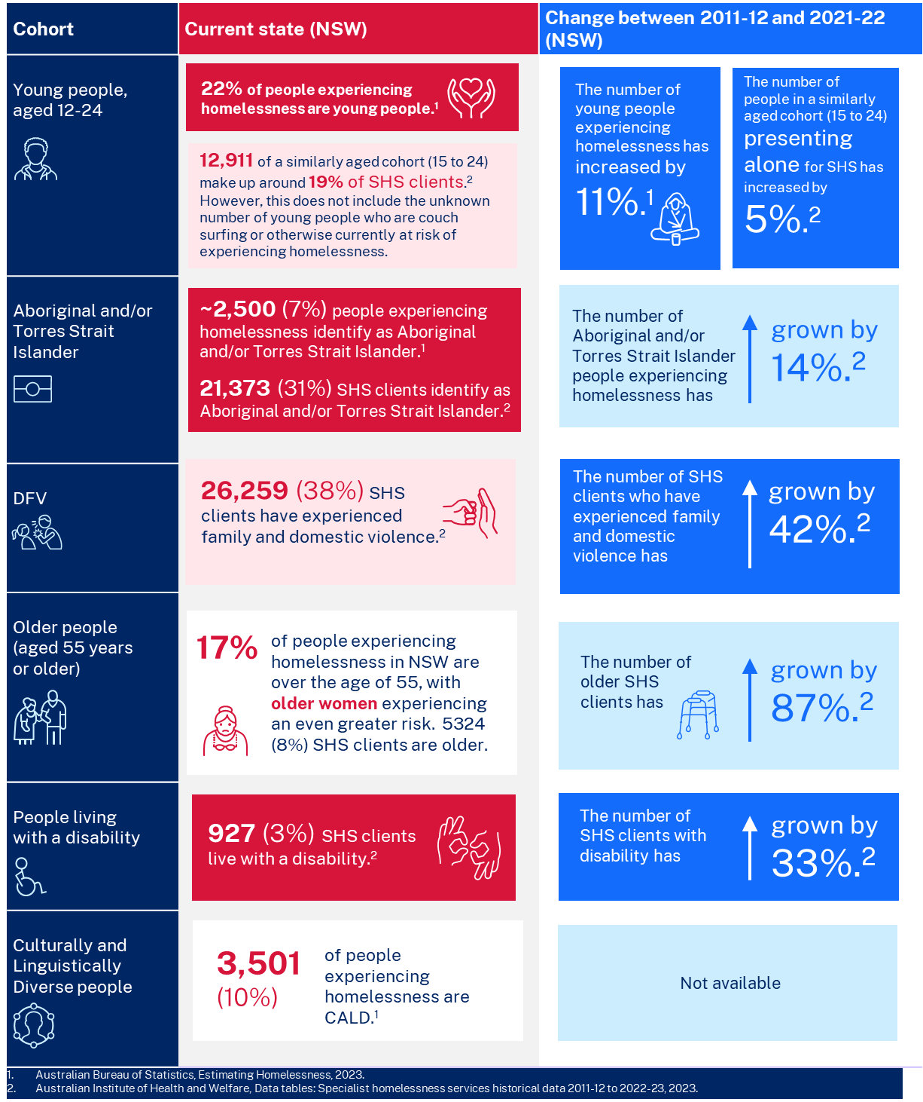

## Domestic and family violence victim-survivors

* **Domestic and family violence (DFV) is a key driver of homelessness experienced by women and children, with one-third of people accessing SHS reporting experiences of DFV**[5]**.**
* **Some people have unique barriers to accessing support. For example, women from culturally and linguistically diverse backgrounds experiencing DFV may face language and communication barriers,** distrust of authorities due to pre-settlement experiences and community belief that family and domestic violence issues should be dealt with within the family unit[6].
* The timing of support is critical. Analysis suggests that DFV victim-survivors are most likely to access homelessness services within three months of a DFV victim incident involving police[7].
* **A trauma-informed, integrated responsive service system is essential for people experiencing DFV to be able to access safe, appropriate supports and housing quickly.**

## Aboriginal and Torres Strait Islander Peoples

* Many Aboriginal families experience intergenerational disadvantage, structural barriers, discrimination and trauma because of past injustices and government policies. This has resulted in Aboriginal people being overrepresented in our service systems, including justice, out of home care and homelessness.
* Aboriginal people make up 31 per cent of all people presenting to SHS in NSW. They are also more likely to experience drivers of homelessness such as DFV (40 times more likely),[8] experiences in out-of-home care (11 times more likely)[9] and experiences in the justice system (14 times the adult imprisonment rate) [10].
* These challenges affect access to safe and affordable housing. Aboriginal people can also be particularly affected by remoteness and overcrowding.
* Aboriginal people generally prefer to access services from Aboriginal Community Controlled Organisations, where they exist, which deliver culturally safe services. Mainstream services should also strive to deliver culturally safe services that meet the needs of Aboriginal families and communities to ensure that choice is available.

## People from culturally and linguistically diverse backgrounds

* Ten per cent of people experiencing homelessness identify as culturally and linguistically diverse (CALD). This likely includes (but does not reflect the scale of) asylum seekers, temporary migrants, and international students who are unable to access income or health supports, increasing their risk of poverty and housing insecurity. These groups are also at greater risk of specific challenges like overcrowding12.
* People from CALD backgrounds can face discrimination and barriers when seeking homelessness assistance. This can include English proficiency and literacy a lack of culturally and linguistically appropriate information; a lack of knowledge in navigating Australian systems and services, particularly for older migrants; poorer overall socioeconomic status; differing cultural practices and norms; and a preference for family members to provide care. People from refugee backgrounds may be living with trauma.
* Non-residents of Australia (including asylum seekers, temporary visa holders, and undocumented people) can be particularly vulnerable to homelessness as they are ineligible for healthcare and most homelessness services and may not be permitted to work. Homelessness is especially hidden in CALD and non-resident communities as women tend to stay in overcrowded or unstable accommodation rather than sleep rough.

## People sleeping on the street and people with complex needs

* The longer a person experiences homelessness, the more complex their problems become and the more likely it is that the experience will become chronic. This in turn increases the level of support that is needed for a person to successfully exit homelessness.
* People with multiple and complex needs, such as those experiencing mental illness, trauma and/or substance use issues, are the most likely to experience long-term and chronic homelessness and require intensive support.
* One in eight people leaving custody (12.4 per cent) access homelessness services within a year in NSW, which is 20 times the rate of the wider population. The rate for Aboriginal people is double that of non-Aboriginal people[11]. Research suggests that ex-prisoners with complex support needs who receive public housing have better criminal justice outcomes than comparable ex-prisoners who receive private rental assistance only, as stable housing allows for other personal challenges to be addressed[12].

## Older people

* Older people are increasingly becoming homeless. This is driven by a lack of affordable housing, high cost of living, elder abuse, and domestic and family violence[13]. Older, lower-income private renters can be particularly at risk of homelessness[14].
* For older women, the drivers of homelessness include relationship separation, the pay and superannuation gap, and domestic and family violence[15].
* The number of people experiencing homelessness aged 55 years and over has steadily increased over the past three Censuses[16]. However, it is difficult to accurately understand the extent of older people experiencing homelessness. Older women in particular are more likely to stay with friends or family or live in their cars, than sleep rough[17].
* Older people need stable, accessible, and appropriate housing which allows them to age-in-place and avoid further transitions. Engagement with health care and aged care services is essential to allow older people to have choice and dignity about their housing and supports.
* The 2022 Legislative Council Inquiry into Homelessness amongst older people aged over 55 in NSW made 40 recommendations to reduce the risk of homelessness for older people.[18] The NSW Government supported nine recommendations in full and 24 in principle relating to homelessness data collection and reporting, adopting Housing First approaches; improving homelessness services responses for older people, increasing social housing, maintenance and retrofitting social housing stock, and advocating with the Commonwealth Government[19].

## People with disability

* Nationally, people living with disability make up 18 per cent of the population yet represent approximately 25 per cent of the clients of specialist homelessness services[20].
* People with disability can have poorer housing outcomes due to fewer employment opportunities and a lifetime of lower earnings, lack of social support, lack of suitable housing options, and the need for specialised assistance and services[21].
* People with disability who are homeless can be at risk of abuse, exploitation and discrimination. They may also face access barriers to housing and other supports, and long wait times for housing due to the limited number of social or private rental homes that meet their needs[22].
* It is essential that people with disability have choice about where to live and with whom, from a range of options including public and community housing, private rental and home ownership. Accessible, well-designed housing supports independence and social and economic participation.

## Alcohol and other drugs

* The use of alcohol and other drugs can be a contributing factor to experiences of homelessness. Experiences of homelessness can also trigger self-medication through alcohol and other drugs.
* Evidence from Australian studies shows a strong correlation between people using alcohol and other drug services and homelessness services. In 2022-23, 8.6 per cent of people presenting at SHS across Australia reported having problematic alcohol or other drug use, and four out of five of those with problematic alcohol or drug use were returning SHS clients[23].
* Problematic use of alcohol and other drugs can reduce people’s access to some support and accommodation options. A Housing First approach would support housing people even if they are still using alcohol or drugs, using harm reduction techniques to support recovery.

## Mental health

* Mental health issues can be a contributing factor to homelessness. Having a safe and secure place to call home is a fundamental foundation for health and wellbeing. In 2021-22 31% of people accessing a specialist homelessness service in Australia reported having a current mental health issue[24].
* People leaving government services, such as mental health facilities can be at increased risk of homelessness. People with mental health issues are between three and 26 times more likely than the wider NSW population to access homelessness services within a year of accessing a range of health services[25]. People experiencing mental health issues are one of the fastest growing groups of clients accessing SHS. In 2022-23, of the 31,600 accessing SHS services across Australia and reporting health conditions 23,700 identified a mental health issue[26].
* People with mental health issues can also face barriers to accessing support, such as the stigma associated with mental health issues, feeling judged or stereotyped[27].
* People who live with mental health conditions need to have timely access to safe, secure, appropriate housing; and mental health supports in place when needed, to sustain housing, live well in the community and lead their recovery.

## Gender

* Gender impacts people’s experiences of homelessness. According to the 2021 Census, men make up 58 per cent of people experiencing homelessness in NSW and women make up 42 per cent[28]. However women made up 59 per cent of all presentations to specialist homelessness services (SHS) in 2022/23[29]. They represented 66 per cent of daily unassisted requests to SHS, and the majority (87 per cent) of unassisted requests made by single adults with children.
* Evidence suggests that women are largely underrepresented in homeless counts as they are less visible in their experiences of homelessness[30]. Women are also at increased risk of homelessness because of domestic and family violence and low income due to gender pay gaps, casualised work and low superannuation.
* Rough sleepers are more likely to be men, aged over 35 years, have mental health or drug and alcohol issues[31].
* There is limited research on homelessness amongst people of diverse sexualities and genders in NSW due to data collection limitations. However, research indicates:
* LGBTQIA+ young people are twice as likely to experience homelessness, and about half will have compromised or sub-standard living conditions[32]. For those who identify as gender diverse, that jumps to 71 per cent.
* Trans men are at the highest risk of homelessness within trans and gender diverse groups[33].
* Twenty to 40 per cent of homeless young people in the UK, USA and Canada identify as LGBTQIA+[34]. This is similar to rates reported in Australia, with increases in trans, gender diverse and nonbinary clients noted by service providers in recent years[35].

1. Davies, A. & Wood, L. (2018). Homeless health care: Meeting the challenges of providing primary care. The Medical journal of Australia
2. Flatau, P., Lester, L., Seivwright, A., Teal, R., Dobrovic, J., Vallesi, S., Hartley, C. and Callis, Z. (2021). Ending homelessness in Australia: An evidence and policy deep dive. Perth: Centre for Social Impact, The University of Western Australia and the University of New South Wales.
3. Family and Community Services Insights, Analysis Research (FACSIAR), Pathways to homelessness for young people leaving out-of-home care in NSW, 2023.
4. Anglicare, Annual Report, 2021.
5. NSW Government submission, Productivity Commission review of the National Housing and Homelessness Agreement, 2022.
6. Australian Institute of Health and Welfare, Family, Domestic and Sexual Violence: People from Culturally and Linguistically Diverse Backgrounds, 2024 <https://www.aihw.gov.au/family-domestic-and-sexual-violence/population-groups/cald>
7. NSW Family and Community Services Insights, Analysis and Research (FACSIAR) Evidence Brief (January 2023) Pathways to homelessness for people with mental health issues in NSW <https://www.facs.nsw.gov.au/__data/assets/pdf_file/0008/842471/Pathways-to-homelessness-for-people-with-mental-health-issues-in-NSW-January-2023-Evidence-Brief.pdf>
8. Australian Institute of Health and Welfare, Family, domestic and sexual violence in Australia: continuing the national story, 2019.
9. Australian Institute of Health and Welfare, Child protection Australian 2021-22, 2023.
10. Australian Institute of Health and Welfare, Contact with the criminal justice system, 2021.
11. NSW Department of Families and Communities, Pathways to Homelessness <https://www.facs.nsw.gov.au/housing/nsw-response-to-homelessness/understanding-homelessness-through-data/pathways-to-homelessness#:~:text=this%20vulnerable%20group.-,Exiting%20custody,that%20for%20non%2DAboriginal%20people>
12. Martin, C., Reeve, R., McCausland, R., Baldry, E., Burton, P., White, R., Thomas, S., ‘Exiting Prison with Complex Support Needs: the Role of Housing Assistance’ AHURI Final Report No. 361 https://www.ahuri.edu.au/sites/default/files/documents/2021-09/AHURI-Final-Report-361-Exiting-prison-with-complex-support-needs-the-role-of-housing-assistance_0.pdf
13. NSW Parliament Inquiry, Homelessness Amongst Older People Aged over 55 in New South Wales
14. NSW Ageing and Disability Commission, in conjunction with the NSW Ageing and Disability Advisory Board, the NSW Ministerial Advisory Council on Ageing, the Disability Council of NSW, and the NSW Carer’s Advisory Council, ‘Housing Issues for People with Disability, Older People and Carers in NSW’, 2023
15. NSW Ageing and Disability Commission, in conjunction with the NSW Ageing and Disability Advisory Board, the NSW Ministerial Advisory Council on Ageing, the Disability Council of NSW, and the NSW Carer’s Advisory Council, ‘Housing Issues for People with Disability, Older People and Carers in NSW’, 2023
16. NSW Government submission, Productivity Commission review of the National Housing and Homelessness Agreement, 2022.
17. NSW Parliament Inquiry, Homelessness Amongst Older People Aged over 55 in New South Wales, 2022
18. NSW Parliament Inquiry, Homelessness Amongst Older People Aged over 55 in New South Wales, 2022
19. NSW Government Response to Recommendations: NSW Parliament Inquiry, Homelessness Amongst Older People Aged over 55 in New South Wales, 2022
20. NSW Government submission, Productivity Commission review of the National Housing and Homelessness Agreement, 2022.
21. NSW Ageing and Disability Commission, in conjunction with the NSW Ageing and Disability Advisory Board, the NSW Ministerial Advisory Council on Ageing, the Disability Council of NSW, and the NSW Carer’s Advisory Council, ‘Housing Issues for People with Disability, Older People and Carers in NSW’, 2023
22. NSW Ageing and Disability Commission, in conjunction with the NSW Ageing and Disability Advisory Board, the NSW Ministerial Advisory Council on Ageing, the Disability Council of NSW, and the NSW Carer’s Advisory Council, ‘Housing Issues for People with Disability, Older People and Carers in NSW’, 2023
23. Australian Institute of Health and Welfare, Alcohol, Tabacco and Other Drugs in Australia: People Experiencing Homelessness (accessed 26 July 2024) <https://www.aihw.gov.au/reports/alcohol/alcohol-tobacco-other-drugs-australia/contents/priority-populations/people-experiencing-homelessness>
24. Australian Institute of Health and Welfare, Specialist Homelessness Services (accessed 19 July 2024) https://www.aihw.gov.au/mental-health/snapshots/specialist-homelessness-services
25. NSW Family and Community Services Insights, Analysis and Research (FACSIAR) Evidence Brief (January 2023) Pathways to homelessness for people experiencing domestic and family violence in NSW
26. Australian Institute of Health and Welfare, Health of People Experiencing Homelessness, 2024 https://www.aihw.gov.au/reports/australias-health/health-of-people-experiencing-homelessness
27. Australian Institute of Health and Welfare, Health of People Experiencing Homelessness, 2024 https://www.aihw.gov.au/reports/australias-health/health-of-people-experiencing-homelessness
28. ABS Census of Population and Housing 2021
29. Australian Institute of Health and Welfare, Specialist Homelessness Services report for 2022-2023
30. Gaetz, S., B. O’Grandy, S. Kidd, and K. Schwan. 2016. Without a Home: The National Youth Homelessness Survey. Toronto: Canadian Observatory on Homelessness Press.
31. Australian Institute of Health and Welfare, Sleeping Rough: A Profile of Specialist Homelessness Services Clients, 2018 <https://www.aihw.gov.au/reports/homelessness-services/sleeping-rough-profile-shs-clients/summary>
32. National LGBTI Health Alliance
33. Fraser, Brodie, Nevil Pierse, Elinor Chisholm, and Hera Cook.2019.“LGBTIQ+ Homelessness: A Review of the Literature.” International Journal of Environmental Research and Public Health16(15): 2677.http://doi.org/10.3390/ijerph16152677.
34. Abramovich, A., and J. Shelton, eds. 2017. Where Am I Going to Go? Intersectional Approaches to Ending LGBTQ2S Youth Homelessness in Canada & the U.S. Toronto: Canadian Observatory on Homelessness Press.
35. McNair, R., C. Andrews, S. Parkinson, and D. Dempsey. 2017. LGBTQ Homelessness: Risks, Resilience, and Access to Services in Victoria – Final Report. Melbourne