# South District – What’s happening in the Housing Market

This Housing Snapshot looks at rents, vacancy rate, affordable rental, rental stress, loss of affordable rental stock, impact on key workers, sales price, purchase affordability and purchase stress in South District – particularly changes between 2016 and 2021.

## There have been changes across the District since the 2021 Census, with Covid having an impact on the housing market. Recent additional cost of living pressures, including rising inflation and interest rates with continued low wage growth, have created further difficulties for lower income earners and their capacity to manage housing costs.

## Wage growth has lagged well behind house price growth for decades. In 1984 the average Australian could buy a home that costs 3.3 times their annual income. By 2022 the average Australian needed 10 times their income to buy a home. Further, the real value of wages declined by 4.5% in 2022, the largest documented deterioration. With annual inflation running at 6.0 per cent, wages need to be growing by 6.0 per cent to maintain their purchasing power.

Consequently households are increasingly struggling with housing costs – saving a deposit, taking on a mortgage, competing for rental properties, paying rising rents – as well as a wide range of other goods, such as food, power, medication, education, transport. There are many anecdotal reports of tenants having to choose between paying the rent and paying for medication, their education or food as well as rising homelessness.

While these macro issues are beyond the influence of local government, councils can identify local housing need and work with other levels of government and the non-government sector to address it.

## *Housing Market – Rental*

## Rents

* There has been strong growth in median rents for all dwellings (including all housing types and all bedroom categories) in the South District for a long time, as the graph below shows. It tracks the change in median rent (for all dwellings) for all the South District LGAs from June 1990 to June 2022 (from 2017 for Canterbury-Bankstown and Georges River).
* Note from the graph that clearly there was a recent significant dip in median rents in 2019 and 2020, before an emphatic recovery.

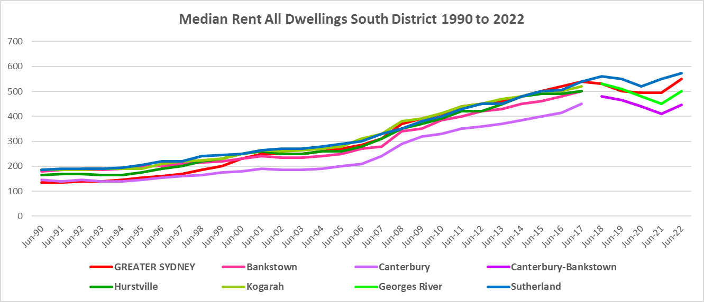

* The table below gives the change in median rent for all dwellings from September 2017 (post council amalgamations) to June 2023. It shows strong increases in median rents over that period, with the highest increase occurring in Georges River.
* At June 2023, median rents for all dwellings were highest in Sutherland at $660 per week.



* However, changes in median rents over that time frame were more nuanced. Between 2019 and 2020 when Covid lockdowns were introduced, median rents in the South District local government areas generally dropped, as the table below demonstrates.
* During that period, the largest percentage drop in median rents occurred in Georges River for three bedroom homes (-6.7%), followed by two bedroom homes in Georges River (-6.3%).
* Canterbury-Bankstown saw declines of -5.4% for one bed and -5.5% for three bedroom homes.
* Median rents in Sutherland experienced the least change over this time frame, with no change to rents for two and three bedroom properties, a tiny change (-0.2%) for four bedroom and just -2.5% for one bedroom homes.



* However, between 2020 and 2022 when Covid restrictions were relaxed, there were strong increases in median rents across the District, as the table below shows
* Georges River had the strongest increase in median rents with a 26.7% rise for four bedroom homes, followed by a 23.5% increase in Sutherland also for four bedroom homes.
* While Canterbury experienced strong rises for three bed (13.5%) and four bed (13.2%) properties, it saw declines (-5.7%) for one bed and (-1.3%) two bed homes. The only LGA in the District to see any decline in median rents over this period.
* At June 2022, median rent for:
  + studio/bedsits ranged from $280 per week in Canterbury-Bankstown to $450 per week in Sutherland.
  + one bedroom homes ranged between $330 per week in Canterbury-Bankstown and $415 in Sutherland;
  + two bedroom homes ranged between $395 in Canterbury-Bankstown and $540 in Sutherland;
  + three bedroom homes ranged between $590 in Canterbury-Bankstown and $780 in Sutherland;
  + four or more bedroom properties ranged between $770 in Canterbury-Bankstown and $1,050 in Sutherland.
* Note that Georges River and Sutherland had insufficient new bonds lodged for studio/bedsits to determine the median rent at June 2020 and therefore any change in rents between 2020 and 2022.



## Vacancy Rate

* A vacancy rate of 3% is understood to represent a balance between supply and demand. Vacancy rates below 3% represent a tight rental market while longer term vacancy rates below 2% represent a chronic undersupply of rental housing.
* According to REINSW data, vacancy rates were below 3% for the inner, middle and outer rings of Sydney for almost all of the period from 2006 through to 2018.
* At April 2023 the vacancy rate in Sydney was 1.3%, in the middle ring was 1.2% and for the outer ring was 1.3%, indicating a tight rental market across Sydney and most particularly in the middle ring.
* Vacancy rates are tight across almost all of NSW, indicating a significant undersupply of rental accommodation. At April 2023, the vacancy rate on the Central Coast was 1.7%, in Wollongong was 1.3%, for the Illawarra was 1.7%, in Newcastle was 1.5%, in the rest of the Hunter was 2.0% and in the Central West was 1.6%. All at or below 2%, signifying chronic undersupply of private rental accommodation.
* Anecdotal information on the current vacancy rate underlines the difficulty tenants are facing finding and retaining rental accommodation - the fierce competition for rental housing, rent bidding and the rapid increase in rents– with tenants facing eviction, homelessness, overcrowding and paying too much of their income in rent.
* The graph below shows the vacancy rate for the inner, middle and outer rings of Sydney for the period from 2006 to 2023, using data from the Real Estate Institute of NSW. Note that Sutherland is in the Outer Ring, while Canterbury-Bankstown and Georges River are part of the middle Ring.

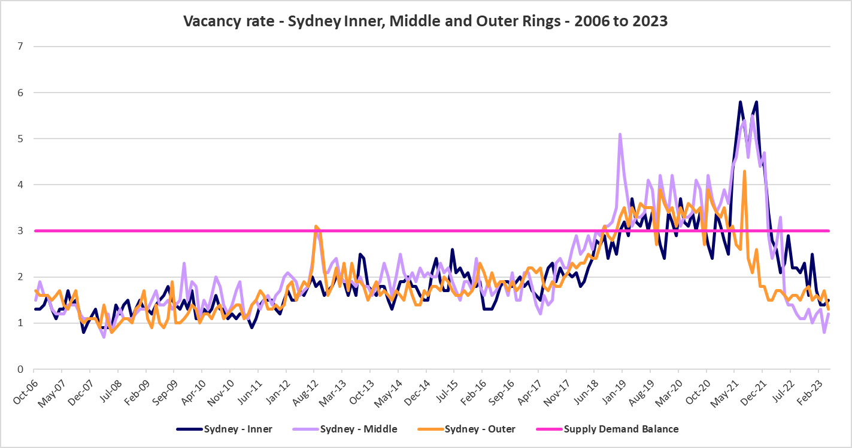

## Affordable Rental

* Between 2006 and 2017, the general trend across Sydney and NSW has been for a decline in the proportion of rental stock which is affordable for very low, low and moderate income earners. Between 2017 (a little later in some LGAs) and 2021, the proportion of affordable private rental improved. Since 2021 affordability has worsened.
* This trend is evident in South District, although along with elsewhere in NSW, there were more complex factors at play between 2019 and 2022, with the pandemic, lockdowns and cessation of tourism.
* At June 2022, Sutherland (3.8%) and Georges River (9.1%) both had a lower proportion of affordable rental for very low income households than the Greater Sydney average of 10.7%. Canterbury-Bankstown, historically a more affordable rental area, had a higher proportion with 26.6% - however, this still does not mean there is sufficient affordable private rental to meet demand.
* The table and graph below show the change in the proportion of private rental accommodation affordable to **very low income** households, as measured by new rental bonds lodged, in the South District LGAs and Greater Sydney between 2017 and 2022.

Proportion of new rental bonds lodged affordable for very low income households

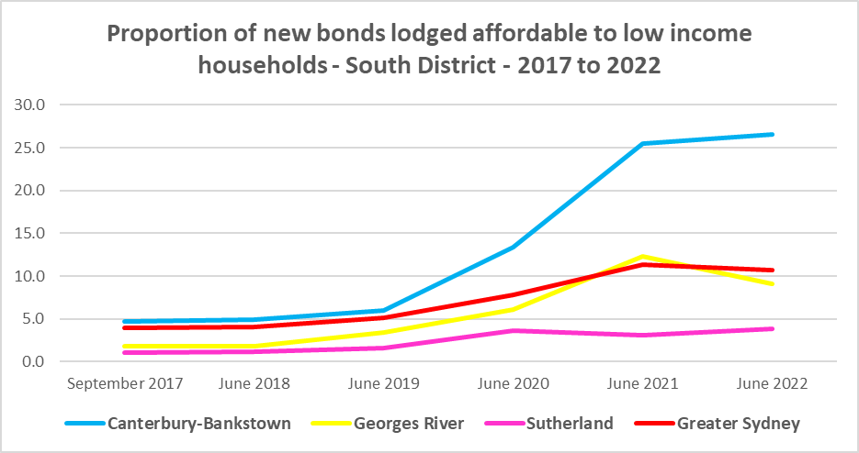

* Between 2018 and 2021 the proportion of rental affordable for **low income** households increased in Greater Sydney from 23.2% to 44.8% before declining to 41.5% in June 2022.
* Canterbury-Bankstown and Georges River followed this pattern, but Sutherland experienced a drop in affordability between 2020 and 2021 then an increase in the proportion of private rental that is affordable for low income households between 2021 and 2022 – against the trend elsewhere.
* At June 2022 of the South District LGAs, only Sutherland has a lower proportion of affordable private rental for low income households than the average of 41.5% for Greater Sydney. Both Canterbury-Bankstown and Georges River have a higher proportion. It is worth reiterating that having a higher proportion than the Greater Sydney average still does not make either LGA affordable for rental. As noted above, the vacancy rate is very tight and anecdotally, there is fierce competition for rental properties, with stories of significant hikes in rentals and tenants struggling to find homes.
* The table and graph below show the change in the proportion of private rental accommodation affordable to **low income** households, as measured by new rental bonds lodged, in the South District and Greater Sydney between 2017 and 2022.

Proportion affordable rental for low income households

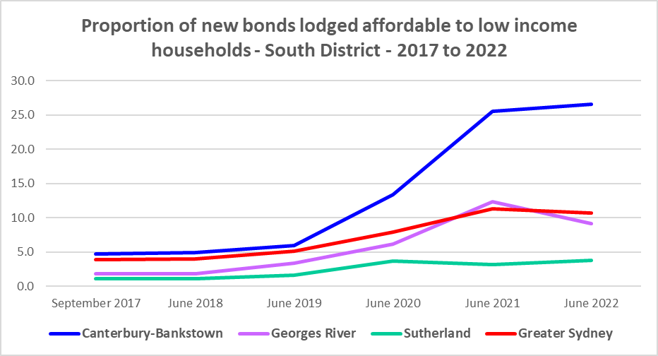

* There is evidence that short term holiday rentals such as Airbnb are impacting the supply of housing, including long term rental and affordable housing in cities, particularly inner city, and coastal communities.
* It is likely that both Georges River and Sutherland have had some impact from the rise of short term rentals, with a key impact being a preference for investment in short term rather than long term rental – potentially impacting the supply of housing for long term rental.

## Rental Stress

* Households are regarded as being in rental stress when renting in the private rental market and paying more than 30% of their income in rent. Lower income households in rental stress will struggle to pay for other essential household costs, such as medical or educational expenses, food, transport and energy costs.
* In 2021 the proportion of very low income households in rental stress in Greater Sydney was 94.0%.
* Within South District, the average proportion of very low income households in stress was 93.6%, with 96.6% in Sutherland, 95.1% in Georges River and 92.6% in Canterbury-Bankstown. All LGAs in the District had a very high proportion of very low income households in rental stress.
* For low income households in rental stress at 2021, the average for Greater Sydney was 61.4%, with the South District average a little lower on 58.5%. Sutherland had 79.1% in stress, Georges River 58.7% and Canterbury-Bankstown 52.1%. Again – these are high proportions in stress – with the majority of low income renters paying more than 30% of their income in rent.
* However, while the **proportion** of very low and low income households in stress declined in every South District LGA between 2016 and 2021, in line with the trend in Greater Sydney – the actual number of very low income households in stress increased across the District, while the number of low income households in stress declined marginally.
* Georges River was the exception – the number of very low income households in stress declined in that LGA between 2016 and 2021.
* Below is a graph of the proportion of very low and low income households in rental stress in each South District LGA at 2021, and a table showing the change in the proportion of very low and low income households in stress between 2016 and 2021.

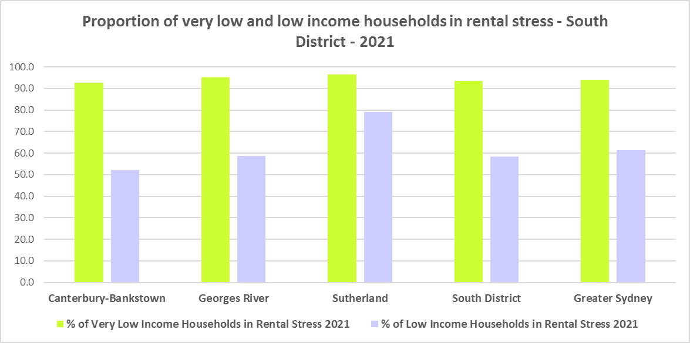

Proportion of very low and low income households in rental stress

* The next table shows the change in the number of very low and low income households in rental stress at 2016 and at 2021.

Number of very low and low income households in rental stress



* A look at CRA (Commonwealth Rent Assistance) recipients in housing stress gives some further information on what has been happening with lower income households in rental stress over this time frame.
* Between 2016 and 2020, the total number of CRA recipients in South District increased as did the number of CRA recipients in rental stress.
* However, between 2020 and 2021, the total number of CRA recipients declined, while
* Generally across Australia, the number of CRA recipients in housing stress has increased from the June 2020 figures as the temporary Coronavirus Supplement ended on 31 March 2021, entailing a drop in income and an increase in tenants in housing stress.
* The Coronavirus Supplement was $550 per fortnight for new and existing recipients of JobSeeker Payment, Parenting Payment, Youth Allowance for jobseekers, Farm Household Allowance and Special Benefit. The temporary supplement almost doubled the maximum payment rate for a JobSeeker Payment recipient. Hence it made rent more affordable for some CRA recipients in June 2020 and resulted in a lower proportion of CRA recipients in rental stress than usual.
* Since the end of Covid restrictions, the number of people in employment has increased, so fewer people are relying on rent assistance from the Commonwealth.
* The two graphs below clearly demonstrate the change in total CRA recipients and CRA recipients in stress between 2016 and 2020 and 2020 and 2021 in South District.

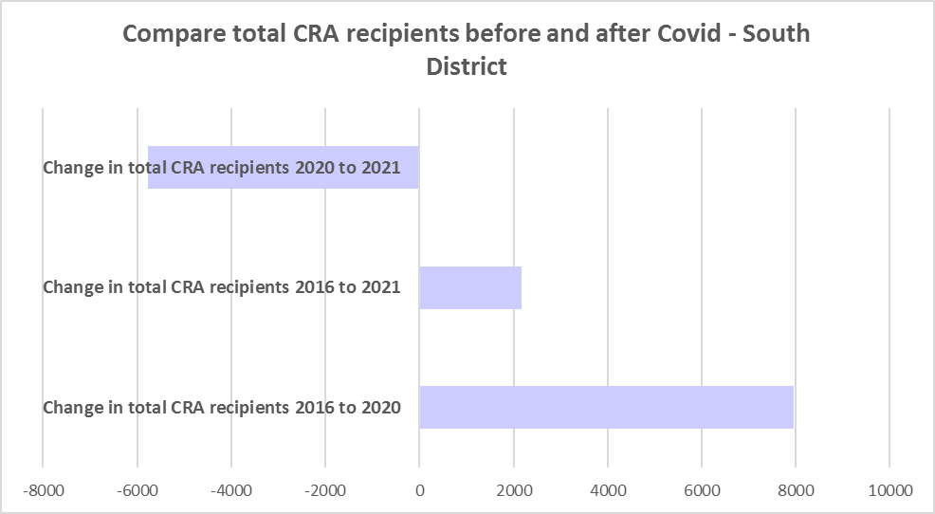

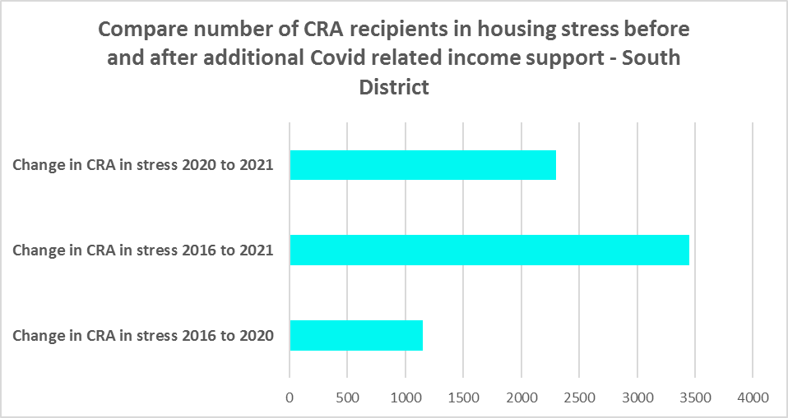

* The table below shows the number and proportion of tenants in South District who are in the private rental market, are in receipt of Commonwealth Rent Assistance, and even with this additional income support, are in housing stress.
* There were a total of 21,311 tenants in receipt of CRA and in housing stress across the District in 2021, up from 17,861 in 2016. In 2016, 52.8% of CRA recipients in South District were in stress, increasing to 59.2% in 2021. This compares to 50.7% CRA recipients in stress in 2016 for Greater Sydney and 56.2% in 2021.
* Every local government area in the District has a higher proportion of CRA recipients in stress than the average for Greater Sydney. Sutherland has the highest proportion in stress with 60.6%, followed by Georges River with 60.1% and Canterbury-Bankstown with 58.6%. Clearly lower income tenants struggle to find affordable rental housing in the private rental market in South District.



## Loss of Affordable Housing Stock

* DCJ has calculated the number of new bonds lodged with the Rental Bond Board that were affordable to low income earners in South District for 2021 and 2022. The District experienced a -7.1% decline in affordable bonds lodged, and consequently loss of affordable housing, in just that 12 month period.
* Note that while both Canterbury-Bankstown (-4.1%) and Georges River (-23.4%) experienced a reduction in affordable private rental, Sutherland actually had an increase of 10.7% against the trend elsewhere.
* In numeric terms, Georges River had the greatest loss of affordable private rental, with 218 fewer affordable bonds lodged in 2022 than in 2021.
* The table below shows the number of new bonds lodged that were affordable to low income households (including very low income households) in 2021 and 2022 in each of the South District LGAs as well as the total for the District.

Number of new bonds lodged affordable to low income households



**Impact on Key Workers**

* This loss of affordable housing is having a direct impact on key workers (including teachers, registered nurses, hospitality service workers, accommodation and food service workers, early childhood, police and aged care workers).
* South District in particular has a high number of health care and aged care workers who work in the District, due to the number of aged care facilities and the Sutherland and St George Hospital precincts, as well as Canterbury Hospital and Bankstown Hospital. In fact, health care and social assistance is the largest employment sector of residents in South District, comprising 13.3% of residents. Another 9.4% are employed in retail trade and a further 5.5% in accommodation and food services. Many of these will be lower paid workers.
* Without appropriate affordable housing, these workers will be forced to move from the area, either increasing the commute time for these workers or it may result in a shortage of available workforce.
* Analysis by AHURI (May 2021 Policy Evidence Summary – Housing for Australia’s Key Workers) shows that:
  + In Sydney key workers are more likely than the labour force generally to live in outer suburbs and satellite cities and to commute 30kms or more to work.
  + Around 31,000 key workers in Sydney live in overcrowded homes, with the greatest concentration in inner subregions and among lower paid occupation groups.
  + Over 52,000 key workers in Sydney are living in households that can be classified as being in housing stress, equating to 20 per cent of key workers.
  + In February 2020, only 2 per cent of new tenancies across Greater Sydney had starting rents that were at or below the affordability threshold for households earning $790 per week gross (broadly indicative of a wage for a laundry worker). Just 5 per cent were affordable to households earning $960 (broadly indicative of wages for a commercial cleaner, delivery driver and entry level firefighter) and 11 per cent were affordable with an income of $1,150 (broadly indicative of the wage for an enrolled nurse, child care worker and ICT support technician).
  + At a weekly income of $1,450/$1,500 (an indicative wage for an early career Registered Nurse), there are generally no LGAs with affordable median unit purchase prices in the inner and middle ring LGAs of Sydney.
* There is clearly demand for affordable housing for lower paid and key workers in South District, yet affordable private rental is diminishing and housing costs are rising much faster than incomes.

## *Housing Market – Purchase*

## Sales Price

* Changes in the median sales price of both houses and flats in Greater Sydney and also Sutherland over the ten years to March 2022 have been upward and for Sutherland have been significantly larger than the increases experienced over the same period for Greater Sydney.
* Given the council amalgamations to create Canterbury-Bankstown and Georges River Councils it is difficult to calculate the long term increase in median sales price for houses and flats for these two LGAs.
* At March 2022, all the South District LGAs had a higher median sales price for houses than the Greater Sydney median of $1,203,000. Georges River had the highest median sales price for houses with $1,852,000, followed by Sutherland with $1,811,000 and Canterbury-Bankstown $1,330,000.
* Sutherland was the only LGA in South District with a higher median sales price for strata properties than the Greater Sydney median of $770,000, with $957,000, followed by Georges River with $708,000 and Canterbury-Bankstown with $599,000.
* The table below shows changes in the median sales price of both houses and flats over the last ten years in South District.



* The long term median sales price trend for both houses and flats shows growth across all LGAs.
* The two graphs below show the median sales price trend for houses and for strata properties from 2008 to 2022 in each of the South District LGAs.

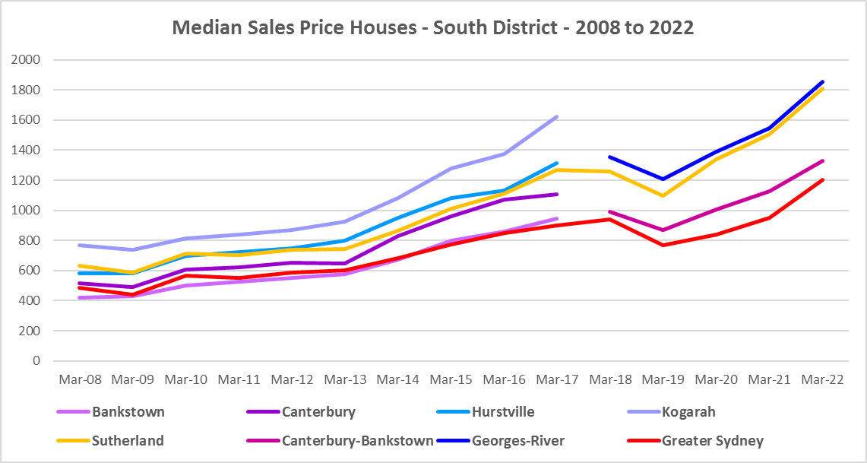

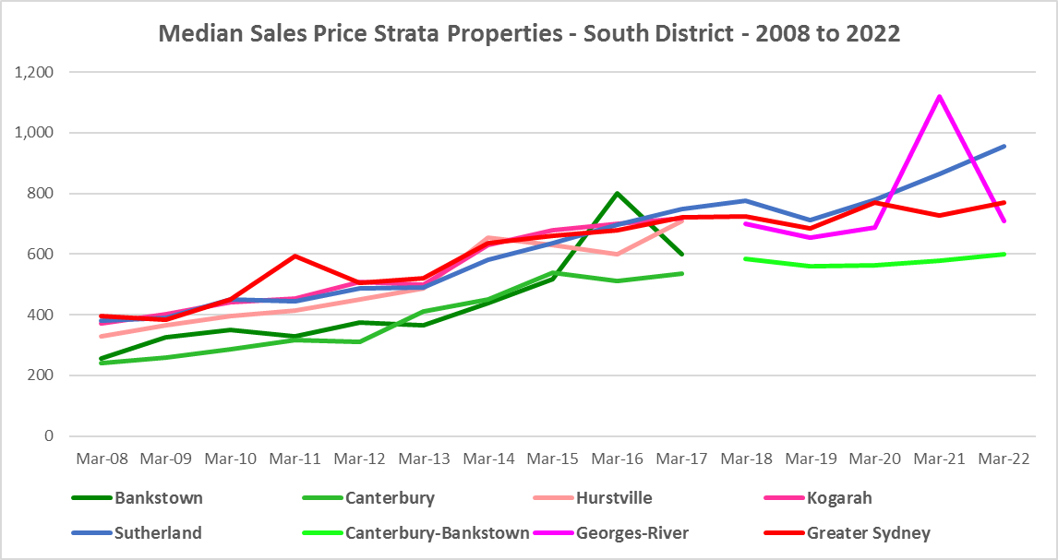

* However, between 2018 and 2022 there were more complex changes in the market, as the graphs above and the two tables below demonstrate.
* Between March 2018 and March 2019 median house and strata prices declined in all South District LGAs. Changes in the median sales price for houses over that 12 month period ranged between -13.0% in Sutherland and -10.9% in Georges River, while for strata the change in the median ranged between -8.0% in Sutherland and -4.1% in Canterbury-Bankstown.
* Between March 2020 and March 2022 there was strong growth in median house and strata prices across South District. Increases in the median sales price for houses ranged between 35.1% in Sutherland and 32.1% in Canterbury-Bankstown. For strata over the same period, increases ranged between 22.7% in Sutherland and 3.1% in Georges River.
* Clearly the pandemic also had an impact on sales prices in the region.

Median Sales Price Houses



Median Sales Price Strata



## Purchase Affordability

* Purchase affordability for very low income earners has varied only marginally over the period from 2006 to 2021 in Greater Sydney and in the South District
* At June 2021, all the South District LGAs, along with Greater Sydney, had a 0.0% of sales affordable for purchase by very low income households.
* The graph and table below show purchase affordability for very low income households in the South District LGAs and Greater Sydney between 2017 and 2021.

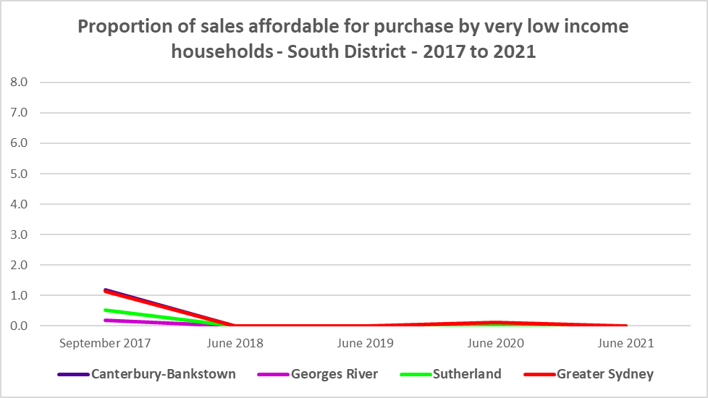

Affordable purchase for very low income households



* There was more variation in affordable purchase for low income households in Canterbury-Bankstown between 2017 and 2021, but much less for Georges River and Sutherland. Both Georges River and Sutherland had 0.0% of housing affordable for purchase by low income households in 2021- below the average of just 2.3% in Greater Sydney – while Canterbury-Bankstown was above the Greater Sydney average with 6.7% affordable purchase. While Canterbury-Bankstown had a little more affordable purchase for low income households than the Greater Sydney average, it is still an extremely low proportion that is affordable.
* The graph and table below show the change in purchase affordability for low income households in the South District, compared to Greater Sydney, between 2006 and 2021 (and from September 2017 for Canterbury-Bankstown and Georges River).

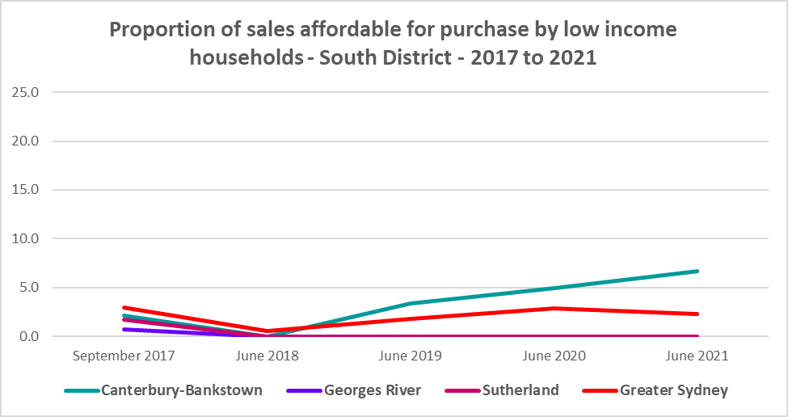

Affordable purchase for low income households



* Purchase affordability for moderate income households is more feasible in South District, with both Canterbury-Bankstown (27.2%) and Georges River (23.8%) having a higher proportion of sales at a price affordable for moderate income households at June 2021 than the average for Greater Sydney of 18.1%, with Sutherland somewhat lower at 12.2%.
* Nevertheless, these are still low proportions of affordable purchase for moderate income households.
* The graph and the table below show the proportion of sales affordable for purchase by moderate income households in South District and Greater Sydney between 2006 and 2021 (and from 2017 for Canterbury-Bankstown and Georges River).

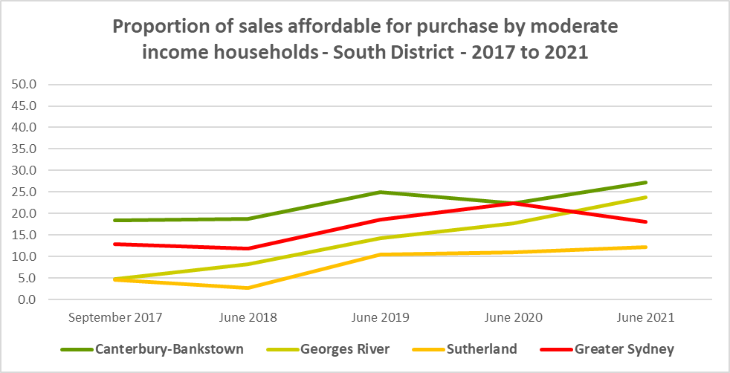

Affordable purchase for moderate income households



**Purchase Stress**

* In 2021 there were 6,477 very low income households and 5,466 low income households purchasing a home and in stress across South District – that is, paying more than 30% of their income on their mortgage. This represents 69.5% of very low income purchasers and 46.3% of low income purchasers in the District – a higher proportion than the average for Greater Sydney at 69.3% and 43.8% respectively.
* Georges River had the highest proportion of very low income purchasers in stress with 70.9%, followed by Canterbury-Bankstown with 70.2% and Sutherland had the lowest proportion in stress with 65.7%.
* Georges River also had the highest proportion of low income purchasers in stress with 51.4%, followed by Sutherland with 47.3% and Canterbury-Bankstown had the lowest proportion in stress with 44.0%.
* Canterbury-Bankstown had the highest number of very low (4,072) and low (2,907) income purchasers in stress, followed by Georges River (1,336 and 1,208) and Sutherland (1,068 and 1,350).

Very Low and Low Income Households in Purchase Stress



* However the number of very low and low income purchasers in stress is significantly lower than the number of very low and low income renters in stress in the District, as the graph below demonstrates. There is a stronger need for more affordable housing for lower income renters than purchasers in South District

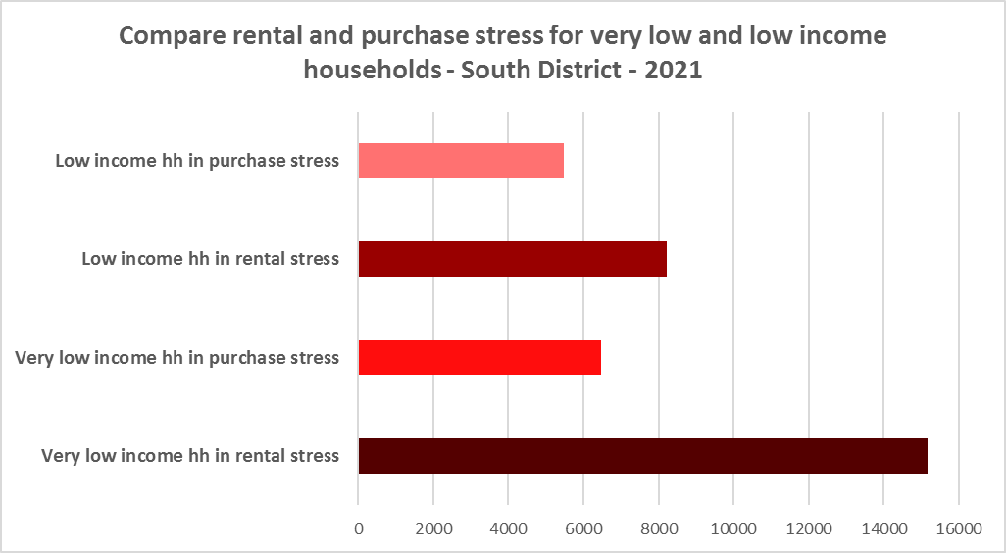

## Additional Data

Additional data on rents and sale prices, including both current and historical data, is available from the Rent and Sales Report and the interactive Dashboard on the Housing NSW website at:

<https://www.facs.nsw.gov.au/resources/statistics/rent-and-sales/dashboard>

More detailed housing data and tables used in this Snapshot are available from the Local Government Housing Kit Database on the DCJ website at:

<https://www.facs.nsw.gov.au/resources/nsw-local-government-housing-kit/chapters/local-government-housing-kit-database>

More information on vacancy rates is available from the Real Estate Institute of NSW website:

<https://www.reinsw.com.au/Web/Web/Members/Property_data/Vacancy_Rates_Survey.aspx>

The Rental Affordability Index is at

<https://sgsep.com.au/projects/rental-affordability-index>