**Central Coast – What’s Happening in the Housing Market?**

This Housing Snapshot looks at aspects of the housing market in the Central Coast, particularly from the 2016 Census to the 2021 Census – including rents, vacancy rate, affordable private rental for very low and low income households, rental stress for low income households, number of new bonds lodged affordable to low income households, sales price, purchase affordability for very low and low income households and purchase stress for low income households.

Located between Sydney and Newcastle, the Central Coast housing market is impacted by both cities and at the same time has much in common with regional NSW. While historically this region has been more affordable than Sydney, there has been strong price growth, tight vacancy rates, a loss of private rental affordable housing supply and high demand from the significant number of low income households resident here.

More recently Covid has had an impact, along with insufficient housing supply, growing cost of living pressures, including rising inflation and interest rates with continued low wage growth. These have created further difficulties for lower income earners and their capacity to manage housing costs.

# ***Housing Market - Rental***

**Rents**

* There have been strong increases in median rents for all dwelling types, in all bedroom categories in the Central Coast region for well over a decade, with prices increasing over the 12 month period to June 2022. The graph below shows the increase in median rents for Gosford and Wyong from June 90 to June 2017 and for Central Coast from June 2018 to June 2022.
* The table immediately below shows that median rent for all dwellings for the Central Coast increased by 26.8% between June 2018 and June 2022.



* Between 2019 and 2020 when COVID lockdowns were introduced, median rents in the Central Coast were fairly stable – with just a 1.8% increase in the median rent for one bedroom homes, no change in the median rent for two bedroom dwellings, a 2.3% increase for three bedroom homes and just 0.9% increase in the median rent for four bedroom dwellings.
* The table below gives the change in median rents for one, two, three and four bedroom homes between June 2019 and June 2020.



* However, between 2020 and 2022 when COVID restrictions were relaxed, there were strong increases in median rents in the Central Coast, with a 15.8% increase for one bedroom homes, 22.2% for two bedroom, 25.0% for three bedroom and 23.6% increase for four bedroom homes, as the table below shows

.



At June 2022, the median rent for one bedroom homes was $330 per week, for two bedroom homes was $440 per week, for three bedroom homes was $550 per week and for four bedroom homes was $680 per week.

**Vacancy Rate**

* A vacancy rate of 3% is understood to represent a balance between supply and demand.
* According to REINSW data, vacancy rates were below 3% for the Central Coast for almost all the whole period from 2007 through to 2019 and again since May 2020. For some of that time the vacancy rate has been below 2% - indicating a chronic shortage of rental housing.
* Vacancy rates are tight across almost all of NSW, indicating a significant undersupply of rental accommodation across both regional and metropolitan NSW. Anecdotally there are reports of tenants struggling to find accommodation and potentially facing homelessness, reports of stiff competition for properties, strong, rapid increases in rents and tenants paying more than 50% of their income in rent.
* At April 2023, the vacancy rate in the Central Coast was 1.7%, in Sydney it was 1.3% and in the Hunter, it was 1.8%.

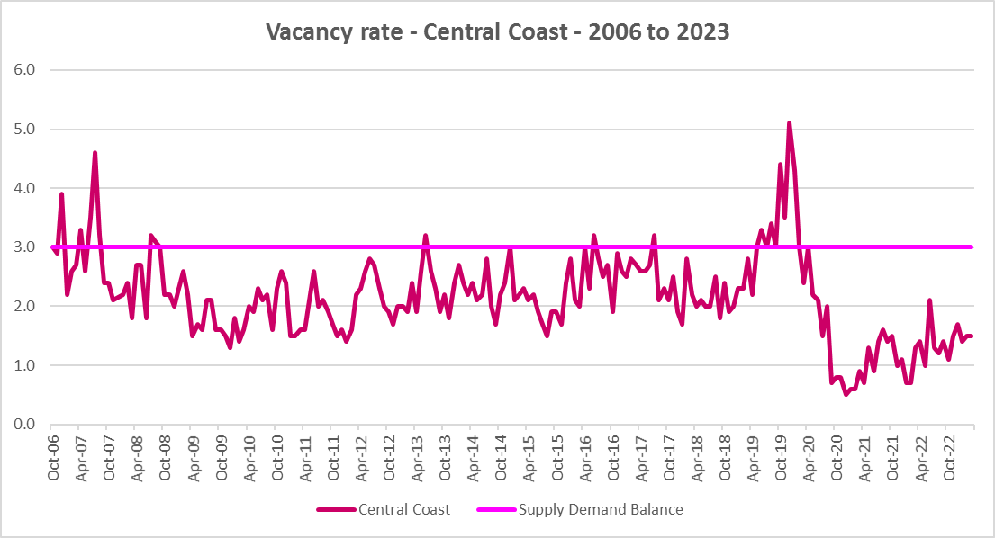

**Affordable Rental**

* The general trend across Sydney and NSW has been for a decline in the proportion of rental stock which is affordable for very low, low and moderate income earners. Although this region is more affordable than Sydney, the reduction in the proportion of rental housing that is affordable has been concerning.
* Across the Rest of NSW, the proportion of affordable rental for very low income households stayed at the 2018 level of 22.0% for 2019, improved slightly to 21.7% in 2020 and again to 21.9% in 2021 then declined in line with the longer term trend to 17.0% in 2022.
* In the Central Coast, this pattern was a little different. Between 2018 and 2020 rental affordability for very low income households improved. However, the proportion of affordable rental declined between 2020 and 2022.
* At June 2022, the Central Coast (at 10.8%) had a lower proportion of affordable rental for very low income households than the Rest of NSW average of 17.0% and just a little above the Greater Sydney average of 10.7%.
* The table and graph below show the change in the proportion of private rental accommodation affordable to **very low income** households in the Central Coast, Greater Sydney and Rest of NSW between 2001 and 2022.



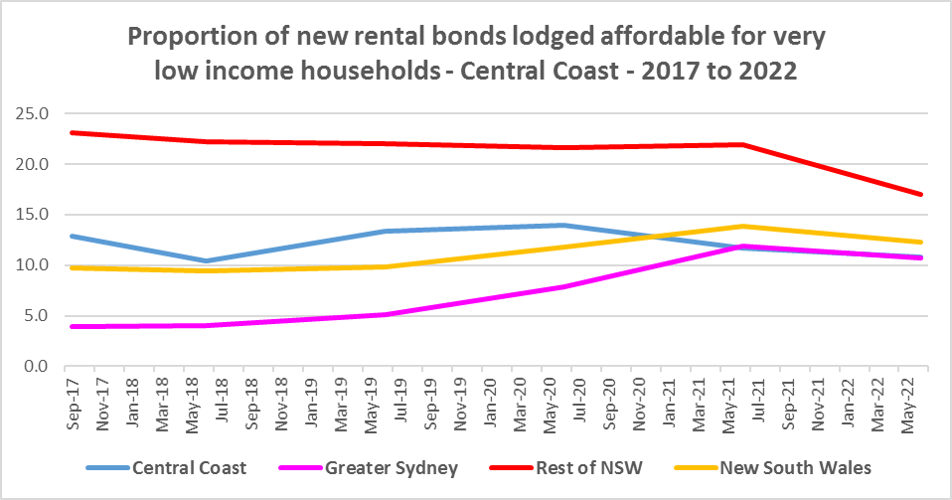

* The proportion of rental affordable for **low income** households has also declined in the Central Coast. At September 2017, the proportion of new bonds lodged which were affordable to low income households was 57.4%, which declined to 54.1% in June 2021, a little above the Rest of NSW average of 51.0% and above the Greater Sydney average of 44.8%.
* Between 2018 and 2020, the proportion of rental affordable for low income households increased gently from 54.1% to 55.2% and then declined again to 45.4% in June 2022 in the Rest of NSW.
* The Central Coast followed the same trend as for the Rest of NSW, increasing from 55.4% in 2018 to 65.3% in 2020 then declining to 47.7% in 2022.
* The table and graph below show the change in the proportion of private rental accommodation affordable to **low income** households in the Central Coast, Greater Sydney, Rest of NSW and NSW between 2001 and 2022.



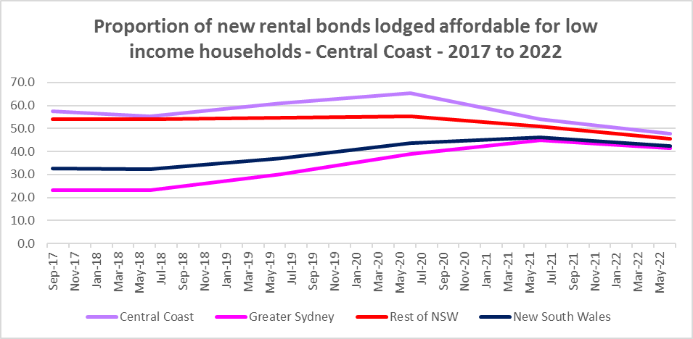

* There is evidence that short term holiday rentals such as Airbnb are impacting the supply of housing, including long term rental and affordable housing in cities and coastal communities.
* Homes that could be used as long-term rental properties to house essential workers are now used for holiday accommodation, raising concerns that some regional towns will not be able to attract and keep staff in caring professions or hospitality.
* The rapid growth in on line listings and loss of affordable rental accommodation are likely connected, with tourist accommodation outcompeting longer term renting for locals.
* Communities within a 3 hour radius of capital cities, including the Central Coast, have seen significant growth in short-stay rental properties. Research by SQM showed that between July 2019 and July 2020 short term rental in Wyong increased by 2% from 2,619 to 2,662. Since 2020 it is likely that these listings have picked up further.
* Even in towns where Airbnb listings have not rebounded to normal levels there are more short-stay lets on offer than long-term rental properties, triggering concern that if short-stay listings normalise the consequences will be grim for would-be tenants.
* Both supply and demand for rental properties have been hit by the pandemic. Sea and tree-changers who could work remotely moved out of capital cities and secured rentals in coastal areas and regional towns or bought properties from landlords to convert to owner-occupied housing.

**Rental Stress**

* Households are regarded as being in rental stress when renting in the private rental market and paying more than 30% of their income in rent. Lower income households in rental stress will struggle to pay for other essential household costs, such as medical or educational expenses, food, transport and energy costs.
* At June 2021, the proportion of very low income households in rental stress in the Rest of NSW (that is, excluding Sydney) was 91.7%. In the Central Coast the proportion was 93.7% - above the average for the Rest of NSW and just below the average for Greater Sydney of 94.0%
* Central Coast (57.5%) has lower levels of low income households in rental stress than the average of 68.3% for the Rest of NSW and lower than Greater Sydney (61.4%).
* At the 2021 Census, there were 7,782 very low income renters in housing stress in the Central Coast – up from 7093 in 2016 or a 9.7% increase.
* At the 2021 Census, there were a further 4,663 low income renters in housing stress in the Central Coast, up from 4,278 in 2016, or a 9.0% increase.
* Below is a graph of the proportion of very low and low income households in rental stress in the Central Coast at 2021 and a table showing the change in the proportion of very low and low income households in stress between 2016 and 2021.

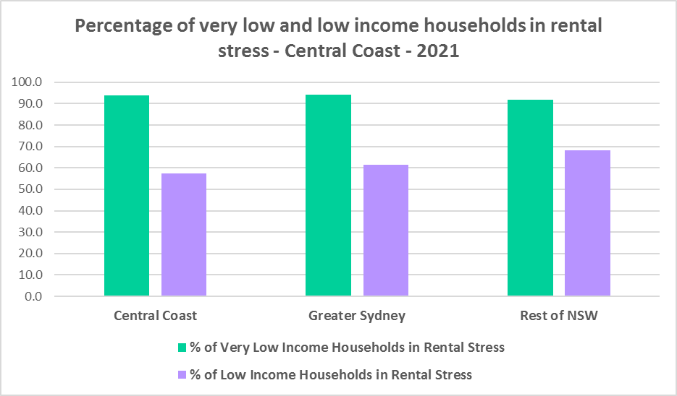



* The next table shows the change in the number of very low and low income households in rental stress at 2016 and at 2021.



* In summary, while the number of both very low and low income rental households in stress increased between 2016 and 2021, the proportion of very low and low income renters in stress declined.
* A look at CRA (Commonwealth Rent Assistance) recipients in housing stress gives some further information on what has been happening with lower income households in rental stress over this time frame and explains why the proportion of very low and low income renters in stress declined between 2016 and 2021.
* In line with other parts of NSW, between 2016 and 2020, the total number of CRA recipients in the Central Coast increased significantly, while the number in stress actually declined. However, between 2020 and 2021 the number of CRA recipients declined while the number in stress increased.
* The number of CRA recipients in housing stress has increased from the June 2020 figures as the temporary Coronavirus Supplement ended on 31 March 2021.
* The Coronavirus Supplement was $550 per fortnight for new and existing recipients of JobSeeker Payment, Parenting Payment, Youth Allowance for jobseekers, Farm Household Allowance and Special Benefit. The temporary supplement almost doubled the maximum payment rate for a JobSeeker Payment recipient. Hence, it made rent more affordable for some CRA recipients in June 2020 and resulted in a lower proportion of CRA recipients (very low and low income renters) in rental stress than usual.
* In addition, since the end of Covid restrictions, the number of people in employment has increased, so fewer people are relying on rent assistance from the Commonwealth.
* This scenario is evident in the two graphs below.
* Note that, according to SGS Economics and Planning Rental Affordability Index of November 2022 “Regional rental markets were not exposed to the same COVID-19 restrictions that capital cities were; therefore, the rebound from the pandemic played out differently. While Australia’s regions were spared the worst of pandemic response measures, there has been concern regarding the impacts of outward-migrating city residents on housing, and rental, affordability. This phenomenon is observed in the most recent data, which shows that affordability has worsened in the regional areas of every state, even more so than in the capital cities (P55)”.
* The two graphs below compare the number of CRA recipients and the number in stress in the Central Coast, before and after additional Covid related income support.
* The table below shows the number and proportion of tenants in the Central Coast who are in the private rental market, are in receipt of Commonwealth Rent Assistance, and even with this additional income support, are in housing stress.
* There were a total of 13,658 tenants in receipt of CRA and in housing stress across the Central Coast in 2021, up from 11,098 in 2016.
* The Central Coast has a higher proportion of CRA recipients in housing stress (47.8%) than the Rest of NSW (39.2%) at 2021.

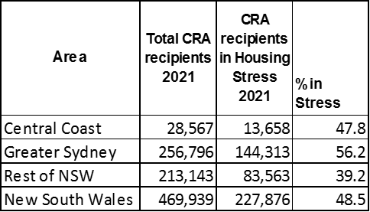

* Given the current very tight vacancy rate and rapid increases in rents, it is highly likely there has been an increase in both the number and proportion of very low and low income rental households experiencing housing stress.

**Loss of Affordable Housing Stock**

* DCJ has calculated the number of new bonds lodged with the Rental Bond Board that were affordable to low income earners in the Central Coast in 2017, 2021, and 2022. The Central Coast experienced a significant decline in affordable bonds lodged, and consequently loss of affordable housing between 2017 and 2022 – with -489 fewer affordable bonds lodged – representing a loss of -28.5% of affordable stock between 2017 and 2022. This a significant loss, particularly given that historically the Central Coast has been more affordable, particularly in comparison with Sydney.
* The table and graph below show the number of bonds lodged that were affordable to low income households (including very low income households) in 2017, 2021 and 2022 in the Central Coast.



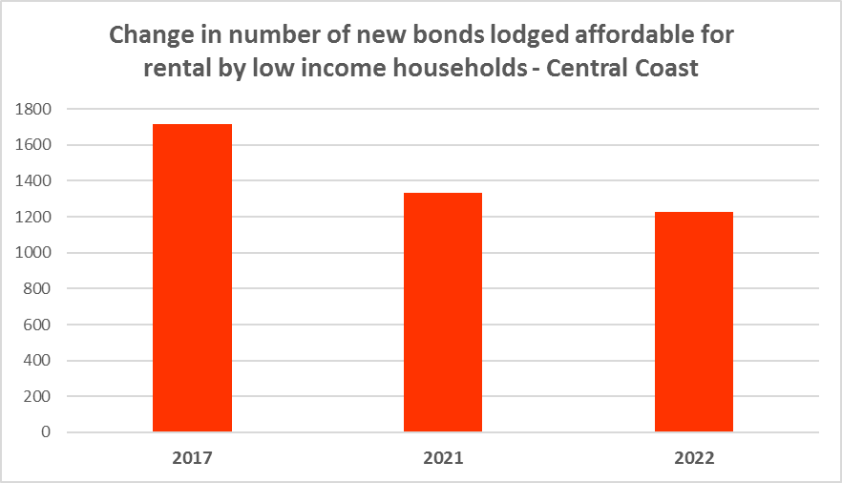

# ***Housing Market - Purchase***

**Sales Price**

* In the period from 1994 to 2022 median house and strata prices rose strongly. The following graphs presenting the long term median sales price trend for houses and for strata properties show that there has been a significant increase in the sales price of both over that time frame.
* The two graphs below show the median sales price for houses and for strata homes between 1994 and 2017 for Gosford and Wyong and from 2018 to 2022 for the Central Coast.
* The median sales price for houses has increased significantly over the ten year period from 2012, from $410,000 in Gosford and $346,000 in Wyong to stand at $1,071,000 for Central Coast at March 2022.
* Similarly, the median sales price for strata properties has increased from $178,000 in Gosford and $121,000 in Wyong at 2012 to $709,000 in Central Coast in 2022.
* The table below shows changes in the median sales price of both houses and flats over the last ten years in the Central Coast.



* However, between 2019 and 2022 there were more complex changes in the market, as the table below demonstrates. Between March 2019 and 2020 median house and strata prices experienced relatively low growth in the Central Coast. The median sales price for houses increased by 7.4% and for strata 4.4% in that 12 month period.
* Between March 2021 and March 2022 there was strong growth in median house and strata prices across the Central Coast. The median sales price for houses increased by 25.8% and for strata properties by 22.0% in that 12 month period.
* Clearly Covid also had an impact on sales prices in the region.



**Purchase Affordability**

* Purchase affordability for very low income earners has varied over the period from 2001 to 2021 and in the Rest of NSW, the proportion of sales affordable to purchase by very low income households is slightly higher in 2021 than in 2001.
* Due to Council amalgamations, data is only available for the Central Coast from 2017 onwards. As the graph below demonstrates, purchase affordability for very low income households has been very tight over the whole period from 2017 to 2021 and is currently on 0.0%. This is equal to the Greater Sydney average of 0.0% and is significantly lower than the Rest of NSW average of 7.5%.
* The subsequent increases in interest rates would have exacerbated the issue of affordability on the Central Coast.
* The graph and table below show purchase affordability for very low income households in the Central Coast from 2017 to 2021 and for Greater Sydney, the Rest of NSW and NSW between 2001 and 2021.

Affordable purchase for very low income households



* At June 2021, only 2.3% of stock was affordable for purchase by low income households for the Central Coast and Greater Sydney, well below the average of 23.8% in the Rest of NSW.
* The graph and table below shows the change in purchase affordability for low income households in the Central Coast from 2017 to 2021, compared to Greater Sydney, the Rest of NSW and NSW, between 2001 and 2021.

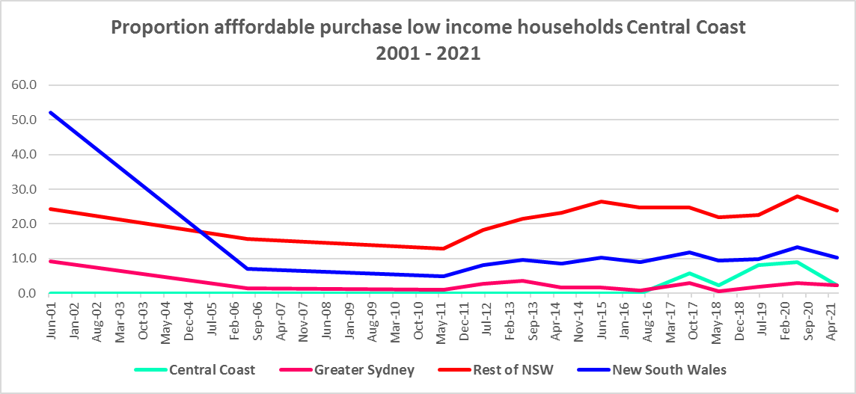

Affordable purchase for low income households



**Purchase Stress**

* In 2021 there were 2,479 very low income households and 2,209 low income households purchasing a home and in stress across the Central Coast – that is, paying more than 30% of their income on their mortgage. This represents 58.6% of very low and low income purchasers in the region – a slightly higher proportion than the average for the Rest of NSW at 56.5%.

Number of very low and low households in purchase stress



* The number of very low and low income purchasers in stress is significantly lower than the number of very low and low income renters in stress in the region, as the graph below demonstrates. There is a stronger need for more affordable housing for lower income renters than purchasers in the Central Coast.

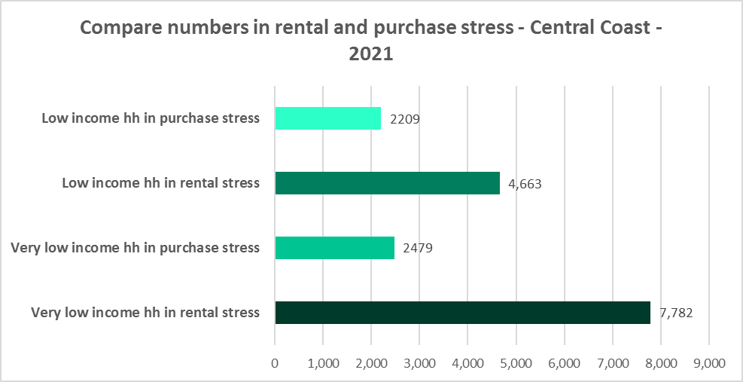

**Additional Data**

Additional data on rents and sale prices, including both current and historical data, is available from the Rent and Sales Report and the interactive Dashboard on the Housing NSW website at:

<https://www.facs.nsw.gov.au/resources/statistics/rent-and-sales/dashboard>

More detailed housing data and tables used in this Snapshot are available from the Local Government Housing Kit Database on the DCJ website at:

<https://www.facs.nsw.gov.au/resources/nsw-local-government-housing-kit/chapters/local-government-housing-kit-database>

More information on vacancy rates is available from the Real Estate Institute of NSW website:

<https://www.reinsw.com.au/Web/Web/Members/Property_data/Vacancy_Rates_Survey.aspx>

The Rental Affordability Index is at

<https://sgsep.com.au/projects/rental-affordability-index>