**North Coast Region – What’s the Housing Demand?**

This Housing Snapshot looks at aspects of housing demand in the North Coast, particularly from the 2016 Census to the 2021 Census – including population, age profile, household type, household size, income (change in low, moderate and high income households and low income rental households), homelessness and people with disability.

There have been significant challenges to this region since the 2016 Census, including natural disasters, tourism and unexpectedly high additional inmigration – in part due to the desire for sea and tree changes and increased ability to work remotely - which have impacted the community and the demand for housing.

**Population**

* Between 2016 and 2021, the population of the North Coast grew by 7.7% or 38,526, from 502,520 to 541,046, using ABS Census population data.
* On an individual LGA basis, population growth ranged from 2.8% in Lismore to 14.5% in Byron.
* In numeric terms, the largest population increase occurred in Port-Macquarie Hastings with 8,221, followed by Tweed with 6,018 and Coffs Harbour with 5,810.
* Tweed has the largest population of the North Coast LGAs with 97,392 (comprising 18.0% of the region’s total population), while Kyogle has the smallest population with 9,359 (comprising 1.7% of the region’s population).
* Note that Byron LGA ranks sixth in the whole of NSW for percentage population growth between 2016 and 2021, (behind Camden 52.54%, The Hills 22.03%, Blacktown 17.75%, Maitland 16.72% and Cessnock 14.51%).
* The Department of Planning and Environment have prepared demographic information on every LGA in the region. Their projections indicates that the majority of the LGAs in the region are anticipated to increase in population to 2041, with the exception of Kyogle and Lismore, for which the Department predicts a decline. NSW Planning forecasts the strongest proportional population growth in Byron (the only LGA in the region they anticipate will have stronger annual growth than the NSW average of 0.95% per annum). However, numerically the largest increases in population to 2041 are predicted for Port Macquarie-Hastings, followed by Tweed and Coffs Harbour.
* The table below shows the population change for each North Coast LGA and the region from 2011 to 2021, using ABS Census data.



**Age**

* The age profile of the region and particularly each LGA will impact on housing need and demand, including number of bedrooms, affordability, location and dwelling type.
* The median age of the population of the twelve LGAs comprising the North Coast region at the 2021 Census ranges between 43 years (Byron) and 52 (Kyogle and Nambucca Valley). All North Coast LGAs have a median age at or above the median age for the Rest of NSW (excluding Sydney) of 43 years.
* There is a strong similarity in the age profile of the North Coast LGAs. All have a higher proportion of residents aged over 55. Generally, the North Coast has a lower proportion of young children (0-4 particularly, but also 5-14), young adults (15-19 and 20- 24) and 25-34 and 35-44 year olds as well as higher proportions of 45-54, 55-64, 65 – 74, 75 – 84 year cohorts and frail aged (85+) than the Rest of NSW.
* Of course there are exceptions:
  + Richmond Valley, Bellingen and Coffs Harbour have a higher proportion of 5-14 year olds than the Rest of NSW average;
  + Byron has a higher proportion of 25-34, 35-44 and 45-54 year olds;
  + Coffs Harbour and Lismore also have a higher proportion of 35-44 year olds;
  + Bellingen and Lismore also have a higher proportion of 45-54 year olds;
* Kyogle, Bellingen and Nambucca Valley have the highest proportions of 55-64 and 65-74 year olds in the region.
* Port Macquarie-Hastings, Clarence Valley and Tweed have the highest proportion of 75-84 year olds.
* Ballina, Port Macquarie-Hastings and Tweed have the highest proportion of 85+ year olds in the North Coast.
* The Department of Planning and Environment forecast a strong increase in residents aged over 65 to 2041 across all the LGAs in the North Coast.
* The diversity of age groups requires a range of different housing to meet the needs of the community throughout the housing life cycle. However the higher median age and higher proportions of older age cohorts indicates that there is a need for housing to suit older residents, in particular.
* As the Australian Institute for Health and Welfare (AIHW) note:

Many older Australians prefer to age in place, meaning they wish to stay in their local home or community. However, their capacity to do so can be influenced by:

* + the appropriateness and quality of their home (for example, size, layout)
  + their ability to modify their home to suit their functional requirements
  + the cost and availability of suitable housing
  + their need for formal care and assistance
  + their proximity to services and social support.
* Although the majority of older Australians own their own home, this number is declining. About 15% of older Australians are renters. These people are generally a highly vulnerable and economically disadvantaged group, particularly single person households, with older women being the fastest growing demographic of people experiencing homelessness. There is therefore a need for more adaptable, accessible dwellings, well located, secure, low maintenance and affordable to meet the needs of seniors and frail aged in particular, within their communities. Those most in need are households in the private rental market, who struggle to afford housing on an Aged Pension or inadequate superannuation. (Source: "Housing Decisions of Older Australians" Productivity Commission December 2015).
* The graph and table below show the proportion of the population in each key age cohort in Ballina, Bellingen, Byron, Clarence Valley, Coffs Harbour, Kempsey, Kyogle, Lismore, Nambucca, Port-Macquarie Hastings, Richmond Valley and Tweed, compared with the total for the North Coast and the Rest of NSW.

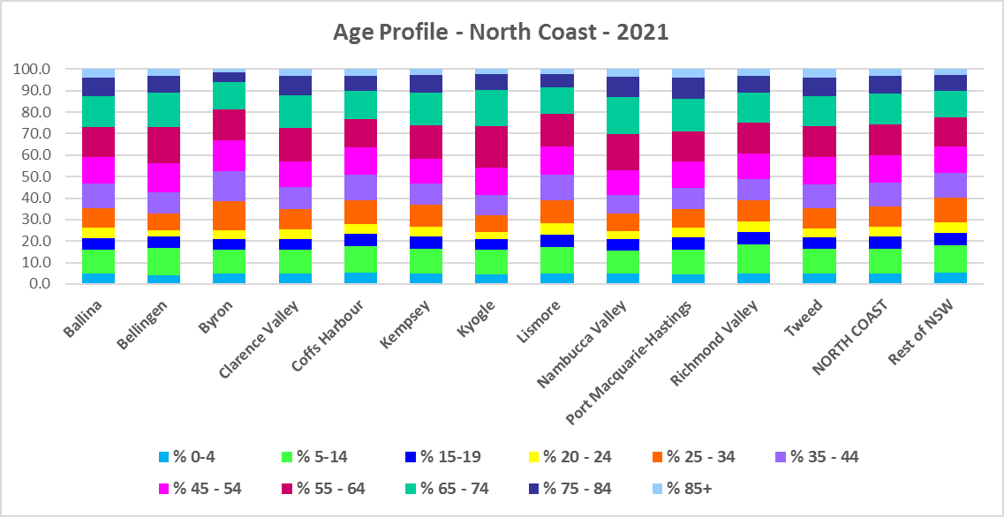



**Household Type**

* A look at household types gives some insight into the type of housing – particularly number of bedrooms – that is likely to be appropriate to meet the housing needs of the community.
* Household types in the North Coast differ from the average for the Rest of NSW.
* On the North Coast, couple families without children are the most common household type, followed by lone person households, with both single parent household and other household types being more prevalent than in the Rest of NSW. In the Rest of NSW, couple families with children households are the largest household type.
* At the 2021 Census, all the North Coast region LGAs have a **higher** proportion of couple families without children than the average for the Rest of NSW of 25.0%, with the exception of both Byron and Lismore. At 2021, the proportion of couple families without children in the North Coast LGAs ranged from 23.6% in Byron to 31.9% in Port Macquarie-Hastings.
* While couple only households are the largest household type in the Rest of NSW, comprising 30.8% of all households – every LGA on the North Coast had a much lower proportion of this household type (ranging from just 17.2% in Kyogle to 23.8% in Coffs Harbour).
* One parent families are more common in North Coast LGAs than for the Rest of NSW generally (ranging from 13.1% in Lismore to 10.5% in Port Macquarie-Hastings, compared to 10.6% in the Rest of NSW).
* There are significantly higher proportions of lone person households on the North Coast compared to the average for the Rest of NSW – ranging from 30.1% in Nambucca Valley to 23.6% in Byron, with 23.7% in the Rest of NSW. This is the second largest household type on the North Coast, averaging 26.7% of all households.
* Other households comprise between 11.6% of all households in Byron and 4.9% in Port Macquarie-Hastings, or 7.5% on average across the region compared to 5.2% in the Rest of NSW.
* Group households comprise 3.7% of all households in the Rest of NSW, 3.5% on average in North Coast, ranging between 7.9% in Byron and 2.6% in Richmond Valley.
* The graph and table below show the proportion in each key household type for every North Coast region LGA and Rest of NSW (excluding Sydney) at 2021.

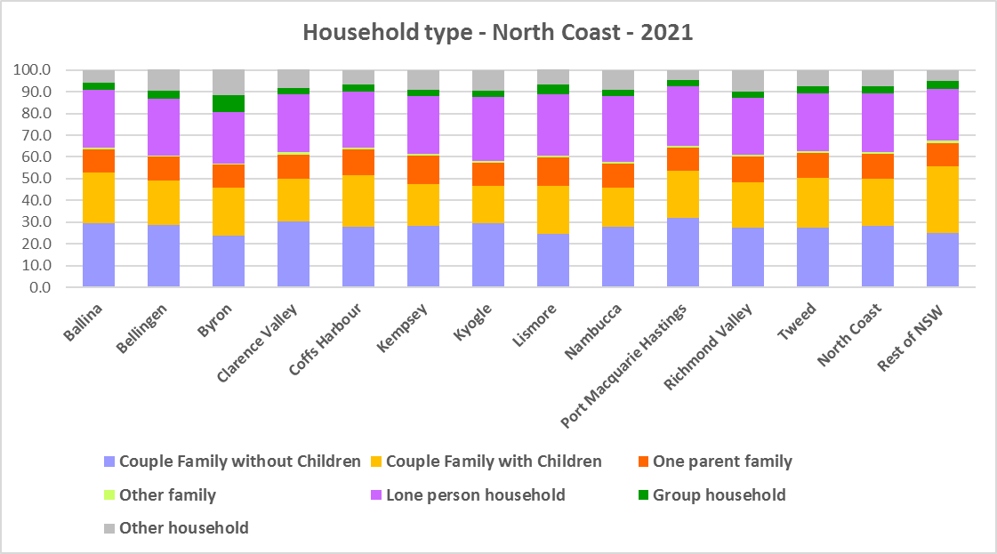



* This mix of household types suggests the need for a variety of housing, ensuring housing choice for a range of household types, including studio, one and two bedroom homes to suit smaller households. The provision of smaller more affordable dwellings is important given the significant number of lone person households on the North Coast.

**Household Size**

* All the North Coast region LGAs have an equal to or lower average household size than the Rest of NSW (2.4 persons per household), with the exception of Byron (with a slightly larger average household size of 2.5).
* Since 2006, average household size has either stayed stable or declined in almost every North Coast region LGA, in line with the trend for the Rest of NSW. The exceptions are Ballina and Byron – both of which saw an increase in average household size between 2016 and 2021
* The table below gives the average household size in all 12 LGAs in the North Coast and the Rest of NSW (excluding Sydney) for 2006, 2011, 2016 and 2021.



**Income**

* At the 2021 Census, low income households comprise the largest proportion of all households in every North Coast region LGA, with the exception of Ballina.
* All the North Coast LGAs have a higher proportion of low income households than the average for the Rest of NSW (49.3%), except for Ballina (well under with 38.2%) and Byron (just under at 48.5%). Across the North Coast the proportion of low income households ranges from 38.2% in Ballina to 71.0% in Kyogle.
* Moderate income households in the Rest of NSW comprise 21.5% of all households, while in the North Coast they range from 17.3% in Kyogle to 23.1% in Byron.
* High income households comprise 29.2% of all households in the Rest of NSW and in North Coast range between 11.8% in Kyogle and 40.3% in Ballina.
* The graph and table below show the proportion of low, moderate and high income households in all the North Coast LGAs, compared with the region and the Rest of NSW at the 2021 Census.

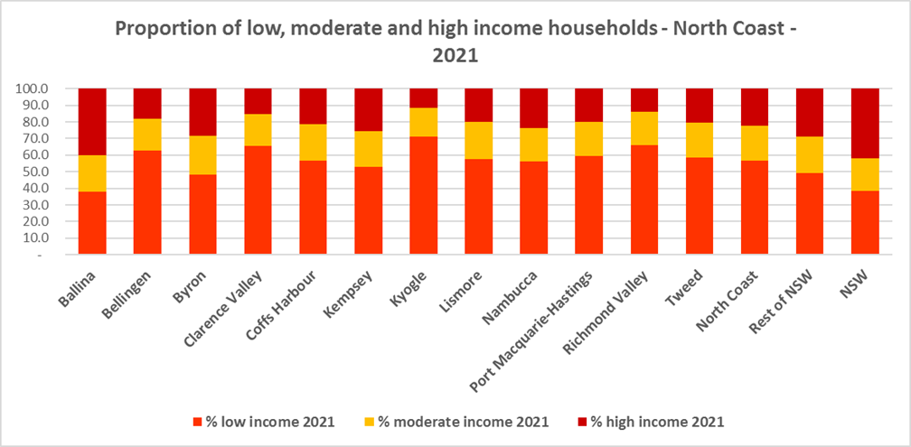



* Between 2016 and 2021 the number of low income households increased in every North Coast LGA, in line with the trend for the Rest of NSW, except for Ballina, Kempsey and Nambucca.
* Over the same period, the number of moderate income households increased in every North Coast LGA excepting Bellingen, Kyogle and Richmond Valley.
* The number of high income households declined in every North Coast LGA other than Ballina, Byron, Kempsey and Nambucca – which all experienced an increase.
* Between 2016 and 2021, Kyogle, Bellingen, Port Macquarie-Hastings and Richmond Valley had the largest proportional increases in low income households.
* Collectively North Coast as a region experienced an increase of 2.9% in the number of low income households and every LGA except Byron had a larger increase in the proportion of low income households than the Rest of NSW – excepting that Ballina, Kempsey and Nambucca all experienced a decline in low income households.
* The graph below shows the change in the proportion of very low and low (collectively low) income households from 2011 to 2016 to 2021 in the North Coast LGAs.

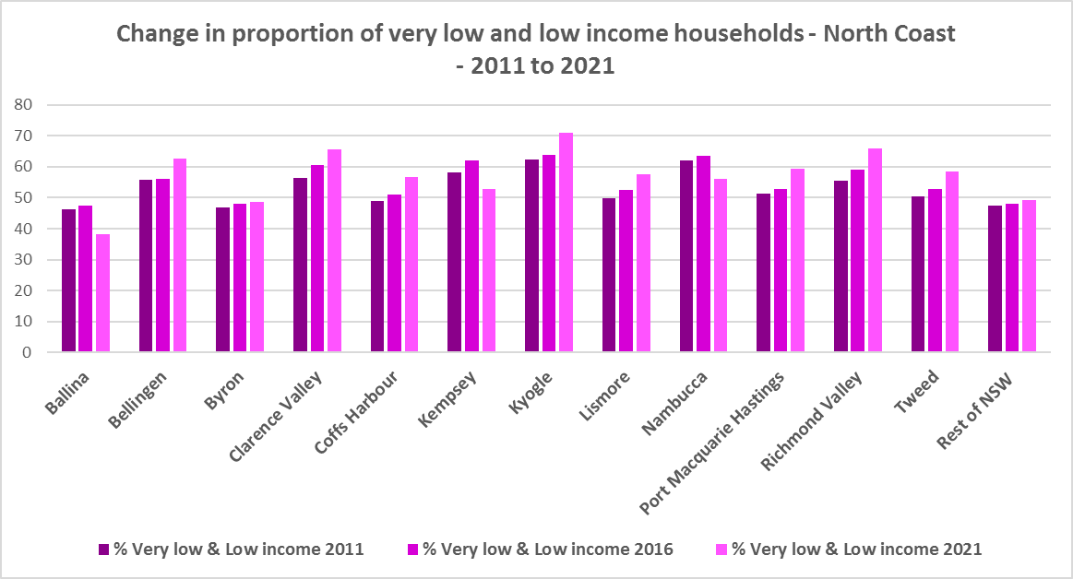

* However, despite the increase in the number of low income households between 2016 and 2021, all North Coast LGAs experienced a very strong decline in very low income **rental** households over the same period, varying between a -47.9% decline in Byron and a -20.4% decline in Coffs Harbour.
* Most also had declines in low income **rental** households over the same period, with Byron again having the largest proportional decline of 20.0%. However, Kyogle, Nambucca Valley, Port Macquarie-Hastings and Richmond Valley all had increases in the proportion of low income rental households.
* The significant reduction in both very low (-3,671) and low income renters (-847) across the North Coast region is likely due to the additional Commonwealth financial assistance to renters during the pandemic and may therefore be temporary – as this has subsequently been discontinued, as explained in the What’s Happening in the Housing Market” snapshot for the North Coast. It is also likely that at least some lower income rental households have been priced out of some LGAs and even the region and/or impacted by the loss of long term rental to short term rental or home purchase/ownership. The snapshot of What’s Happening in the Housing Market shows the significant decline in the proportion of private rental that is affordable to very low income households.
* These changes underline the need to consider tenure as well as price point when developing housing responses to meet housing needs in the North Coast communities.
* The graph below shows the change in the number of very low and low income renters between 2016 and 2021 in the North Coast.

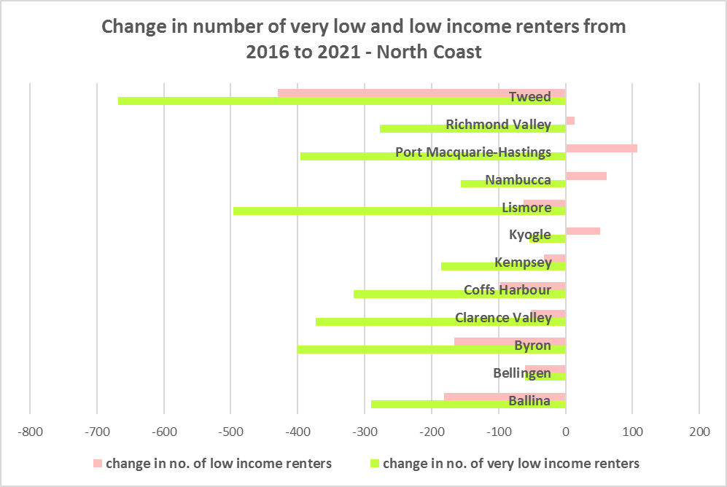

* Byron ($1602) is the only LGA in the North Coast region with a higher median income at 2021 than the Rest of NSW ($1,434), with Ballina just below ($1,429).
* The table below shows the change in median income in each North Coast LGA along with the Rest of NSW from the 2011, 2016 and 2021 Census.



**Homelessness**

* People experiencing homelessness and those at risk of homelessness are among Australia’s most socially and economically disadvantaged. State, Commonwealth and local government fund services to support people who are homeless, or at risk of homelessness. Services are delivered mainly by non–government organisations, some of which specialise in delivering services to specific groups (such as young people or people experiencing domestic violence).
* Inadequate income and inability to access affordable housing are significant contributing factors to homelessness, along with individual factors such as experience of family and domestic violence, ill health and disability.
* The ABS identifies someone as homeless “where they do not have suitable accommodation alternatives and their current living arrangement:
  + Is in a dwelling that is inadequate;
  + Has no tenure or their initial tenure is short and not extendable; or
  + Does not allow them to have control of and access to space for social relations.”
* The ABS uses “six operational groups for presenting estimates of people experiencing homelessness on Census night:
  + People living in improvised dwellings, tents or sleeping out
  + People living in supported accommodation for the homeless
  + People staying temporarily with other households
  + People living in boarding houses
  + People in other temporary lodgings
  + People living in ‘severely’ overcrowded dwellings.”
* The ABS “also compiles estimates from Census data for the following three groups of people who may be marginally housed but are not classified as homeless:
  + People living in other crowded dwellings
  + People in other improvised dwellings
  + People marginally housed in caravan parks.”
* The table below shows that ABS 2021 Census data for the Central Coast on the homeless and marginally housed.
* Note that due to additional assistance provided during the pandemic, the number of people counted as homeless on Census night in 2021 is lower than at the 2016 Census across Australia. Nevertheless there were 2,459 people counted as homeless in the North Coast at the 2021 Census and a further 2,287 who were counted as marginally housed.
* Of those who were counted as homeless on the North Coast at the 2021 Census, the largest number were people staying temporarily with other households (697 or 28.3%), followed by people living in severely overcrowded dwellings (566 or 23.0%), then people staying in supported accommodation for the homeless (376 or 15.3%).
* Of those who were counted as marginally housed, the majority were people living in other crowded dwellings (1,346 or 58.9%). However, unlike most other regions in NSW, the North Coast also has a significant number of people who are marginally housed in caravan parks (857 or 37.5%).
* This indicates the need for more affordable rental housing.



* The 2023 NSW street count, the NSW Government’s fourth annual rough sleeping street count, was completed between 2 February and 27 February 2023.
* The table below gives the street count results for the North Coast region locations.
* Over 300 local organisations either consulted in the planning phase or participated in the delivery of street counts. Organisations which partnered with the Department of Communities and Justice (DCJ) included Community Housing Providers, local councils and Specialist Homelessness Services, as well Aboriginal organisations, Local Health Districts, local community groups, and Police.
* 1,623 people were counted sleeping rough during these street counts, a 34% increase from 2022.
* Street counts took place in more than 350 towns in 76 LGAs, compared to 71 LGAs in 2021 and 65 LGAs in 2020.
* Most North Coast LGAs saw a significant increase in the number of people sleeping rough in 2023 compared with 2022.



**\***Byron Bay Shire result for 2022 excludes Brunswick Heads, Mullumbimby and surrounding areas as counts were unable to be completed in these areas due to extreme weather.

## People with Disability

* According to the Australian Institute of Health and Welfare (AIHW) and data from the 2018 Australian Bureau of Statistics (ABS) Survey of Disability, 18% of people in Australia have disability. Another 22% have a long term health condition but not disability.
* Nearly one third (32%) of people with disability have severe or profound disability. This means needing help with daily self-care, mobility or communication activities, having difficulty understanding or being understood by family or friends, or communicating more easily using sign language or other non-spoken forms of communication.
* The survey data shows:
  + 7.6% of children aged 0–14 have disability
  + 9.3% of people aged 15–24 have disability
  + 13% of people aged 15–64 have disability
  + 50% of people aged 65 and over have disability (ABS 2019b).
* For about 3 in 4 (77%) people with disability, the main type of disability is physical, while for the remaining 1 in 4 (23%), the main type of disability is mental or behavioural.
* Clearly housing is a significant factor in the health and wellbeing of people with disability. The availability of affordable, sustainable and appropriate housing helps people with disability to participate in the social, economic and community aspects of everyday life. Someone without access to affordable, secure and appropriate housing is more likely to experience homelessness, poor health, and lower rates of employment and education.
* While most people with disability live at home in the community (96% in private dwellings), some live in cared accommodation.
* Cared accommodation is usually long term and may be institutional in style, including hospitals, residential aged care, cared components of retirement villages, aged care hostels, psychiatric institutions and group homes for people with disability. The more severe a person’s disability is, the more likely they are to live in cared accommodation and the less likely they are to live in the community.
* There has been a significant shift towards supporting people with disability to live in private dwellings, rather than being in institutional care over recent decades. Largely this has been driven by changes for young people with disability.

## Additional Data

More detailed housing data and tables used in this Snapshot are available from the Local Government Housing Kit Database on the FACS website at:

<https://www.facs.nsw.gov.au/resources/nsw-local-government-housing-kit/chapters/local-government-housing-kit-database>

More information on the housing needs of older Australians and people with disability:

The Australian Institute of Health and Welfare – Older Australians Housing and Living Arrangements on the AIHW website at:

<https://www.aihw.gov.au/reports/older-people/older-australians/contents/housing-and-living-arrangements>

The Australian Institute of Health and Welfare – People with Disability in Australia

<https://www.aihw.gov.au/reports/disability/people-with-disability-in-australia/contents/people-with-disability/prevalence-of-disability>

and relating to housing needs

<https://www.aihw.gov.au/reports/disability/people-with-disability-in-australia/contents/housing>

The Productivity Commission’s report Housing Decisions of Older Australians is at:

<https://www.pc.gov.au/research/completed/housing-decisions-older-australians>

More detailed information on population, household and dwelling projections is available on the Department of Planning and Environment website at:

<https://www.planning.nsw.gov.au/Research-and-Demography/Population-Projections/Projections>

<https://pp.planningportal.nsw.gov.au/populations>

More data on homelessness, specifically homelessness service data is available on the Homelessness NSW website at:

<https://homelessnessnsw.org.au/resource/specialist-homelessness-service-data/>

And from the AIHW website here:

<https://www.aihw.gov.au/reports/australias-welfare/homelessness-and-homelessness-services>

The 2023 Street Count result is at the DCJ/ FACS website here:

<https://www.facs.nsw.gov.au/reforms/homelessness/premiers-priority-to-reduce-street-homelessness/street-count>

Further information on ABS estimation of homelessness is available at the ABS website:

<https://www.abs.gov.au/statistics/people/housing/estimating-homelessness-census/2021>