**Central West and Orana – What’s Happening in the Housing Market?**

This Housing Snapshot looks at aspects of the housing market in the Central West and Orana, particularly from the 2016 Census to the 2021 Census – including rents, vacancy rate, affordable private rental for very low and low income households, rental stress for low income households, number of new bonds lodged affordable to low income households, sales price, purchase affordability for very low and low income households and purchase stress for low income households.

The Central West and Orana region covers nineteen local government areas, including several regional centres. Housing market conditions and rent and purchase affordability varies significantly within the region, particularly between the larger centres and the rest of the region. There are declining numbers of affordable rental properties, the rental market is very tight, rents are rising and there are higher numbers of lower income rental households in housing stress. Across NSW there is insufficient housing supply to meet demand, growing cost of living pressures, including rising inflation and interest rates with continued low wage growth. These have created further difficulties for lower income earners and their capacity to manage housing costs.

**Central West and Orana Region – What’s Happening in the Housing Market?**

# ***Housing Market - Rental***

**Rents**

* Looking at all residential rentals combined together, there have been strong increases in median rents in the Central West and Orana region for a couple of decades. However, the period from 2019 to 2022 has been more varied and complex.
* The graph below shows the increase in median rents for all dwellings (including all bedroom categories) in each Central West and Orana LGA from June 1990 to June 2022.

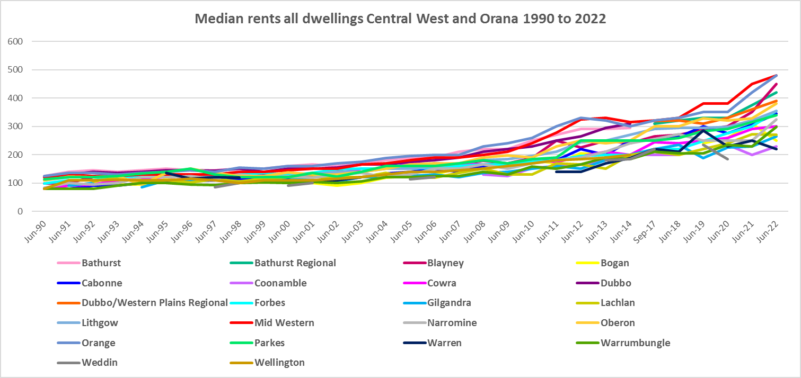

* The table below shows the change in median rents from 2017 to 2022 in the Central West and Orana LGAs. Over this five year time frame rents increased from between 0% in Warren and 69.8% increase in Blayney. The largest increases in dollar terms were in Blayney (an increase of $185 per week), Mid-Western and Orange ($160 per week), Forbes ($135) and Bathurst Regional ($110).



* However, there were variations in the rate of increase over that time frame.
* Between 2019 and 2020 when Covid lockdowns were introduced, there were generally lower increases, and in some cases decreases in median rents. Dubbo/ Western Plains Regional (-13.6% for one bed), Lithgow (-7.4% for two bed and -2.6% for four bed) and Cabonne (-3.3% for three bed) along with Cowra (-3.8% for two bed) experienced declines in median rentals over this period.
* Nevertheless, over the same period Mid-Western Regional experienced strong median rental increases particularly for one bedroom properties (20.8%) and four bedroom properties (10.5%), along with Forbes (15.0% for two bed and 10.0% for four bed), while some LGAs saw no change at all in median rents in some bedroom categories (Dubbo, Lithgow, Mid-Western and Parkes).
* The table below gives the weekly median rents in dollar terms and the changes between 2019 and 2020 for Central West and Orana LGAs.



* Between June 2020 and June 2022 a different pattern emerges, with all LGAs in Central West and Orana experiencing strong increases in median rents as the table below shows.
* Over this time frame Orange and Mid-Western Regional experienced the strongest increases in median rents in dollar terms, followed by Dubbo/ Western Plains Regional, Bathurst and Lithgow. In percentage terms the biggest increases were in Dubbo, Orange, Cabonne, Forbes and Lithgow.
* Between 2020 and 2022 median rents for one bedroom homes increased by 38.4% in Dubbo/ Western Plains Regional, for two bedroom dwellings by 31.7% in Orange, for three bedroom dwellings by 36.2% in Cabonne and for four bedroom homes by 36.4% in Forbes.



* At June 2022, median rents for one, two and three bedroom homes were highest in Orange ($310, $395 and $500 respectively) while for four bedroom homes the median rent was highest in Mid-Western ($600).

**Vacancy Rate**

* A vacancy rate of 3% is understood to represent a balance between supply and demand in the rental market. According to the Real Estate Institute of NSW (REINSW) data, vacancy rates were below 3% for both the Central West and Orana for much of the period from 2006 through to 2023. Indeed, for much of that time the vacancy rate has been below 2% - indicating a chronic shortage of rental housing. The vacancy rate in the Central West has been below 2% since May 2020 and in Orana the last time the vacancy rate was as high as 2% was November 2021.
* At March 2023 the vacancy rate in both the Central West and Orana was 1.7%. Vacancy rates are tight across both regional and metropolitan New South Wales, with for example New England having a vacancy rate of 1.6% at March 2023, the Riverina 0.9%, Murrumbidgee 1.4%, Albury 0.5% and Sydney 1.3%.
* Anecdotally, the tight vacancy rate is negatively impacting many tenants, who are struggling to find accommodation and potentially facing homelessness.

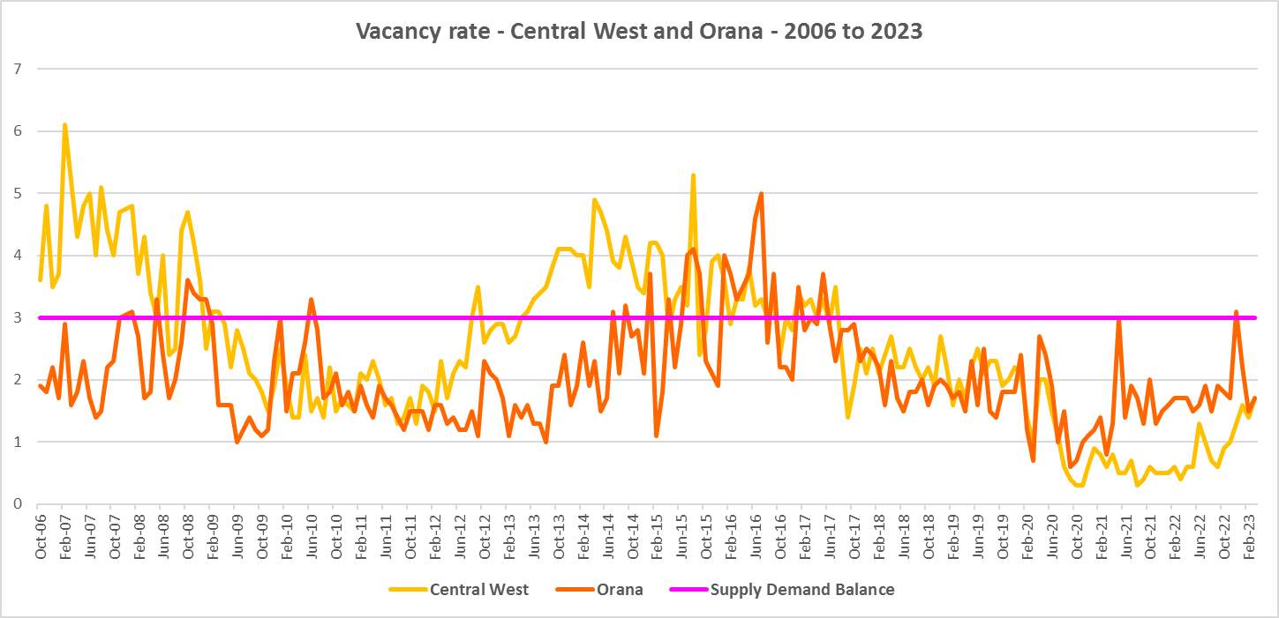

**Affordable Rental**

* The general trend across Sydney and NSW has been for a decline in the proportion of rental stock which is affordable for very low, low and moderate income earners.
* This has been the trend also in the Central West and Orana, although along with elsewhere in NSW, there were more complex factors at play between 2019 and 2022.
* Across the Rest of NSW, the proportion of affordable rental for very low income households stayed at the 2018 level of 22.0% for 2019, improved slightly to 21.7% in 2020 and again to 21.9% in 2021 then declined in line with the longer term trend to 17.0% in 2022.
* In the Central West and Orana, this pattern was more varied. Between 2018 and 2019 rental affordability for very low income households improved in Dubbo/ Western Regional, Lithgow, Narromine, Orange and Warrumbungle Shire and declined in all other LGAs in the region.
* Between 2019 and 2020 the proportion affordable for rental by very low income households was stable in Bathurst Regional, declined in Blayney, Cowra, Dubbo/ Western Plains Regional, Forbes, Mid Western Regional, Oberon and Parkes and improved in Cabonne, Lithgow, Narromine, Orange, and Warrumbungle Shire.
* Between 2020 and 2021 rental affordability improved in Blayney, Forbes, Lithgow, Mid Western Regional and Warrumbungle and declined everywhere else.
* Between 2021 and 2022 rental affordability for very low income households declined in Bathurst Regional, Cabonne, Cowra, Dubbo/ Western Plains Regional, Narromine, Orange and Parkes in line with the trend in the Rest of NSW and improved in Blayney, Forbes, Lithgow, Mid Western Regional and Warrumbungle Shire.
* At June 2022, of the Central West and Orana LGAs, only Orange (12.5%) and Mid Western Regional (14.5%) had a lower proportion of affordable rental for very low income households than the Rest of NSW average of 17.0%. Bathurst had 17.3%, just above the Rest of NSW average.
* The table and graph below show the change in the proportion of private rental accommodation affordable to **very low income** households in the Central West and Orana between 2001 and 2022. Note there are not always sufficient new bonds lodged in a local government area to reliably calculate the proportion – so no data will be recorded where this is the case.

Proportion private rental affordable for very low income households



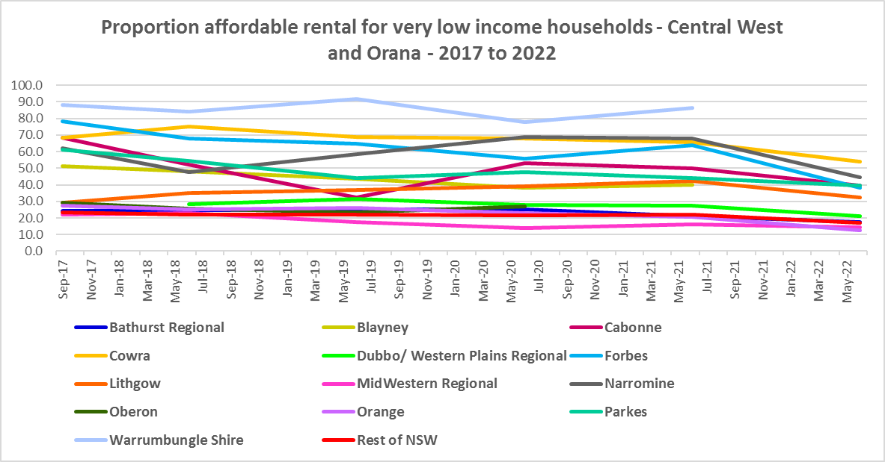

* The proportion of rental affordable for **low income** households has also improved recently in many LGAs in the Central West and Orana compared with 2017.
* Between 2018 and 2020 the proportion of rental affordable for low income households increased gently from 54.1% to 55.2% and then declined again to 45.4% in June 2022 in the Rest of NSW.
* Again the picture in the region was more varied.
* Overall Bathurst, Cowra, Dubbo/ Western Plains Regional, Forbes, Lithgow, Mid-Western Regional, Narromine, Orange and Parkes have a lower proportion of private rental affordable for low income households in 2022 than in 2018, but experienced rises and falls over that time frame rather than a continuous decline. Cabonne, and Oberon actually have a higher proportion affordable for rental by low income households in 2022 than in 2018 while there are data gaps for the remaining LGAs.
* The table and graph below show the change in the proportion of private rental accommodation affordable to **low income** households in the Central West and Orana and Rest of NSW between 2001 and 2022.

Proportion private rental affordable for low income households



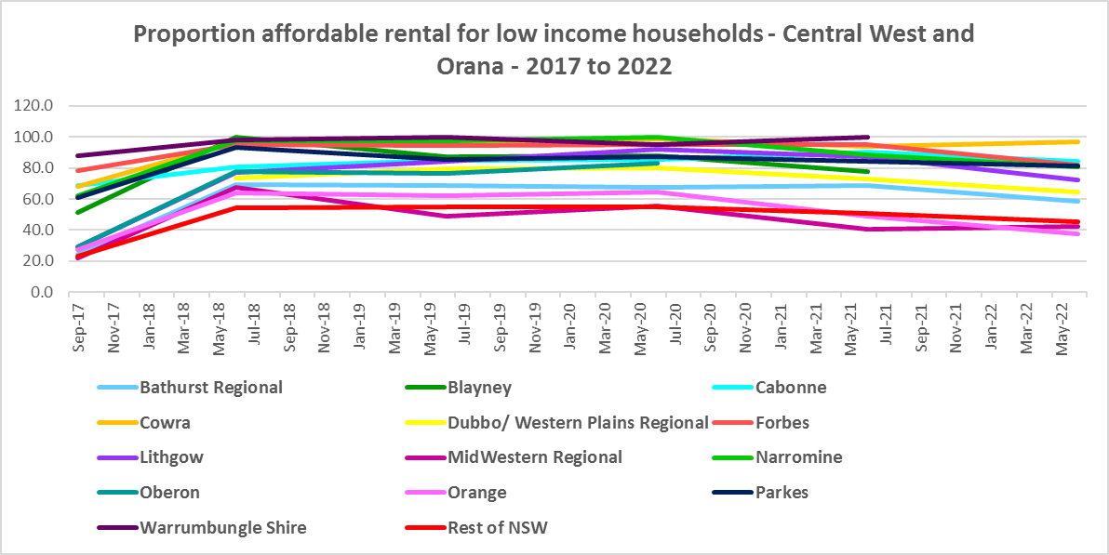

* At June 2022, Orange (37.3%) and Mid-Western Regional (42.5%) were the only LGAs in the region to have a lower proportion of private rental affordable for low income households than the average of 45.3% for the Rest of NSW.
* The University of Sydney Urban Housing Lab undertook a study and prepared a report for the Australian Coastal Councils on short term holiday rentals: “Planning responses to online short term holiday rental platforms” - Research Project for Australian Coastal Councils Association Inc. September 2018 by Nicole Gurran, Yuting Zhang, Pranita Shrestha, Catherine Gilbert.
* The study found (p7) “that there has been a rapid growth in online holiday rental listings overall and in coastal Australia in particular. Since Airbnb was launched in Australia, the number of listings has risen to over 130,000 properties, amounting to 3.5% of rental accommodation. In coastal communities, the rate is much higher.
* Further (p7) “the majority of these listings are whole houses, and more than half appear to be frequently available holiday lets rather than permanent residences. Considered as part of the rental housing stock, these whole houses, frequently available, amount to 19.7% of the rental housing stock in Kiama…and 48.3% of the rental housing stock in Byron.
* The study also identified a new class of investor purchasing specifically to provide short term holiday rental accommodation. This is impacting communities in a number of ways – by increasing competition for purchase, purchase prices are increasing as are rents. This impacts both home purchasers and long term renters, with evidence of lower income renters being priced out of some communities.
* The study also identified impact to communities within a 3 hour radius of capital cities. Parts of the Central West and Orana fall into this category – with Lithgow adjacent to Sydney and Bathurst and Oberon within a 3 hour drive. This report, in discussing the implications for local housing markets, noted that (p36) “Many, but not all, of the case study communities report that lower income residents and local workers face barriers in securing affordable rental housing or entering home ownership”
* More recently, research by SQM showed that between July 2019 and July 2020 Warrumbungle had a 60% increase in Airbnb listings, Blayney 57%, Mid-Western Regional 47%, Lithgow 29%, Cabonne 16%, Orange 14%, Dubbo/ Western Plains Regional 9%, Oberon 8%, while Bathurst -7%, Cowra -13% and Forbes -41% all experienced declines.
* Since 2020 it is likely that Airbnb listings have picked up again in the Central West and Orana region.

**Rental Stress**

* Households regarded as being in rental stress are renting in the private rental market and paying more than 30% of their income in rent. Lower income households in rental stress will struggle to pay for other essential household costs, such as medical or educational expenses, food, transport and energy costs.
* Overall, between 2016 and 2021, the proportion of very low income households in rental stress across the Central West and Orana increased by 3.1%, compared to an increase of 2.4% on average for the Rest of NSW.
* For low income households over the same period, there was an increase of 10.8% in rental stress in Central West and Orana as a whole, compared to 6.2% in the Rest of NSW.
* At June 2021 the proportion of very low income households in rental stress in the Rest of NSW (that is, excluding Sydney) was 91.7%. Within the Central West and Orana the average was 86.3%, with the proportion varying from 95.1% in Orange to 57.7% in Bogan.
* Orange and Lithgow (91.9%) were the only two Central West and Orana LGAs which had a higher proportion of very low income households in rental stress than the average for the Rest of NSW.
* For the Rest of NSW at 2021 the proportion of low income households in rental was 68.3%, with Central West and Orana on average much lower with 54.3%. Across the region the proportion of low income households in stress ranged from 67.0% in Mid-Western Regional to 8.2% in Warren. None of the LGAs in Central West and Orana had a higher proportion of low income households in rental stress than the Rest of NSW.
* However, while the proportion of low income rental households in stress increased in every LGA in Central West and Orana between the 2016 and 2021 Census, four LGAs (Blayney, Bogan, Warren and Weddin) experienced a decline in the proportion of very low income households in rental stress.
* Below is a graph of the proportion of very low and low income households in rental stress in each Central West and Orana LGA at 2021 and a table showing the change in the proportion of very low and low income households in stress between 2016 and 2021.

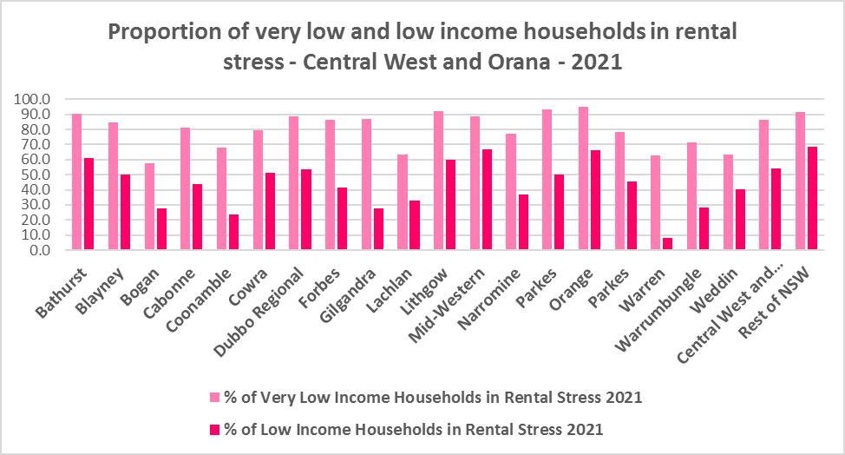

* Below is a table comparing the proportion of very low and low income households in rental stress in Central West and Orana in 2016 and 2021.



* Over the same period the actual numbers of very low income households in rental stress declined in most LGAs in the region, in the region as a whole and in the Rest of NSW. However, the number of low income households in rental stress increased in the Central West and Orana and in the Rest of NSW.
* The next two tables show the change in the number of very low and low income households in rental stress at 2016 and at 2021 in firstly in the LGAs of the region and then in the Central West and Orana region compared to the Rest of NSW.





* A look at CRA (Commonwealth Rent Assistance) recipients in housing stress gives some further information on what has been happening with lower income households in rental stress over this time frame.
* In line with other parts of NSW, between 2016 and 2020, the total number of CRA recipients in the Central West and Orana increased significantly, while the number in stress actually declined. However, between 2020 and 2021 the number of CRA recipients declined while the number in stress increased.
* The number of CRA recipients in housing stress has increased from the June 2020 figures as the temporary Coronavirus Supplement ended on 31 March 2021.
* The Coronavirus Supplement was $550 per fortnight for new and existing recipients of JobSeeker Payment, Parenting Payment, Youth Allowance for jobseekers, Farm Household Allowance and Special Benefit. The temporary supplement almost doubled the maximum payment rate for a JobSeeker Payment recipient. Hence it made rent more affordable for some CRA recipients in June 2020 and resulted in a lower proportion of CRA recipients in rental stress than usual.
* Since the end of Covid restrictions, the number of people in employment has increased, so fewer people are relying on rent assistance from the Commonwealth.
* The two graphs below clearly demonstrate this experience in Central West and Orana.

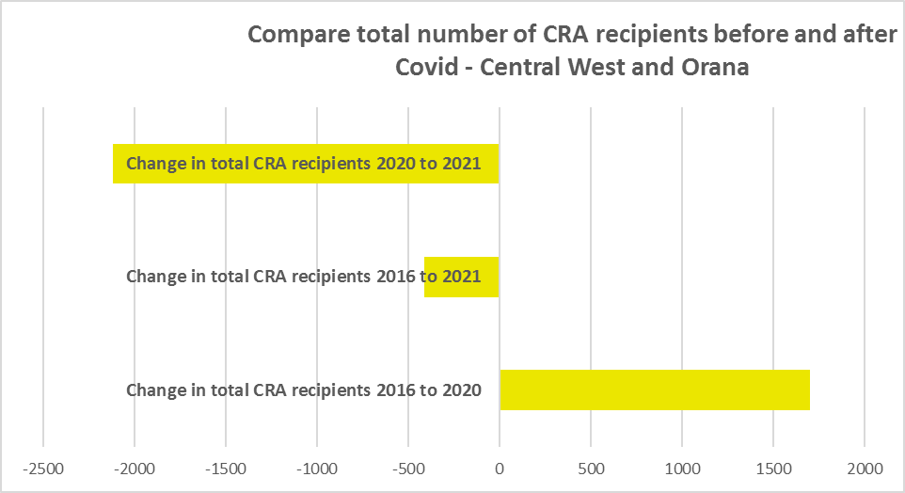

* The table below shows the number and proportion of tenants in the Central West and Orana region who are in the private rental market, are in receipt of Commonwealth Rent Assistance, and even with this additional income support, are in housing stress.
* There were a total of 6,335 tenants in receipt of CRA and in housing stress across the region in 2021, up from 5,637 in 2016. In 2016, 29.1% of CRA recipients in Central West and Orana were in stress, increasing to 33.4% in 2021.
* This indicates that this region is becoming less affordable for lower income tenants.
* Central West and Orana as a whole (33.4%) has a lower proportion of CRA recipients in housing stress than the Rest of NSW average (39.2%). However, both Bathurst (41.3%) and Orange (40.2%) have a higher proportion of CRA recipients in housing stress than the Rest of NSW average.



**Loss of Affordable Housing Stock**

* DCJ has calculated the number of new bonds lodged with the Rental Bond Board that were affordable to low income earners in Central West and Orana between 2017 and 2022. The region experienced a significant decline in affordable bonds lodged, and consequently loss of affordable housing over that five year period – with 2,721 fewer affordable bonds lodged – representing a loss of 71.0% of affordable private rental stock.
* The table below shows the number of new bonds lodged that were affordable to low income households (including very low income households) in 2017, 2021 and 2022 in each of the Central West and Orana LGAs as well as the total for the Region.
* It is clear from the table that Orange had the largest numeric losses, while Bathurst Regional, Dubbo Regional, Lithgow and Mid-Western Regional also lost a significant number of affordable dwellings.
* Proportionately, Blayney, Bogan, Coonamble, Gilgandra, Lachlan and Warrumbungle experienced the largest decline – all losing 100%.

Number of affordable rental properties (new bonds lodged) affordable to low income households



* These are significant losses and together with the tight vacancy rate, recent increases in rent and end of the Coronavirus income support from the Commonwealth, indicate the need for additional affordable housing supply.

# ***Housing Market - Purchase***

**Sales Price**

* The general trend in the median sales price of all dwellings (including houses and flats) over the ten years to March 2022 has been increasing.
* Due to Council amalgamations over the intervening period, there is no comparative data for Dubbo/Western Plains Regional. Also in LGAs with insufficient sales the median cannot be calculated.
* For the remaining LGAs Forbes (142.9%), Bathurst (129.7%), Orange (125.9%), Lithgow (112.7%) and Mid-Western Regional (100.3%) had the strongest increases in median sales price for houses between March 2012 and March 2022.
* The table below shows changes in the median sales price of all dwellings (including both houses and flats) over the last ten years in the Central West and Orana region.

Median Sales Price – all dwellings



* However, between 2019 and 2022 there were clear impacts from Covid, creating more complex changes in the market, as the table below demonstrates.
* Between March 2019 and 2020 median house prices experienced relatively low growth in most LGAs in the region, with Blayney actually seeing a fall in median house prices over that year. Changes in the median sales price for houses ranged between -9.4% in Blayney and an unusually high 30.6% in Forbes, with most LGAs (with sufficient sales data to calculate the median) seeing much smaller increases.
* Between March 2021 and March 2022 there was strong growth in median house prices. Increases in the median sales price for houses ranged between 42.5% in Lithgow and 13.3% in Blayney, with the biggest increase in dollar terms being the $190,000 increase in the median in Bathurst.



* The long term median sales price trend for houses and flats shows growth across all LGAs.
* At March 2022, the median sales price for houses is highest in Orange ($703,000), Bathurst ($653,000), Mid Western Regional ($628,000), Lithgow ($550,000), Western Plains Regional ($494,000) and Cabonne ($488,000).
* The graph below shows the median sales price trend for all dwellings from 1991 to 2022 in all the Central West and Orana LGAs.

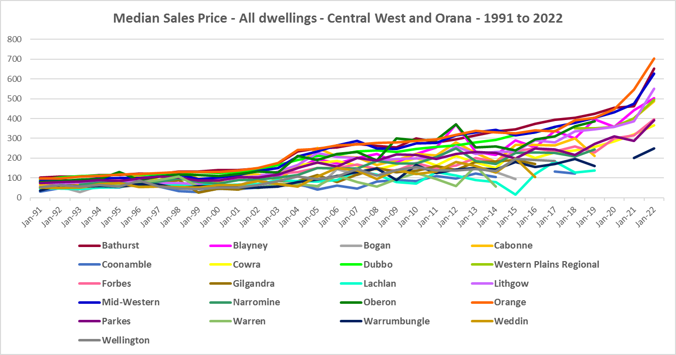

**Purchase Affordability**

* Purchase affordability for very low income earners has varied over the period from 2017 to 2021 and in the Rest of NSW the proportion of sales affordable to purchase by very low income households is lower in 2021 than in 2017.
* Purchase affordability has also declined in every LGA in the Central West and Orana.
* Four LGAs had a lower proportion affordable for purchase than the average for the Rest of NSW of 7.5% at June 2021 - Orange (0.4%), Bathurst (1.8%), Mid-Western Regional (3.2%) and Oberon (6.5%).
* At June 2021, within the region, the proportion affordable for purchase by very low income households ranged from 0.4% in Orange to 73.0% n Warrumbungle.
* The graph and table below shows purchase affordability for very low income households in the Central West and Orana LGAs and the Rest of NSW between 2017 and 2021.

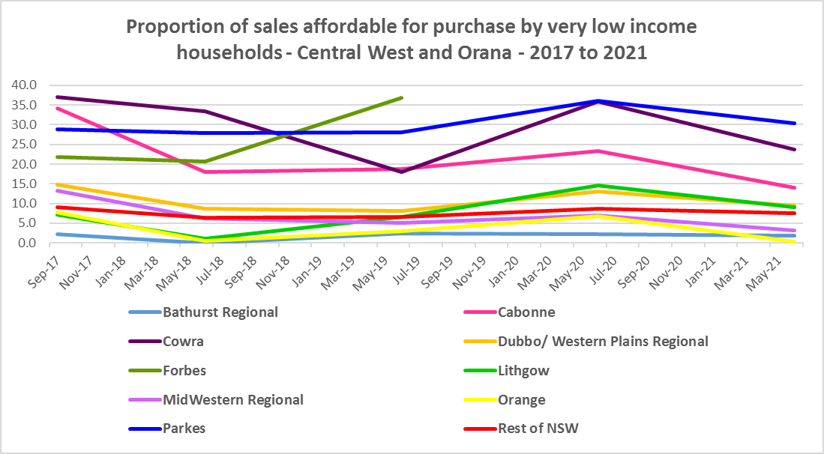

* Note there were insufficient sales in some LGAs to calculate the proportion affordable for purchase for both very low and low income households, so not all Central West and Orana LGAs have been included in the graphs and tables.

Proportion affordable purchase for very low income households



* In the Rest of NSW, the proportion of affordable purchase for low income households in 2021 (23.8%) is only marginally below that for 2001 (24.2%) with significant variation in the intervening period.
* There have been much more significant declines in affordable purchase for low income households over the same period for the majority of Central West and Orana LGAs.
* At June 2021, Orange had the lowest proportion of affordable purchase for low income households with 17.6%, followed by Bathurst with 22.1% and Mid Western Regional with 22.7%. These were the only LGAs in the region with a lower proportion than the Rest of NSW average.
* The graph and table below show the change in purchase affordability for low income households in the Central West and Orana, compared to the Rest of NSW, between 2001 and 2021.

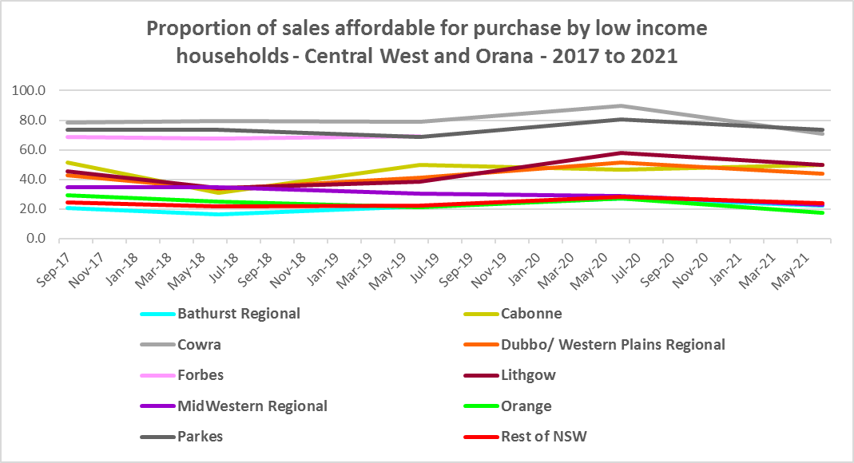

Affordable purchase for low income households



**Purchase Stress**

* In 2021 there were 1,104 very low income households and 1,050 low income households purchasing a home and in stress across the region – that is, paying more than 30% of their income on their mortgage. This represents 38.3% of very low and low income purchasers in Central West and Orana – well below the proportion for the average for the Rest of NSW at 43.9%.
* Orange had the highest proportion of very low and low income purchasers combined in stress with 47.6%, followed by Bathurst with 45.6%, Oberon with 45.5% and Cabonne with 44.9%. These were the only LGAs in the region with a higher proportion in stress than the Rest of NSW average.
* Dubbo/ Western Plains Regional had the highest number in stress with 943 very low and low income purchasers paying more than 30% of their income in housing costs.



* However the number of very low and low income purchasers in stress is significantly lower than the number of very low and low income renters in stress in the region, as the graph below demonstrates.

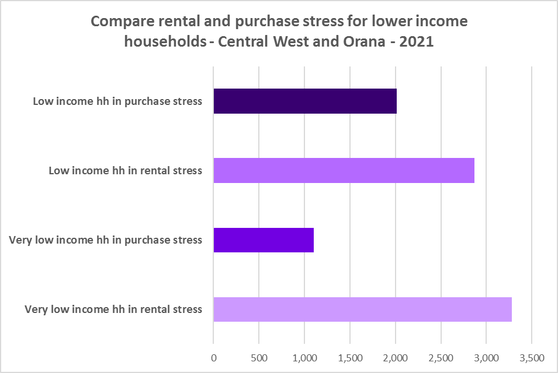

**Additional Data**

Additional data on rents and sale prices, including both current and historical data, is available from the Rent and Sales Report and the interactive Dashboard on the Housing NSW website at:

<https://www.facs.nsw.gov.au/resources/statistics/rent-and-sales/dashboard>

More detailed housing data and tables used in this Snapshot are available from the Local Government Housing Kit Database on the Housing NSW website at:

<https://www.facs.nsw.gov.au/resources/nsw-local-government-housing-kit/chapters/local-government-housing-kit-database>

More information on vacancy rates is available from the Real Estate Institute of NSW website:

<https://www.reinsw.com.au/Web/Web/Members/Property_data/Vacancy_Rates_Survey.aspx>

The Rental Affordability Index is at

<https://sgsep.com.au/projects/rental-affordability-index>