**New England North West – What’s the Housing Demand?**

This Housing Snapshot looks at aspects of housing demand in the New England North West, particularly from the 2016 Census to the 2021 Census – including population, age profile, household type, household size, income (change in low, moderate and high income households and low income rental households), homelessness and people with disability.

There have been challenges across Australia and in this region since the 2016 Census, including extreme weather events and the pandemic - which have impacted the community and the demand for housing. Subsequent cost of living pressures, including inflation, rising interest rates and further tightening of the rental market also have affected the demand for housing.

**Population Forecast**

* Changes in population will impact on the demand for housing.
* Between 2016 and 2021, the population of the New England North West grew by 2.2% or 4,028, from 181,591 to 185,619 (using ABS Census population data).
* This overall growth for the region masks significant differences in the experience of population change in individual LGAs within the region.
* Gwydir, Liverpool Plains, Moree Plains, Narrabri, Uralla and Walcha all experienced a loss of population over this period, while all the remaining LGAs in the region saw population growth.
* Changes in population between 2016 and 2021 ranged from a 5.9% increase in Gunnedah to -6.6% decline in Gwydir. In terms of numbers, Tamworth Regional had the largest increase with an additional 3,408 people, followed by Gunnedah with 715 and Armidale Regional with 656.
* Tamworth Regional has the largest population of the New England North West LGAs with 63,070 (comprising 34% of the region’s population), while Walcha has the smallest population with 3,016 (comprising 1.6% of the region’s population).
* The Department of Planning and Environment have prepared population projections for every LGA in the region. Their projections forecast growth for Armidale Regional (0.29% per annum), Glen Innes Severn (0.05%), Gunnedah (0.3%), Gwydir (0.25%), Moree Plains (1.37%) and Tamworth Regional (0.69%).
* Additionally, Inverell (-0.05%), Liverpool Plains (-0.54%), Narrabri (-0.36%), Tenterfield (-1.39%), Uralla (-1.15%) and Walcha (-0.24%) are all predicted to lose population.
* Moree Plains is the only LGA in the New England North West predicted to have a stronger annual growth rate than the average for NSW of 0.95% per annum.
* Numerically the largest increase in population forecast to 2041 is predicted for Tamworth Regional, followed by Moree Plains and Armidale Regional.
* The table below shows the population change for each New England North West LGA and the region as a whole from 2016 to 2021, using ABS Census data.



**Age**

* The age profile of the region and particularly each LGA will impact on housing need and demand, including number of bedrooms, affordability, location and dwelling type.
* The median age of the population of the New England North West LGAs at the 2021 Census ranges between 37 years (Armidale Regional and Gunnedah) and 55 (Tenterfield). Tamworth Regional (39) and Narrabri (40), like Armidale Regional and Gunnedah have a younger median age while Glen Innes Severn, Gwydir and Walcha (50), like Tenterfield, have an older median age. The other LGAs in the region fall between these two extremes. This compares to the median age for the Rest of NSW (excluding Sydney) of 43 years.
* Given the range in the median age, it is unsurprising that there is variation in the age profiles of the New England North West LGAs.
* As a region, New England North West has a higher proportion of 0-4, 5-14, 15-19, 20-24 and 25-34 year olds than the Rest of NSW average and lower proportions of older age groups. However, not every LGA in the region follows this pattern.
* Generally, Glen Innes Severn, Gwydir, Liverpool Plains, Tenterfield, Uralla and Walcha have higher proportions of cohorts aged over 55 years than the Rest of NSW average. While Armidale Regional, Gunnedah, Inverell, Moree Plains, Narrabri and Tamworth Regional tend to have higher proportions of cohorts under 35 years than the Rest of NSW average.
* This is not cut and dried, with for example Uralla having higher proportions of 5-14 and 15-19 year olds.
* The graph below shows the proportion of the population in each key age cohort in the New England North West LGAs, the region and Rest of NSW.

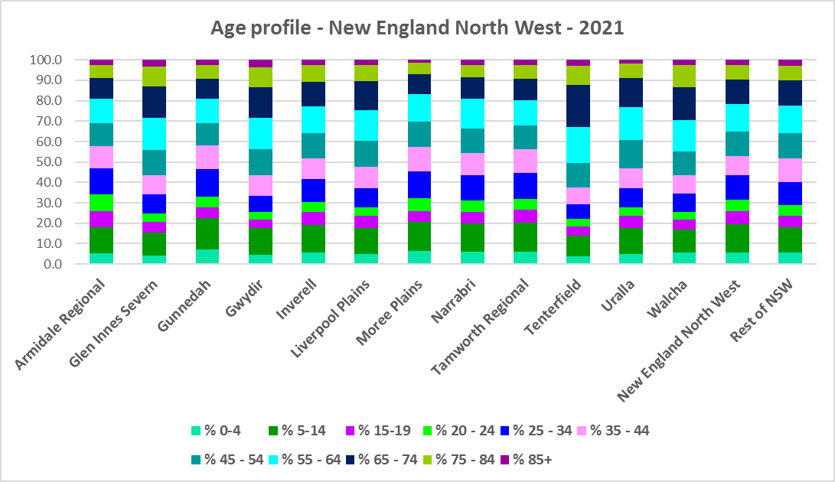

* The table below gives more detail of the breakdown of age cohorts by LGA, by region and for the Rest of NSW.



* The Department of Planning and Environment forecast increases in residents aged over 65 to 2041 in every New England North West LGA.
* The Department also projects an increase in younger age groups in Gunnedah and a decrease in younger age groups in Glen Innes Severn, Tenterfield, Uralla and Walcha.
* The diversity of age groups requires a range of different housing to meet the needs of the community throughout the housing life cycle. However the higher median age and higher proportions of older age cohorts in some of the region’s LGAs indicates that there is a need for housing to suit older residents. Increasingly this will be the case in all the New England North West LGAs as the number in older age groups grows.
* As the Australian Institute for Health and Welfare (AIHW) note:

Many older Australians prefer to age in place, meaning they wish to stay in their local home or community. However, their capacity to do so can be influenced by:

* + the appropriateness and quality of their home (for example, size, layout)
  + their ability to modify their home to suit their functional requirements
  + the cost and availability of suitable housing
  + their need for formal care and assistance
  + their proximity to services and social support.
* Although the majority of older Australians own their own home, this number is declining. About 15% of older Australians are renters. These people are generally a highly vulnerable and economically disadvantaged group, particularly single person households, with older women being the fastest growing demographic of people experiencing homelessness. There is therefore a need for more adaptable, accessible dwellings, well located, secure, low maintenance and affordable to meet the needs of seniors and frail aged in particular, within their communities. Those most in need are households in the private rental market, who struggle to afford housing on an Aged Pension or inadequate superannuation. (Source: "Housing Decisions of Older Australians" Productivity Commission December 2015).
* Given the very high proportions of low income households across this region, affordability is a key issue for all age groups, including older residents, and particularly tenants.
* The Australian Housing and Urban Research Institute (AHURI) has undertaken research on “What is the ideal home for older Australians?”:
  + “Older Australians and the housing aspirations gap” and
  + “Understanding the housing aspirations of older Australians”
* This research is part of a broader study on “Housing aspirations and constraints for lower income Australians.” AHURI’s research demonstrates that one of the most valued aspects of older residents’ housing is the location – that the neighbourhood feels safe and secure; that there is good (including walkable) access to services such as health, shopping, recreational amenities, public open space; and that it is close to family and friends.

**Household Type**

* A look at household types and average household size gives some insight into the type of housing – particularly number of bedrooms – that is likely to be appropriate to meet the housing needs of the community.
* Household types in the New England North West differ somewhat from the average for Rest of NSW.
* At the 2021 Census in the Rest of NSW, couple families without children (27.7%) and lone person households (26.1%) are the largest two household types.
* All the New England North West LGAs have higher proportions of other household types than the Rest of NSW. As whole the region has 9.5% other households compared to 6.5% in the Rest of NSW – with the highest proportion being 23.6% in Moree Plains.
* For the New England North West region as a whole, lone person households are the largest household type (27.0%) along with couple families without children (26.5%).
* Gunnedah is the only LGA in the region with couple family with children as the largest household type at 26.3% (compared to 22.4% in the region and 24.8% in the Rest of NSW).
* There has been a small shift since the 2016 Census, with an increase in couple family without children households in the Rest of NSW (0.7%), a decline in couple families with children households (-0.6%) and a small increase in lone person households (0.5%).
* Changes in the New England North West differed from the trend in the Rest of NSW:
  + There was a much stronger decline in couple families with children households – across the region it was -1.4% and as much as -2.8% in Moree Plains – with every LGA in the region experiencing a decline in the proportion of this household type between 2016 and 2021.
  + Generally, across the region there was a much lower increase in the proportion of couple families with no children (0.1% for the region as a whole – although this varied across the LGAs, with some experiencing an increase). There was also a slightly stronger increase in the proportion of lone person households in the region (0.7% - although some LGAs such as Moree Plains experienced a decline in this household type). Also the region as a whole had an increase of 0.9% in the proportion of other household types compared to a -0.5% decline in the Rest of NSW.
* The graph and table below show the proportion in each key household type for every New England North West LGA, for the region and for the Rest of NSW at the 2021 Census.

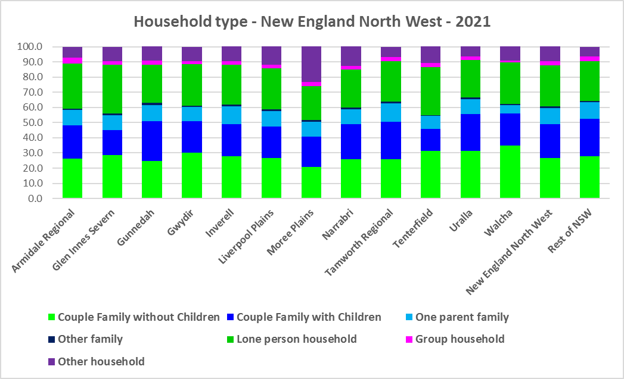



* Given the predominance of lone person and couple only households in the region, this suggests the need for an increasing diversity of bedroom mix, including more studio (bedsit), one and two bedroom homes to suit different household sizes as the number and proportion of smaller household types increases in the region.
* There are also high proportions of other household types, suggesting the need for more homes with a larger number of bedrooms. Although this may also be an issue of affordability.

**Household Size**

* At the 2021 Census, the average household size for the Rest of NSW was 2.4 persons per household – unchanged from 2016 and 2011.
* Average household size in the New England North West ranges from 2.1 persons per household in Glen Innes Severn and Tenterfield to 2.5 persons per household in Gunnedah and Moree Plains.
* In line with the trend in the Rest of NSW, between 2016 and 2021, average household size was stable in most New England North West LGAs – although Armidale Regional, Glen Innes Severn, Narrabri, Tamworth Regional and Walcha experienced a decline in the number of persons per household.
* The table below gives the average household size in each of the New England North West LGAs as well as the Rest of NSW for 2011, 2016 and 2021.



**Income**

* At the 2021 Census, low income households comprise the largest proportion of all households in the Rest of NSW, in the New England North West as a whole and each New England North West LGA.
* Ten of the twelve LGAs in the region have a higher proportion of low income households than the average for the Rest of NSW of 49.3% (the exceptions being Moree Plains which has the same proportion as the Rest of NSW and Uralla, which has a lower proportion).
* Across the region the proportion of low income households ranges from 42.1% in Uralla to 69.5% in Glen Innes Severn. New England North West as a whole has an average of 55.2% low income households, well above the Rest of NSW average.
* Moderate income households in the Rest of NSW comprise 21.5% of all households and 21.3% for the New England North West as a whole, while in the LGAs of the region they range from 17.0% in Glen Innes Severn and Gwydir to 22.4% in Uralla.
* High income households comprise 29.2% of all households in the Rest of NSW, 23.4% on average across the New England North West region and range from 13.5% of households in Glen Innes Severn to 35.5% in Uralla.
* The graph and table below show the proportion of low, moderate and high income households in all the New England North West LGAs, compared with the region and Rest of NSW at the 2021 Census.

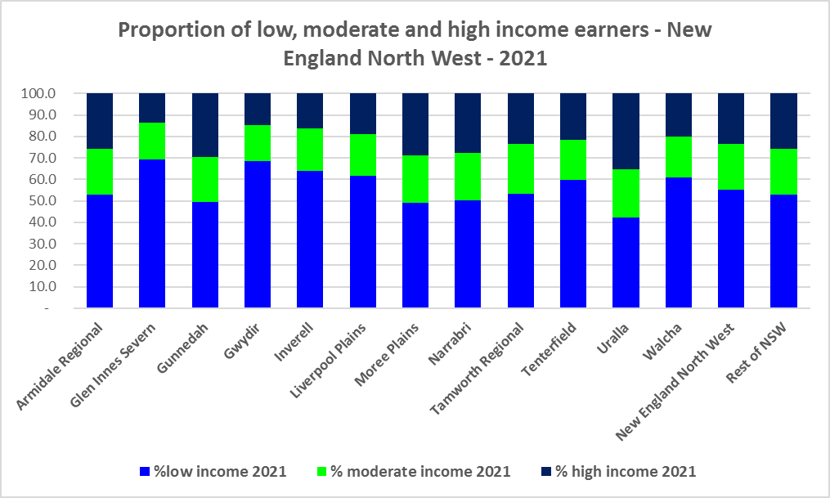



* Between 2016 and 2021 the number of low income households increased in the New England North West region and most LGA’s except for Moree Plains, Tenterfield and Uralla, which all experienced a decline in the number of low income households.
* Over the same period, the number of moderate income households increased in in most LGAs in the region and in the region as a whole but declined in Glen Innes Severn, Gwydir, Liverpool Plains, Moree Plains and Walcha.
* The number of high income households declined overall in the region and in every LGA except for Tenterfield and Uralla, which experienced an increase in high income households.
* The graph below shows the change in the number of low (including very low), moderate and high income households from 2016 to 2021 in the New England North West region.

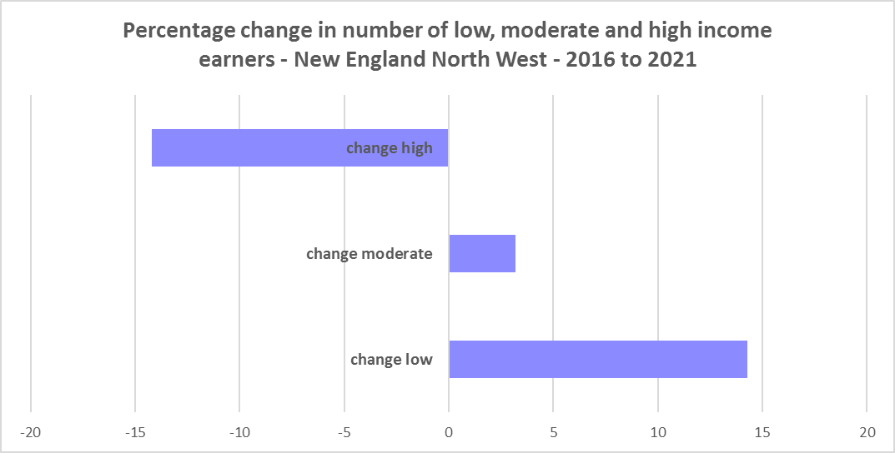

* However, despite the increase in the number of low income households between 2016 and 2021, the New England North West region as a whole and every LGA in the region experienced a decline in very low income **rental** households over the same period, varying between a -33.9% decline in Gwydir and a -6.9% decline in Walcha.
* The region as whole and six of the twelve LGAs in New England North West also had declines in low income **rental** households over the same period, with Uralla having the largest proportional decline of -29.4%. The LGAs experiencing increases in low income rental households ranged from 62.0% in Walcha to 0.7% in Tamworth Regional.
* The reduction in both very low (-890) and low income renters (-116) across the New England North West region is likely due to the additional Commonwealth financial assistance to renters during the pandemic – which has subsequently been discontinued, as explained in the What’s Happening in the Housing Market” snapshot for the New England North West.
* These changes underline the need to consider tenure as well as price point when considering responses to meet housing need.
* The graph below shows the change in the number of very low and low income **renters** between 2016 and 2021 in the New England North West.

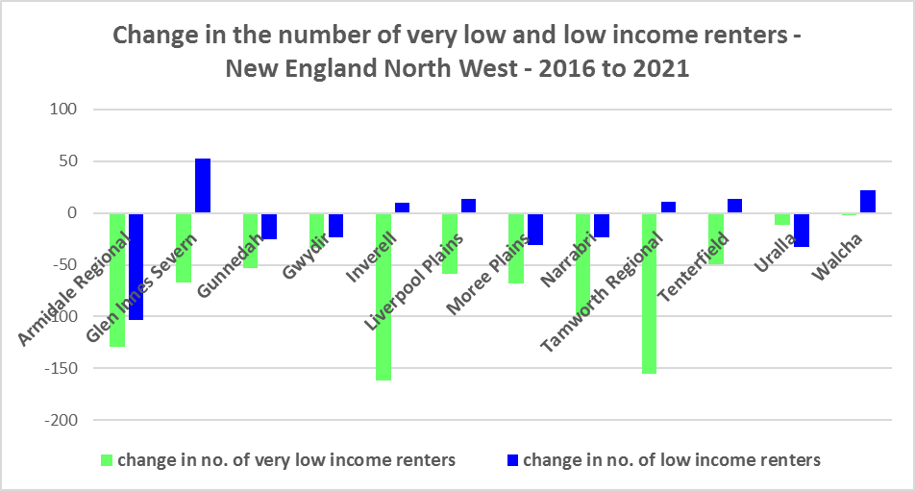

* Gunnedah, Moree Plains and Narrabri have a higher median household weekly income at 2021 than the Rest of NSW ($1,434). Gunnedah ($1557) has the highest median weekly income in the region while Tenterfield has the lowest ($885).



**Homelessness**

* People experiencing homelessness and those at risk of homelessness are among Australia’s most socially and economically disadvantaged. State, Commonwealth and some local governments fund services to support people who are homeless, or at risk of homelessness. Services are delivered mainly by non–government organisations, some of which specialise in delivering services to specific groups (such as young people or people experiencing domestic violence).
* Inadequate income and inability to access affordable housing are significant contributing factors to homelessness, along with individual factors such as experience of family and domestic violence, ill health and disability.
* The ABS identifies someone as homeless “where they do not have suitable accommodation alternatives and their current living arrangement:
  + Is in a dwelling that is inadequate;
  + Has no tenure or their initial tenure is short and not extendable; or
  + Does not allow them to have control of and access to space for social relations.”
* The ABS uses “six operational groups for presenting estimates of people experiencing homelessness on Census night:
  + People living in improvised dwellings, tents or sleeping out
  + People living in supported accommodation for the homeless
  + People staying temporarily with other households
  + People living in boarding houses
  + People in other temporary lodgings
  + People living in ‘severely’ overcrowded dwellings.”
* The ABS “also compiles estimates from Census data for the following three groups of people who may be marginally housed but are not classified as homeless:
  + People living in other crowded dwellings
  + People in other improvised dwellings
  + People marginally housed in caravan parks.”
* The table below shows ABS 2021 Census data for the New England North West on the homeless and marginally housed.
* Note that due to additional assistance provided during the pandemic, the number of people counted as homeless on Census night in 2021 is lower than at the 2016 Census across Australia. Nevertheless, there were 570 people counted as homeless at the 2021 Census in New England North West and a further 560 who were counted as marginally housed.
* Of those who were counted as homeless in New England North West at the 2021 Census, the largest number (183 or 32.1%) were people in supported accommodation for the homeless, followed by people living in severely overcrowded dwellings (153 or 26.8%), then people living temporarily with other households (127 or 22.3%).
* Of those who were counted as marginally housed, the majority (433 or 77.3%) were people in other crowded dwellings.
* This clearly indicates the need for more affordable rental housing.



* The 2023 NSW street count, the NSW Government’s fourth annual rough sleeping street count, was completed between 2 February and 27 February 2023.
* Over 300 local organisations either consulted in the planning phase or participated in the delivery of street counts. Organisation which partnered with the Department of Communities and Justice (DCJ) included Community Housing Providers, local councils and Specialist Homelessness Services, as well Aboriginal organisations, Local Health Districts, local community groups, and Police.
* 1,623 people were counted sleeping rough during these street counts, a 34% increase from 2022.
* Street counts took place in more than 350 towns in 76 LGAs, compared to 71 LGAs in 2021 and 65 LGAs in 2020.
* The table below gives the street count results for the New England North West locations. The numbers for 2023 are a little lower than for 2022 overall but varied from LGA to LGA.



## People with Disability

* According to the Australian Institute of Health and Welfare (AIHW) and data from the 2018 Australian Bureau of Statistics (ABS) Survey of Disability, 18% of people in Australia have disability. Another 22% have a long term health condition but not disability.
* Nearly one third (32%) of people with disability have severe or profound disability. This means needing help with daily self-care, mobility or communication activities, having difficulty understanding or being understood by family or friends, or communicating more easily using sign language or other non-spoken forms of communication.
* The survey data shows:
  + 7.6% of children aged 0–14 have disability
  + 9.3% of people aged 15–24 have disability
  + 13% of people aged 15–64 have disability
  + 50% of people aged 65 and over have disability (ABS 2019b).
* For about 3 in 4 (77%) people with disability, the main type of disability is physical, while for the remaining 1 in 4 (23%), the main type of disability is mental or behavioural.
* Clearly housing is a significant factor in the health and wellbeing of people with disability. The availability of affordable, sustainable and appropriate housing helps people with disability to participate in the social, economic and community aspects of everyday life. Someone without access to affordable, secure and appropriate housing is more likely to experience homelessness, poor health, and lower rates of employment and education.
* While most people with disability live at home in the community (96% in private dwellings), some live in cared accommodation.
* Cared accommodation is usually long term and may be institutional in style, including hospitals, residential aged care, cared components of retirement villages, aged care hostels, psychiatric institutions and group homes for people with disability. The more severe a person’s disability is, the more likely they are to live in cared accommodation and the less likely they are to live in the community.
* There has been a significant shift towards supporting people with disability to live in private dwellings, rather than being in institutional care over recent decades. Largely this has been driven by changes for young people with disability.

## Additional Data

More detailed housing data and tables used in this Snapshot are available from the Local Government Housing Kit Database on the FACS website at:

<https://www.facs.nsw.gov.au/resources/nsw-local-government-housing-kit/chapters/local-government-housing-kit-database>

More information on the housing needs of older Australians and people with disability:

The Australian Institute of Health and Welfare – Older Australians Housing and Living Arrangements on the AIHW website at:

<https://www.aihw.gov.au/reports/older-people/older-australians/contents/housing-and-living-arrangements>

The Australian Institute of Health and Welfare – People with Disability in Australia

<https://www.aihw.gov.au/reports/disability/people-with-disability-in-australia/contents/people-with-disability/prevalence-of-disability>

and relating to housing needs

<https://www.aihw.gov.au/reports/disability/people-with-disability-in-australia/contents/housing>

The Productivity Commission’s report Housing Decisions of Older Australians is at:

<https://www.pc.gov.au/research/completed/housing-decisions-older-australians>

More detailed information on population, household and dwelling projections is available on the Department of Planning and Environment website at:

<https://www.planning.nsw.gov.au/Research-and-Demography/Population-Projections/Projections>

<https://pp.planningportal.nsw.gov.au/populations>

More data on homelessness, specifically homelessness service data is available on the Homelessness NSW website at:

<https://homelessnessnsw.org.au/resource/specialist-homelessness-service-data/>

And from the AIHW website here:

<https://www.aihw.gov.au/reports/australias-welfare/homelessness-and-homelessness-services>

The 2023 Street Count result is at the DCJ/ FACS website here:

<https://www.facs.nsw.gov.au/reforms/homelessness/premiers-priority-to-reduce-street-homelessness/street-count>

Further information on ABS estimation of homelessness is available at the ABS website:

<https://www.abs.gov.au/statistics/people/housing/estimating-homelessness-census/2021>