# South District – What’s happening with Supply and is it a good match

This Housing Snapshot looks at dwelling type, bedroom mix, tenure, social housing supply and the gaps between demand and supply, with a focus on lower income households.

There have been significant changes in South District since the 2016 Census and further developments impacting housing supply since the 2021 Census.

The Australian Bureau of Statistics reported that across Australia for January 2023, "approvals for private sector houses fell by 13.8 per cent, the fifth consecutive drop, to be the lowest result recorded since June 2012". Further, total dwelling approvals decreased in New South Wales by -49.0 per cent.

At a time when immigration is surging and there is strong demand for housing, there is a critical shortage of private rental accommodation as well as a skills shortage in the building sector. This suggests that it is likely to be some time before supply pressures ease.

## Dwelling Type

* At the 2021 Census there were 271,326 dwellings in South District, up from 249,145 in 2016.
* Of these 93.1% were occupied, (down slightly from 93.4% in 2016), above the 92.0% average percentage occupied in Greater Sydney.
* Consequently 6.9% were unoccupied (up from 6.6% in 2016) and compared to 8.0% in Greater Sydney.
* The reasons homes are unoccupied vary and include (according to a report by the Australian Housing and Urban Research Institute “Are there 1 million empty homes and 13 million unused bedrooms?”):
  + homes are being renovated
  + homes being sold as vacant possession
  + newly built or bought homes where no one has moved in yet
  + rental homes awaiting new tenants
  + people living away temporarily from home during the census count (travelling or visiting other homes)
  + homes are deemed unliveable
  + subject to a probate application or other legal proceedings
  + holiday homes
  + homes owned by people currently living overseas
  + homes being land banked, that is held vacant until the local area economics (or personal circumstances) make it more profitable to sell or redevelop the property.
* The graph below shows the proportion of occupied and unoccupied dwellings in South District and Greater Sydney at the 2021 Census.

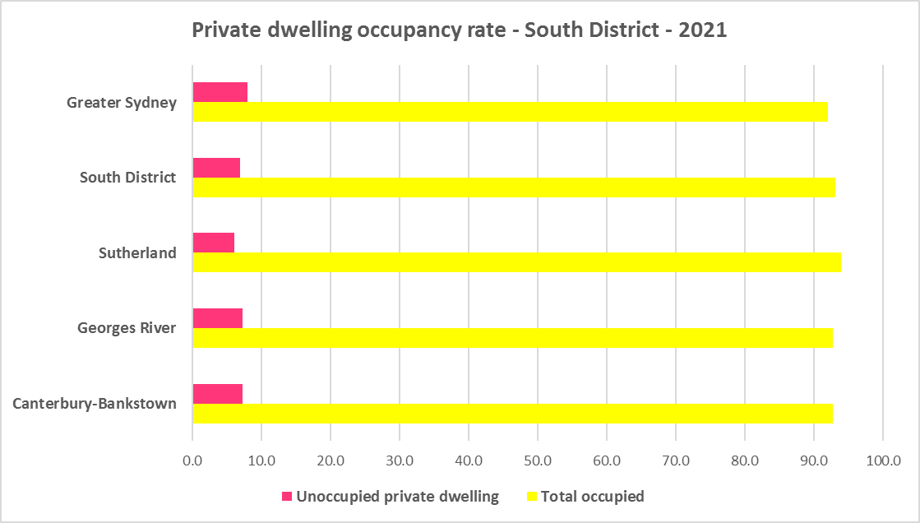

* At the 2021 Census, the majority of occupied dwellings in South District were separate houses, comprising 56.2% of all occupied dwellings, a little above the average of 55.4% for Greater Sydney. This is an improvement in diversity from 2016 when 58.6% of homes in South District were separate houses. Within South District the proportion of separate houses ranges from 60.8% in Sutherland to 51.6% in Georges River.
* A further 14.2% of occupied homes in South District were semi-detached, terrace or town houses (down marginally from 14.3% in 2016), compared to 31.0% in Greater Sydney. Within the District the proportion of semi-detached, terrace or town houses ranges from 15.7% in Canterbury-Bankstown to 11.4% in Georges River
* 28.9% of occupied homes in South District were flats (up from 26.2% in 2016), compared to 12.9% in Greater Sydney. Within South District the proportion of flats ranges between 36.2% in Georges River and 24.8% in Sutherland.
* While there has been an increase in the proportion of flats in the region, the proportion of semi-detached, terrace and townhouses has declined marginally. This type of housing is popular and generally in short supply in Sydney.
* The graph and table below show the proportion of dwelling types for South District at the 2021 Census.

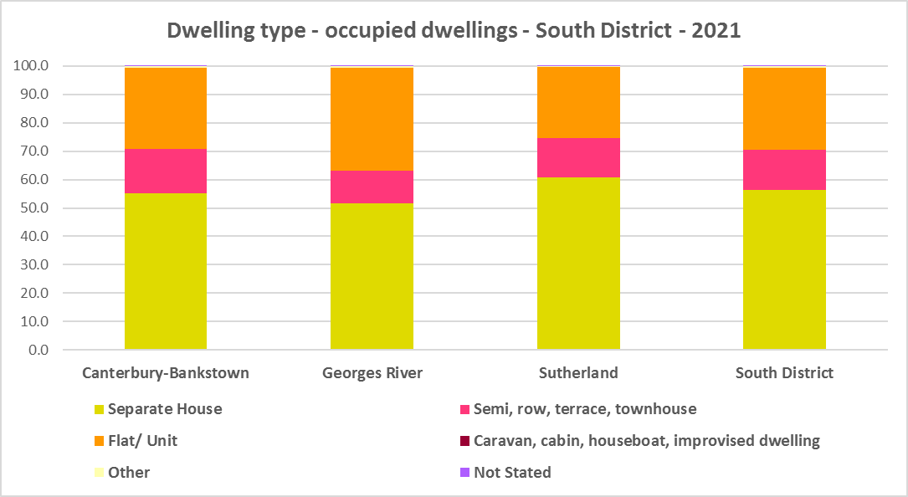



* The graph below compares the proportion of dwelling types in South District with the average for Greater Sydney.

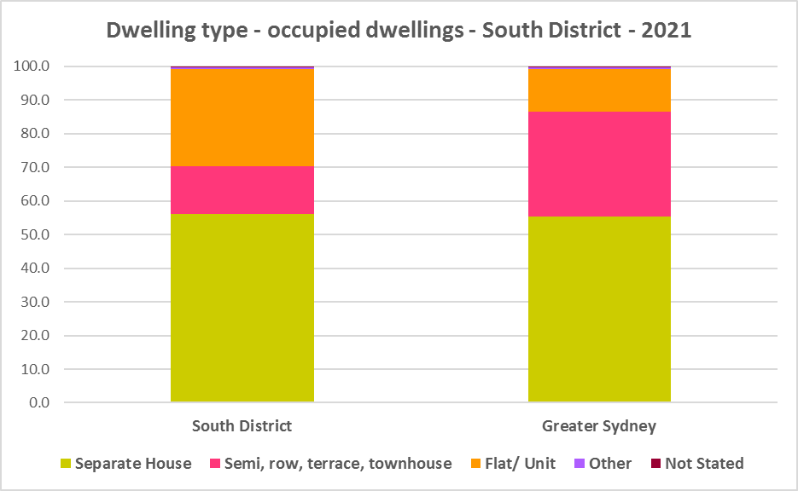

* Other types of dwellings comprised 0.5% of occupied dwellings in the region at the 2021 Census and include caravans, cabins, houseboats, improvised dwellings and flats attached to shops or offices. Census data shows 73 households living in caravans, 42 living in cabins or houseboats, none living in improvised dwellings and 1065 in flats attached to shops or offices in the region.
* Note that at the 2021 Census there were 115 households living in caravan, cabin/houseboat accommodation, down from 204 in 2016.
* While people living in caravans are included in the homeless data in the Census, caravan or residential parks are one of the few remaining affordable housing options for lower income earners. The loss of this accommodation reduces housing alternatives for lower income households and is another indicator of the loss of affordable housing.

## Bedroom Mix

* South District has insufficient variation in the number of bedrooms per dwelling, with the overwhelming majority of homes having three or more bedrooms. At the 2021 Census, 33.2% of dwellings had three bedrooms and a further 32.2% had four or more bedrooms, totalling 65.4% with three or more bedrooms. Only 0.4% of homes are studios, 5.4% have one bedroom and 27.3% have two bedrooms in South District.
* This compares to 0.9% studios, 8.1% one bedroom and 25.9% two bedroom, 31.0% three bedroom and 32.8% four or more bedrooms in Greater Sydney as a whole.
* There has been some change in bedroom mix from the 2016 Census when studios were 0.4% of occupied dwellings (no change to 2021); one bedroom homes comprised 4.6% (an increase to 5.4% in 2021); two bedrooms 26.9% (up to 27.3% in 2021); three bedrooms were 36.0% (down to 33.2% in 2021); and four or more bedrooms comprised 29.7% (up to 32.2% in 2021) of residential stock on average across the region.
* Within the region,
  + Canterbury Bankstown has the highest proportion of studio dwellings with 0.6% and Sutherland the lowest with 0.3%;
  + Georges River has the highest proportion of one bedroom homes with 5.5% and Sutherland the lowest with 5.3%;
  + Georges River has the highest proportion of two bedroom homes with 30.6% and Sutherland the lowest with 21.9%;
  + Canterbury Bankston has the highest proportion of three bedroom homes with 33.9% and Georges River the lowest with 32.3%; and
  + Sutherland has the highest proportion of four or more bedroom homes with 38.7% and Canterbury Bankstown the lowest with 28.6%.
* The graph and table below show the proportion of studio, one, two, three and four or more bedroom occupied dwellings in South District compared to Greater Sydney at the 2021 Census.

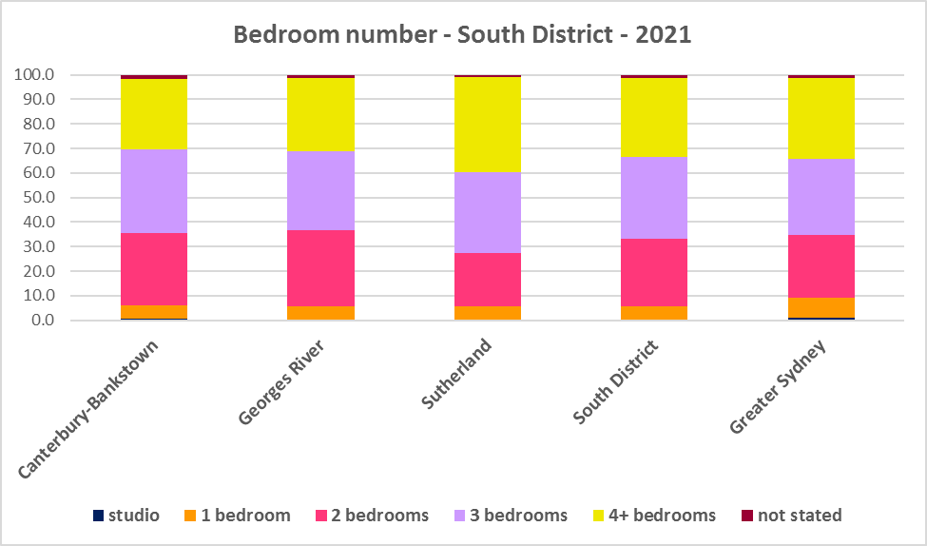



* Given that lone person and couple only households comprised 45.5% of all households in South District (up from 42.8% in 2016), the fact that studio and one bedroom homes combined comprise just 5.8% of the housing stock means there is a mismatch between household type and bedroom number. There are insufficient housing options for smaller households. Note that Sutherland with 47.8% lone person and couple only households has 71.6% of homes of three or more bedrooms.
* While both Canterbury-Bankstown and Georges River have higher proportions of two bedroom properties than Greater Sydney they have below average proportions of one bedroom homes and studio dwellings.
* The forecast increase in older age groups in South District is likely to increase the demand for smaller, more manageable and affordable homes.
* Ideally there should be an increase in the number of studio, one and two bedroom dwellings to suit these household types and to offer some housing choice, especially given the increasing proportion of lone person and couple only households in the District. Two bedroom dwellings in particular offer the most flexibility, given they are also suitable for small families and allow older residents to have family members or carers to stay while giving them a more manageable size home to maintain. Providing choice in the number of bedrooms enables them to downsize and stay in their community and more broadly may help with affordability. Sutherland in particular could improve housing choice by increasing the number of two bedroom homes.
* Note that new dwelling stock generally represents 1 – 2% of the total dwelling stock while established dwellings represent the remaining 98 – 99% of stock – so alterations and additions to existing stock have a significant impact on bedroom mix.
* When considering the fit of housing stock to household type into the future, this is an important consideration.

## Tenure

* At the 2021 Census, the most common tenure type in the South District was households owning their home with a mortgage (unlike regional NSW or North District where owning a home outright is the most common tenure, or Eastern City where rental is the largest tenure) – comprising 33.7% of all households. Within the district this ranged from 39.4% in Sutherland to 30.6% in Canterbury Bankstown.
* Households owning their home outright and rental households both comprise 32.7% of households in South District.
* Rental households range between 39.1% in Canterbury Bankstown and 22.8% in Sutherland, within South District.
* Households renting from a real estate agent comprise 22.4% of all households in South District – with Georges River having the highest proportion at 26.0% and Sutherland the lowest with 16.8% of households renting though a real estate agent.
* The remainder of rental households are comprised of households renting from the state housing authority (4.1% in the region), community housing providers (1.0%) and other landlords (5.1%).
* Within South District, households owning their home outright range from 37.1% in Sutherland to 29.2% in Canterbury Bankstown.
* The graph and table below give the tenure composition for the district and individual LGAs at the 2021 Census.

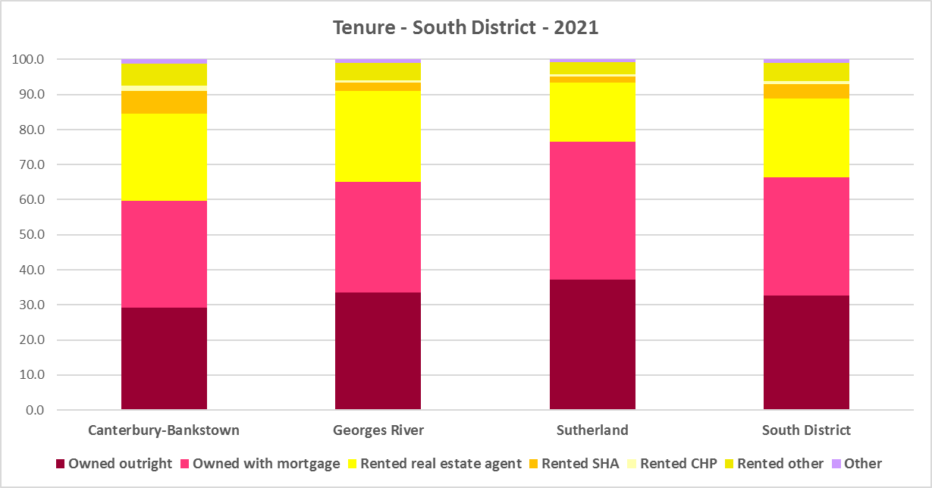



* The general trend is for increasing numbers of households relying on the private rental market as a long term tenure rather than a transitional one between leaving home and buying a home, as housing costs have increased much faster than wages.
* Subsequent high interest rates and high inflation levels have made it increasingly difficult for lower income households in particular to manage housing costs.
* The lack of housing affordability has had a significant impact on tenure, with younger households unable to afford to purchase a home. Although Canterbury Bankstown has historically been more affordable, it has become impossible for lower income earners to purchase here. The private rental market and provision of affordable rental housing is increasingly important to meet local housing needs.
* Noting that the rental market in Sydney – and NSW generally – is very tight (see the Housing Snapshot on What’s Happening in the Housing Market) it is therefore important to encourage tenure diversity and a range of price points to meet local needs, including facilitating social and affordable housing development.

**Social Housing**

* Social housing is secure and affordable rental housing for people on low incomes with housing needs. It includes public, community and Aboriginal housing. Public housing is managed by DCJ while community housing is managed by non-government organisations.
* As at June 2022, there are 154,600 social housing dwellings in NSW, with 96,712 managed by public housing, 48,264 managed by community housing and 9,624 managed exclusively for Aboriginal people – of these the Aboriginal Housing Office (AHO) are responsible for 4,120 and Aboriginal Community Housing Providers (ACHP) manage 5,504.
* The table below shows the number of public housing properties in South District LGAs as at June 2022. Please note that Census data on public housing is not totally accurate, as public housing tenure is under reported in the Census. The figures below do not include community housing properties.



* In addition, community housing providers manage a significant number of properties – including social housing, affordable housing, transitional housing and crisis accommodation in South District, as outlined in the table below.
* Note that affordable housing is not the same as social housing. Affordable housing is open to a broader range of household incomes than social housing. Households do not have to be eligible for social housing to apply for affordable housing, though people who are eligible for social housing may also be eligible for affordable housing properties.
* Affordable housing is managed more like a private rental property, but there are eligibility criteria and the managers are mostly not for profit community housing providers.



* The next table gives the number of AHO homes and the number managed by ACHPs in South Eastern Sydney as at June 2022.



* Note that there are 3 types of social housing available for Aboriginal people:
  + Public housing – these properties are managed by the Department of Communities and Justice (DCJ).
  + Aboriginal Housing Office homes – these are properties owned by the Aboriginal Housing Office and managed by DCJ.
  + Community housing properties – these properties are managed by community housing providers and Aboriginal community housing providers.
* The table below shows the expected waiting times for general housing approved social housing applicants (not for priority housing applicants) by bedroom category in the South District at June 2022. Although this District has a higher than average provision of social housing compared to other Sydney Districts, waiting times for general housing are between 5-10 years or 10+ years depending on allocation zone or bedroom numbers.



More information on Expected Waiting Times for Public Housing is available on the DCJ website by region at: <http://www.housingpathways.nsw.gov.au/How+to+Apply/Expected+Waiting+Times/>

## The Gap

* There is a large and growing gap between the increasing number of low income earners in the private rental market and the declining number of private rental properties that are affordable for low income households in South District. There is also extremely limited opportunity for low income purchasers to buy a home in South District.
* Low income (including very low income) households comprise a significant proportion of all households across the District. However, low income (including very low income) as well as moderate income households have declined in number in South District while high income households have increased significantly and are the dominant income group. Between 2016 and 2021 low income households declined by -20.7%, moderate income households declined by -22.7% and high income households increased by 57.2%.
* However, over the same time period, low income **rental** households have increased by 15.8% in South District. Low income rental households have increased despite the fact that low income households generally in this District have declined. In addition, low income rental households in housing stress have also increased between 2016 and 2021.
* Yet affordable private rental housing, as measured by new rental bonds lodged that were affordable to low income households, declined by -7.6% in South District just between 2021 and 2022.
* There is a clear need for more affordable rental accommodation to begin to address the significant demand supply imbalance, particularly for lower income households and the increasing number of seniors and frail aged.
* The vacancy rate in Sydney and regional areas of NSW has been tight for over a year, indicating a chronic shortage of rental accommodation. At April 2023 the vacancy rate was just 1.3% in Sydney overall, with 1.2 in the middle ring and 1.3% in the outer ring.
* The strong increase in rental levels, decline in rental affordability for lower income earners and loss of affordable rental properties, combined with the very high proportion and increase in low income rental households and lower income rental households in housing stress, further demonstrates the need to increase the supply of private rental housing and more particularly, affordable rental housing for long term tenants.
* The graph below shows the decline in the number of new bonds lodged that were affordable to rent for low income households in South District between 2021 and 2022.

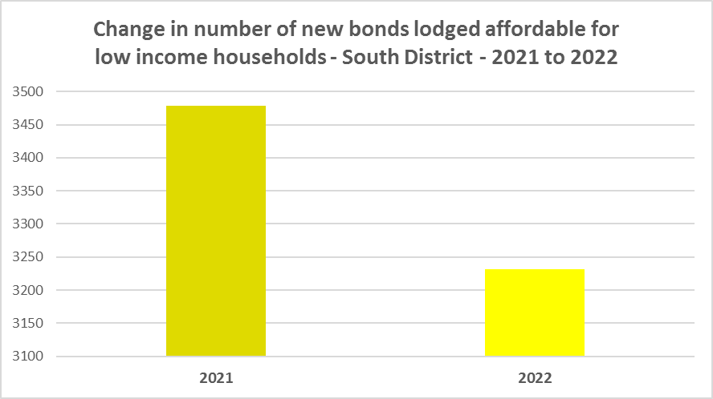

* The next graph compares changes in population, income, renters and housing stress in South District between 2016 and 2021. As previously noted, although the number of low income households declined over this period, the number of low income rental households and low income rental households in stress increased. Of note also is that the number of CRA recipients in housing stress are increasing more rapidly than low income rental households and the population generally in South District.

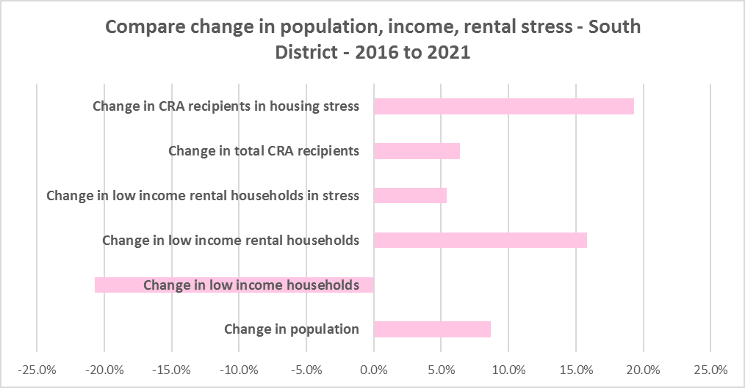

* This again demonstrates the increase in demand and need for affordable rental housing in South District.
* As well as the gap between supply and demand for affordable rental, there is generally a significant gap between dwelling size (bedroom numbers) and household size. The graph below compares the number of smaller household types - lone person and couple only – with the amount of studio and one bedroom accommodation available. It is clear that if smaller households wished to live in smaller housing, they have very little opportunity to do so. While 42.7% of households in South District are lone person or couple only (below the 45.5% average in Greater Sydney), only 5.8% of dwelling stock is studio or one bedroom (compared with 9.0% in Greater Sydney).
* This mismatch can impact on affordability, with smaller households required to consume more housing than they need or to share because of lack of choice.
* It also limits the opportunity for empty nesters or older single households to downsize to smaller more manageable homes within their communities. This can impact on the independence of older residents and their ability to age in place. This will become increasingly important as the population of South District is forecast to have an increase in older age groups.

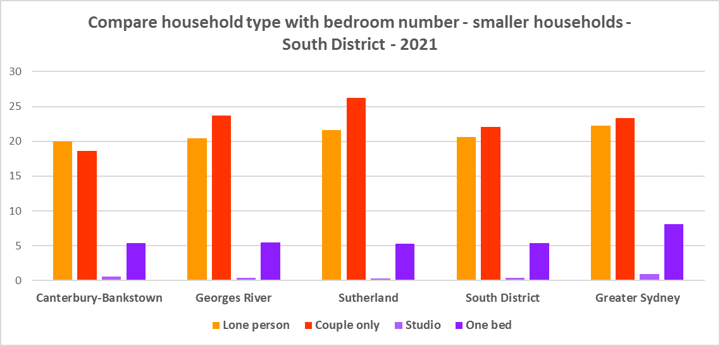

* While there has been an increase in studio and one bedroom homes since the 2016 Census in South District, the number is easily outweighed by the increase in the number of four and more bedroom homes, as seen in the graph below. Although notably there has been a strong increase in two bedroom properties, which helps provide flexibility in housing supply as they are suitable for single people, couples and small families.

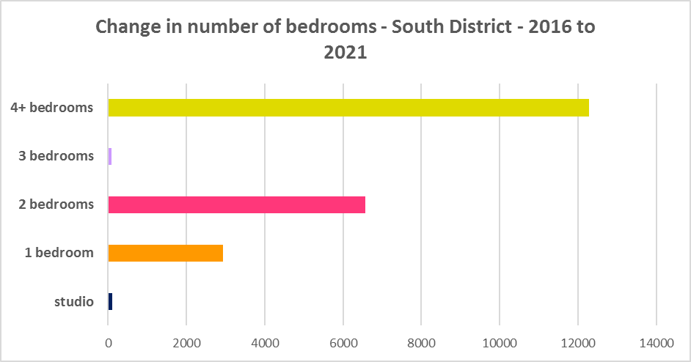

* A proactive stance is required to encourage an increase in studio and one bedroom properties. This is important given that annually the addition of new dwellings represents around 1% of the total dwelling stock – so change occurs very slowly. There is also a need to take into account the impact of alterations and additions to existing stock, for example, adding extra bedrooms to two and three bedroom houses. Given the current overwhelming supply of and increase in four plus bedroom homes, strong incentives/requirements would need to be put in place to ensure a better balance and more diversity to meet housing need. Continuing to encourage development of two bedroom homes is helpful.
* New generation boarding houses would also help fulfil some of this demand – particularly as they cannot be subdivided and must provide rental accommodation. Note that the NSW Community Housing Industry Association has an Affordable Housing Tool Kit to help deal with community resistance to affordable housing, which is available on their website. They also have a couple of excellent vimeos showcasing new generation boarding house developments and their tenants.
* The next graph compares larger household types – couple family with children, one parent family and group households – with the amount of two, three and four or more bedroom accommodation available. It is clear that there is an oversupply of larger dwellings, by comparison with the household types which might need large homes, particularly in Sutherland.

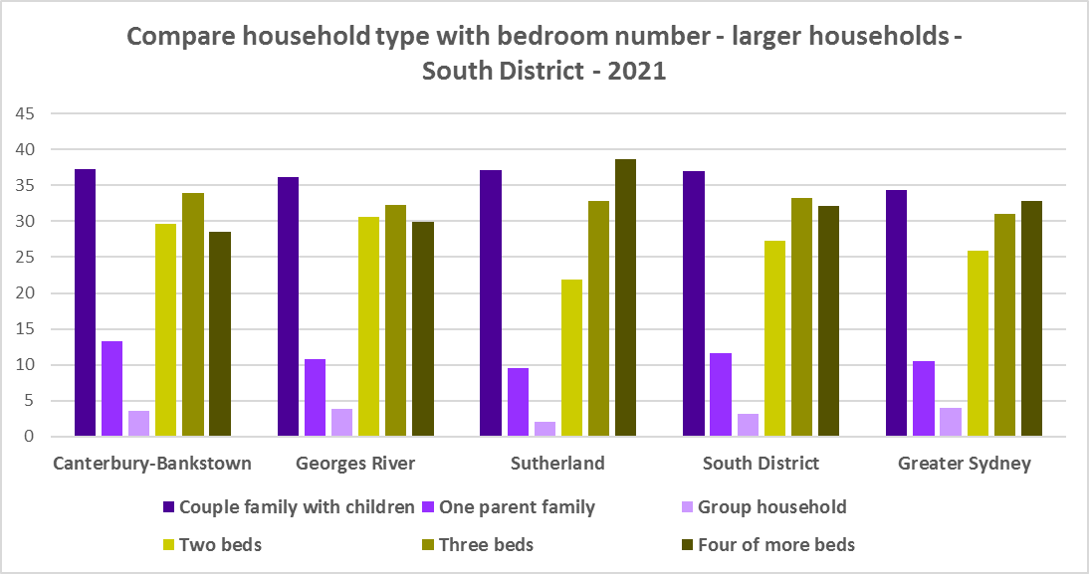

* As couple only households comprise a little over a fifth of all households in South District, it is important to continue to encourage provision of one and two bedroom stock as well as studios, new generation boarding houses and secondary dwellings, to maintain a balance to meet local need and potentially assist in affordability.
* Enabling the provision of more semi-detached, terrace and town houses could help fulfil some of the demand for smaller more manageable homes.

**Who needs affordable housing**

* A wide range of people need affordable housing. Single income earners who fall into the low income category include aged care and disability workers, retail sales assistants, production workers, receptionists and early career child care workers.
* People working in accommodation and food services comprise 5.5% of the workforce living in South District and are amongst the lowest paid workers. Similarly retail trade employs 9.4% of workers living in South District.
* Health care and social assistance is the largest employment sector of residents in South District (employing 13.3%). A 2017 survey of NSW Nurses and Midwives Association (NSWMA) members showed that thirty six per cent of respondents moved home or changed jobs in the previous 12 months because of housing affordability issues.
* For example, households earning $790 per week gross (broadly indicative of a wage for a laundry worker) could afford to pay just $237 per week in rent before being in housing stress. Households earning $960 (broadly indicative of wages for a commercial cleaner, delivery driver and entry level firefighter) could afford to pay just $288 per week in rent before being in housing stress. Households with an income of $1,150 (broadly indicative of the wage for an enrolled nurse, child care worker and ICT support technician) can afford to pay just $345 per week in rent before being in housing stress.
* At a weekly income of $1,450/$1,500 (an indicative wage for an early career Registered Nurse), a household could afford to pay $435 to $450 per week in rent before being in housing stress.
* At December 2022, there were insufficient new bonds lodged for studio dwellings to calculate a median rent in any of the South District LGAs – an indication of lack of supply.
* At December 2022, the median rent for a one bedroom home in South District ranged between was $350 per week in Canterbury-Bankstown and $493 per week in Georges River; for a two bedroom home ranged between $450 per week in Canterbury-Bankstown and $570 per week in Sutherland Shire; for a three bedroom home ranged between $610 per week in Canterbury-Bankstown and $800 in Sutherland; and for a four or more bedroom home ranged between $810 per week in Canterbury-Bankstown and $1100 per week in Sutherland. This median rent data demonstrates the issue with affordability for lower income rental households.
* Single income households in particular are less able to compete in the housing market.
* Increasing numbers of older single women are homeless or at risk of homelessness due to the lack of available affordable rental housing. In fact they are the fastest growing cohort of the homeless population.
* Partnering or collaborating with community housing providers is one effective way to meet some of the local need for appropriate affordable housing. Not for profit community housing providers are owners, managers and developers of affordable rental housing for lower income households and residents with specific housing needs. They work with partners, investors and government to provide housing and deliver support for tenants. For more information about community housing providers, see the NSW Community Housing Industry Association website.

**Additional Data**

Housing data and tables used in this Snapshot are available from the Local Government Housing Kit Database on the Housing NSW website at:

<https://www.facs.nsw.gov.au/resources/nsw-local-government-housing-kit/chapters/local-government-housing-kit-database>

More information on Expected Waiting Times for Public Housing is available on the DCJ/FACS website by region at:

<https://www.facs.nsw.gov.au/housing/help/applying-assistance/expected-waiting-times>

Additional data on social housing dwellings and delivery is available on the FACS website at:

<https://www.facs.nsw.gov.au/resources/statistics/social-housing-residential-dwellings/facs-quarterly-statistics-social-housing-dwellings>

or go straight to the dashboard:

<https://public.tableau.com/app/profile/facs.statistics/viz/Social_Housing_Residential_Dwellings/Dashboard>

and

<https://www.facs.nsw.gov.au/resources/statistics/social-housing-delivery2/interactive-dashboard>

More information about community housing providers is available on the NSW CHIA (Community Housing Industry Association) website:

NSW CHIA Snapshot of the Community Housing Sector in NSW:

<https://communityhousing.org.au/wp-content/uploads/2022/08/Community-Housing-Snapshot-2022.pdf>

Data on community housing properties is available from the NSW CHIA Dashboard at:

<https://communityhousing.org.au/our-impact/data-dashboard/>

CHIA NSW affordable housing tool kit. The Tool Kit is based on extensive research about reasons for community resistance to affordable housing, and effective ways of building support for affordable housing:

https://nswfha-my.sharepoint.com/personal/josha_communityhousing_org_au/_layouts/15/onedrive.aspx?ga=1&id=%2Fpersonal%2Fjosha%5Fcommunityhousing%5Forg%5Fau%2FDocuments%2FAffordable%20Housing%20Toolkit%2FFiles