# Central City District – What’s happening with Supply and is it a good match

This Housing Snapshot looks at dwelling type, bedroom mix, tenure, social housing supply and the gaps between demand and supply, with a focus on lower income households.

There have been significant changes in Central City since the 2016 Census and further developments impacting housing supply since the 2021 Census.

The Australian Bureau of Statistics reported that across Australia for January 2023, "approvals for private sector houses fell by 13.8 per cent, the fifth consecutive drop, to be the lowest result recorded since June 2012". Further, total dwelling approvals decreased in New South Wales by -49.0 per cent.

At a time when immigration is surging and there is strong demand for housing, there is a critical shortage of private rental accommodation as well as a skills shortage in the building sector. This suggests that it is likely to be some time before supply pressures ease.

## Dwelling Type

* At the 2021 Census there were 371,098 dwellings in Central City, up from 306,807 in 2016.
* Of these 92.9% were occupied, (up slightly from 92.4% in 2016), above the 92.0% average percentage occupied in Greater Sydney.
* Consequently 7.1% were unoccupied (down from 7.6% in 2016) and compared to 8.0% in Greater Sydney.
* The reasons homes are unoccupied vary and include (according to a report by the Australian Housing and Urban Research Institute “Are there 1 million empty homes and 13 million unused bedrooms?”):
  + homes are being renovated
  + homes being sold as vacant possession
  + newly built or bought homes where no one has moved in yet
  + rental homes awaiting new tenants
  + people living away temporarily from home during the census count (travelling or visiting other homes)
  + homes are deemed unliveable
  + subject to a probate application or other legal proceedings
  + holiday homes
  + homes owned by people currently living overseas
  + homes being land banked, that is held vacant until the local area economics (or personal circumstances) make it more profitable to sell or redevelop the property.
* The graph below shows the proportion of occupied and unoccupied dwellings in Central City and Greater Sydney at the 2021 Census.

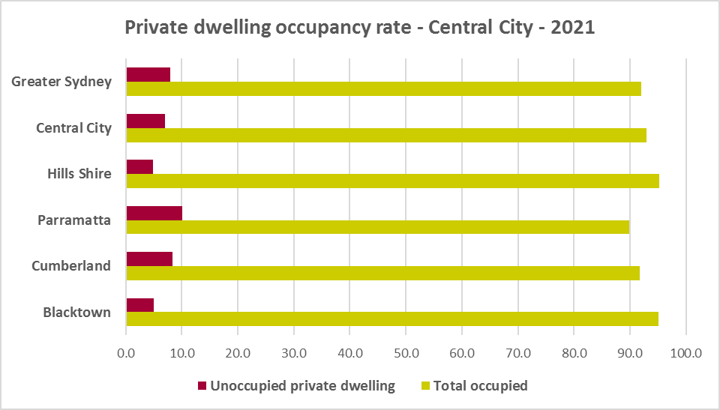

* At the 2021 Census, the majority of occupied dwellings in Central City were separate houses, comprising 63.8% of all occupied dwellings, well above the average of 55.4% for Greater Sydney. However this is more diverse than in 2016 when 65.3% of homes in Central City were separate houses. The proportion of separate houses in Central City ranged from 81.2% in The Hills Shire to 38.9% in Parramatta at the 2021 Census.
* A further 12.4% of occupied homes in Central City were semi-detached, terrace or town houses (down from 15.2% in 2016), compared to 31.0% in Greater Sydney. The proportion of attached homes in Central City ranged from 15.1% in Cumberland to 8.9% in The Hills.
* 23.4% of occupied homes in Central City were flats (up from 18.7% in 2016), compared to 12.9% in Greater Sydney. The proportion of flats in Central City ranged from 47.3% in Parramatta to 6.7% in Blacktown.
* While there has been a significant increase in the proportion of flats in the District, the proportion of semi-detached, terrace and townhouses has declined. While Cumberland and Parramatta have housing mix in terms of dwelling types, Blacktown and The Hills do not and a greater diversity of housing is needed to suit different household types and age cohorts in those LGAs.
* The graph and table below show the proportion of dwelling types for Central City at the 2021 Census.

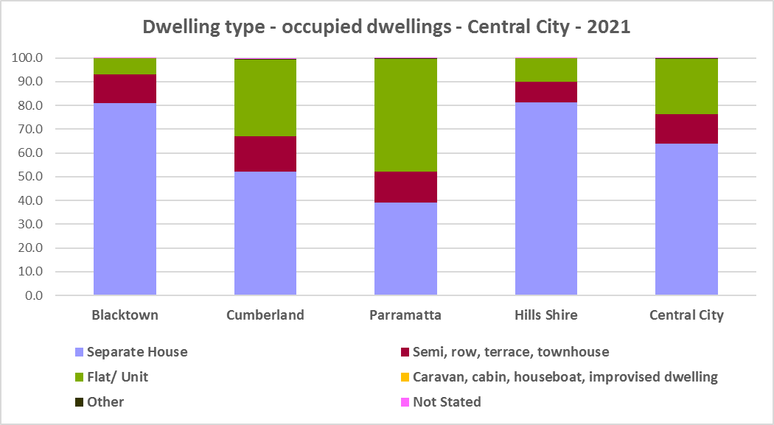



* The graph below compares the proportion of dwelling types in Central City with the average for Greater Sydney.

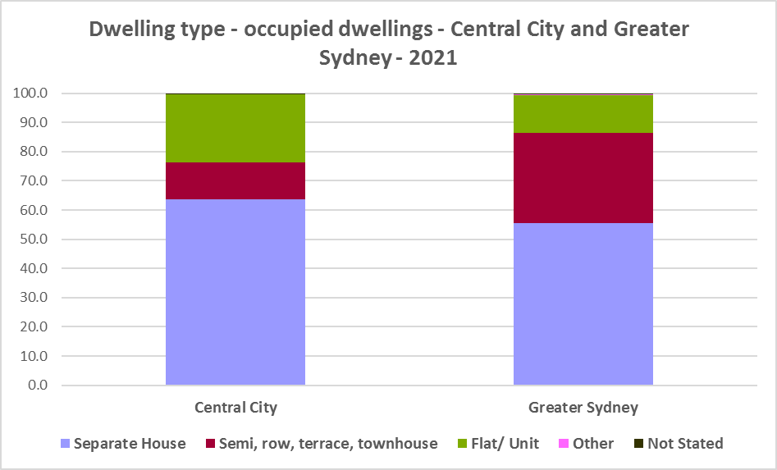

* Other types of dwellings comprised just 0.1% of occupied dwellings in the region at the 2021 Census and include caravans, cabins, houseboats, improvised dwellings and flats attached to shops or offices. Census data shows 8 households living in caravans, 5 living in cabins or houseboats, 16 living in improvised dwellings and 456 in flats attached to shops or offices in the region.
* Note that at the 2021 Census there were just 11 household living in caravan, cabin/houseboat accommodation, down from 284 in 2016.
* While people living in caravans are included in the homeless data in the Census, caravan or residential parks are one of the few remaining affordable housing options for lower income earners. The loss of this accommodation reduces options for lower income households and is another indicator of the loss of affordable housing.
* The region also has 16 improvised dwellings. According to the ABS;
  + “Persons in other improvised dwellings are those people who were enumerated on Census night in the dwelling category of an improvised dwelling, tent or sleepers out who reported either being 'at home' on Census night or having no usual address, and are not considered, on balance, to be homeless. Under the ABS definition they are not classified as homeless because they have accommodation alternatives, and in many living situations, the dwelling will be adequate. They are however included in marginal housing and may be at risk of homelessness.”

## Bedroom Mix

* Central City also has insufficient variation in the number of bedrooms per dwelling, with 31.7% of dwellings having three bedrooms and a further 39.5% having four or more bedrooms, totalling 71.3% with three or more bedrooms. Only 0.4% of homes are studios, 4.9% have one bedroom and 22.0% have two bedrooms in Central City.
* This compares to 0.9% studios, 8.1% one bedroom and 25.9% two bedroom in Greater Sydney as a whole.
* It is important to note that this is an improvement from 2016, when one bedroom homes comprised 3.6% and two bedrooms 19.7% of residential stock on average across the region. There has been no increase in the proportion of studio dwellings since 2016 however.
* Within the region,
  + Parramatta has the highest proportion of studio dwellings with 0.7% and The Hills Shire the lowest with 0.1%;
  + Parramatta has the highest proportion of one bedroom homes with 9.9% and The Hills Shire the lowest with 1.9%;
  + Parramatta has the highest proportion of two bedroom homes with 36.7% and The Hills the lowest with 9.5%;
  + Blacktown has the highest proportion of three bedroom homes with 39.1% and The Hills the lowest with 20.2%; and not surprisingly
  + The Hills has the highest proportion of four or more bedroom homes with an exceptionally high 67.5% (in NSW the only LGA with a higher proportion is Camden with 71.6%, the next closest is 60.8% in Wollondilly followed by 52.1% in Yass Valley) and Parramatta the lowest with 23.5%.
* The graph and table below show the proportion of studio, one, two, three and four or more bedroom occupied dwellings in Central City at the 2021 Census.

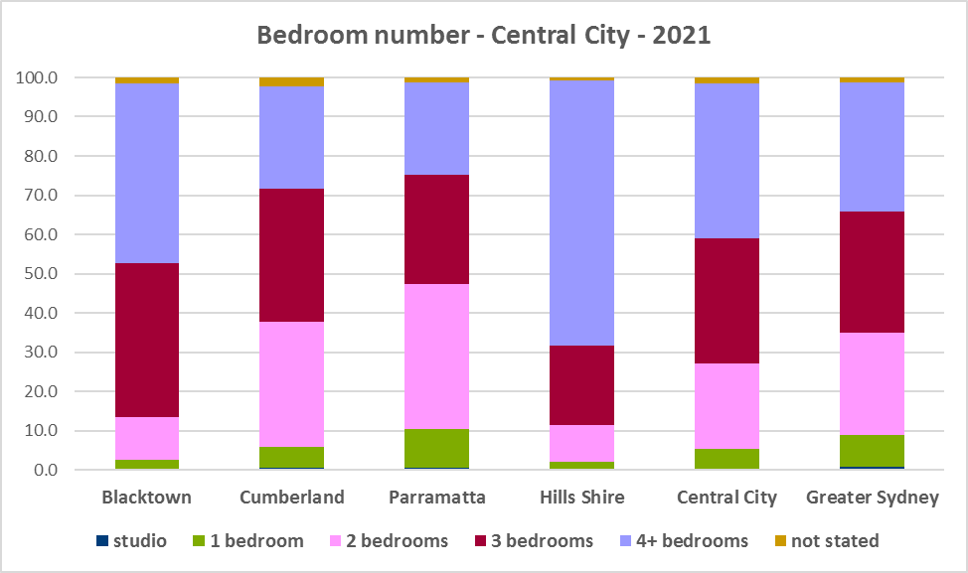



* Given that lone person and couple only households comprised 37.5% of all households in Central City (up from 35.7% in 2016), the fact that studio and one bedroom homes combined comprise just 5.3% of the housing stock means there is a mismatch between household type and bedroom number. There are insufficient housing options for smaller households. Note that The Hills Shire, with 87.7% homes of three or more bedrooms has 35.3% of households comprising lone person or couples without children.
* While both Parramatta and Cumberland have high proportions of two bedroom properties and above Greater Sydney average proportions of one bedroom homes, they, like Blacktown and The Hills, have lower proportions of studio dwellings.
* The forecast increase in older age groups in Central City is likely to increase the demand for smaller, more manageable and affordable homes.
* Ideally there should be an increase in the number of studio, one and two bedroom dwellings to suit these household types and to offer some housing choice. Two bedroom dwellings in particular offer the most flexibility, given they are also suitable for small families and allow older residents to have family members or carers to stay while giving them a more manageable size home to maintain. Providing choice in the number of bedrooms enables them to downsize and stay in their community and more broadly may help with affordability.
* Note that new dwelling stock generally represents 1 – 2% of the total dwelling stock while established dwellings represent the remaining 98 – 99% of stock – so alterations and additions to existing stock has a significant impact on bedroom mix.
* When considering the fit of housing stock to household type into the future, this is an important consideration.

## Tenure

* At the 2021 Census, the most common tenure type in the Central City District was households owning their home with a mortgage (unlike regional NSW or North District where owning a home outright is the most common tenure, or Eastern City where rental is the largest tenure) – comprising 37.9% of all households. Within the district this ranged from 46.7% in The Hills to 30.2% in Cumberland.
* Rental households comprised a total of 37.7% of all households in Central City (just under the proportion purchasing their home), ranging between 47.0% in Parramatta and 20.8% in The Hills.
* Households renting from a real estate agent comprise 27.4% of all households in Central City – with Parramatta having the highest proportion at 36.8% and The Hills the lowest with 17.3% of households renting though a real estate agent.
* The remainder of rental households are comprised of households renting from the state housing authority (4.3% in the region), community housing providers (0.8%) and other landlords (5.2%).
* The next largest tenure type was households owning their home outright – comprising 23.5% of all households. The proportion in this tenure ranged from 31.4% in The Hills to 20.6% in Blacktown, within the region.
* The graph and table below give the tenure composition for the district and individual LGAs at the 2021 Census.

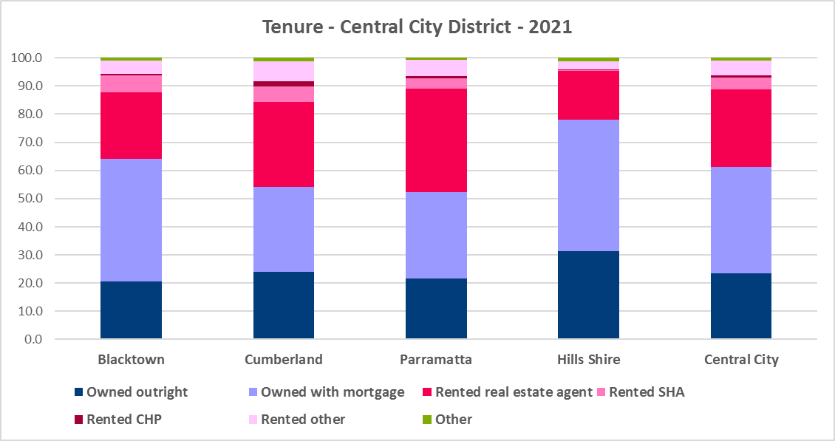



* The general trend is for increasing numbers of households relying on the private rental market as a long term tenure rather than a transitional one between leaving home and buying a home, as housing costs have increased much faster than wages.
* Subsequent high interest rates and high inflation levels have made it increasingly difficult for lower income households in particular to manage housing costs.
* Noting that the rental market in Sydney – and NSW generally – is very tight (see the Housing Snapshot on What’s Happening in the Housing Market) it is therefore important to encourage tenure diversity and a range of price points to meet local needs, including facilitating social and affordable housing development.

**Social Housing**

* Social housing is secure and affordable rental housing for people on low incomes with housing needs. It includes public, community and Aboriginal housing. Public housing is managed by DCJ while community housing is managed by non-government organisations.
* As at June 2022, there are 154,600 social housing dwellings in NSW, with 96,712 managed by public housing, 48,264 managed by community housing and 9,624 managed exclusively for Aboriginal people – of these the Aboriginal Housing Office (AHO) are responsible for 4,120 and Aboriginal Community Housing Providers (ACHP) manage 5,504.
* The table below shows the number of public housing properties in the South District LGAs as at June 2022. Please note that Census data on public housing is not totally accurate, as public housing tenure is under reported in the Census. The figures below do not include community housing properties.



* In addition, community housing providers manage a significant number of properties – including social housing, affordable housing, transitional housing and crisis accommodation in the Central West and Orana region, as outlined in the table below.
* Note that affordable housing is not the same as social housing. Affordable housing is open to a broader range of household incomes than social housing. Households do not have to be eligible for social housing to apply for affordable housing, though people who are eligible for social housing may also be eligible for affordable housing properties.
* Affordable housing is managed more like a private rental property, but there are eligibility criteria and the managers are mostly not for profit community housing providers.



* The next table gives the number of AHO homes and the number managed by ACHPs in Western Sydney as at June 2022.



* Note that there are 3 types of social housing available for Aboriginal people:
  + Public housing – these properties are managed by the Department of Communities and Justice (DCJ).
  + Aboriginal Housing Office homes – these are properties owned by the Aboriginal Housing Office and managed by DCJ.
  + Community housing properties – these properties are managed by community housing providers and Aboriginal community housing providers.
* The table below shows the expected waiting times for general housing approved social housing applicants (not for priority housing applicants) by bedroom category in the Central City at June 2022.



More information on Expected Waiting Times for Public Housing is available on the DCJ website by region at: <http://www.housingpathways.nsw.gov.au/How+to+Apply/Expected+Waiting+Times/>

## The Gap

* There is a large and growing gap between the increasing number of low income earners in the private rental market and the declining number of private rental properties that are affordable for low income households in Central City. There is also extremely limited opportunity for low income purchasers to buy a home in Central City.
* Low income (including very low income) households have increased by 7.0% between 2016 and 2021 (from 122,001 to 130,524). Over the same time period, low income **rental** households have increased by 29.7% in Central City. Clearly low income rental households are increasing at a faster rate than low income households generally in this District.
* Yet affordable private rental housing, as measured by new rental bonds lodged that were affordable to low income households, declined by 7.7% in Central City just between 2021 and 2022.
* There is a clear need for more affordable rental accommodation to begin to address the significant demand supply imbalance, particularly for lower income households and the increasing number of seniors and frail aged.
* The vacancy rate in Sydney and regional areas of NSW has been tight for over a year, indicating a chronic shortage of rental accommodation. At March 2023 the vacancy rate was just 1.3% in Sydney overall, with 0.8% in the middle ring and 1.7% in the outer ring.
* The strong increase in rental levels, decline in rental affordability for lower income earners and significant loss of affordable rental properties, combined with the very high proportion and increase in both low income and low income rental households, further demonstrates the need to increase the supply of private rental housing and more particularly, affordable rental housing for long term tenants.
* The graph below shows the decline in the number of new bonds lodged that were affordable to rent for low income households in Central City between 2021 and 2022.

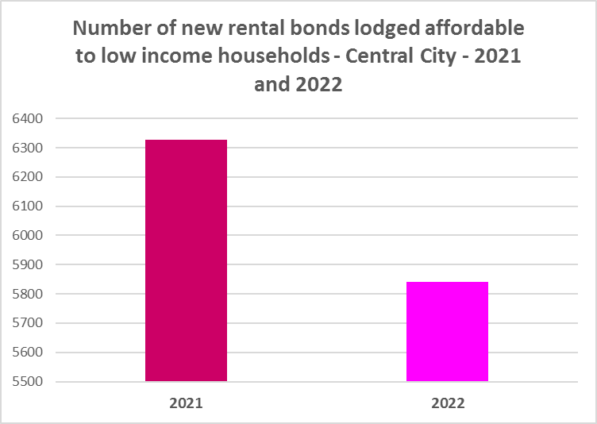

* The next graph compares changes in population, income, renters and housing stress between 2016 and 2021. It is clear that population has increased at a greater rate than low income households between 2016 and 2021 in the Central City. Yet low income **rental** households have increased at a much faster rate than low income households and the population generally. Of note also is that the number of CRA recipients are growing more quickly than the population generally, and CRA recipients in housing stress are increasing more rapidly than low income households in Central City.

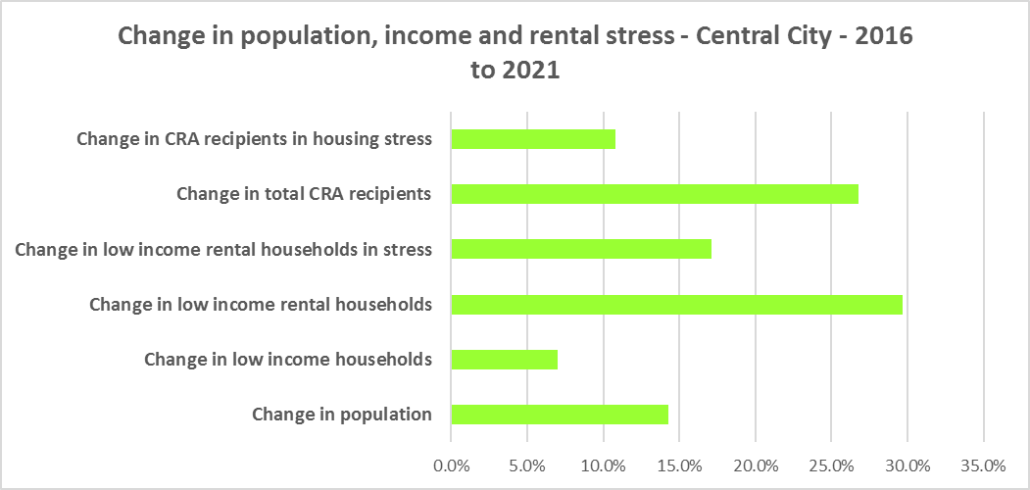

* This again demonstrates the increase in demand and need for affordable rental housing in Central City.
* As well as the gap between supply and demand for affordable rental, there is generally a significant gap between dwelling size (bedroom numbers) and household size. The graph below compares the number of smaller household types - lone person and couple only – with the amount of studio and one bedroom accommodation available. It is clear that if smaller households wished to live in smaller housing, they have very little opportunity to do so (although clearly both Parramatta and Cumberland have a better supply than The Hills and Blacktown). While 37.6% of households in Central City are lone person or couple only (below the 45.5% average in Greater Sydney), only 5.3% of dwelling stock is studio or one bedroom.
* This mismatch can impact on affordability, with smaller households required to consume more housing than they need because of lack of choice.
* It also limits the opportunity for empty nesters or older single households to downsize to smaller more manageable homes within their communities. This can impact on the independence of older residents and their ability to age in place. This will become increasingly important as the population of Central City is forecast to have an increase in older age groups.

* While there has been an increase in studio and one bedroom homes since the 2016 Census, the number is easily outweighed by the increase in the number of four and more bedroom homes, as seen in the graph below. Although notably there has been a strong increase in two bedroom properties, which helps provide flexibility in housing supply as they are suitable for single people, couples and small families.

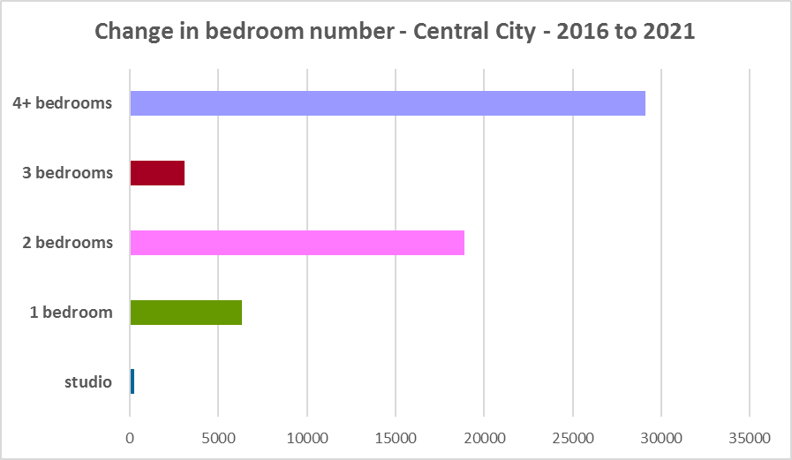

* A proactive stance is required to encourage an increase in studio and one bedroom properties. This is important given that annually the addition of new dwellings represents around 1% of the total dwelling stock – so change occurs very slowly. There is also a need to take into account the impact of alterations and additions to existing stock, for example, adding extra bedrooms to two and three bedroom houses. Given the current overwhelming supply of and increase in four plus bedroom homes, strong incentives/requirements would need to be put in place to ensure a better balance and more diversity to meet housing need. Continuing to encourage development of two bedroom homes is helpful.
* New generation boarding houses would also help fulfil some of this demand – particularly as they cannot be subdivided and must provide rental accommodation. Note that the NSW Community Housing Industry Association has an Affordable Housing Tool Kit to help deal with community resistance to affordable housing, which is available on their website. They also have a couple of excellent vimeos showcasing new generation boarding house developments and their tenants.
* The next graph compares larger household types – couple family with children, one parent family and group households – with the amount of two, three and four or more bedroom accommodation available. It is clear that there is an oversupply of larger dwellings, by comparison with the household types which might need large homes, particularly in The Hills and Blacktown.

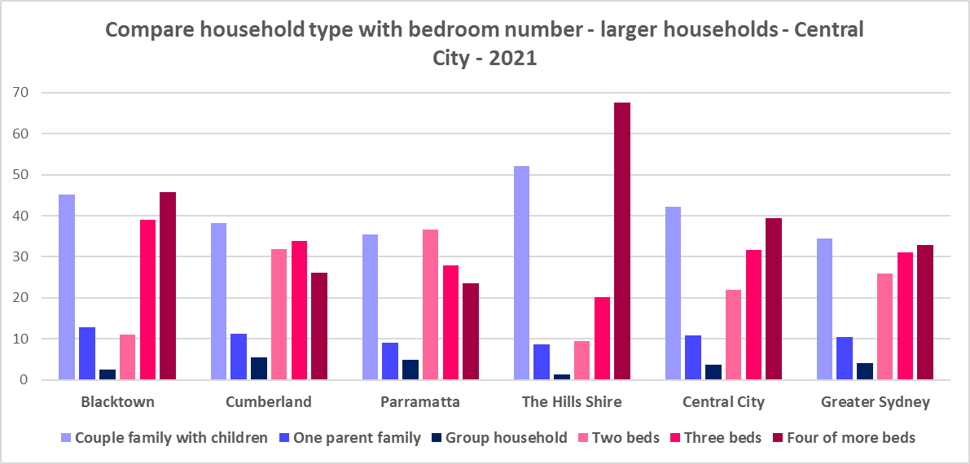

* As couple only households comprise a little over a fifth of all households in Central City, it is important to continue to encourage provision of one and two bedroom stock as well as studios, new generation boarding houses and secondary dwellings, to maintain a balance to meet local need, particularly where there are higher proportions of seniors and frail aged. This will give older residents opportunity to downsize into more manageable and appropriate homes.
* Enabling the provision of more semi-detached, terrace and town houses could help fulfil some of the demand for smaller more manageable homes.

**Who needs affordable housing**

* A wide range of people need affordable housing. Single income earners who fall into the low income category include aged care and disability workers, retail sales assistants, production workers, receptionists and early career child care workers.
* People working in accommodation and food services comprise around 5% of the workforce living in Central City and are amongst the lowest paid workers. Similarly retail trade employs 9.4% of workers living in Central City.
* Health care and social assistance is the largest employment sector of residents in Central City (employing 14.3%). A 2017 survey of NSW Nurses and Midwives Association (NSWMA) members showed that thirty six per cent of respondents moved home or changed jobs in the previous 12 months because of housing affordability issues.
* For example, households earning $790 per week gross (broadly indicative of a wage for a laundry worker) could afford to pay just $237 per week in rent before being in housing stress. Households earning $960 (broadly indicative of wages for a commercial cleaner, delivery driver and entry level firefighter) could afford to pay just $288 per week in rent before being in housing stress. Households with an income of $1,150 (broadly indicative of the wage for an enrolled nurse, child care worker and ICT support technician) can afford to pay just $345 per week in rent before being in housing stress.
* At a weekly income of $1,450/$1,500 (an indicative wage for an early career Registered Nurse), a household could afford to pay $435 to $450 per week in rent before being in housing stress.
* At December 2022, the median rent for a one bedroom home in Central City ranged between was $370 per week in Blacktown and $500 per week in Parramatta; for a two bedroom home ranged between $430 per week in Blacktown and $600 per week in The Hills Shire; for a three bedroom home ranged between $510 per week in Blacktown and $690 in The Hills; and for a four or more bedroom home ranged between $695 per week in Blacktown and $865 per week in Parramatta.
* Single income households in particular are less able to compete in the housing market.
* Increasing numbers of older single women are homeless or at risk of homelessness due to the lack of available affordable rental housing. In fact they are the fastest growing cohort of the homeless population.
* Partnering or collaborating with community housing providers is one effective way to meet some of the local need for appropriate affordable housing. Not for profit community housing providers are owners, managers and developers of affordable rental housing for lower income households and residents with specific housing needs. They work with partners, investors and government to provide housing and deliver support for tenants. For more information about community housing providers, see the NSW Community Housing Industry Association website.

**Additional Data**

Housing data and tables used in this Snapshot are available from the Local Government Housing Kit Database on the Housing NSW website at:

<https://www.facs.nsw.gov.au/resources/nsw-local-government-housing-kit/chapters/local-government-housing-kit-database>

More information on Expected Waiting Times for Public Housing is available on the DCJ/FACS website by region at:

<https://www.facs.nsw.gov.au/housing/help/applying-assistance/expected-waiting-times>

Additional data on social housing dwellings and delivery is available on the FACS website at:

<https://www.facs.nsw.gov.au/resources/statistics/social-housing-residential-dwellings/facs-quarterly-statistics-social-housing-dwellings>

or go straight to the dashboard:

<https://public.tableau.com/app/profile/facs.statistics/viz/Social_Housing_Residential_Dwellings/Dashboard>

and

<https://www.facs.nsw.gov.au/resources/statistics/social-housing-delivery2/interactive-dashboard>

More information about community housing providers is available on the NSW CHIA (Community Housing Industry Association) website:

NSW CHIA Snapshot of the Community Housing Sector in NSW:

<https://communityhousing.org.au/wp-content/uploads/2022/08/Community-Housing-Snapshot-2022.pdf>

Data on community housing properties is available from the NSW CHIA Dashboard at:

<https://communityhousing.org.au/our-impact/data-dashboard/>

CHIA NSW affordable housing tool kit. The Tool Kit is based on extensive research about reasons for community resistance to affordable housing, and effective ways of building support for affordable housing:

https://nswfha-my.sharepoint.com/personal/josha_communityhousing_org_au/_layouts/15/onedrive.aspx?ga=1&id=%2Fpersonal%2Fjosha%5Fcommunityhousing%5Forg%5Fau%2FDocuments%2FAffordable%20Housing%20Toolkit%2FFiles