**Central West and Orana Region – What’s the Housing Demand?**

This Housing Snapshot looks at aspects of housing demand in the Central West and Orana, particularly from the 2016 Census to the 2021 Census – including population, age profile, household type, household size, income (change in low, moderate and high income households and low income rental households), homelessness and people with disability.

There have been challenges across Australia and in this region since the 2016 Census, including the pandemic - which have impacted the community and the demand for housing. Subsequent cost of living pressures, including inflation, rising interest rates and tightening of the rental market also have significant impacts on the demand for housing.

**Population Forecast**

* Changes in population will impact on the demand for housing.
* Between 2016 and 2021, the population of the Central West and Orana grew by 4.0% or 11,292, from 278,842 to 290,134 (using ABS Census population data).
* This overall growth for the region masks significant differences in the experience of population change in individual LGAs within the region.
* On an individual LGA basis, population growth ranged from 9.7% in Dubbo Regional to -8.3% in Bogan. In terms of numbers, Dubbo Regional had the largest increase with an additional 4,847, followed by Orange with 3,164, Bathurst with 2,266 and Mid-Western Regional with 1,634.
* Dubbo Regional has the largest population of the Central West and Orana LGAs with 54,922 (comprising 18.9% of the region’s population), while Bogan has the smallest population with 2,467 (comprising 0.9% of the region’s population).
* The Department of Planning and Environment have prepared population projections for every LGA in the region. Their projections forecast growth for Bathurst Regional (1.27% per annum), Blayney (0.35%), Cabonne (0.64%), Cowra (0.53%), Dubbo Regional (0.78%), Forbes (1.4%), Mid-Western Regional (0.77%), Orange (0.88%) and Parkes (0.38%)
* Additionally, Oberon is forecast to remain stable (0.01%) while Bogan (-2.26%), Coonamble (-1.35%), Gilgandra (-1.1%), Lachlan (-1.18%), Lithgow (-0.07%), Narromine (-1.46%), Warren (-2.07%), Warrumbungle (-0.89%) and Weddin (-0.5%) are all predicted to lose population.
* Forbes and Bathurst Regional are the only LGAs in the Central West and Orana predicted to have a stronger annual growth rate than the average for NSW of 0.95% per annum.
* Numerically the largest increases in population to 2041 is predicted for Bathurst Regional, followed by Dubbo Regional and Orange.
* The table and graph below show the population change for each Central West and Orana LGA from 2016 to 2021, using Census data and the table also gives the total population growth for the region over that five year time frame.



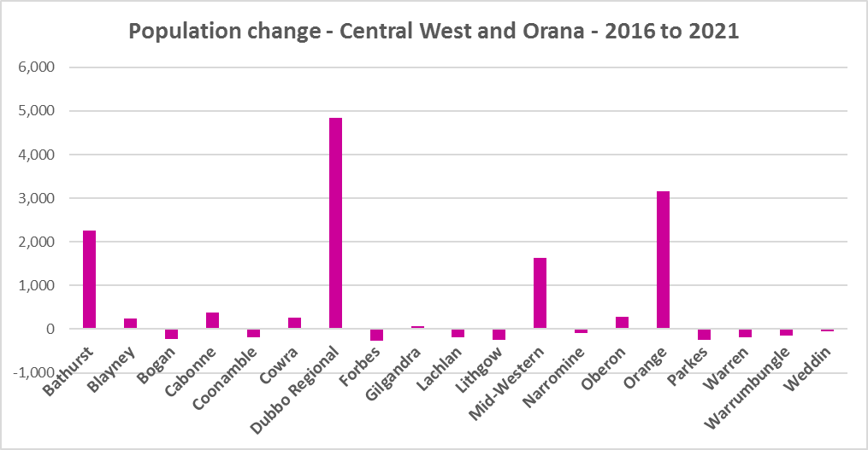

**Age**

* The age profile of the region and particularly each LGA will impact on housing need and demand, including number of bedrooms, affordability, location and dwelling type.
* The median age of the population of the Central West and Orana LGAs at the 2021 Census ranges between 36 years (Dubbo Regional) and 52 (Weddin). Orange (37) and Bathurst (38), like Dubbo Regional have a younger median age while Warrumbungle (50), like Weddin has an older median age. The other LGAs in the region fall between these two extremes. This compares to the median age for the Rest of NSW (excluding Sydney) of 43 years.
* Not surprisingly, given the range in the median age, there is variation in the age profiles of the Central West and Orana LGAs.
* Generally, most LGAs in the region have higher proportions of 0-4 year olds and 5-14 year olds, lower proportions of 15-19, 20-24 (in particular), 25-34 and 35-44 year olds and higher proportions of 55-64 and 75-84 year olds than the average for the Rest of NSW.
* Not unexpectedly, the larger regional centres of Dubbo Regional, Bathurst and Orange tend to have more teenagers and younger adults, although they are not the only LGAs to have higher proportions of these age groups than the Rest of NSW average.
* Many of the smaller more rural LGAs have higher proportions of aged and/or frail aged – including Weddin and Warrumbungle as well as Bogan, Cowra, Forbes, Gilgandra, Lachlan, Lithgow, Narromine, Oberon, Parkes and Warren.
* The graph below show the proportion of the population in each key age cohort in the Central West and Orana LGAs.

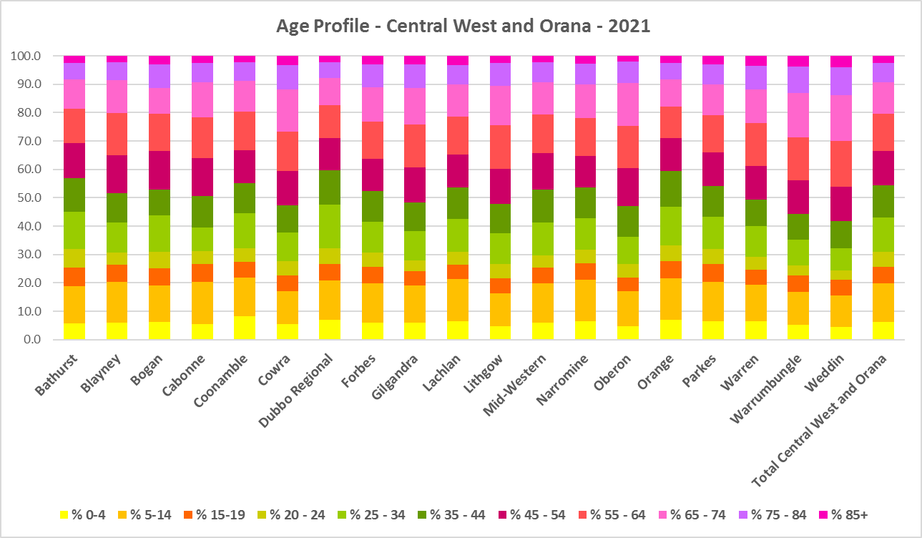

* The Department of Planning and Environment forecast increases in residents aged over 65 to 2041 in every Central West and Orana LGA, with the exception of Lachlan, Warren and Warrumbungle.
* The Department also projects an increase in younger age groups in Orange and Dubbo Regional.
* The diversity of age groups requires a range of different housing to meet the needs of the community throughout the housing life cycle. However the higher median age and higher proportions of older age cohorts indicates that there is a need for housing to suit older residents in many parts of the region. Increasingly this will be the case in all the Central West and Orana LGAs as the number in older age groups grows.
* The table below gives more detail of the breakdown of age cohorts by LGA, by region and for the Rest of NSW.

Proportion of population in each age cohort - Central West and Orana - 2021



* As the Australian Institute for Health and Welfare (AIHW) note:

Many older Australians prefer to age in place, meaning they wish to stay in their local home or community. However, their capacity to do so can be influenced by:

* + the appropriateness and quality of their home (for example, size, layout)
  + their ability to modify their home to suit their functional requirements
  + the cost and availability of suitable housing
  + their need for formal care and assistance
  + their proximity to services and social support.
* Although the majority of older Australians own their own home, this number is declining. About 15% of older Australians are renters. These people are generally a highly vulnerable and economically disadvantaged group, particularly single person households, with older women being the fastest growing demographic of people experiencing homelessness. There is therefore a need for more adaptable, accessible dwellings, well located, secure, low maintenance and affordable to meet the needs of seniors and frail aged in particular, within their communities. Those most in need are households in the private rental market, who struggle to afford housing on an Aged Pension or inadequate superannuation. (Source: "Housing Decisions of Older Australians" Productivity Commission December 2015).
* The Australian Housing and Urban Research Institute (AHURI) has undertaken research on “What is the ideal home for older Australians?”:
  + “Older Australians and the housing aspirations gap” and
  + “Understanding the housing aspirations of older Australians”
* This research is part of a broader study on “Housing aspirations and constraints for lower income Australians.” AHURI’s research demonstrates that one of the most valued aspects of older residents housing is the location – that the neighbourhood feels safe and secure; that there is good (including walkable) access to services such as health, shopping, recreational amenities, public open space; and that it is close to family and friends.

**Household Type**

* A look at household types and average household size gives some insight into the type of housing – particularly number of bedrooms – that is likely to be appropriate to meet the housing needs of the community.
* Household types in the Central West and Orana vary between the LGAs and frequently differ from the average for Rest of NSW.
* At the 2021 Census in the Rest of NSW, couple families without children (27.7%) and lone person households (26.1%) are the largest two household types.
* For the Central West and Orana region as a whole, lone person households are the largest household type (26.8%), along with couple families without children (i.e couple only) (26.1%).
* However, for Bathurst, Bogan, Dubbo Regional and Orange, couple family with children and lone person households are the two largest household types.
* For Blayney, Cabonne and Mid-Western Regional, couple family with children and couple only households are the largest two household types.
* The remaining LGAs are in line with the region and the Rest of NSW.
* Of note also is that almost every LGA in the region has a higher proportion of other household types (which include multi-family households) than the average for the Rest of NSW of 6.5%.
* There has been a small shift since the 2016 Census, with an increase in couple only households in the Rest of NSW (0.7%), a decline in couple families with children households (-0.6%) and a small increase in lone person households (0.5%).
* Changes in some Central West and Orana LGAs were not in accord with the trend in the Rest of NSW:
  + The proportion of couple only households declined in Bogan, Coonamble, Forbes, Gilgandra, Lachlan, Narromine, Oberon, Warren, Warrumbungle and Weddin and increased in the other Central West and Orana LGAs.
  + The proportion of couple family with children households increased in Bogan, Coonamble, Mid-Western Regional and Warren, were stable in Orange and declined elsewhere in the region.
  + The proportion of lone person households declined in Blayney, Cabonne, Gilgandra and Narromine and increased everywhere else in the region.
* The graph and table below show the proportion in each key household type for every Central West and Orana LGA, for the region and for the Rest of NSW at the 2021 Census.

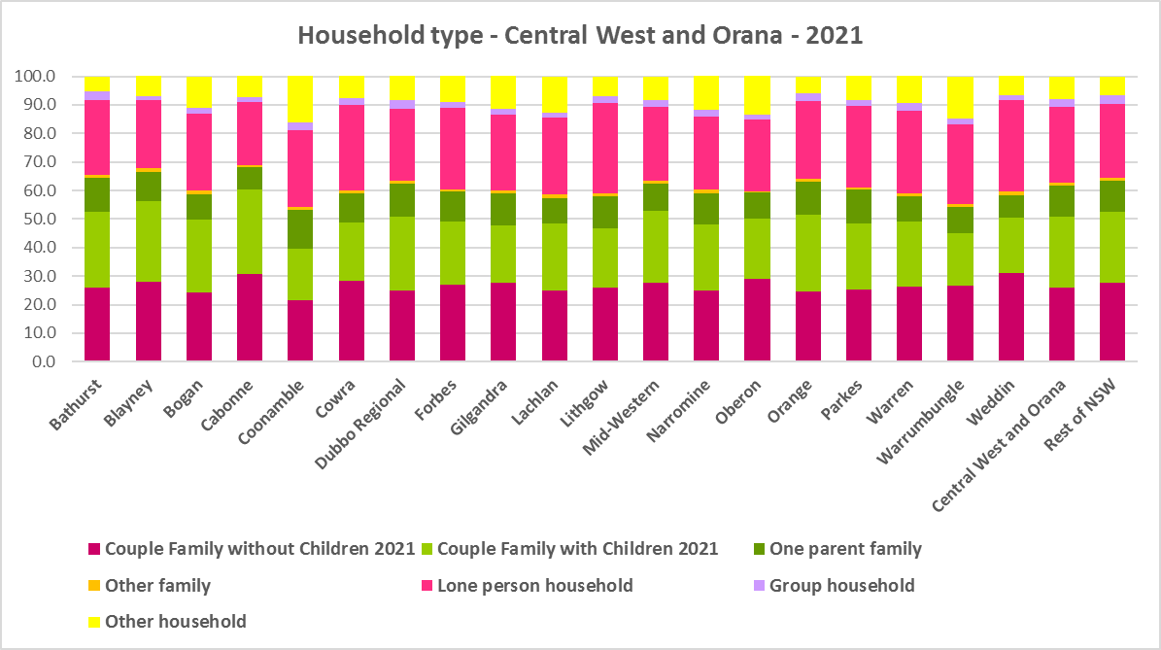

* Given the number of lone person and couple only households in the region (comprising 52.9% of all households), this suggests the need for an increasing diversity of bedroom mix, including more studio (bedsit), one and two bedroom homes to suit different household sizes as the number and proportion of smaller household types increases in the region.



**Household Size**

* At the 2021 Census, the average household size for the Rest of NSW was 2.4 persons per household – unchanged from 2016 and 2011.
* Average household size in the Central West and Orana ranges from 2.2 persons per household in Weddin to 2.6 persons per household in Cabonne. Six of the 19 Central West and Orana LGAs have a larger average household size than the average for the Rest of NSW (Bathurst, Blayney, Cabonne, Dubbo Regional, Narromine and Orange).
* In line with the trend in the Rest of NSW, between 2016 and 2021, average household size was stable in every Central West and Orana LGA, with the exception of Gilgandra and Oberon, both of which experienced a decline in the number of persons per household.
* The table below gives the average household size in each of the Central West and Orana LGAs as well as the Rest of NSW for 2011, 2016 and 2021.



**Income**

* At the 2021 Census, low income households comprise the largest proportion of all households in the Rest of NSW, in the Central West and Orana as a whole and each Central West and Orana LGA, with the exception of Bogan.
* Fourteen of the nineteen LGAs in the region have a higher proportion of low income households than the Rest of NSW average of 49.3% (the exceptions being Bathurst, Bogan, Dubbo Regional, Orange and Parkes).
* Across the region the proportion of low income households ranges from 40.7% in Bogan to 67.2% in Weddin. Central West and Orana as a whole has an average of 51.4% low income households, a little above the Rest of NSW average.
* Moderate income households in the Rest of NSW comprise 21.5% of all households and 21.6% for the Central West and Orana as a whole, while within the region they range from 17.3% in Weddin to 23.6% in Dubbo Regional.
* High income households comprise 29.2% of all households in the Rest of NSW, 27.0% on average across the Central West and Orana region and range from 15.5% of households in Weddin to 41.7% in Bogan.
* The graph and table below show the proportion of low, moderate and high income households in all the Central West and Orana LGAs, compared with the region and Rest of NSW at the 2021 Census.

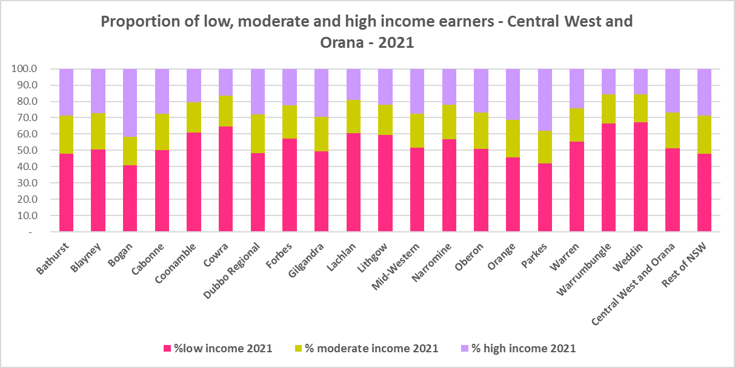



* Between 2016 and 2021 while the number of low income households increased in the Central West and Orana region as a whole, the number of low income households increased in every Central West and Orana LGA except for Bogan, Gilgandra and Parkes, which all experienced a decline in the number of low income households.
* Over the same period, the number of moderate income households increased in in ten of the nineteen LGAs in the region and in the region as a whole.
* The number of high income households declined overall in the region and in every LGA except for Bogan, Gilgandra and Parkes, which experienced an increase in high income households.
* The graph below shows the change in the number of low (including very low), moderate and high income households from 2016 to 2021 in the Central West and Orana region.

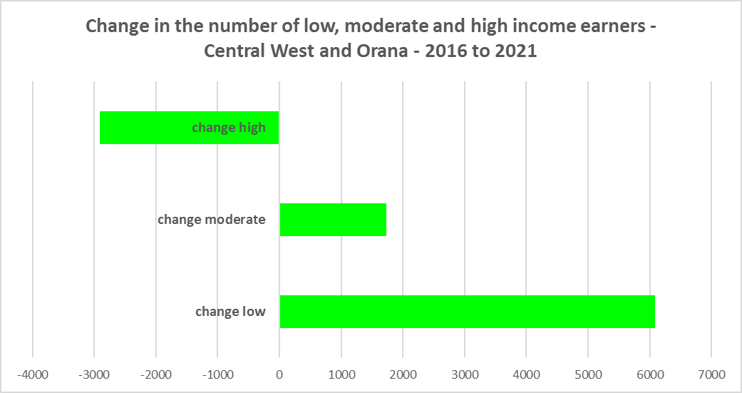

* However, despite the increase in the number of low income households between 2016 and 2021, all the Central West and Orana LGAs (except Bogan) experienced a decline in very low income **rental** households over the same period, varying between a -47.8% decline in Lachlan and a -13.6% decline in Weddin (with Bogan the outlier with a 26.2% increase).
* The region as whole and 12 of the 19 LGAs in Central West and Orana also had declines in low income **rental** households over the same period, with Warren having the largest proportional decline of -40.2%. The LGAs experiencing increases in low income rental households ranged from 13.8% in Lithgow to 1.9% in Parkes.
* The reduction in both very low (-1,714) and low income renters (-220) across the Central West and Orana region is likely due to the additional Commonwealth financial assistance to renters during the pandemic and may therefore be temporary – as this additional assistance has subsequently been discontinued, as explained in the What’s Happening in the Housing Market” snapshot for the Central West and Orana.
* These changes also underline the need to consider tenure as well as price point when considering responses to meet housing need.
* The graph below shows the change in the number of very low and low income **renters** between 2016 and 2021 in the Central West and Orana.

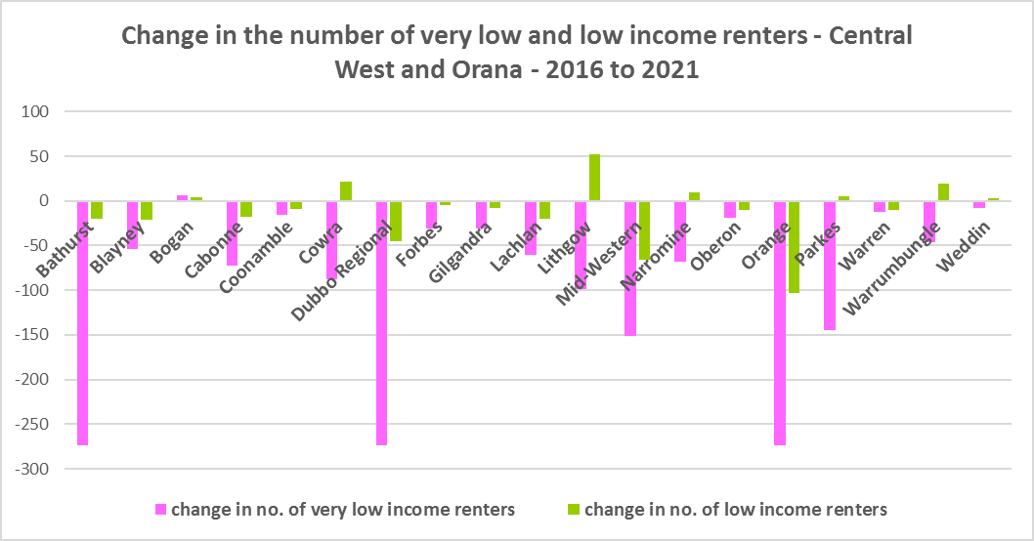

* Bathurst, Blayney, Bogan, Cabonne, Dubbo Regional, Mid-Western Regional, Oberon and Orange all have a higher median household weekly income at 2021 than the Rest of NSW ($1,434). Orange ($1665) has the highest median weekly income in the region while Weddin has the lowest ($1046).
* The table below shows median income by LGA for the Central West and Orana for 2011, 2016 and 2021.



**Homelessness**

* People experiencing homelessness and those at risk of homelessness are among Australia’s most socially and economically disadvantaged. State, Commonwealth and some local governments fund services to support people who are homeless, or at risk of homelessness. Services are delivered mainly by non–government organisations, some of which specialise in delivering services to specific groups (such as young people or people experiencing domestic violence).
* Inadequate income and inability to access affordable housing are significant contributing factors to homelessness, along with individual factors such as experience of family and domestic violence, ill health and disability.
* The ABS identifies someone as homeless “where they do not have suitable accommodation alternatives and their current living arrangement:
  + Is in a dwelling that is inadequate;
  + Has no tenure or their initial tenure is short and not extendable; or
  + Does not allow them to have control of and access to space for social relations.”
* The ABS uses “six operational groups for presenting estimates of people experiencing homelessness on Census night:
  + People living in improvised dwellings, tents or sleeping out
  + People living in supported accommodation for the homeless
  + People staying temporarily with other households
  + People living in boarding houses
  + People in other temporary lodgings
  + People living in ‘severely’ overcrowded dwellings.”
* The ABS “also compiles estimates from Census data for the following three groups of people who may be marginally housed but are not classified as homeless:
  + People living in other crowded dwellings
  + People in other improvised dwellings
  + People marginally housed in caravan parks.”
* The table below shows that ABS 2021 Census data for the Central West and Orana on the homeless and marginally housed.
* Note that due to additional assistance provided during the pandemic, the number of people counted as homeless on Census night in 2021 is lower than at the 2016 Census. Nevertheless there were 797 people counted as homeless and a further 811 counted as marginally housed across the Central West and Orana.
* The largest group of homeless (241 or 30.2%) were staying temporarily with other households, followed by people living in severely overcrowded dwellings (220 or 27.6%), then people in supported accommodation for the homeless (175 or 22.0%).
* The largest group of marginally housed were people living in other crowded dwellings (660 or 81.4%).



* This clearly implies the need for more affordable rental housing.
* The 2023 NSW street count, the NSW Government’s fourth annual rough sleeping street count, was completed between 2 February and 27 February 2023.
* Over 300 local organisations either consulted in the planning phase or participated in the delivery of street counts. Organisations which partnered with the Department of Communities and Justice (DCJ) included Community Housing Providers, local councils and Specialist Homelessness Services, as well Aboriginal organisations, Local Health Districts, local community groups, and Police.
* 1,623 people were counted sleeping rough during these street counts, a 34% increase from 2022.
* Street counts took place in more than 350 towns in 76 LGAs, compared to 71 LGAs in 2021 and 65 LGAs in 2020.
* The table below gives the street count results for the Central West and Orana locations.



## People with Disability

* According to the Australian Institute of Health and Welfare (AIHW) and data from the 2018 Australian Bureau of Statistics (ABS) Survey of Disability, 18% of people in Australia have disability. Another 22% have a long term health condition but not disability.
* Nearly one third (32%) of people with disability have severe or profound disability. This means needing help with daily self-care, mobility or communication activities, having difficulty understanding or being understood by family or friends, or communicating more easily using sign language or other non-spoken forms of communication.
* The survey data shows:
  + 7.6% of children aged 0–14 have disability
  + 9.3% of people aged 15–24 have disability
  + 13% of people aged 15–64 have disability
  + 50% of people aged 65 and over have disability (ABS 2019b).
* For about 3 in 4 (77%) people with disability, the main type of disability is physical, while for the remaining 1 in 4 (23%), the main type of disability is mental or behavioural.
* Clearly housing is a significant factor in the health and wellbeing of people with disability. The availability of affordable, sustainable and appropriate housing helps people with disability to participate in the social, economic and community aspects of everyday life. Someone without access to affordable, secure and appropriate housing is more likely to experience homelessness, poor health, and lower rates of employment and education.
* While most people with disability live at home in the community (96% in private dwellings), some live in cared accommodation.
* Cared accommodation is usually long term and may be institutional in style, including hospitals, residential aged care, cared components of retirement villages, aged care hostels, psychiatric institutions and group homes for people with disability. The more severe a person’s disability is, the more likely they are to live in cared accommodation and the less likely they are to live in the community.
* There has been a significant shift towards supporting people with disability to live in private dwellings, rather than being in institutional care over recent decades. Largely this has been driven by changes for young people with disability.

## Additional Data

More detailed housing data and tables used in this Snapshot are available from the Local Government Housing Kit Database on the FACS website at:

<https://www.facs.nsw.gov.au/resources/nsw-local-government-housing-kit/chapters/local-government-housing-kit-database>

More information on the housing needs of older Australians and people with disability:

The Australian Institute of Health and Welfare – Older Australians Housing and Living Arrangements on the AIHW website at:

<https://www.aihw.gov.au/reports/older-people/older-australians/contents/housing-and-living-arrangements>

The Australian Institute of Health and Welfare – People with Disability in Australia

<https://www.aihw.gov.au/reports/disability/people-with-disability-in-australia/contents/people-with-disability/prevalence-of-disability>

and relating to housing needs

<https://www.aihw.gov.au/reports/disability/people-with-disability-in-australia/contents/housing>

The Productivity Commission’s report Housing Decisions of Older Australians is at:

<https://www.pc.gov.au/research/completed/housing-decisions-older-australians>

More detailed information on population, household and dwelling projections is available on the Department of Planning and Environment website at:

<https://www.planning.nsw.gov.au/Research-and-Demography/Population-Projections/Projections>

<https://pp.planningportal.nsw.gov.au/populations>

More data on homelessness, specifically homelessness service data is available on the Homelessness NSW website at:

<https://homelessnessnsw.org.au/resource/specialist-homelessness-service-data/>

And from the AIHW website here:

<https://www.aihw.gov.au/reports/australias-welfare/homelessness-and-homelessness-services>

The 2023 Street Count result is at the DCJ/ FACS website here:

<https://www.facs.nsw.gov.au/reforms/homelessness/premiers-priority-to-reduce-street-homelessness/street-count>

Further information on ABS estimation of homelessness is available at the ABS website:

<https://www.abs.gov.au/statistics/people/housing/estimating-homelessness-census/2021>