**Central Coast – What’s the Housing Demand?**

This Housing Snapshot looks at aspects of housing demand in the Central Coast, particularly from the 2016 Census to the 2021 Census – including population, age profile, household type, household size, income (change in low, moderate and high income households and low income rental households), homelessness and people with disability.

There have been significant challenges to this region since the 2016 Census, including the desire for sea and tree changes becoming more pronounced due to the increased ability to work remotely during Covid - which have impacted the community and the demand for housing.

**Population Forecast**

* Changes in population will impact on the demand for housing.
* Between 2016 and 2021, the population of the Central Coast grew by 5.75% or 18,860, from 327,736 to 346,596 (using ABS Census population data).
* NSW Planning have prepared population projections for every LGA in NSW. Their projections anticipate that the Central Coast will continue to increase in population to 2041, with an annual growth rate of 0.76% per annum. This is a little lower than the average for NSW of 0.95% per annum.
* The table below shows the population change for the Central Coast from 2011 to 2016 to 2021.



**Age**

* The age profile of the region will impact on housing need and demand, including number of bedrooms, affordability, location and dwelling type.
* The median age of the population of the Central Coast at the 2021 Census was 43, up from 42 in 2016. This is the same as the median age for the Rest of NSW (excluding Sydney) of 43 years.
* The age profile of the Central Coast is similar to that for the Rest of NSW, with some small differences:
  + The Central Coast has slightly higher proportions of 0-4 year olds, 15-19 year olds, 20-24 year olds, 35-44 year olds, 45-54 year olds as well as 75-84 year olds and those aged 85 and over than the Rest of NSW;
  + The Central Coast has slightly lower proportions of 25-34 year olds, 55-64 year olds and 65-74 year olds than the Rest of NSW.
* The graph below gives the age profile for the Central Coast at the 2021 Census.

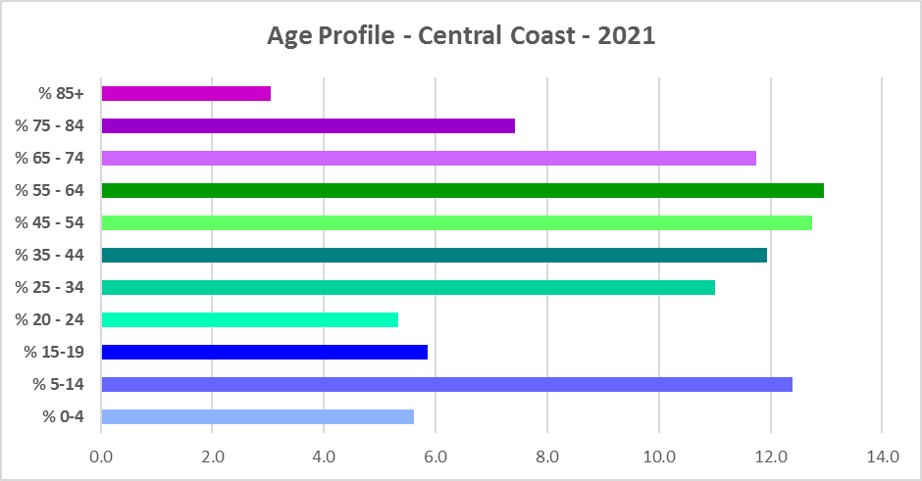

* The graph and table below show the proportion of the population in each key age cohort in the Central Coast and the Rest of NSW

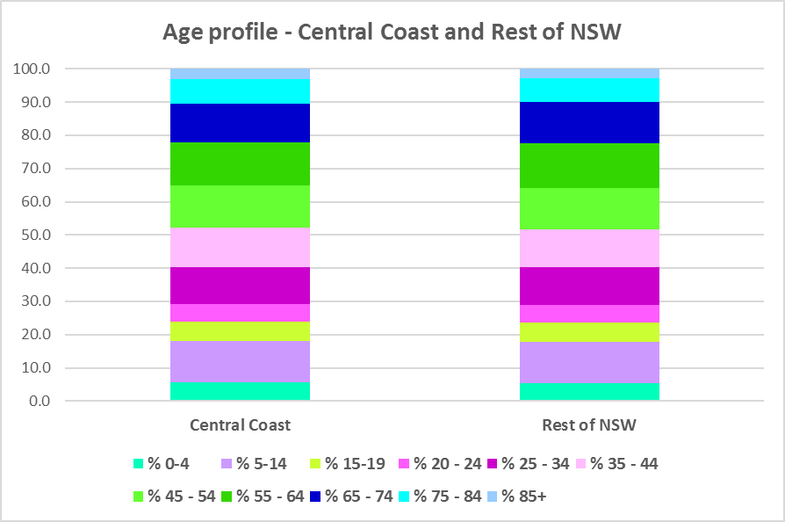

Proportion of population in each age cohort at the 2021 Census for the Hunter



* The Department of Planning and Environment forecast increases in residents aged over 65 as well as an increase in younger age groups in the Central Coast to 2041.
* The diversity of age groups requires a range of different housing to meet the needs of the community throughout the housing life cycle, including a need for housing to suit older residents. Increasingly this will be the case as the number in older age groups grows.
* As the Australian Institute for Health and Welfare (AIHW) note:

Many older Australians prefer to age in place, meaning they wish to stay in their local home or community. However, their capacity to do so can be influenced by:

* + the appropriateness and quality of their home (for example, size, layout)
  + their ability to modify their home to suit their functional requirements
  + the cost and availability of suitable housing
  + their need for formal care and assistance
  + their proximity to services and social support.
* Although the majority of older Australians own their own home, this number is declining. About 15% of older Australians are renters. As the AIHW point out, often older Australians rent out of necessity rather than choice. Further, renting at an older age can be associated with the risk of poverty and adverse impacts on health and wellbeing as well as an increased risk of homelessness.
* Note that according to the AIHW, in 2017–18 older lone persons were more likely to rent (22%) than older people in couple only households (6.2%).
* Older renters are generally a highly vulnerable and economically disadvantaged group, particularly single person households, with older women being the fastest growing demographic of people experiencing homelessness. There is therefore a need for more adaptable, accessible dwellings, well located, secure, low maintenance and affordable to meet the needs of seniors and frail aged in particular, within their communities. Those most in need are households in the private rental market, who struggle to afford housing on an Aged Pension or inadequate superannuation. (Source: "Housing Decisions of Older Australians" Productivity Commission December 2015).
* The Australian Housing and Urban Research Institute (AHURI) has undertaken research on “What is the ideal home for older Australians?”
  + “Older Australians and the housing aspirations gap” and
  + “Understanding the housing aspirations of older Australians”
* This research is part of a broader study on “Housing aspirations and constraints for lower income Australians.” AHURI’s research demonstrates that one of the most valued aspects of older residents housing is the location – that the neighbourhood feels safe and secure; that there is good (including walkable) access to services such as health, shopping, recreational amenities, public open space; and that it is close to family and friends.

**Household Type**

* A look at household types and average household size gives some insight into the type of housing – particularly number of bedrooms – that is likely to be appropriate to meet the housing needs of the community.
* Household types in the Central Coast generally differ from the average for the Rest of NSW and for Greater Sydney.
* At the 2021 Census in the Rest of NSW, couple families without children (27.7%) and lone person households (26.1%) are the largest two household types. In Greater Sydney, couple families with children (34.4%) and couple families without children (23.3%) are the largest two household types. The Central Coast is different again.
* In the Central Coast at the 2021 Census, the two largest household types are couple families with children (27.1%) and lone person households (26.0%).
* However, couple families without children comprise 25.8% of all households in the Central Coast – a significant proportion. It is worth noting that the Central Coast has a much higher proportion of one parent families (12.8%) than the average for Greater Sydney (10.5%) and Rest of NSW (10.9%).
* There has been a small shift since the 2016 Census, with an increase in the proportion of couple family without children households in the Rest of NSW (0.7%), a decline in the proportion of couple families with children households (-0.6%) and a small increase in the proportion of lone person households (0.5%).
* Changes in the Central Coast have differed from the Rest of NSW average:
  + The proportion of couple family with children households declined by -1.2% in the Central Coast between 2016 and 2021.
  + The proportion of lone person households increased by 0.9% in the Central Coast.
  + The proportion of couple family without children households increased by 0.6% in the Central Coast.
* The graph and table below show the proportion in each key household type for the Central Coast, Greater Sydney, the Rest of NSW and NSW at the 2021 Census.

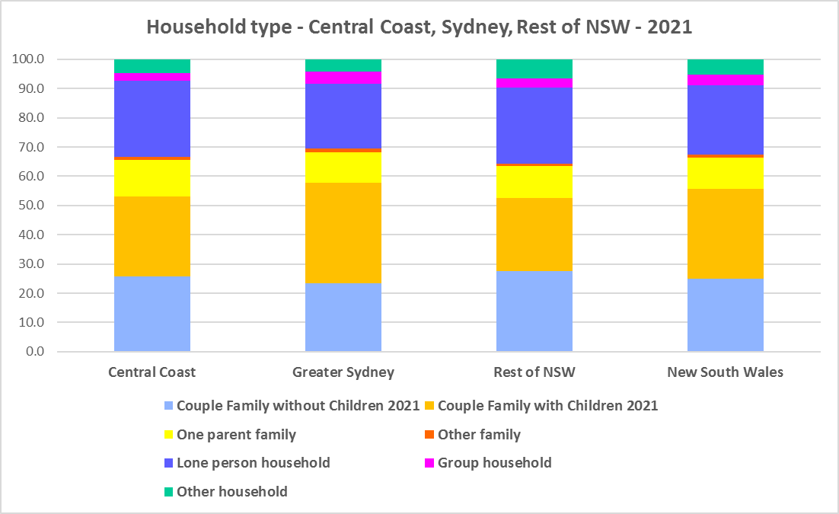



* Given the number of lone person and couple only households, it is important to ensure that housing choice in the Central Coast reflects this through availability of studio, one and two bedroom homes.

**Household Size**

* At the 2021 Census, the average household size for the Rest of NSW was 2.4 persons per household – unchanged from 2016 and 2011. The average household size for Greater Sydney was 2.7 persons per household – down from 2.8 in 2016.
* Average household size in the Central Coast was 2.5 persons per household in 2021, unchanged from 2016.
* The table below gives the average household size in the Central Coast, as well as the Rest of NSW and NSW for 2011, 2016 and 2021.



**Income**

* At the 2021 Census, low income households comprise the largest proportion of all households in the Rest of NSW and the Central Coast but not in Greater Sydney.
* The proportion of low income households at 2021 in the Central Coast is 51.3%, compared to 49.3% for the Rest of NSW and 32.1% in Greater Sydney.
* Moderate income households in the Rest of NSW comprise 21.6% of all households, 22.1% for the Central Coast and 18.2% in Greater Sydney.
* High income households comprise 29.2% of all households in the Rest of NSW, 26.5% in the Central Coast and 49.7% in Greater Sydney.
* The graph below shows the proportion of low, moderate and high income households in all the Central Coast, compared with the Rest of NSW, Greater Sydney and NSW at the 2021 Census. Clearly Central Coast is much more like the Rest of NSW than Greater Sydney in income profile of residents.
* The predominance of low income households emphasises the need for affordable housing in the Central Coast.

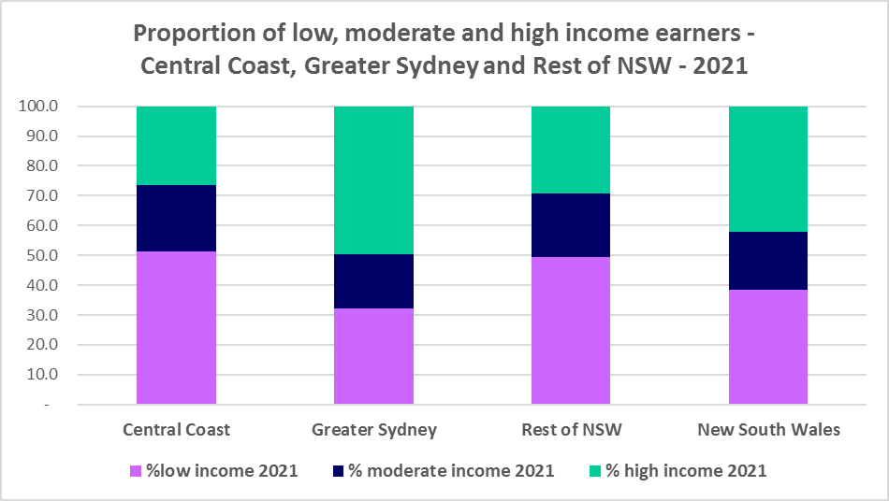

* The graph below shows the change in the number of low (including very low), moderate and high income households from 2016 to 2021 in the Central Coast. It is evident that while there has been a pronounced increase in high income households in the area, the increase in low income households has been much stronger.

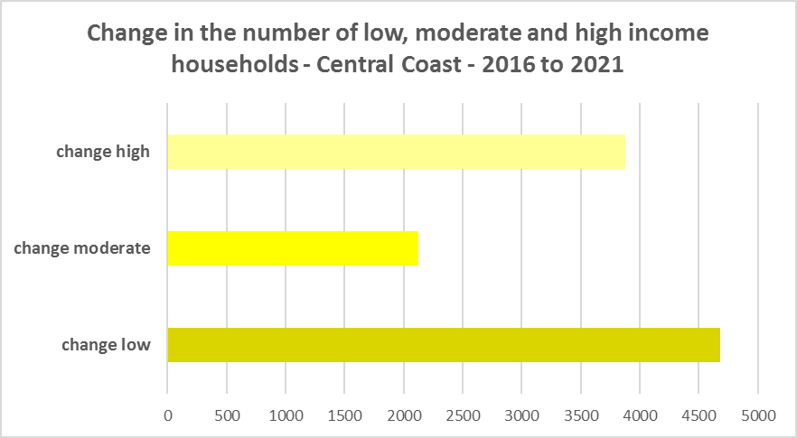

* In the neighbouring region of the Hunter, despite the increase in the number of low income households between 2016 and 2021, all the Hunter LGAs experienced a very strong decline in very low income **rental** households over the same period. Most also had declines in low income **rental** households. This is most likely attributable to changes in income assistance during and post the Covid pandemic.
* This has not been the experience in the Central Coast, which has seen very strong increases in both very low income rental households and low income rental households between 2016 and 2021. These numbers increased despite the changes in income assistance – suggesting that significant numbers of lower income renters moved to the Central Coast over this time frame.
* The graph below shows the change in the number of very low and low income **renters** between 2016 and 2021 in the Central Coast.

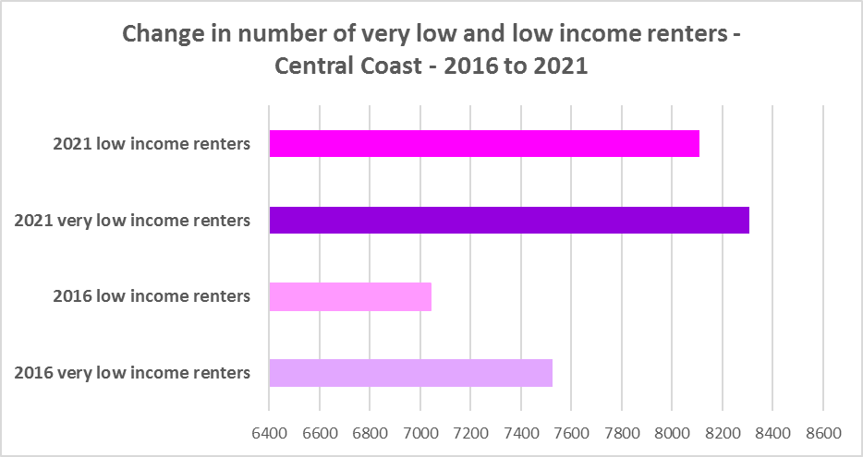

* The Central Coast ($1,507) has a higher median household weekly income at 2021 than the Rest of NSW ($1,434), but significantly lower than Greater Sydney ($2,077).
* The table below shows the change in median household weekly income in the Central Coast, along with the Rest of NSW, Greater Sydney and NSW from the 2011, 2016 and 2021 Census.



* The predominance of low income households, the significant increase in low income households and very low and low income rental households shows the strong and increasing demand for affordable housing for lower income households in this region. There is a need to ensure affordable housing supply commensurate with this increasing demand. Given the number and increase in lower income rental households, ensuring an increase in the supply of affordable rental housing is particularly important.

**Homelessness**

* People experiencing homelessness and those at risk of homelessness are among Australia’s most socially and economically disadvantaged. State, Commonwealth and some local governments fund services to support people who are homeless, or at risk of homelessness. Services are delivered mainly by non–government organisations, some of which specialise in delivering services to specific groups (such as young people or people experiencing domestic violence).
* Inadequate income and inability to access affordable housing are significant contributing factors to homelessness, along with individual factors such as experience of family and domestic violence, ill health and disability.
* The ABS identifies someone as homeless “where they do not have suitable accommodation alternatives and their current living arrangement:
  + Is in a dwelling that is inadequate;
  + Has no tenure or their initial tenure is short and not extendable; or
  + Does not allow them to have control of and access to space for social relations.”
* The ABS uses “six operational groups for presenting estimates of people experiencing homelessness on Census night:
  + People living in improvised dwellings, tents or sleeping out
  + People living in supported accommodation for the homeless
  + People staying temporarily with other households
  + People living in boarding houses
  + People in other temporary lodgings
  + People living in ‘severely’ overcrowded dwellings.”
* The ABS “also compiles estimates from Census data for the following three groups of people who may be marginally housed but are not classified as homeless:
  + People living in other crowded dwellings
  + People in other improvised dwellings
  + People marginally housed in caravan parks.”
* The table below shows the ABS 2021 Census data for the Central Coast on the homeless and marginally housed.
* Note that due to additional assistance provided during the pandemic, the number of people counted as homeless on Census night in 2021 is lower than at the 2016 Census. Nevertheless, there were 802 people who were counted as homeless at the 2021 Census in the Central Coast, with a further 571 who were marginally housed.
* The largest group of homeless in the Central Coast were people in supported accommodation for the homeless (206 or 25.7%), followed by people staying temporarily with other households (196 or 24.4%), then people living in severely crowded dwellings (163 or 20.3%).
* Of those who were counted as marginally housed, the majority (418 or 73.2%) were living in other crowded dwellings.
* This clearly indicates the need for more affordable rental housing.



* The 2023 NSW street count, the NSW Government’s fourth annual rough sleeping street count, was completed between 2 February and 27 February 2023.
* Over 300 local organisations either consulted in the planning phase or participated in the delivery of street counts. Organisations which partnered with the Department of Communities and Justice (DCJ) included Community Housing Providers, local councils and Specialist Homelessness Services, as well Aboriginal organisations, Local Health Districts, local community groups, and Police.
* 1,623 people were counted sleeping rough during these street counts, a 34% increase from 2022.
* Street counts took place in more than 350 towns in 76 LGAs, compared to 71 LGAs in 2021 and 65 LGAs in 2020.
* The table below gives the street count results for the Central Coast locations.



## People with Disability

* According to the Australian Institute of Health and Welfare (AIHW) and data from the 2018 Australian Bureau of Statistics (ABS) Survey of Disability, 18% of people in Australia have disability. Another 22% have a long term health condition but not disability.
* Nearly one third (32%) of people with disability have severe or profound disability. This means needing help with daily self-care, mobility or communication activities, having difficulty understanding or being understood by family or friends, or communicating more easily using sign language or other non-spoken forms of communication.
* The survey data shows:
  + 7.6% of children aged 0–14 have disability
  + 9.3% of people aged 15–24 have disability
  + 13% of people aged 15–64 have disability
  + 50% of people aged 65 and over have disability (ABS 2019b).
* For 77% of people with disability, the main type of disability is physical, while for the remaining 23%, the main type of disability is mental or behavioural.
* Clearly housing is a significant factor in the health and wellbeing of people with disability. The availability of affordable, sustainable and appropriate housing helps people with disability to participate in the social, economic and community aspects of everyday life. Someone without access to affordable, secure and appropriate housing is more likely to experience homelessness, poor health, and lower rates of employment and education.
* While most people with disability live at home in the community (96% in private dwellings), some live in cared accommodation.
* Cared accommodation is usually long term and may be institutional in style, including hospitals, residential aged care, care components of retirement villages, aged care hostels, psychiatric institutions and group homes for people with disability. The more severe a person’s disability is, the more likely they are to live in cared accommodation and the less likely they are to live in the community.
* There has been a significant shift towards supporting people with disability to live in private dwellings, rather than being in institutional care over recent decades. Largely this has been driven by changes for young people with disability.

## Additional Data

More detailed housing data and tables used in this Snapshot are available from the Local Government Housing Kit Database on the FACS website at:

<https://www.facs.nsw.gov.au/resources/nsw-local-government-housing-kit/chapters/local-government-housing-kit-database>

More information on the housing needs of older Australians and people with disability:

The Australian Institute of Health and Welfare – Older Australians Housing and Living Arrangements on the AIHW website at:

<https://www.aihw.gov.au/reports/older-people/older-australians/contents/housing-and-living-arrangements>

The Australian Institute of Health and Welfare – People with Disability in Australia

<https://www.aihw.gov.au/reports/disability/people-with-disability-in-australia/contents/people-with-disability/prevalence-of-disability>

and relating to housing needs

<https://www.aihw.gov.au/reports/disability/people-with-disability-in-australia/contents/housing>

The Productivity Commission’s report Housing Decisions of Older Australians is at:

<https://www.pc.gov.au/research/completed/housing-decisions-older-australians>

More detailed information on population, household and dwelling projections is available on the Department of Planning and Environment website at:

<https://www.planning.nsw.gov.au/Research-and-Demography/Population-Projections/Projections>

<https://pp.planningportal.nsw.gov.au/populations>

More data on homelessness, specifically homelessness service data is available on the Homelessness NSW website at:

<https://homelessnessnsw.org.au/resource/specialist-homelessness-service-data/>

And from the AIHW website here:

<https://www.aihw.gov.au/reports/australias-welfare/homelessness-and-homelessness-services>

The 2023 Street Count result is at the DCJ/ FACS website here:

<https://www.facs.nsw.gov.au/reforms/homelessness/premiers-priority-to-reduce-street-homelessness/street-count>

Further information on ABS estimation of homelessness is available at the ABS website:

<https://www.abs.gov.au/statistics/people/housing/estimating-homelessness-census/2021>