**Illawarra Shoalhaven Region – What’s the Housing Demand?**

This Housing Snapshot looks at aspects of housing demand in the Illawarra Shoalhaven, particularly from the 2016 Census to the 2021 Census – including population, age profile, household type, household size, income (change in low, moderate and high income households and low income rental households), homelessness and people with disability.

There have been significant challenges to this region since the 2016 Census, including natural disasters and unexpectedly high additional inmigration – in part due to the desire for sea and tree changes and increased ability to work remotely - which have impacted the community and the demand for housing. The popularity of short term rental accommodation through platforms such as Airbnb have also impacted the housing market and demand for housing.

**Population Forecast**

* Between 2016 and 2021, the population of the Illawarra Shoalhaven grew by 7.4% or 29,235, from 393,205 to 422,440 (using ABS Census population data).
* On an individual LGA basis, population growth ranged from 5.4% in Wollongong to 11.4% in Shellharbour. In terms of numbers, Wollongong had the largest increase with an additional 10,934, followed by Shoalhaven with 8,882.
* Wollongong has the largest population of the Illawarra Shoalhaven LGAs with 214,564 (comprising 50.8% of the region’s total population), while Kiama has the smallest population with 23,074 (comprising 5.5% of the region’s population).
* The Department of Planning and Environment have prepared demographic information on every LGA in the region. Their projections indicates that all of the LGAs in the region are expected to increase in population to 2041 and anticipates a stronger growth rate in each of the four Illawarra Shoalhaven LGAs than the NSW average of 0.95% per annum. DPE forecasts the strongest proportional population growth in Shellharbour with an annual growth rate of 1.67%. However, numerically the largest increases in population to 2041 is predicted for Wollongong.
* The table below shows the population change between 2016 and 2021 for each Illawarra Shoalhaven LGA and the region as a whole, using ABS Census data.



**Age**

* The age profile of the region and particularly each LGA will impact on housing need and demand, including number of bedrooms, affordability, location and dwelling type.
* The median age of the population of the four Illawarra Shoalhaven LGAs at the 2021 Census ranges between 39 years (Shellharbour and Wollongong) and 48 (Kiama and Shoalhaven). This compares to the median age for the Rest of NSW (excluding Sydney) of 43 years.
* Not surprisingly – the age profiles of Shellharbour and Wollongong are similar and the age profiles of Kiama and Shoalhaven are more alike.
* Both Shellharbour and Wollongong have higher proportions of every age cohort under 55 years and Kiama and Shoalhaven have higher proportions of every age cohort over 55 years of age.
* Shellharbour is the only Illawarra Shoalhaven LGA with higher proportions of 0-4 (6.0%) and 5-14 (13.1%) year olds than the Rest of NSW average of 5.5% and 12.4% respectively.
* The graph and table below show the proportion of the population in each key age cohort in the Illawarra Shoalhaven and the Rest of NSW.

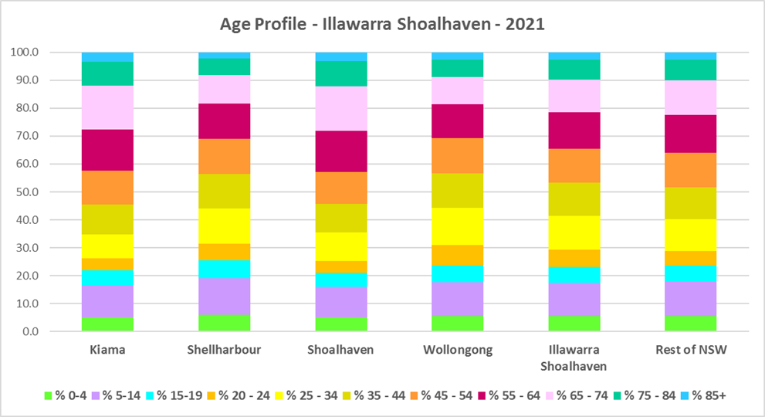

Proportion of population in each age cohort - 2021 Census for Illawarra Shoalhaven



* DPE forecast increases in residents aged over 65 to 2041 in every Illawarra Shoalhaven LGA, as well as an increase in younger age groups in Kiama and Shoalhaven.
* The diversity of age groups requires a range of different housing to meet the needs of the community throughout the housing life cycle. However the higher median age and higher proportions of older age cohorts indicates that there is a need for housing to suit older residents in Kiama and Shoalhaven. Increasingly this will be the case in Shellharbour and Wollongong as the number in older age groups grows in both these LGAs.
* As the Australian Institute for Health and Welfare (AIHW) note:

Many older Australians prefer to age in place, meaning they wish to stay in their local home or community. However, their capacity to do so can be influenced by:

* + the appropriateness and quality of their home (for example, size, layout)
  + their ability to modify their home to suit their functional requirements
  + the cost and availability of suitable housing
  + their need for formal care and assistance
  + their proximity to services and social support.
* Although the majority of older Australians own their own home, this number is declining. About 15% of older Australians are renters. These people are generally a highly vulnerable and economically disadvantaged group, particularly single person households, with older women being the fastest growing demographic of people experiencing homelessness. There is therefore a need for more adaptable, accessible dwellings, well located, secure, low maintenance and affordable to meet the needs of seniors and frail aged in particular, within their communities. Those most in need are households in the private rental market, who struggle to afford housing on an Aged Pension or inadequate superannuation. (Source: "Housing Decisions of Older Australians" Productivity Commission December 2015).

**Household Type**

* A look at household types gives some insight into the type of housing – particularly number of bedrooms – that is likely to be appropriate to meet the housing needs of the community.
* Household types in the Illawarra Shoalhaven vary between the LGAs and generally differ from the average for NSW.
* At the 2021 Census in the Rest of NSW, couple families without children (27.7%) and lone person households (26.1%) are the largest two household types. In the Illawarra Shoalhaven, only Shoalhaven (31.8% and 26.5% respectively) is in line with the Rest of NSW. Kiama (34.5% and 28.9%) and Shellharbour (26.8% and 32.1%) have couple families without children and couple families with children as the largest household types. Wollongong (29.3% and 25.4%) has couple families with children and lone person households as the largest household types.
* There has been a small shift since the 2016 Census, with an increase in couple family without children households in the Rest of NSW (0.7%), a decline in couple families with children households (-0.6%) and a small increase in lone person households (0.5%).
* Changes in the Illawarra Shoalhaven have been more pronounced:
  + Couple family without children households increased by 2.4% in Kiama, 1.6% in Shellharbour and 1.1% in Wollongong
  + Couple family with children households declined by -1.9% in Shellharbour, -1.3% in Kiama and -0.9% in Wollongong.
  + Lone person households increased by 1.5% in Kiama, 1.2% in Shellharbour, 1.0% in Wollongong and declined by -0.2% in Shoalhaven.
* The graph and table below show the proportion in each key household type for every Illawarra Shoalhaven region LGA and Rest of NSW at the 2021 Census.

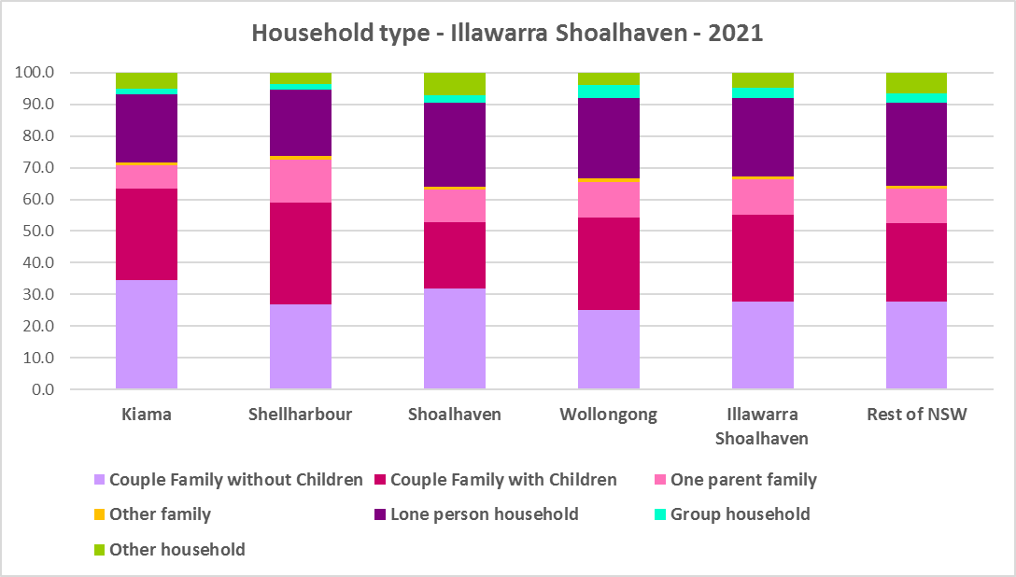



* Given the number of lone person and couple only households, it is important to ensure that housing choice in the community reflects this through availability of studio, one and two bedroom homes.

**Household Size**

* At the 2021 Census, the average household size for the Rest of NSW was 2.4 persons per household – unchanged from 2016 and 2011.
* Shellharbour (2.6 persons per household) and Kiama and Wollongong (2.5 persons per household) have a larger average household size than the Rest of NSW, while Shoalhaven (2.3 persons per household) has a smaller average household size than the Rest of NSW.
* Since 2016, average household size has been stable in Kiama and Shoalhaven and declined in Shellharbour and Wollongong.
* The table below gives the average household size in each of the Illawarra Shoalhaven LGAs as well as the Rest of NSW for 2011, 2016 and 2021.



**Income**

* At the 2021 Census, low income households comprise the largest proportion of all households in the Rest of NSW and each Illawarra Shoalhaven region LGA, with the exception of Kiama.
* Shellharbour is the only Illawarra Shoalhaven LGA to have a higher proportion of low income households than the average for the Rest of NSW (49.3%). Across the region the proportion of low income households ranges from 29.4% in Kiama to 49.6% in Shellharbour.
* Moderate income households in the Rest of NSW comprise 21.5% of all households, while in the Illawarra Shoalhaven they range from 20.0% in Kiama to 23.2% in Shellharbour.
* High income households comprise 29.2% of all households in the Rest of NSW and in the Illawarra Shoalhaven range between 27.1% in Shellharbour and 50.6% in Kiama.
* The graph and table below shows the proportion of low, moderate and high income households in all the Illawarra Shoalhaven LGAs, compared with the Region and Rest of NSW at the 2021 Census.

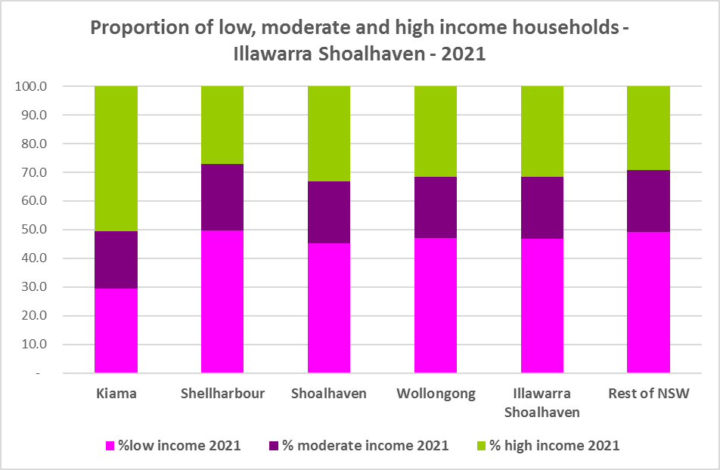



* Between 2016 and 2021 while the number of low income households increased in the Illawarra Shoalhaven as a whole, the number of low income households declined in Shoalhaven and Kiama and increased in Shellharbour and Wollongong.
* Over the same period, the number of moderate income households increased in every Illawarra Shoalhaven LGA.
* While the number of high income households increased overall in the region, the number of high income households declined in Wollongong and Shellharbour and increased in Shoalhaven and Kiama.
* The graph below shows the change in the number of low (including very low), moderate and high income households from 2016 to 2021 in the Illawarra Shoalhaven region.

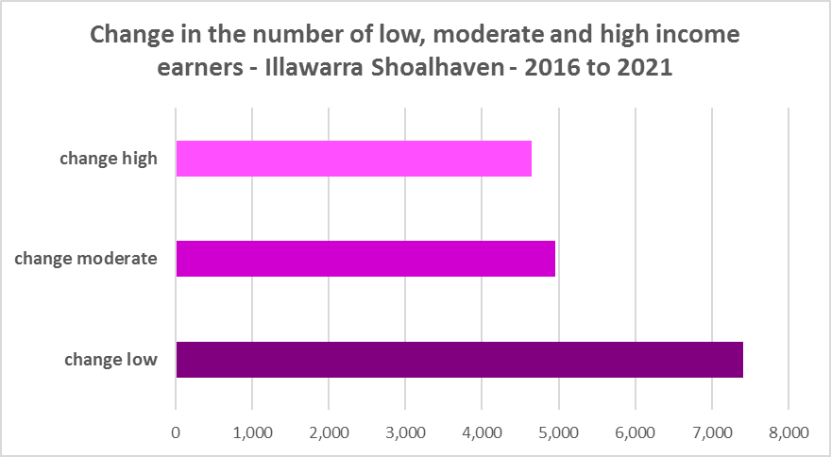

* However, despite the increase in the number of low income households between 2016 and 2021, all the Illawarra Shoalhaven LGAs experienced a very strong decline in very low income **rental** households over the same period, varying between a -32.2% decline in Kiama and a -13.2% decline in Shellharbour.
* All also had declines in low income **rental** households over the same period, with Kiama again having the largest proportional decline of -17.0% and Wollongong the lowest with -1.1%.
* The reduction in both very low (-1,889) and low income renters (-207) across the Illawarra Shoalhaven region is likely due to the additional Commonwealth financial assistance to renters during the pandemic and may therefore be temporary – as this has subsequently been discontinued, as explained in the What’s Happening in the Housing Market” snapshot for the Illawarra Shoalhaven. It is also likely that at least some lower income rental households have been priced out of the region and/or impacted by the loss of long term rental to short term rental or home purchase/ownership. The snapshot of What’s Happening in the Housing Market shows the significant decline in the proportion of private rental that is affordable to very low income households.
* These changes underline the need to consider tenure as well as price point when considering responses to meet housing need.
* The graph below shows the change in the number of very low and low income **renters** between 2016 and 2021 in the Illawarra Shoalhaven.

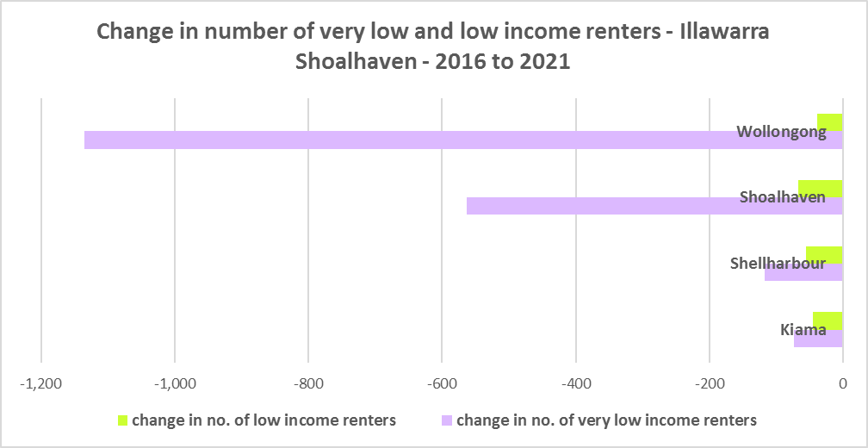

* None of the Illawarra Shoalhaven LGAs has a higher median household weekly income at 2021 than the Rest of NSW ($1,434). Wollongong is the closest with $1,682.
* The table below shows the change in median income in each Illawarra Shoalhaven LGA along with the Rest of NSW from the 2011, 2016 and 2021 Census.



**Homelessness**

* People experiencing homelessness and those at risk of homelessness are among Australia’s most socially and economically disadvantaged. State, Commonwealth and some local governments fund services to support people who are homeless, or at risk of homelessness. Services are delivered mainly by non–government organisations, some of which specialise in delivering services to specific groups (such as young people or people experiencing domestic violence).
* Inadequate income and inability to access affordable housing are significant contributing factors to homelessness, along with individual factors such as experience of family and domestic violence, ill health and disability.
* The ABS identifies someone as homeless “where they do not have suitable accommodation alternatives and their current living arrangement:
  + Is in a dwelling that is inadequate;
  + Has no tenure or their initial tenure is short and not extendable; or
  + Does not allow them to have control of and access to space for social relations.”
* The ABS uses “six operational groups for presenting estimates of people experiencing homelessness on Census night:
  + People living in improvised dwellings, tents or sleeping out
  + People living in supported accommodation for the homeless
  + People staying temporarily with other households
  + People living in boarding houses
  + People in other temporary lodgings
  + People living in ‘severely’ overcrowded dwellings.”
* The ABS “also compiles estimates from Census data for the following three groups of people who may be marginally housed but are not classified as homeless:
  + People living in other crowded dwellings
  + People in other improvised dwellings
  + People marginally housed in caravan parks.”
* The table below shows that ABS 2021 Census data for the Illawarra Shoalhaven on the homeless and marginally housed.
* Note that due to additional assistance provided during the pandemic, the number of people counted as homeless on Census night in 2021 is lower than at the 2016 Census across Australia. Nevertheless, there were 1,484 people counted as homeless at the 2021 Census in the Illawarra Shoalhaven and a further 861 who were counted as marginally housed.
* Of those who were counted as homeless, the largest number (472 or 31.8%) were people in supported accommodation for the homeless, followed by people staying temporarily with other households (327 or 22.0%), then people living in boarding houses (276 or 18.6%).
* Of those who were counted as marginally housed, the majority were people living in other crowded dwellings (638 or 74.1%).
* This clearly indicates the need for more affordable rental housing.



* The 2023 NSW street count, the NSW Government’s fourth annual rough sleeping street count, was completed between 2 February and 27 February 2023.
* Over 300 local organisations either consulted in the planning phase or participated in the delivery of street counts. Organisations which partnered with the Department of Communities and Justice (DCJ) included Community Housing Providers, local councils and Specialist Homelessness Services, as well Aboriginal organisations, Local Health Districts, local community groups, and Police.
* 1,623 people were counted sleeping rough during these street counts, a 34% increase from 2022.
* Street counts took place in more than 350 towns in 76 LGAs, compared to 71 LGAs in 2021 and 65 LGAs in 2020.
* The table below gives the street count results for the Illawarra Shoalhaven locations.



## People with Disability

* According to the Australian Institute of Health and Welfare (AIHW) and data from the 2018 Australian Bureau of Statistics (ABS) Survey of Disability, 18% of people in Australia have disability. Another 22% have a long term health condition but not disability.
* Nearly one third (32%) of people with disability have severe or profound disability. This means needing help with daily self-care, mobility or communication activities, having difficulty understanding or being understood by family or friends, or communicating more easily using sign language or other non-spoken forms of communication.
* The survey data shows:
  + 7.6% of children aged 0–14 have disability
  + 9.3% of people aged 15–24 have disability
  + 13% of people aged 15–64 have disability
  + 50% of people aged 65 and over have disability (ABS 2019b).
* For about 3 in 4 (77%) people with disability, the main type of disability is physical, while for the remaining 1 in 4 (23%), the main type of disability is mental or behavioural.
* Clearly housing is a significant factor in the health and wellbeing of people with disability. The availability of affordable, sustainable and appropriate housing helps people with disability to participate in the social, economic and community aspects of everyday life. Someone without access to affordable, secure and appropriate housing is more likely to experience homelessness, poor health, and lower rates of employment and education.
* While most people with disability live at home in the community (96% in private dwellings), some live in cared accommodation.
* Cared accommodation is usually long term and may be institutional in style, including hospitals, residential aged care, cared components of retirement villages, aged care hostels, psychiatric institutions and group homes for people with disability. The more severe a person’s disability is, the more likely they are to live in cared accommodation and the less likely they are to live in the community.
* There has been a significant shift towards supporting people with disability to live in private dwellings, rather than being in institutional care over recent decades. Largely this has been driven by changes for young people with disability.

## Additional Data

More detailed housing data and tables used in this Snapshot are available from the Local Government Housing Kit Database on the FACS website at:

<https://www.facs.nsw.gov.au/resources/nsw-local-government-housing-kit/chapters/local-government-housing-kit-database>

More information on the housing needs of older Australians and people with disability:

The Australian Institute of Health and Welfare – Older Australians Housing and Living Arrangements on the AIHW website at:

<https://www.aihw.gov.au/reports/older-people/older-australians/contents/housing-and-living-arrangements>

The Australian Institute of Health and Welfare – People with Disability in Australia

<https://www.aihw.gov.au/reports/disability/people-with-disability-in-australia/contents/people-with-disability/prevalence-of-disability>

and relating to housing needs

<https://www.aihw.gov.au/reports/disability/people-with-disability-in-australia/contents/housing>

The Productivity Commission’s report Housing Decisions of Older Australians is at:

<https://www.pc.gov.au/research/completed/housing-decisions-older-australians>

More detailed information on population, household and dwelling projections is available on the Department of Planning and Environment website at:

<https://www.planning.nsw.gov.au/Research-and-Demography/Population-Projections/Projections>

<https://pp.planningportal.nsw.gov.au/populations>

More data on homelessness, specifically homelessness service data is available on the Homelessness NSW website at:

<https://homelessnessnsw.org.au/resource/specialist-homelessness-service-data/>

And from the AIHW website here:

<https://www.aihw.gov.au/reports/australias-welfare/homelessness-and-homelessness-services>

The 2023 Street Count result is at the DCJ/ FACS website here:

<https://www.facs.nsw.gov.au/reforms/homelessness/premiers-priority-to-reduce-street-homelessness/street-count>

Further information on ABS estimation of homelessness is available at the ABS website:

<https://www.abs.gov.au/statistics/people/housing/estimating-homelessness-census/2021>