# **North District – What’s the Housing Demand**

This Housing Snapshot looks at aspects of housing demand, particularly from the 2016 Census to the 2021 Census – including population, age profile, household type, household size, income (change in low, moderate and high income households and low income rental households), homelessness, Indigenous residents and people with disability.

There have been challenges across Australia and in this region since the 2016 Census, including the pandemic and subsequent surge in immigration - which have impacted the community and the demand for housing. Subsequent cost of living pressures, including inflation, rising interest rates and tightening of the rental market also have significant impacts on the demand for housing.

## Population

* Changes in population will impact on the demand for housing.
* Between 2016 and 2021, the population of North District grew by 4.2% or 38,829, from 914,366 to 953,195, using ABS Census population data.
* However, these figures mask considerable variation in population change between 2016 and 2021 amongst the LGAs of North District.
* Changes in population between 2016 and 2021 within North District ranged from an 11.0% increase in Ryde and a -3.1% decline in Hunters Hill.
* In terms of numbers, Ryde had the largest increase in the District with an additional 12,819 people, followed by Northern Beaches with 10,678 and Hornsby with 9,145.
* Note that Hunters Hill ranked 6th in the state in terms of numerical loss of population between 2016 and 2021.
* Northern Beaches has the highest population in the District with 263,554 and Hunters Hill the smallest with 13,559.
* The Department of Planning and Environment have prepared population projections for every LGA in the district, however only Ryde (1.52% per annum) is forecast to have a higher growth rate than the average for NSW of 0.95% per annum.
* Numerically the largest increase in population forecast to 2041 is predicted for Ryde (46,981) followed by Northern Beaches (15,514), Ku-ring-gai (13,358) and Hornsby (11,232).
* The table below shows the population change for each North District LGA and the district as a whole from 2016 to 2021, using ABS Census data.



## Age

* The age profile of the region and particularly each LGA will impact on housing need and demand, including number of bedrooms, affordability, location and dwelling type.
* The median age of the population of the North District LGAs at the 2021 Census is generally older than the average for Greater Sydney of 37 years, and ranges between 37 years (Lane Cove and Ryde) and 46 (Hunters Hill). Willoughby (39) has the next youngest median age and Mosman (45) has the next oldest. The table below gives the median age for all the North District LGAs and Greater Sydney.



* There is some similarity in the age profiles of the North District LGAs.
* The District as a whole has lower proportions of 0-4, 20-24 and 25-34 year olds and higher proportions of all other age cohorts than the average for Greater Sydney. The higher proportions of older age groups is not surprising given the higher median age of most North District LGAs.
* However, there are also differences in the age profiles of LGAs in the District, compared to the District as a whole and Greater Sydney.
  + Lane Cove has higher proportions of 0-4 and 25-34 year olds and lower proportions of 55-64, 65-74, 75-84 and 85+ year olds than the average for Greater Sydney.
  + Hornsby, Hunters Hill, Ku-ring-gai and Northern Beaches have higher proportions of 5-14 and 15-19 year olds than the average for Greater Sydney.
  + North Sydney has higher proportions of 25-34 year olds and lower proportions of 55-64 and 85+ year olds than the average for Greater Sydney.
  + Ryde has higher proportions of 20-24 and 25-34 year olds and lower proportions of 45-54, 55-64 and 75-84 year olds than the average for Greater Sydney.
  + Willoughby has higher proportions of 5-14 year olds and lower proportions of 55-64 year olds than the average for Greater Sydney.
* The graph below shows the proportion of the population in each key age cohort in the North District LGAs as well as the District and Greater Sydney.

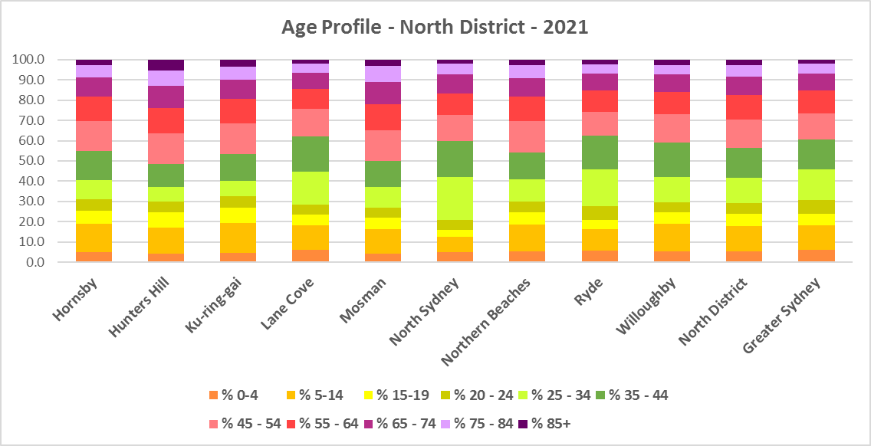

* The table below gives more detail of the breakdown of age cohorts by LGA, for the North District and for Greater Sydney.



* The Department of Planning and Environment forecast increases in residents aged over 65 to 2041 in every North District LGA.
* The Department also projects an increase in younger age groups in Lane Cove, North Sydney and Ryde and no change in younger age groups in all the other LGAs in the District.
* The diversity of age groups requires a range of different housing to meet the needs of the community throughout the housing life cycle. However the higher median age and higher proportions of older age cohorts in most of the North District LGAs, indicates that there is a need for housing to suit older residents. Increasingly this will be the case as the number in older age cohorts grows.
* As the Australian Institute for Health and Welfare (AIHW) note:

Many older Australians prefer to age in place, meaning they wish to stay in their local home or community. However, their capacity to do so can be influenced by:

* + the appropriateness and quality of their home (for example, size, layout)
  + their ability to modify their home to suit their functional requirements
  + the cost and availability of suitable housing
  + their need for formal care and assistance
  + their proximity to services and social support.
* Although the majority of older Australians own their own home, this number is declining. About 15% of older Australians are renters. These people are generally a highly vulnerable and economically disadvantaged group, particularly single person households, with older women being the fastest growing demographic of people experiencing homelessness. There is therefore a need for more adaptable, accessible dwellings, well located, secure, low maintenance and affordable to meet the needs of seniors and frail aged in particular, within their communities. Those most in need are households in the private rental market, who struggle to afford housing on an Aged Pension or inadequate superannuation. (Source: "Housing Decisions of Older Australians" Productivity Commission December 2015).
* Although the proportions of low income households are not high in this District, the actual numbers are significant. Therefore affordability is a key issue for all age groups, including older residents, and particularly tenants.
* The Australian Housing and Urban Research Institute (AHURI) has undertaken research on “What is the ideal home for older Australians?”
  + “Older Australians and the housing aspirations gap” and
  + “Understanding the housing aspirations of older Australians”
* This research is part of a broader study on “Housing aspirations and constraints for lower income Australians.” AHURI’s research demonstrates that one of the most valued aspects of older residents housing is the location – that the neighbourhood feels safe and secure; that there is good (including walkable) access to services such as health, shopping, recreational amenities, public open space; and that it is close to family and friends.

## Household Type

* A look at household types and average household size gives some insight into the type of housing – particularly number of bedrooms – that is likely to be appropriate to meet the housing needs of the community.
* At the 2021 Census in Greater Sydney, couple families with children are the largest household type, comprising 34.4% of all households, followed by couple family without children households (23.3%) and lone person households (22.2%). One parent family households (10.5%), other family households (1.2%), group households (4.0%) and other households (4.3%) make up the remainder.
* Household types in North District are similar to the average for Greater Sydney, with couple families with children being the largest household type, followed by couple families without children and lone person households.
* In North District as a whole, there are slightly higher proportions of couple families without children (25.7%), couple families with children (35.9%), lone person households (23.2%) and other households (which include multi-family households) (4.3%) and slightly lower proportions of one parent families (8.3%), other family households (0.9%) and group households (4.0%) than the average for Greater Sydney.
* However, individual LGAs in the District vary from this pattern.
  + Mosman has lone person households (30.7%) followed by couple family with children (28.0%) as the largest two household types.
  + North Sydney has lone person households (37.0%) followed by couple family without children (28.9%) as the largest two household types.
  + Ryde has couple family with children (32.1%) and lone person households (25.5%) as the largest two household types.
  + North Sydney (4.8%) and Ryde (4.0%) have higher proportions of group households than the average for Greater Sydney.
* There has been a shift in the proportions of different household types since the 2016 Census, with an increase in the proportion of lone person households in Greater Sydney (1.8%) and couple family without children households (0.9%), and declines in the proportion of couple family with children households (-0.9%), other household types (-1.3%) and group households (-0.5%).
* The changes in household type from 2016 to 2021 in North District were very similar, with exactly the same decline in the proportion of couple family with children households (-0.9%), a similar decline in the proportion of group household (-0.6%) and a slightly larger decline in other households (-1.7%), as well as similar increases in the proportions of couple family without children (1.1%) and lone person households (1.9%).
* Changes in individual LGAs are not all in line with this trend:
  + North Sydney (4.6%), Mosman (3.3%) and Ryde (3.2%) all had a significant increase in the proportion of lone person households, with Willoughby (2.2%) and Lane Cove (2.1%) not far behind.
  + Ryde (-2.4%) had a significant decline in the proportion of couple family with children households.
  + Hunters Hill (2.3%) and Mosman (1.7%) had larger increases in the proportion of couple family without children households.
* This data should be compared with the data on bedroom numbers to determine if there is a good fit between household types and housing stock.
* Although there should be plenty of housing suitable for families of different sizes, there is also a need for a variety of dwellings with different bedroom numbers to suit couples and single person households.
* The graph and table below show the proportion in each key household type for every North District LGA, for the District and for Greater Sydney at the 2021 Census.

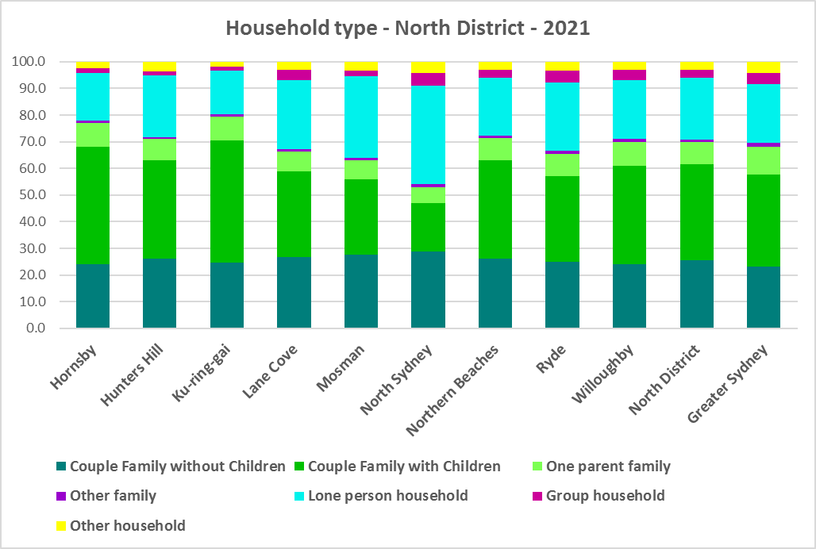



## Household Size

* At the 2021 Census, the average household size for Greater Sydney was 2.7 persons per household – down from 2.8 persons per household in 2016 and the same as 2.7 persons per household in 2011.
* Average household size in North District ranges from 2.0 persons per household in North Sydney to 2.9 persons per household in Ku-ring-gai. Hornsby (2.8) is the only other LGA in North District with a larger average household size than the average for Greater Sydney. While Northern Beaches has the Greater Sydney average of 2.7 person per household, the remaining LGAs in the District have smaller average household sizes.
* Average household size declined in every North District LGA excepting Ku-ring-gai and North Sydney between 2016 and 2021, with Ryde declining the most – from 2.7 to 2.5 persons per household.
* The table below gives the average household size in each of the North District LGAs as well as Greater Sydney for 2011, 2016 and 2021.



## Income

* At the 2021 Census, high income households comprise the largest proportion of all households in Greater Sydney – unlike the Rest of NSW, where low income households predominate.
* North District has a much higher proportion of high income households (66.4% compared to 49.7%) and much lower proportions of low (20.0% compared to 32.1%) and moderate income households (13.6% compared to 18.2%) than the average for Greater Sydney.
* North Sydney has the highest proportion of high income households in North District with 76.3%, followed by Mosman with 75.0%, Ku-ring-gai with 70.1%, Willoughby with 67.7% and Northern Beaches with 66.9%.
* The graph and table below show the proportion of low, moderate and high income households in all the North District LGAs, compared with the District and Greater Sydney at the 2021 Census.

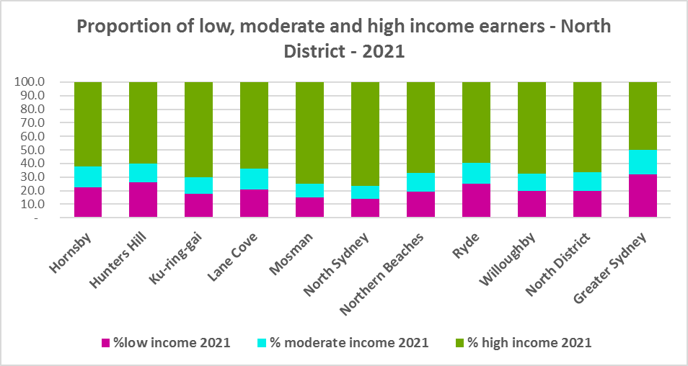



* Between 2016 and 2021 the number of low income households declined in North District as a whole and every LGA except Hunters Hill and Lane Cove, which both experienced an increase in the number of low income households.
* Over the same period, the number of moderate income households also declined in the North District as a whole and in every LGA in the District.
* The number of high income households increased overall in the District and in every LGA in North District.
* The graph below shows the change in the number of low (including very low), moderate and high income households from 2016 to 2021 in the North District.

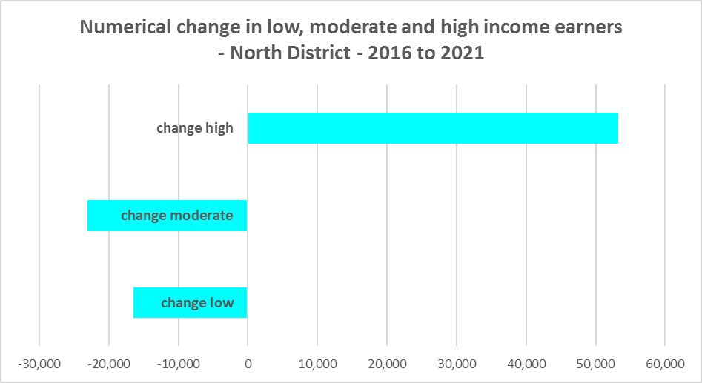

* Yet despite the decline in low income earners across the District, over the same period the number of very low income **renters** and low income **renters** increased in North District, by 12.6% and 22.1% respectively.
* While Hunters Hill experienced a small reduction in the number of both very low and low income **renters** and Mosman in low income **renters** over the period from 2016 to 2021, every other LGA in North District saw an increase in both very low and low income **renters**.
* The increase in very low income **renters** ranged from 24.7% in Hornsby to 6.7% in North Sydney and for low income **renters** from 40.6% in Ku-ring-gai to 10.4% in the Northern Beaches (excluding the decreases in Hunters Hill and Mosman).
* The increase in very low (1,213) and low income **renters** (2,175) across the North District underlines the need to consider tenure as well as price point when considering responses to meet housing need.
* The graph below shows the change in the number of very low and low income **renters** between 2016 and 2021 in the North District LGAs.

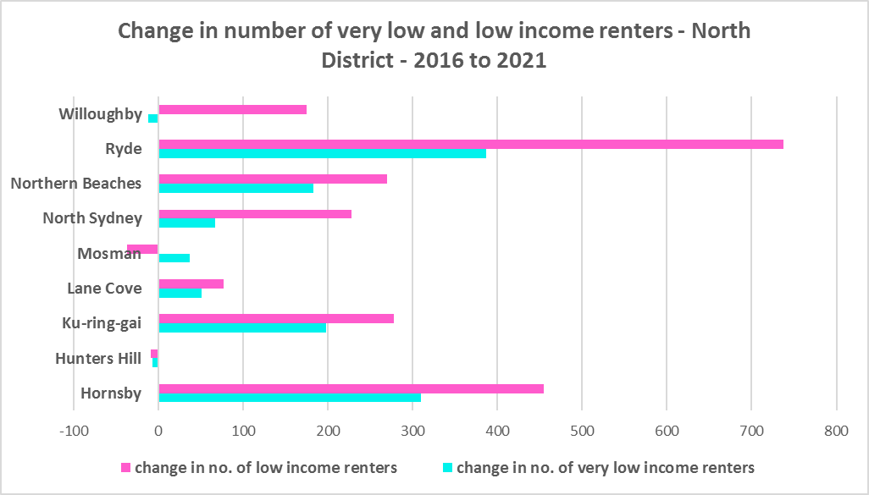

* Every LGA in North District, has a higher median household weekly income at 2021 than the average for Greater Sydney ($2,077). Ku-ring-gai ($3,038) has the highest median weekly income in the District while Ryde has the lowest ($2,098).



## Homelessness

* People experiencing homelessness and those at risk of homelessness are among Australia’s most socially and economically disadvantaged. State, Commonwealth and some local governments fund services to support people who are homeless, or at risk of homelessness. Services are delivered mainly by non–government organisations, some of which specialise in delivering services to specific groups (such as young people or people experiencing domestic violence).
* Inadequate income and inability to access affordable housing are significant contributing factors to homelessness, along with individual factors such as experience of family and domestic violence, ill health and disability.
* The ABS identifies someone as homeless “where they do not have suitable accommodation alternatives and their current living arrangement:
  + Is in a dwelling that is inadequate;
  + Has no tenure or their initial tenure is short and not extendable; or
  + Does not allow them to have control of and access to space for social relations.”
* The ABS uses “six operational groups for presenting estimates of people experiencing homelessness on Census night:
  + People living in improvised dwellings, tents or sleeping out
  + People living in supported accommodation for the homeless
  + People staying temporarily with other households
  + People living in boarding houses
  + People in other temporary lodgings
  + People living in ‘severely’ overcrowded dwellings.”
* The ABS “also compiles estimates from Census data for the following three groups of people who may be marginally housed but are not classified as homeless:
  + People living in other crowded dwellings
  + People in other improvised dwellings
  + People marginally housed in caravan parks.”
* The table below shows that ABS 2021 Census data for North District on the homeless and marginally housed.
* Note that due to additional assistance provided during the pandemic, the number of people counted as homeless on Census night in 2021 is lower than at the 2016 Census. Nevertheless, there were 1,630 people counted as homeless in North District at the 2021 Census and a further 1,243 who were counted as marginally housed.
* Of those who were counted as homeless, the largest number were people living in severely overcrowded dwellings (670 or 41.4%), followed by people living in boarding houses (610 or 37.4%), then people staying temporarily with other households (181 or 11.1%). Of those who were counted as marginally housed, the overwhelming majority were people living in other crowded dwellings (1,205 or 96.9%).
* This clearly indicates the need for more affordable rental housing.



* The 2023 NSW street count, the NSW Government’s fourth annual rough sleeping street count, was completed between 2 February and 27 February 2023.
* Over 300 local organisations either consulted in the planning phase or participated in the delivery of street counts. Organisation which partnered with the Department of Communities and Justice (DCJ) included Community Housing Providers, local councils and Specialist Homelessness Services, as well Aboriginal organisations, Local Health Districts, local community groups, and Police.
* 1,623 people were counted sleeping rough during these street counts, a 34% increase from 2022.
* Street counts took place in more than 350 towns in 76 LGAs, compared to 71 LGAs in 2021 and 65 LGAs in 2020.
* The table below gives the street count results for the North District locations.



## People with Disability

* According to the Australian Institute of Health and Welfare (AIHW) and data from the 2018 Australian Bureau of Statistics (ABS) Survey of Disability, 18% of people in Australia have disability. Another 22% have a long term health condition but not disability.
* Nearly one third (32%) of people with disability have severe or profound disability. This means needing help with daily self-care, mobility or communication activities, having difficulty understanding or being understood by family or friends, or communicating more easily using sign language or other non-spoken forms of communication.
* The survey data shows:
  + 7.6% of children aged 0–14 have disability
  + 9.3% of people aged 15–24 have disability
  + 13% of people aged 15–64 have disability
  + 50% of people aged 65 and over have disability (ABS 2019b).
* For about 3 in 4 (77%) people with disability, the main type of disability is physical, while for the remaining 1 in 4 (23%), the main type of disability is mental or behavioural.
* Clearly housing is a significant factor in the health and wellbeing of people with disability. The availability of affordable, sustainable and appropriate housing helps people with disability to participate in the social, economic and community aspects of everyday life. Someone without access to affordable, secure and appropriate housing is more likely to experience homelessness, poor health, and lower rates of employment and education.
* While most people with disability live at home in the community (96% in private dwellings), some live in cared accommodation.
* Cared accommodation is usually long term and may be institutional in style, including hospitals, residential aged care, cared components of retirement villages, aged care hostels, psychiatric institutions and group homes for people with disability. The more severe a person’s disability is, the more likely they are to live in cared accommodation and the less likely they are to live in the community.
* There has been a significant shift towards supporting people with disability to live in private dwellings, rather than being in institutional care over recent decades. Largely this has been driven by changes for young people with disability.

## Additional Data

More detailed housing data and tables used in this Snapshot are available from the Local Government Housing Kit Database on the FACS website at:

<https://www.facs.nsw.gov.au/resources/nsw-local-government-housing-kit/chapters/local-government-housing-kit-database>

The Australian Institute of Health and Welfare – Older Australians Housing and Living Arrangements on the AIHW website at:

<https://www.aihw.gov.au/reports/older-people/older-australians/contents/housing-and-living-arrangements>

The Australian Institute of Health and Welfare – People with Disability in Australia

<https://www.aihw.gov.au/reports/disability/people-with-disability-in-australia/contents/people-with-disability/prevalence-of-disability>

and relating to housing needs

<https://www.aihw.gov.au/reports/disability/people-with-disability-in-australia/contents/housing>

The Productivity Commission’s report Housing Decisions of Older Australians is at:

<https://www.pc.gov.au/research/completed/housing-decisions-older-australians>

More detailed information on population, household and dwelling projections is available on the Department of Planning and Environment website at:

<https://www.planning.nsw.gov.au/Research-and-Demography/Population-Projections/Projections>

<https://pp.planningportal.nsw.gov.au/populations>

More data on homelessness, specifically homelessness service data is available on the Homelessness NSW website at:

<https://homelessnessnsw.org.au/resource/specialist-homelessness-service-data/>

And from the AIHW website here:

<https://www.aihw.gov.au/reports/australias-welfare/homelessness-and-homelessness-services>

The 2023 Street Count result is at the FACS website here:

<https://www.facs.nsw.gov.au/reforms/homelessness/premiers-priority-to-reduce-street-homelessness/street-count#:~:text=The%202023%20NSW%20Street%20Count%20results&text=1%2C623%20people%20were%20counted%20sleeping,areas%20(LGA)%20across%20NSW>.

Further information on ABS estimation of homelessness is available at the ABS website:

<https://www.abs.gov.au/statistics/people/housing/estimating-homelessness-census/2021>