# North District – What’s Happening in the Housing Market

This Housing Snapshot looks at rents, vacancy rate, affordable rental, rental stress, loss of affordable rental stock, impact on key workers, sales price, purchase affordability and purchase stress in Western City – particularly changes between 2016 and 2021.

## There have been changes across North District since the 2021 Census, with Covid having an impact on the housing market. Recent additional cost of living pressures, including rising inflation and interest rates with continued low wage growth, have created further difficulties for lower income earners and their capacity to manage housing costs.

## Wage growth has lagged well behind house price growth for decades. In 1984 the average Australian could buy a home that costs 3.3 times their annual income. By 2022 the average Australian needed 10 times their income to buy a home. Further, the real value of wages declined by 4.5% in 2022, the largest documented deterioration. With annual inflation running at 6.0 per cent, wages need to be growing by 6.0 per cent to maintain their purchasing power.

Consequently households are increasingly struggling with housing costs – saving a deposit, taking on a mortgage, competing for rental properties, paying rising rents – as well as a wide range of other goods, such as food, power, medication, education, transport. There are many anecdotal reports of tenants having to choose between paying the rent and paying for medication, their education or food as well as rising homelessness.

## *Housing Market Rental*

## Rents

* There has been strong growth in median rents for all dwellings (including all housing types and all bedroom categories) in the North District for decades, as the graph below shows. It tracks the change in median rent (for all dwellings) for all the North District LGAs from June 1990 to June 2022 (from 2017 for Northern Beaches).
* Note from the graph that clearly there was a recent significant dip in median rents in 2020 (with the exception of Northern Beaches, which continued to increase), before a strong recovery.

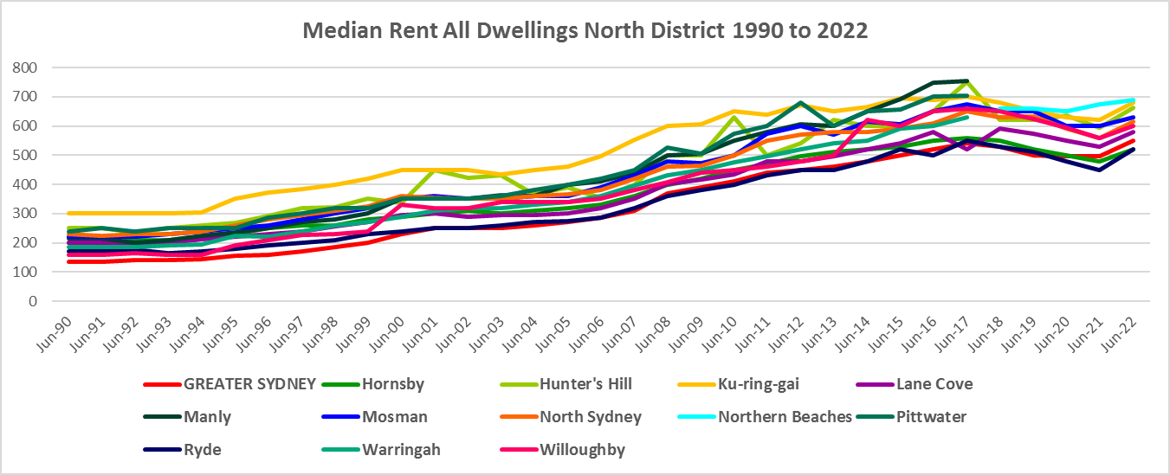

* The table below gives the change in median rent for all dwellings from September 2017 to June 2023 for all the North District LGAs. It shows relatively strong growth in median rents over that period, with the strongest increase occurring in Lane Cove.
* At June 2023 median rent for all dwellings was highest in Northern Beaches at $795 per week and lowest in Hornsby and Ryde at $650 per week



* However, changes in median rents over that time frame were more nuanced. Between 2019 and 2020 when Covid lockdowns were introduced, median rents in the North District local government areas generally dropped, as the table below demonstrates.
* During that period, the largest percentage drop in median rents occurred in Northern Beaches for studios/bedsits (-29.3%). Note that Randwick LGA in Eastern City District experienced a decline of 29.0% in the median rents for bedsit/studio accommodation over the same period, showing the impact of the lockdown on student accommodation in that LGA. North Sydney had the next largest percentage decline for studio/bedsit in North District with -10.7%.
* Over the same time frame, median rents for one bedroom homes dropped most in Lane Cove (-8.7%) and Ryde (-8.5%); for two bedroom homes -10.7% in Hunter’s Hill and -7.7% in Willoughby; for three bedroom homes -19.8% in Hunter’s Hill and -13.0% in Mosman; and for four or more bedroom homes the largest drop in median rents was -10.2% in Lane Cove, with North Sydney (12.3%), Ryde (1.8%) and Willoughby (4.2%) all experiencing rare increases in median rents.



* However, between 2020 and 2022 when Covid restrictions were relaxed, there were strong increases in median rents across the District, as the table below shows.
* Northern Beaches had the strongest increase in median rents to studio/bedsitters with 21.4%, followed by 4.4% in Willoughby.
* The strongest increase in median rents for one bedroom homes occurred in Ryde (11.6%), followed by 9.1% in Ku-ring-gai and 9.0% in Hunter’s Hill. For two bedroom homes the strongest increase occurred in Hunter’s Hill (19.0%), followed by Ku-ring-gai (12.5%) and Ryde (12.0%); for three bedroom homes 21.7% in Hunter’s Hill and 16.7% in Hornsby and Northern Beaches; and for four bedroom properties 39.1% in Lane Cove and 31.6% in Mosman.
* At June 2022, median rents for studio/bedsits ranged between $425 per week in Northern Beaches and $393 in North Sydney (note there is insufficient data in most of the North District LGAs to calculate a median rent for studio/bedsits which speaks to lack of supply); for one bedroom homes ranged between $510 per week in Lane Cove and $400 in Hornsby; for two bedroom homes between $680 in North Sydney and Northern Beaches and $485 in Hornsby; for three bedroom homes between $1,155 in Mosman and $700 in both Hornsby and Ryde; and for four or more bedroom properties between $2,500 in Mosman and $913 in Hornsby.



## Vacancy Rate

* A vacancy rate of 3% is understood to represent a balance between supply and demand. Vacancy rates below 3% represent a tight rental market while longer term vacancy rates below 2% represent a chronic undersupply of rental housing.
* According to REINSW data, vacancy rates were below 3% for the inner, middle and outer rings of Sydney for almost all of the period from 2006 through to 2018.
* At April 2023 the vacancy rate in Sydney was 1.3%, in the inner ring of Sydney was 1.5%, for the middle ring was 1.2% and for the outer ring was 1.3%, indicating a tight rental market across Sydney and most particularly in the middle ring.
* Vacancy rates are tight across almost all of NSW, indicating a significant undersupply of rental accommodation. At April 2023, the vacancy rate on the Central Coast was 1.7%, in Wollongong was 1.3%, for the Illawarra was 1.7%, in Newcastle was 1.5%, in the rest of the Hunter was 2.0% and in the Central West was 1.6%.
* Anecdotal information on the current vacancy rate underlines the difficulty tenants are facing finding and retaining rental accommodation - the fierce competition for rental housing, rent bidding and the rapid increase in rents – with tenants facing eviction, homelessness, overcrowding and paying too much of their income in rent.
* The graph below shows the vacancy rate for the inner, middle and outer rings of Sydney for the period from 2006 to 2022, using data from the Real Estate Institute of NSW. Note that Lane Cove, Mosman and North Sydney are in the Inner Ring, Hunter’s Hill, Ku-ring-gai, Ryde and Willoughby are in the Middle Ring and Hornsby and Northern Beaches are in the Outer Ring.

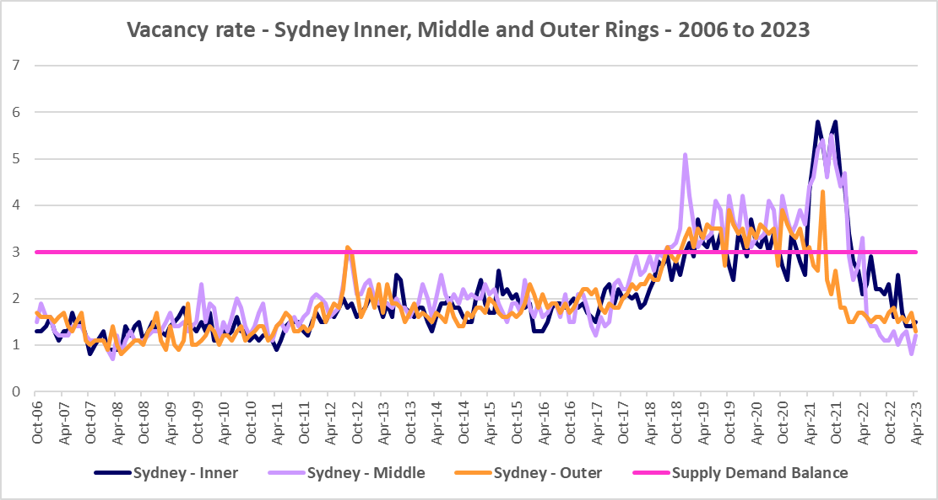

## Affordable Rental

* Since 2001, the general trend across Sydney and NSW has been for a decline in the proportion of rental stock which is affordable for very low, low and moderate income earners.
* This trend is evident in North District, although along with elsewhere in NSW, there were more complex factors at play between 2019 and 2022.
* Across Greater Sydney, the proportion of affordable rental for very low income households increased every year from 2018 to 2021 and then declined between 2021 and 2022.
* In North District, this pattern held true for the majority of LGAs (Hornsby, Hunter’s Hill, Ku-ring-gai, Lane Cove, Ryde and Willoughby). However in both Mosman and Northern Beaches affordable rental for very low income households declined between 2018 and 2019, then in line with the trend elsewhere, increased to 2021 and declined again between 2021 and 2022.
* At June 2022, every North District LGA had a lower proportion of affordable rental for very low income households than the Greater Sydney average of 10.7%. Northern Beaches had the lowest proportion with just 1.7% affordable rental, followed by Ku-ring-gai with 2.1%, Mosman with 2.4%, North Sydney with 4.0% and Willoughby with 4.4%.
* The table and graph below show the change in the proportion of new rental bonds lodged which were affordable to **very low income** households in the North District LGAs and Greater Sydney between 2017 and 2022.

Proportion affordable rental for very low income households

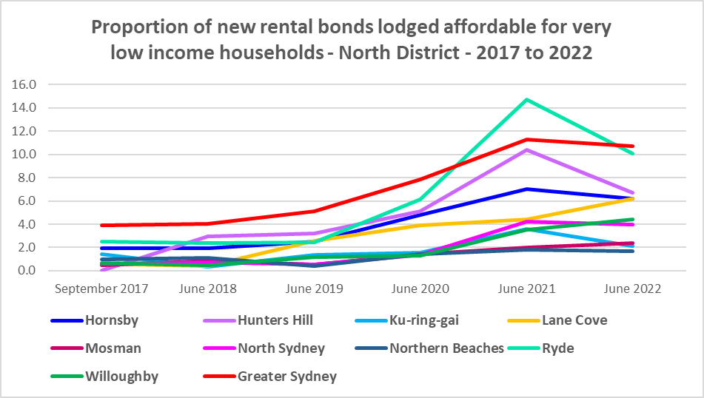

* Between 2018 and 2021 the proportion of rental affordable for **low income** households increased in Greater Sydney from 23.2% to 44.8% before declining to 41.5% in June 2022.
* This trend held true in all the North District LGAs with the exception of Northern Beaches, where the proportion of affordable rental for low income households increased to 2020, declined to 2021, then increased to 2022.
* At June 2022 every North District LGA, with the exception of Hornsby and Ryde (both on 45.9%), had a lower proportion of affordable private rental for low income households than the average of 41.5% for Greater Sydney. Northern Beaches had the lowest proportion with 16.5%, followed by Ku-ring-gai with 19.4%, North Sydney with 26.0% and Willoughby with 27.6%.
* The table and graph below show the change in the proportion of new rental bonds lodged affordable to **low income** households in the North District and Greater Sydney between 2017 and 2022.

Proportion affordable rental for low income households

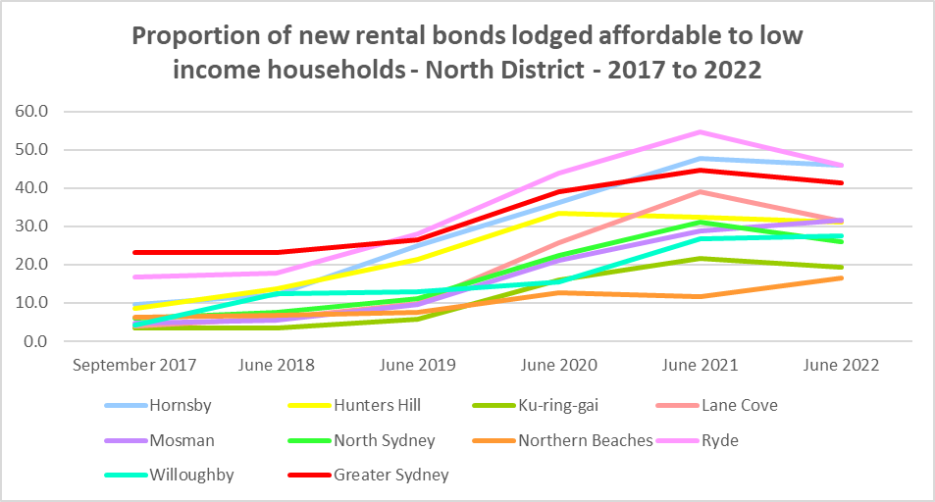

* There is evidence that short term holiday rentals such as Airbnb are impacting the supply of housing, including long term rental and affordable housing in cities and coastal communities.
* An AHURI Policy Evidence summary from November 2018 on “The Airbnb Effect in Sydney and Melbourne” found that “short term letting platforms are probably not significantly worsening rental affordability across our major cities as a whole, but are having an impact on rental properties in high-demand inner city areas with significant tourism appeal.”
* They found a concentration of listings in the eastern suburbs as well as Manly, accounting for between 11.2% and 14.8% of rental housing stock.
* They also noted that the “rise in short term lettings is reshaping the market for investment properties.”
* This evidence points to potential impact on affordable rental for longer term residents in parts of the North District, particularly the Northern Beaches.

## Rental Stress

* Households are regarded as being in rental stress when renting in the private rental market and paying more than 30% of their income in rent. Lower income households in rental stress will struggle to pay for other essential household costs, such as medical or educational expenses, food, transport and energy costs.
* At June 2021 the proportion of very low income households in rental stress in Greater Sydney was 94.0%.
* Within the North District, the average proportion of very low income households in stress was 97.4%, with the proportion varying from 99.3% in Mosman to 95.6% in Lane Cove. All LGAs in the District had a higher proportion in stress than the average for Greater Sydney.
* For low income households in rental stress at 2021, the average for Greater Sydney was 61.4%, with the North District average significantly higher on 80.6%. Across the region the proportion of low income households in stress ranged from 91.9% in Mosman to 69.2% in Hornsby.
* Every North District LGA had a higher proportion of low income households in rental stress than the Greater Sydney average.
* However, while the **proportion** of very low and low income households in stress declined in many North District LGAs (Ku-ring-gai, Lane Cove, Mosman and Northern Beaches had increased proportions for very low income households, while the proportion was steady for North Sydney) between 2016 and 2021, in line with the trend in Greater Sydney – the actual number in stress generally increased across the LGAs in the District.
* There were a couple of exceptions – the number of very low and low income households in stress declined in Hunter’s Hill and the number of low income households in stress declined in Mosman.
* Below is a graph of the proportion of very low and low income households in rental stress in each North District LGA at 2021, and a table showing the change in the proportion of very low and low income households in stress between 2016 and 2021.

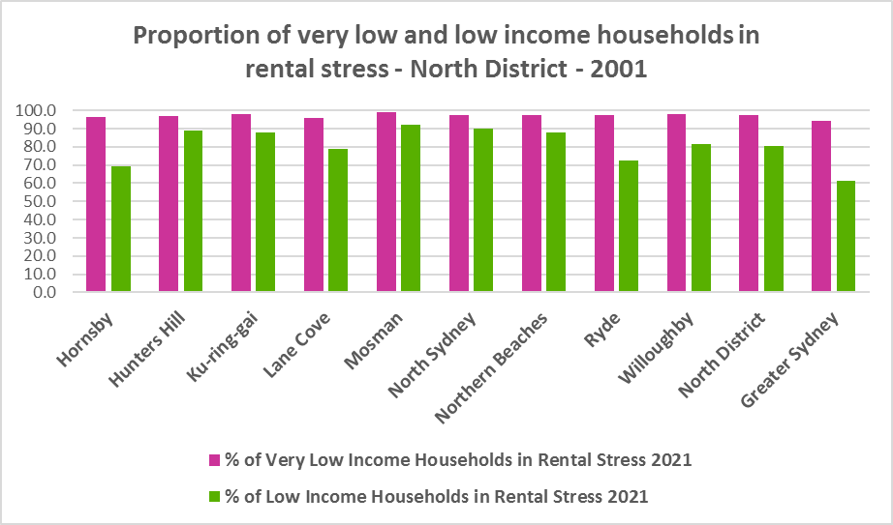

Proportion of very low and low income households in rental stress

* The next table shows the change in the number of very low and low income households in rental stress at 2016 and at 2021.

Number of very low and low income households in rental stress

* A look at CRA (Commonwealth Rent Assistance) recipients in housing stress gives some further information on what has been happening with lower income households in rental stress over this time frame.
* Between 2016 and 2020, the total number of CRA recipients in North District increased as did the number of CRA recipients in rental stress.
* However, between 2020 and 2021, the total number of CRA recipients as well as the number in stress declined.
* Generally across Australia, the number of CRA recipients in housing stress has increased from the June 2020 figures as the temporary Coronavirus Supplement ended on 31 March 2021.
* The Coronavirus Supplement was $550 per fortnight for new and existing recipients of JobSeeker Payment, Parenting Payment, Youth Allowance for jobseekers, Farm Household Allowance and Special Benefit. The temporary supplement almost doubled the maximum payment rate for a JobSeeker Payment recipient. Hence it made rent more affordable for some CRA recipients in June 2020 and resulted in a lower proportion of CRA recipients in rental stress than usual.
* Since the end of Covid restrictions, the number of people in employment has increased, so fewer people are relying on rent assistance from the Commonwealth.
* The two graphs below clearly demonstrate the change in total CRA recipients and CRA recipients in stress between 2016 and 2020 and 2020 and 2021 in North District.
* The table below shows the number and proportion of tenants in the North District who are in the private rental market, are in receipt of Commonwealth Rent Assistance, and even with this additional income support, are in housing stress.
* There were a total of 14,674 tenants in receipt of CRA and in housing stress across the District in 2021, up from 12,227 in 2016. In 2016, 59.3% of CRA recipients in the North District were in stress, declining to 56.2% in 2021. This compares to 50.7% CRA recipients in stress in 2016 for Greater Sydney and 56.2% in 2021, while for Eastern City District, 62.1% of CRA recipients were in stress in 2016, increasing to 66.9% in 2021. The decline in the proportion of CRA recipients in stress in North District between 2016 and 2021 is against the trend elsewhere in Greater Sydney and suggests that the lack of affordability has pushed lower income tenants out of the District.
* In North District at 2021, only four LGAs have a higher proportion of CRA recipients in stress than the average for Greater Sydney of 56.2% (Mosman 71.5%, Ku-ring-gai 68.2%, Willoughby 61.1% and North Sydney 60.9%).



## Loss of Affordable Housing Stock

* DCJ has calculated the number of new bonds lodged with the Rental Bond Board that were affordable to low income earners in the North District in 2021 and 2022. The District experienced a 10.2% decline in affordable bonds lodged, and consequently loss of affordable private rental housing, in just that 12 month period.
* The table below shows the number of new bonds lodged that were affordable to low income households (including very low income households) in 2021 and 2022 in each of the North District LGAs as well as the total for the District.
* Note that over that 12 month period, Hunter’s Hill and Willoughby registered a small increase and Northern Beaches a somewhat larger number of new bonds lodged that were affordable to low income households, while Mosman was stable and all other LGAs in the District experienced a loss.
* Lane Cove had the largest loss of stock in percentage terms with -22.1%, followed by North Sydney with -20.6% and Ryde with -18.8%.
* In numeric terms, Ryde had the greatest loss with 200 fewer affordable bonds lodged, followed by North Sydney with -118.

Number of new rental bonds lodged affordable to low income households



**Impact on Key Workers**

* This loss of affordable housing is having a direct impact on key workers (including teachers, registered nurses, hospitality service workers, accommodation and food service workers, early childhood, police and aged care workers).
* Without appropriate affordable housing, these workers will be forced to move from the area, either increasing the commute time for these workers or it may result in a shortage of available workforce.
* Analysis by AHURI (May 2021 Policy Evidence Summary – Housing for Australia’s Key Workers) shows that:
  + In Sydney key workers are more likely than the labour force generally to live in outer suburbs and satellite cities and to commute 30kms or more to work.
  + Around 31,000 key workers in Sydney live in overcrowded homes, with the greatest concentration in inner subregions and among lower paid occupation groups.
  + Over 52,000 key workers in Sydney are living in households that can be classified as being in housing stress, equating to 20 per cent of key workers. Instances of housing stress are significantly higher amongst key workers living in inner subregions.
  + In February 2020, only 2 per cent of new tenancies across Greater Sydney had starting rents that were at or below the affordability threshold for households earning $790 per week gross (broadly indicative of a wage for a laundry worker). Just 5 per cent were affordable to households earning $960 (broadly indicative of wages for a commercial cleaner, delivery driver and entry level firefighter) and 11 per cent were affordable for those with an income of $1,150 (broadly indicative of the wage for an enrolled nurse, child care worker and ICT support technician).
  + At a weekly income of $1,450/$1,500 (an indicative wage for an early career Registered Nurse), there are generally no LGAs with affordable median unit purchase prices in the inner and middle ring LGAs of Sydney or in higher value outer areas, particularly in the north of Sydney.
* There is clearly demand for affordable housing for lower paid and key workers in the North District, yet affordable private rental is diminishing and housing costs are rising much faster than incomes.

## *Housing Market – Purchase*

## Sales Prices

* Changes in the median sales price of both houses and flats in the North District over the ten years to March 2022 have been upward and generally significantly larger than the increases experienced over the same period for Greater Sydney.
* North Sydney (209.3%), Ryde (191.0%) and Ku-ring-gai (190.2%) had the largest increase in median sales price for houses over this time frame, while Mosman (112.7%) and North Sydney (104.3%) had the strongest rises in the median sales price for strata properties. This compares to increases of 104.6% for houses and 52.5% for units in Greater Sydney.
* Note due to council amalgamations it is not possible to make these 10 year comparisons for Northern Beaches and there were insufficient sales to determine the median sales price for houses and for strata in Hunters Hill for the March quarter 2022.
* At March 2022, Mosman had the highest median sales price for houses with $5,399,000, followed by Lane Cove with $3,843,000 and North Sydney with $3,781,000. North Sydney had the highest sales price for strata properties with $1,328,000, followed by Mosman with $1,319,000 and Northern Beaches with $1,266,000.
* The table below shows changes in the median sales price of both houses and flats over the last ten years in the North District.



* The long term median sales price trend for both houses and flats shows growth across all LGAs.
* The two graphs below show the median sales price trend for houses and for strata properties from 2008 to 2022 in all North District LGAs.

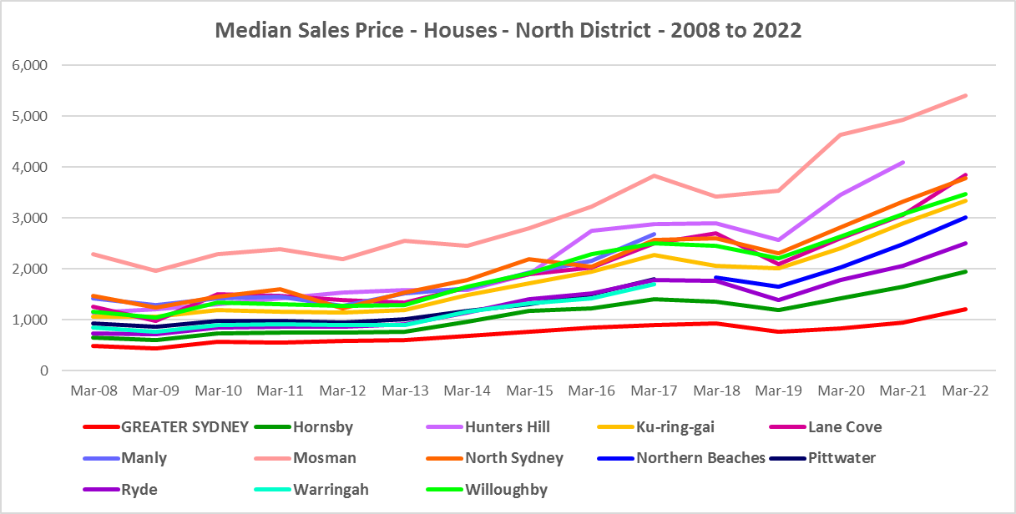

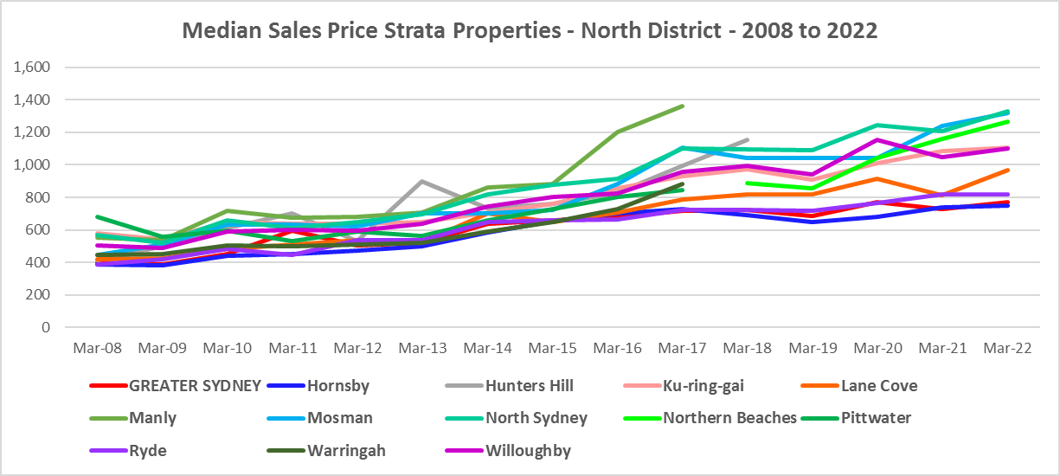

* However, between 2019 and 2022 there were more complex changes in the market, as the graphs above and the two tables below demonstrate. Between March 2019 and March 2020 median house and strata prices declined in most North District LGAs. Changes in the median sales price for houses over that 12 month period ranged between -22.6% in Lane Cove and 3.7% in Mosman, while for strata the change in the median ranged between -6.6% in Ku-ring-gai and 0.4% in Mosman. This compares to -18.4% for houses and -5.5% for strata properties in Greater Sydney.
* Between March 2020 and March 2022 there was strong growth in median house and strata prices across the North District. Increases in the median sales price for houses ranged between 48.4% in Northern Beaches and 16.5% in Mosman. For strata over the same period, increases ranged between 26.7% in Mosman and -4.6% in Willoughby. (Willoughby was the only LGA to register a decline in the median sales price in this time frame in the North District.) This compares to a 43.0% increase in the median sales price of houses and no change for strata in Greater Sydney.
* Clearly Covid also had an impact on sales prices in the region.

Median Sales Price Houses

Median Sales Price Strata

## Purchase Affordability

* Purchase affordability for very low income earners has varied only marginally over the period from 2017 to 2021 in Greater Sydney and in the North District.
* At June 2021, all the North District LGAs, along with Greater Sydney, had 0.0% of sales affordable for purchase by very low income households.
* The graph and table below show purchase affordability for very low income households in the North District LGAs and Greater Sydney between 2017 and 2021.

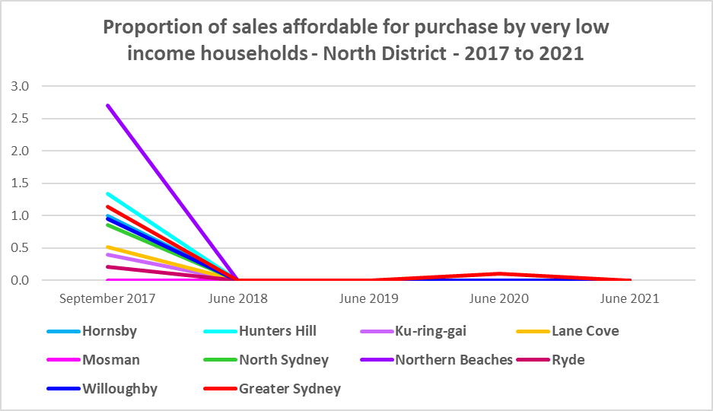

Proportion of sales affordable for purchase by very low income households



* Similarly, there was little variation in affordable purchase for low income households in the North District between 2017 and 2021. Again every North District LGA had 0.0% of housing affordable for purchase by low income households in 2021- all below the average of just 2.3% in Greater Sydney.
* The graph and table below show the change in purchase affordability for low income households in the North District, compared to Greater Sydney, between 2017 and 2021.

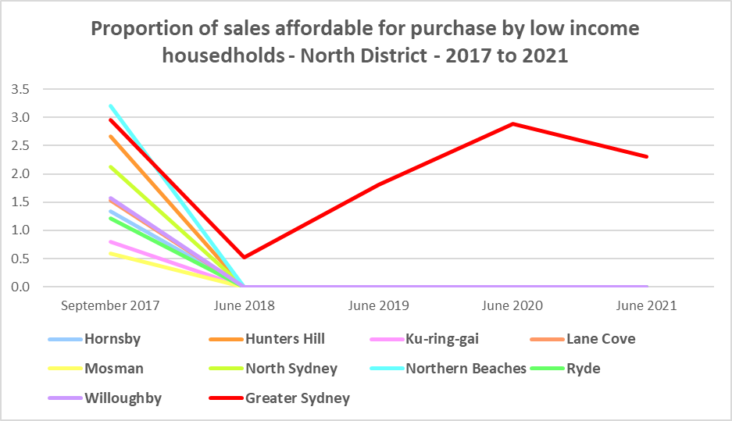

Proportion of sales affordable for purchase by low income households



* Purchase affordability for moderate income households is more difficult than for Greater Sydney but is possible in some North District LGAs. Ryde has the most opportunities with 14.2% of sales affordable to moderate income households, followed by Hornsby with 13.9%. The remaining LGAs have between 0.0% (Hunter’s Hill) and 5.5% (North Sydney) compared to the average for Greater Sydney of 18.1% at June 2021.
* The graph and the table below show the proportion of sales affordable for purchase by moderate income households in North District and Greater Sydney between 2017 and 2021.

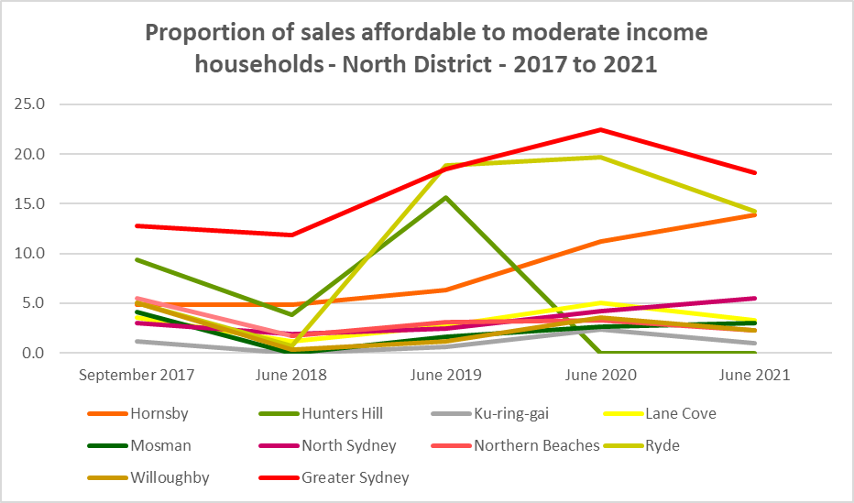

Proportion of sales affordable for purchase by moderate income households



**Purchase Stress**

* In 2021 there were 4,588 very low income households and 4,360 low income households purchasing a home and in stress across the North District – that is, paying more than 30% of their income on their mortgage. This represents 71.4% of very low income purchasers and 54.0% of low income purchasers in the District – higher proportions than the average for Greater Sydney at 69.3% and 43.8% respectively.
* Ku-ring-gai had the highest proportion of very low income purchasers in stress with 77.3%, followed by Hunter’s Hill with 76.8% and Ryde with 75.1%.
* Mosman had the highest proportion of low income purchasers in stress with 65.9%, followed by Ku-ring-gai with 62.9% and Willoughby with 59.5%.
* Northern Beaches had the highest number of very low and low (2,137) income purchasers in stress, followed by Hornsby (1,851) and Ryde (1,767).

Very Low and Low Income Households in Purchase Stress

* However the number of very low and low income purchasers in stress is significantly lower than the number of very low and low income renters in stress in the District, as the graph below demonstrates. There is a stronger need for more affordable housing for lower income renters than purchasers in North District.

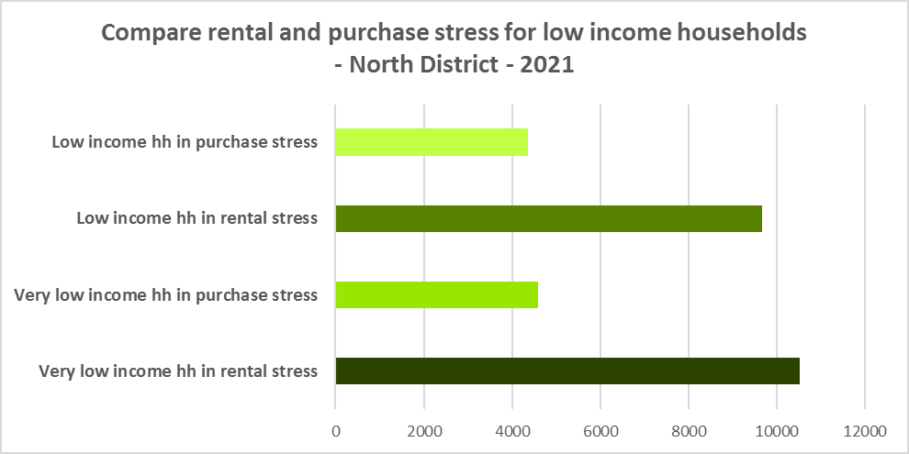

## Additional Data

Additional data on rents and sale prices, including both current and historical data, is available from the Rent and Sales Report and the interactive Dashboard on the Housing NSW website at:

<https://www.facs.nsw.gov.au/resources/statistics/rent-and-sales/dashboard>

More detailed housing data and tables used in this Snapshot are available from the Local Government Housing Kit Database on the DCJ website at:

<https://www.facs.nsw.gov.au/resources/nsw-local-government-housing-kit/chapters/local-government-housing-kit-database>

More information on vacancy rates is available from the Real Estate Institute of NSW website:

<https://www.reinsw.com.au/Web/Web/Members/Property_data/Vacancy_Rates_Survey.aspx>

The Rental Affordability Index is at

<https://sgsep.com.au/projects/rental-affordability-index>