# Western City District – What’s happening in the Housing Market

This Housing Snapshot looks at rents, vacancy rate, affordable rental, rental stress, loss of affordable private rental stock, impact on key workers, sales price, purchase affordability and purchase stress in Western City – particularly changes between 2016 and 2021.

## There have been changes across the District since the 2021 Census, with Covid having an impact on the housing market. Recent additional cost of living pressures, including rising inflation and interest rates with continued low wage growth, have created further difficulties for lower income earners and their capacity to manage housing costs.

## Wage growth has lagged well behind house price growth for decades. In 1984 the average Australian could buy a home that costs 3.3 times their annual income. By 2022 the average Australian needed 10 times their income to buy a home. Further, the real value of wages declined by 4.5% in 2022, the largest documented deterioration. With annual inflation running at 6.0 per cent, wages need to be growing by 6.0 per cent to maintain their purchasing power.

Consequently households are increasingly struggling with housing costs – saving a deposit, taking on a mortgage, competing for rental properties, paying rising rents – as well as a wide range of other goods, such as food, energy, medication, education, transport. There are many anecdotal reports of tenants having to choose between paying the rent and paying for medication, their education or food as well as rising homelessness.

## *Housing Market – Rental*

## Rents

* There has been strong growth in median rents for all dwellings (including all housing types and all bedroom categories) in Western City for a couple of decades, as the graph below shows. It tracks the change in median rent (for all dwellings) for all the Western City LGAs as well as for Greater Sydney from June 1990 to June 2022.
* Note from the graph that median rents stabilised or declined in the Western City LGAs (and Greater Sydney) between 2017 and 2019, before a strong recent recovery.

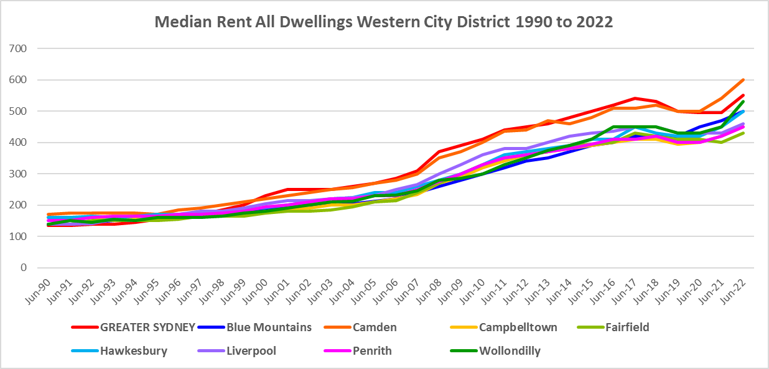

* The table below shows the change in median rent for all dwellings from 2017 to 2023. Generally there were strong increases in median rents over this period in the Western City LGAs, with the biggest increase in both numeric and percentage terms occurring in Camden. At the June quarter 2023, Camden had the highest median rent at $650 per week and Fairfield had the lowest with $485 per week.



* However, over this time frame there was considerable variation in changes to median rents.
* Between 2019 and 2020 when Covid lockdowns were introduced, median rents in most NSW local government areas generally dropped. This pattern is not evident in Western City, where only three LGAs followed this trend – Liverpool, Penrith and to a lesser extent Wollondilly.
* During that period in those three LGAs, the largest percentage drop in median rents occurred in Penrith (-15.7%) and Liverpool -10.8%) for one bedroom homes. Liverpool had the largest percentage decline in two bedroom homes (-7.7%), followed by Penrith with -5.7%; and for three bedroom homes Penrith dropped -2.4% and Wollondilly -2.3%. No LGAs recorded a decline in the median rent for four bedroom homes over the same period.
* Elsewhere in Western City, most LGAs recorded no change in median rents in at least one bedroom category and most recorded an increase in median rents in at least one bedroom category, as the table below shows.



* However, between 2020 and 2022 when Covid restrictions were relaxed, there were strong increases in median rents across Western City, as the table below shows.
* Across the District, the strongest increase in median rents over this period occurred in Liverpool for one bedroom homes (27.6%), followed by Blue Mountains (22.7%) and Camden (22.6%) for four bedroom homes, and then Hawkesbury (22.6%) and Camden (20.9%) for three bedroom homes.
* At June 2022, median rents for one bedroom homes ranged between $370 per week in Liverpool and $270 in Fairfield; for two bedroom homes between $440 in Blue Mountains and $350 in Fairfield; for three bedroom homes between $550 in Blue Mountains and Camden and $470 in Campbelltown; and for four or more bedroom properties between $680 in Liverpool and $600 in Penrith. Note there were insufficient new bonds lodged for bedsit/studio dwellings to calculate the median rents in the Western City LGAs, which is evidence of lack of supply.



## Vacancy Rate

* A vacancy rate of 3% is understood to represent a balance between supply and demand. Vacancy rates below 3% represent a tight rental market while longer term vacancy rates below 2% signify a chronic undersupply of rental housing.
* According to REINSW data, vacancy rates were below 3% for the inner, middle and outer rings of Sydney for almost all of the period from 2006 through to 2018.
* At April 2023 the vacancy rate in the inner ring of Sydney was 1.5%, for the middle ring was 1.2% and for the outer ring was 1.3%, indicating a tight rental market across Sydney and most particularly in the middle ring.
* Vacancy rates are tight across almost all of NSW. At April 2023, the vacancy rate on the Central Coast was 1.7%, in Wollongong was 1.3, for the Illawarra was 1.7%, in Newcastle was 1.8%, in the rest of the Hunter was 2.0% and in the Central West of NSW was 1.6%.
* Anecdotal information on the current vacancy rate underlines the difficulty tenants are facing finding and retaining rental accommodation - the fierce competition for rental housing, rent bidding and the rapid increase in rents – with tenants facing eviction, homelessness, overcrowding and paying too much of their income in rent.
* The graph below shows the vacancy rate for the inner, middle and outer rings of Sydney for the period from 2006 to 2023, using data from the Real Estate Institute of NSW. Note that all Western City LGAs are in the Outer Ring.

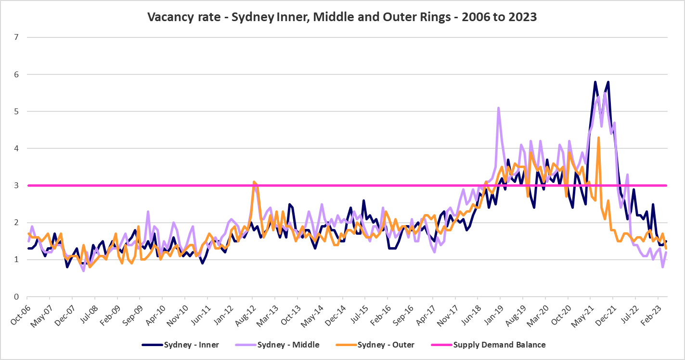

## Affordable Rental

* Since 2001, the general trend across Sydney and NSW has been for a decline in the proportion of rental stock which is affordable for very low, low and moderate income earners, as measured by the number of new bonds lodged which are affordable to those income groups.
* Along with elsewhere in NSW, there were more complex factors at play between 2019 and 2022 in Western City.
* Across Greater Sydney, the proportion of affordable rental for very low income households increased every year from 2018 to 2021 and then declined between 2021 and 2022.
* In Western City this pattern was more varied.
* Between June 2018 and June 2019, the proportion of affordable rental actually declined in Blue Mountains but increased everywhere else in Western City.
* Between June 2019 and June 2020, affordable rental for very low income households increased in every Western City LGA.
* Between June 2020 and June 2021, the proportion affordable private rental for very low income households declined in Blue Mountains, Campbelltown, Hawkesbury, Penrith and Wollondilly but increased in the other Western City LGAs.
* Between June 2021 and June 2022, affordable rental for very low income households declined in Hawkesbury, Liverpool and Wollondilly and increased elsewhere in Western City.
* At June 2022, Camden (6.5%), Wollondilly (10.0%) and Blue Mountains (10.4%) had a lower proportion of affordable rental for very low income households than the Greater Sydney average of 10.7%. The remaining Western City LGAs all had higher proportions, with Fairfield having the largest proportion with 31.7%.
* The table and graph below show the change in the proportion of private rental accommodation affordable to **very low income** households in the Western City LGAs and Greater Sydney between 2017 and 2022.

Proportion of new bonds lodged affordable for very low income households

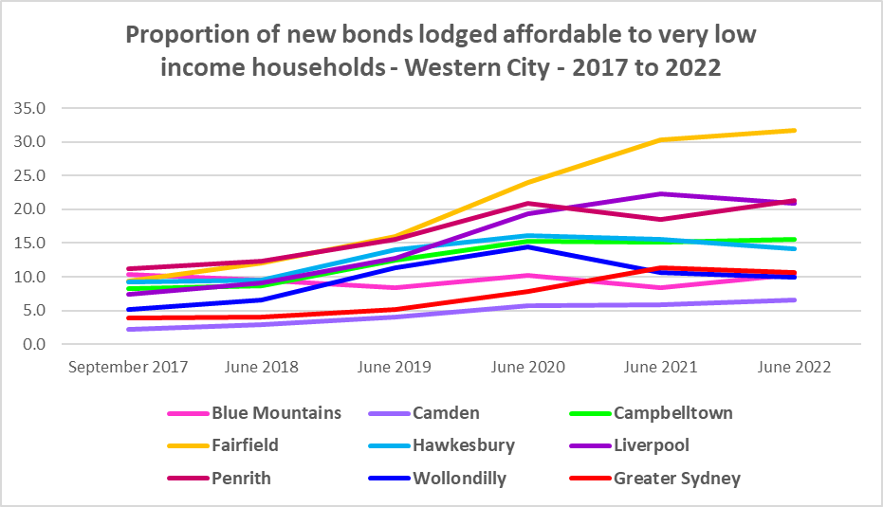

* Between 2018 and 2021 the proportion of rental affordable for **low income** households increased in Greater Sydney from 23.2% to 44.8% before declining to 41.5% in June 2022.
* Again the experience in Western City was more varied:
  + Blue Mountains, Campbelltown, Hawkesbury, Penrith and Wollondilly experienced an increase in the proportion of rental affordable to low income households between 2018 and 2020, then declined to 2022.
  + Camden and Liverpool had an increase in the proportion of rental affordable for low income households between 2018 and 2021 and then the proportion declined to 2022.
  + Fairfield increased every year between 2018 and 2022.
* At June 2022 every Western City LGA (with the exception of Camden), had a higher proportion of affordable private rental for low income households than the average of 41.5% for Greater Sydney. Camden had the lowest proportion with 25.2%, with the next lowest being Wollondilly with 47.7%.
* The table and graph below show the change in the proportion of private rental accommodation affordable to **low income** households in Western City and Greater Sydney between 2017 and 2022.
* Despite the fact that Western City is a little more affordable than the average for Greater Sydney, there is still a very low proportion of affordable rental housing available.

Proportion affordable rental for low income households



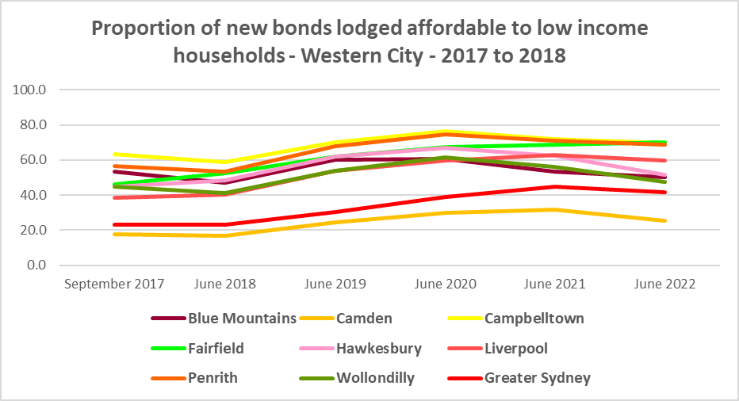

## Rental Stress

* Households are regarded as being in rental stress when renting in the private rental market and paying more than 30% of their income in rent. Lower income households in rental stress will struggle to pay for other essential household costs, such as medical or educational expenses, food, transport and energy costs.
* At June 2021 the proportion of very low income households in rental stress in Greater Sydney was 94.0%.
* Within Western City, the average proportion of very low income households in stress was 91.5%, with the proportion varying from 93.1% in the Blue Mountains to 89.1% in Wollondilly. All LGAs in Western City had a lower proportion in stress than the average for Greater Sydney.
* For low income households in rental stress at 2021, the average for Greater Sydney was 61.4%, with the Western City average significantly lower on 48.8%. Across the region the proportion of low income households in stress ranged from 61.6% in the Blue Mountains to 40.6% in Fairfield.
* Blue Mountains was the only Western City LGA with a higher proportion of low income households in rental stress than the Greater Sydney average.
* However, while the **proportion** of very low and low income households in stress declined in every Western City LGA (or remained stable for very low income households in Blue Mountains) between 2016 and 2021, in line with the trend in Greater Sydney – the actual number of **very low income** households in stress increased in every Western City LGA.
* The number of **low income** households in stress increased in Camden but declined in every other Western City LGA over the same period.
* Below is a graph of the proportion of very low and low income households in rental stress in each Western City LGA at 2021, and a table showing the change in the proportion of very low and low income households in stress between 2016 and 2021.

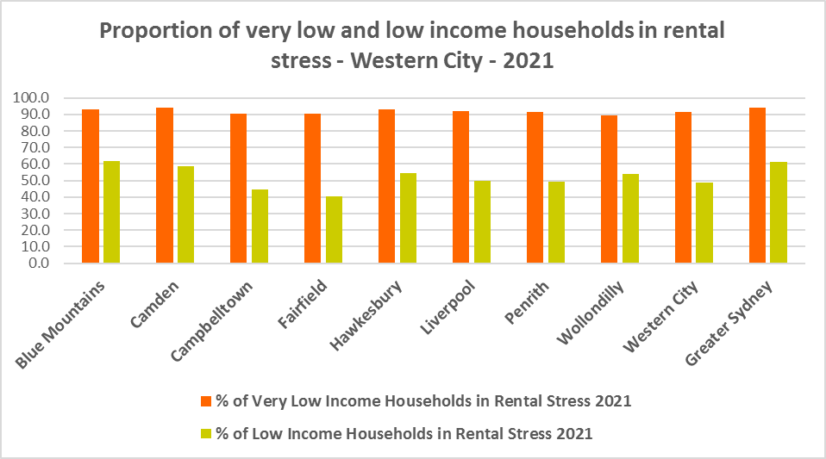

Proportion of very low and low income households in rental stress

* The next table shows the change in the number of very low and low income households in rental stress between 2016 and at 2021.

Number of very low and low income households in rental stress

* A look at CRA (Commonwealth Rent Assistance) recipients in housing stress gives some further information on what has been happening with lower income households in rental stress over this time frame.
* Between 2016 and 2020, the total number of CRA recipients in Western City increased much more significantly than the increase in the number of CRA recipients in rental stress.
* However, between 2020 and 2021, the total number of CRA recipients declined while the number in stress increased in Western City.
* This is a bit different to the trend in regional NSW, where between 2016 and 2020, the total number of CRA recipients increased significantly, while the number in stress actually declined. However, between 2020 and 2021 the number of CRA recipients declined while the number in stress increased.
* This is different also from the trend in Eastern City and North District, where between 2016 and 2020, the total number of CRA recipients in increased as did the number of CRA recipients in rental stress. However, between 2020 and 2021, the total number of CRA recipients as well as the number in stress declined in Eastern City and North District.
* Generally across Australia, the number of CRA recipients in housing stress has increased from the June 2020 figures as the temporary Coronavirus Supplement ended on 31 March 2021.
* The Coronavirus Supplement was $550 per fortnight for new and existing recipients of JobSeeker Payment, Parenting Payment, Youth Allowance for jobseekers, Farm Household Allowance and Special Benefit. The temporary supplement almost doubled the maximum payment rate for a JobSeeker Payment recipient. Hence it made rent more affordable for some CRA recipients in June 2020 and resulted in a lower proportion of CRA recipients in rental stress than usual.
* Since the end of Covid restrictions, the number of people in employment has increased, so fewer people are relying on rent assistance from the Commonwealth.
* The two graphs below clearly demonstrate the change in total CRA recipients and CRA recipients in stress between 2016 and 2020 and 2020 and 2021 in Western City.

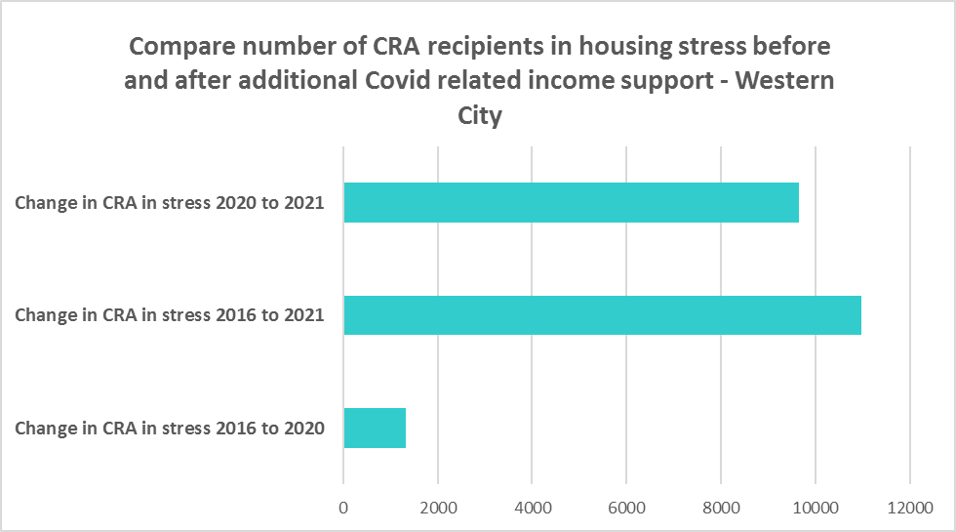

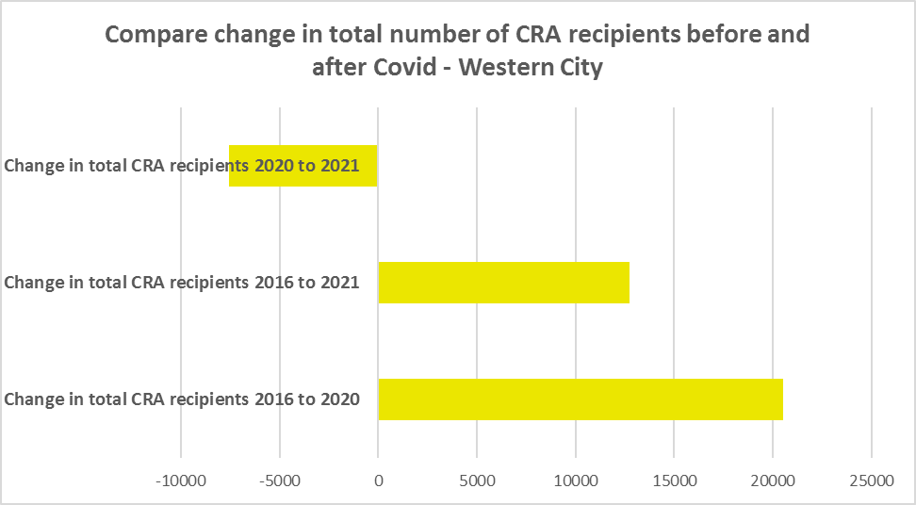

* The table below shows the number and proportion of tenants in Western City who are in the private rental market, are in receipt of Commonwealth Rent Assistance, and even with this additional income support, are in housing stress.
* There were a total of 39,760 tenants in receipt of CRA and in housing stress across Western City in 2021, up from 28,786 in 2016. In 2016, 45.4% of CRA recipients in Western City were in stress, increasing to 52.2% in 2021. This compares to 50.7% CRA recipients in stress in 2016 for Greater Sydney and 56.2% in 2021.
* Camden had the highest proportion of CRA recipients in stress with 55.8% while Fairfield had the highest number with 11,402.



## Loss of Affordable Housing Stock

* DCJ has calculated the number of new bonds lodged with the Rental Bond Board that were affordable to low income earners in Western City in 2021 and 2022. The District experienced a 5.8% decline in affordable bonds lodged, and consequently loss of affordable private rental housing, in just that 12 month period.
* The table below shows the number of new bonds lodged that were affordable to low income households (including very low income households) in 2021 and 2022 in each of the Western City LGAs as well as the total for the District.
* Note that over that 12 month period, Blue Mountains, Fairfield and Wollondilly registered a small increase in new bonds lodged that were affordable to low income households, while all other LGAs in the District experienced a loss.
* Hawkesbury had the largest loss of stock in percentage terms with -24.8%, followed by Camden with -16.2%.
* In numeric terms, Penrith had the greatest loss with 143 fewer affordable bonds lodged (constituting half of the loss for the whole District), followed by Campbelltown with -77.

Number of affordable rental properties (new bonds lodged) affordable to low income households



**Impact on Key Workers**

* This loss of affordable private rental housing is having a direct impact on key workers (who are often low paid) that work or live in the District. There is evidence that high rental prices are “pushing out” some of Sydney’s key workers from inner to middle and outer suburbs – with Western City District now accommodating a lot of these workers.[1]
* Key workers and low income earners include teachers, registered nurses, hospitality service workers, accommodation and food service workers, early childhood, police and aged care workers. These are important occupations and provide necessary services and assistance to the wider District community. In performing their roles in hospitality, education, public health and safety, key and lower paid workers significantly influence the social and economic wellbeing of their local areas.
* Western City in particular has a high number of health care, education and aged care workers who work in the District, due to the hospital precinct at Nepean hospital, the presence of Western Sydney University and the concentrations of aged care in Penrith and Liverpool. There is also a large population of early childhood workers due to the significant numbers of families with young children in the District.
* Analysis by the Australian Housing and Urban Research Institute (AHURI) (May 2021 Policy Evidence Summary – Housing for Australia’s Key Workers) shows that:
  + In Sydney key workers are more likely than the labour force generally to live in outer suburbs and satellite cities and to commute 30kms or more to work.
  + Around 31,000 key workers in Sydney live in overcrowded homes, with the greatest concentration in inner subregions and among lower paid occupation groups.
  + Over 52,000 key workers in Sydney are living in households that can be classified as being in housing stress, equating to 20 per cent of key workers.
  + In February 2020, only 2 per cent of new tenancies across Greater Sydney had starting rents that were at or below the affordability threshold for households earning $790 per week gross (broadly indicative of a wage for a laundry worker). Just 5 per cent were affordable to households earning $960 (broadly indicative of wages for a commercial cleaner, delivery driver and entry level firefighter) and 11 per cent were affordable for those with an income of $1,150 (broadly indicative of the wage for an enrolled nurse, child care worker and ICT support technician).
* Although Western City has historically offered more affordable accommodation, the individual LGAs have lower proportions of rental properties in general and of smaller rental properties, including units. This means that while renting might theoretically be possible for low paid key workers, choice is limited and affordable private rental housing is often not available.

## *Housing Market – Purchase*

## Sales Price

* Changes in the median sales price of both houses and flats in Western City over the ten years to March 2022 have generally been upward. Although a number of LGAs experienced a drop in the median sales price of houses and strata properties between 2018 and 2019/2020, they have all subsequently recovered and increased.
* Wollondilly (185.4%), Blue Mountains (165.5%), Campbelltown (148.8%) and Hawkesbury (148.7%) had the largest proportional increase in median sales price for houses over this time frame. All Western City LGAs experienced stronger increases over this time frame than the average for Greater Sydney of 104.6%.
* Not all Western City LGAs had sufficient sales to calculate the median strata price. For the LGAs that had data available, Campbelltown had the largest increase with 105.3%, followed by Penrith with 103.8% and Fairfield with 83.8%. All the Western City LGAs with data on median sales price of strata properties had a stronger increase than the average for Greater Sydney of 52.5% over the ten year period to 2022.
* At March 2022, Wollondilly had the highest median sales price for houses in Western City with $1,213,000, followed by Hawkesbury with $1,149,000. Wollondilly was also the only LGA with a median sales price for houses higher than the average for Greater Sydney ($1,203,000).
* Blue Mountains had the highest sales price for strata properties with $628,000, followed by Penrith with $589,000. All the Western City LGAs had a lower median sales price for strata properties than the average for Greater Sydney of $770,000.
* The table below shows changes in the median sales price of both houses and flats over the last ten years in Western City.



* The long term median sales price trend for both houses and flats shows growth across all LGAs.
* The two graphs below show the median sales price trend for houses and for strata properties from 2008 to 2022 in all Western City LGAs and Greater Sydney.

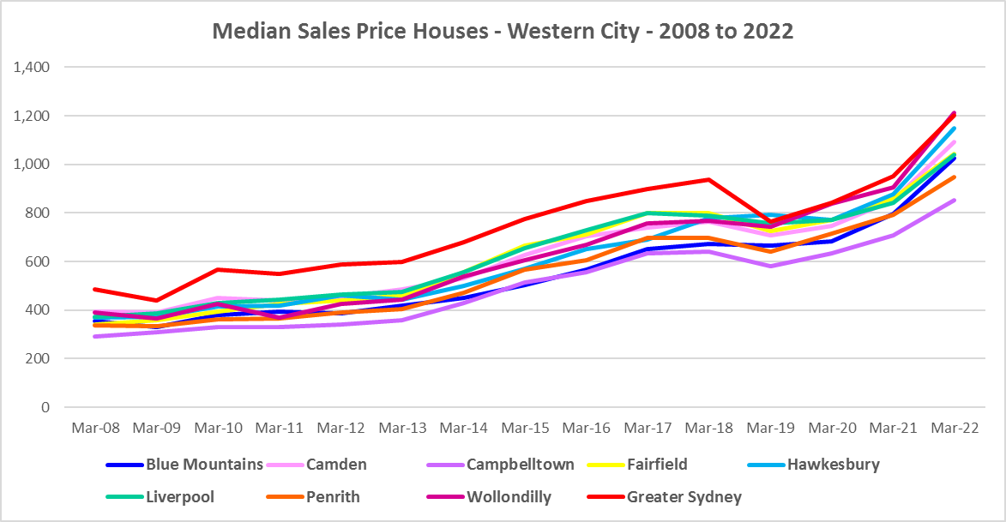

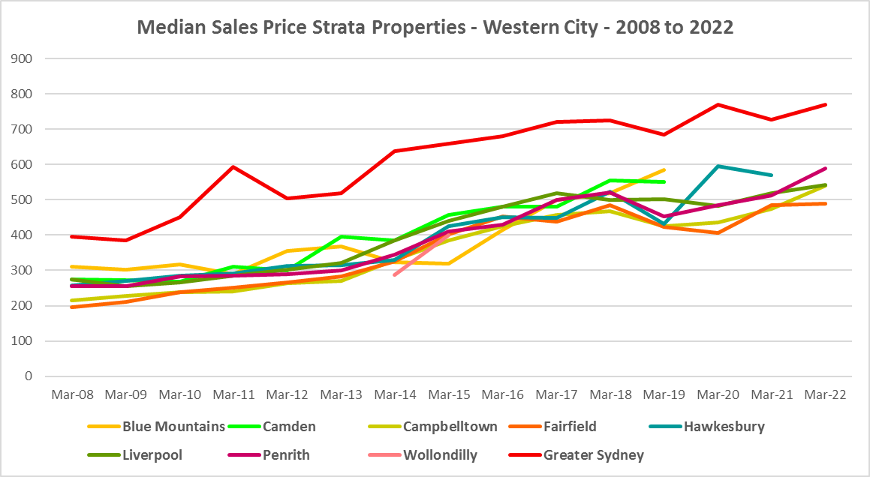

* However, between 2019 and 2022 there were more complex changes in the market, as the graphs above and the two tables below demonstrate. Between March 2019 and March 2020 median house and strata prices declined in most Western City LGAs. Changes in the median sales price for houses over that 12 month period ranged between -9.4% in Campbelltown and Fairfield and a 1.8% increase in Hawkesbury. For strata the change in the median ranged between -17.6% in Hawkesbury and a 12.3% increase in Blue Mountains.
* This compares to a decline of -18.4% for houses and -5.5% for strata properties in Greater Sydney. Note that generally Western City LGAs experienced smaller declines in the median sales price for houses and larger declines in the median sales price for strata than the average for Greater Sydney between 2019 and 2020.
* Then between March 2020 and March 2022 there was strong growth in median house and strata prices across Western City. Increases in the median sales price for houses ranged between 50.3%% in the Blue Mountains and 32.4% in Penrith. For strata over the same period, increases ranged between 14.8% in Penrith and 0.8% in Fairfield. (Noting that several LGAs had insufficient strata sales to calculate a median and therefore the change).
* This compares to a 43.0% increase in the median sales price of houses and 5.8% for strata in Greater Sydney. Note that Blue Mountains, Hawkesbury, Camden and Wollondilly all had a higher increase in the median sales price for houses than Greater Sydney over this period; while both Penrith and Campbelltown had larger increases in the median sales price for strata properties than Greater Sydney.
* Clearly Covid also had an impact on sales prices in the region.

Median Sales Price Houses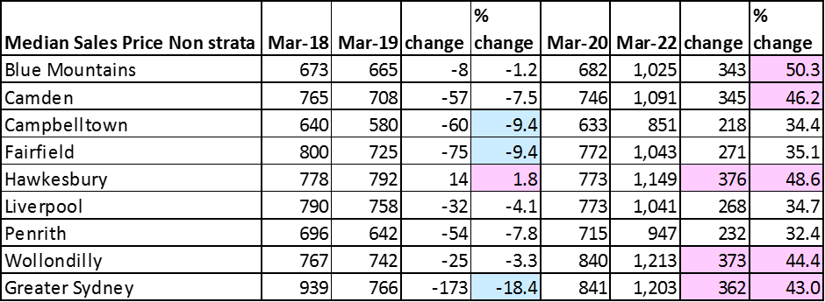

Median Sales Price Strata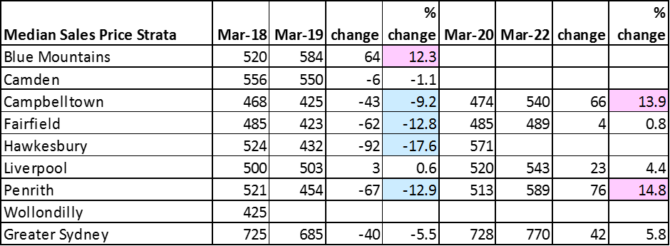

## Purchase Affordability

* Purchase affordability for very low income earners has varied only marginally over the period from 2001 to 2021 in Greater Sydney and in Western City.
* At June 2021, all the Western City LGAs, along with Greater Sydney, had 0.0% of sales affordable for purchase by very low income households.
* The graph and table below show purchase affordability for very low income households in the Western City LGAs and Greater Sydney between 2017 and 2021.

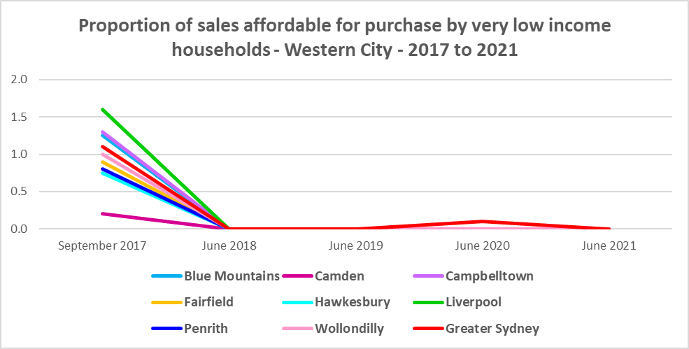

Proportion of sales affordable to very low income households

* There was a little more variation in affordable purchase for low income households in the Western City between 2017 and 2021. The proportion of housing affordable for purchase by low income households in 2021 in Western City ranged between 0.8% in Camden and 12.0% in Fairfield. Camden, Blue Mountains (1.4%), Wollondilly (1.5%) and Hawkesbury (1.6%) all had a lower proportion affordable for purchase than the average of just 2.3% in Greater Sydney.
* The graph and table below show the change in purchase affordability for low income households in Western City, compared to Greater Sydney, between 2017 and 2021.

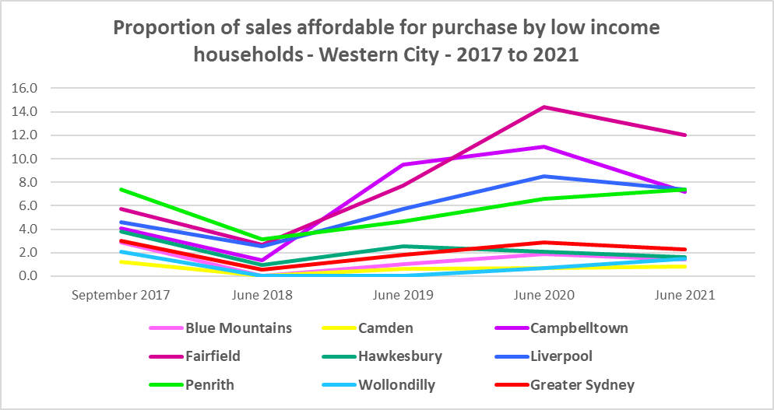

Proportion of sales affordable for purchase by low income households

* Purchase affordability for moderate income households is generally easier in Western City than for Greater Sydney as a whole, however Camden (11.0%), Wollondilly (16.9%) and Hawkesbury (17.4%) are all below the Greater Sydney average of 18.1%, while Blue Mountains is just over with 19.5%.
* Campbelltown has the most opportunities for moderate income households with 39.9%, followed by Penrith with 36.3%, Liverpool with 33.7% and Fairfield with 24.1% at June 2021.
* The graph and the table below show the proportion of sales affordable for purchase by moderate income households in Western City and Greater Sydney between 2001 and 2021.

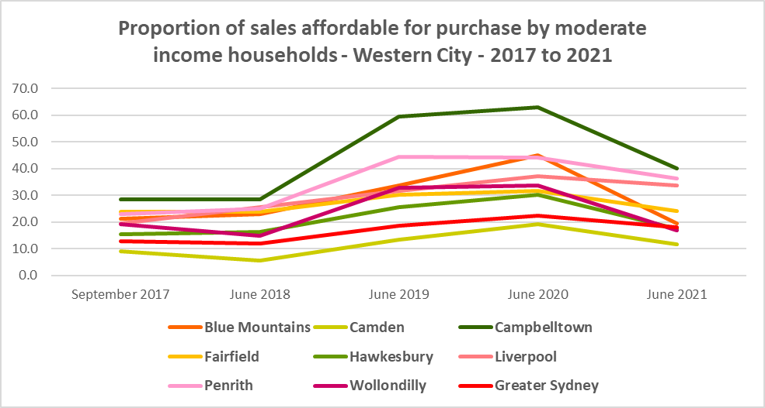

Proportion of sales affordable for purchase by moderate income households



**Purchase Stress**

* In 2021 there were 11,110 very low income households and 9,562 low income households purchasing a home and in stress across Western City – that is, paying more than 30% of their income on their mortgage. This represents 67.2% of very low income purchasers and 38.4% of low income purchasers in the District – lower proportions than the average for Greater Sydney at 69.3% and 43.8% respectively.
* Camden (73.1%) had the highest proportion of very low income purchasers in stress, followed by Liverpool (71.0%) and Campbelltown (69.6%). These were the only LGAs in Western City to have a higher proportion in stress than the Greater Sydney average.
* Camden also had the highest proportion of low income purchasers in stress with 49.1%, followed by Liverpool with 41.3% and Wollondilly with 40.9%. Camden was the only Western City LGA to have a higher proportion of low income purchasers in stress than the average for Greater Sydney.
* Liverpool had the highest number of very low income purchasers in stress (2,744), followed by Fairfield (2,392) and Campbelltown (2,104).
* Liverpool also had the largest number of low income purchasers in stress (2,115), followed by Campbelltown (1,715) and Penrith (1,637).

Very Low and Low Income Households in Purchase Stress



* However the number of very low income purchasers in stress is significantly lower than the number of very low income renters in stress in the District, as the graph below demonstrates. There is less difference between low income renters and purchasers in stress, although there are still more renters in stress than purchasers. This suggests that there is a stronger need for more affordable housing for lower income renters than purchasers in Western City.

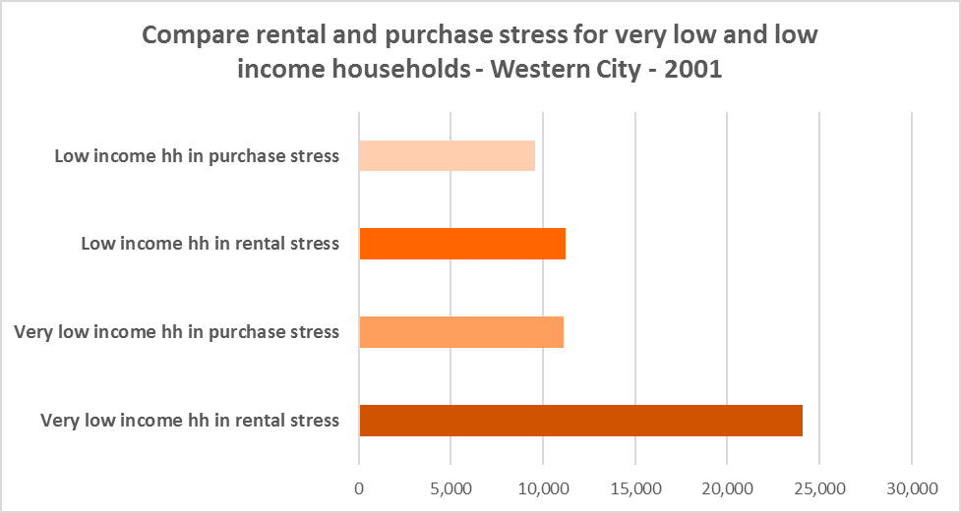

## Additional Data

Additional data on rents and sale prices, including both current and historical data, is available from the Rent and Sales Report and the interactive Dashboard on the Housing NSW website at:

<https://www.facs.nsw.gov.au/resources/statistics/rent-and-sales/dashboard>

More detailed housing data and tables used in this Snapshot are available from the Local Government Housing Kit Database on the DCJ website at:

<https://www.facs.nsw.gov.au/resources/nsw-local-government-housing-kit/chapters/local-government-housing-kit-database>

More information on vacancy rates is available from the Real Estate Institute of NSW website:

<https://www.reinsw.com.au/Web/Web/Members/Property_data/Vacancy_Rates_Survey.aspx>

The Rental Affordability Index is at

<https://sgsep.com.au/projects/rental-affordability-index>

1. Gurran, N., Gilbert, C. Zhang, Y., Phibbs, P. 2018 “Key worker housing affordability in Sydney”, Report prepared for Teachers Mutual Bank, Firefighters Mutual Bank, Police Bank and My Credit Union, The University of Sydney, Sydney