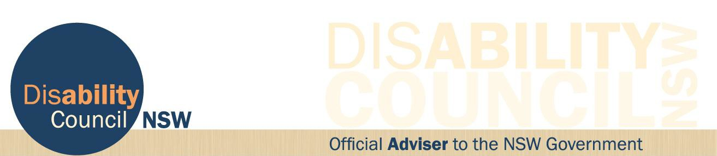

29 June 2017

Communique

The Disability Council NSW held its 29 June 2017 meeting at Parliament House. Council Members were delighted to welcome to the meeting the following guests:
• Mr Graeme Head, Commissioner, Public Service Commission
• Mr Simon Watts, Director, Disability Inclusion and Volunteering, FACS
• Mr Mark Scott, Secretary Department of Education
• Ms Melissa Clements, Director, Disability, Learning and Support, Learning and Wellbeing, Public Schools NSW, NSW Department of Education

Issues discussed included:

• Public Sector Commission Strategy: Improving the access to employment, retention and promotion of people with disability
• How the Council will provide feedback to the Minister on Disability Inclusion
Action Plans
• Discussions with the Secretary of Department of Education about their
Disability Action Plan
• Recruitment to Council will be underway soon.

The Council also received a presentation from Gail Le Bransky, Transport NSW on Transport’s new Disability Inclusion Action Plan and the Taxi Disability Incentives and Subsides Review.

The next meeting will take place in August 2017.

Locked Bag 4001, Ashfield NSW 1800 (02) 8879 9100
www.disabilitycouncil.nsw.gov.au disabilitycouncil@facs.nsw.gov.au

